管理的定义
Management is achieving goals in a way that makes the best use of all resources

- Planning
what to do
when to do
how to do

- Organizing
physical，financial and human resources

- Staffing
manning the organization structure and keeping it manned
selecting the right people for the job

- Directing
Supervision（监督）, Motivation（激励）, Leadership, Communication
Giving instructions

- Controlling
Make sure everything follows the rules

- Monitoring
Checking on progress（检查进度）

- Innovating（创新）
Solving new problems.

- Representing（代表）
Communicating with all people

项目 Project
What Is A Project？
- Temporary: a temporary effort
- Unique: create a unique product or service
- Constraints: cost, schedule or performance outcome

What Is Project Management?
- Discipline: Planning, Organizing, Staffing, Directing, Controlling, Monitoring, Innovating, Representing
- Methodical Approach（有条理的方法）: planning and guiding project
processes from start to finish

Why Project Management？
- Better Control
- Customer Relations
- Development Time
- Cost
- Quality
- Productivity

Characteristics of Projects（项目的特征）
- Non-routine
- Planned
- Aiming at a specific target
- Work carried out for a customer
- Involving several specialists
- Made up of several different phases
- Constrained by time and resources
- large and/or complex

Management approaches
Traditional Culture
Managers: Think
Employees: Do what they are told
Quality Culture
Managers are Coaches of the team they：
Communicate the vision, mission and goals
Provide resources
Remove barriers
Seek employee input and feedback
Build trust
Provide training
Reward and recognize（承认）performance

Characters of software project
- Invisibility
- Complexity
- Conformity: Software system has to conform to the requirement of human clients
- Flexibility

Categories（类别） of Software Project
- Information system project
- System interface with organization
- Embedded（嵌入式） system
- Process control

Key Project Management Responsibilities include：
- Creating clear and realistic project objectives
- Building project requirements
- managing the triple constraint

Triple Constraint
Scope: What must be done to produce the project's end result
Time: The amount of time available to complete a project
Cost: The budgeted amount available for the project

项目经理（PM）所需的关键能力（Competencies）
- Organizational
- Communication
- Leadership
- Technology

the feasibility study/plan/execution
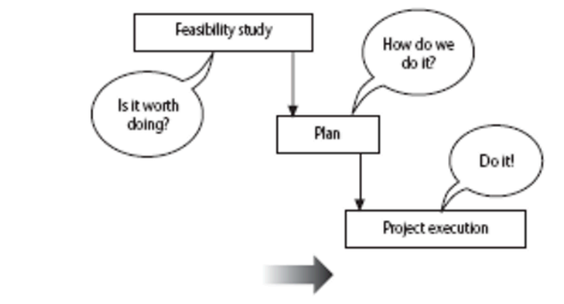

The Software Development Life-Cycle (ISO 12207)
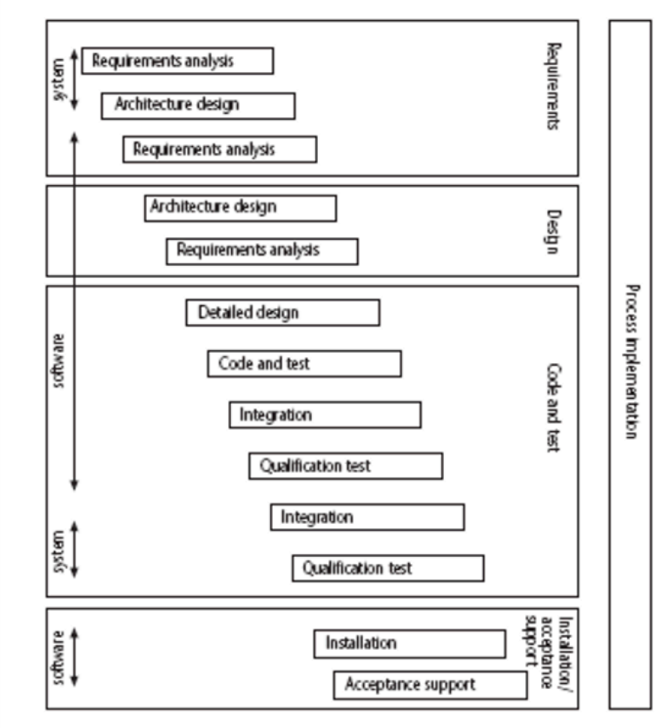
Requirements Analysis:
Requirements elicitation: what does the client need?
Analysis: converting ‘customer-facing’ requirements into equivalents that developers can understand

Requirements will cover:
- Functions
- Quality
- Resource constraints

Architecture design
- Based on System requirements
- Defines components of system: hardware, software, organizational
- Software requirements will come out of this

Code and test: Of individual components（组件）

Integration（集成）: Putting the components together

Qualification testing（资格测试）: Testing the system (not just the software)

Installation:
- The process of making the system operational
- Includes: setting up standing data
setting system parameters
installing on operational
hardware platforms
user training

Acceptance support: Including maintenance and enhancement

Issues with Software Projects
- Bad Plans
- No Rules
- Hard Decisions
- Invisible Work
- Confused Roles
- Wrong Goals

- Unknown Area
- Old Docs
- Late Inputs
- No Talk
- Low Commitment
- Limited Skills
- Law Changes
- Tech Changes
- Deadline Stress
- No Training

Software Project Objectives
Focus on What will be put in place, rather than how activities will be carried out

SMART Objectives
- Specific 具体的
- Measurable 可衡量的
- Achievable 可实现的
- Relevant 相关的
- Time

Sub-Objectives
Often a goal can be allocated to an individual.
Individual may have the capability of achieving goal, but not the objective on their own

Objective - user satisfaction with software product
Analyst goal - accurate requirements
Developer goal - software that is reliable（可靠的）

Stakeholders in SPM
User / Client
Developer / Implementer
Top Management

The Management Guidelines for Decision-Making
- Focus on Goals
- Follow Process
- Study Environment
- Develop Skills
- Boost Creativity
- Manage Opportunity

The Decision Cycle
- Define the Problem
- Collect Facts
- Find Solutions
- Implement Solution
- Monitor Result

