SPM First Principles
One size does not fit all 没有一种方法适合所有情况
Different project need different methods. It depends on the project’s size, type, and formality形式.

Software Engineering
Software Engineering is the science and art of building significant software systems that are:
- on time
- on budget
- with acceptable performance
- with correct operation

Structured set of activities
- Specification规格
- Design
- Install
- Testing
- Maintenance
Must be explicitly（明确的）modeled if it is to be managed

Requirement Collection
User requirements are often expressed informally: Features // Usage
Although requirements may be documented in written form, they may be Incomplete, Ambiguous模糊的, or even Incorrect

Changing Requirements
Requirements will change!
Validation is needed throughout the software lifecycle, not only when the “final system” is delivered

Requirement Analysis & Specification
The result of analysis is a specification document

Object-Oriented Analysis, OOA
The final output of OOA is a series of models.
- Classes of objects
Responsibilities of those classes
- Relationships
- Use cases and scenarios场景
Operations
Allowable sequences of those operations

Prototyping（原型设计）
Prototype tests hypotheses假设 to reduce risks
Exploratory Prototype探索性原型 = Throwaway prototype一次性原型
- UI prototype 用来(validate) 验证用户需求
- Rapid快速 prototype 用来验证功能需求
- Experimental实验性 prototype 用来验证技术可行性

Design
Design: The results are architecture and detailed design documents

Implementation & Testing
Implementation is the activity of constructing a software solution to the customer’s requirements

Testing is the process of validating that the solution meets the requirements

The result of implementation and testing is a fully documented and validated solution

Design, Implementation & Testing
Design, Implementation & Testing are iterative activities
Ideally, test case specification precedes先于 design and implementation

Maintenance
Maintenance is the process of changing a system after it has been deployed.
- Corrective: 纠正性，修bug
- Adaptive: 搬新家，适应新平台或环境
- Perfective: 完整性，实现新需求

Maintenance entails需要:
Configuration and version management
Reengineering
Updating all analysis, design and user documentation
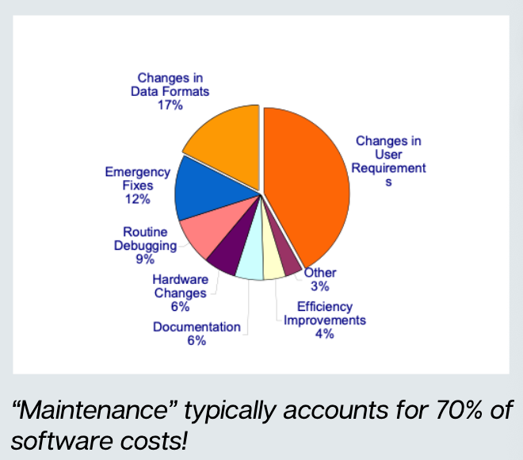

Methods and Methodologies
Definitions
Principle: A general statement about what is good or desirable
Method: General guidelines for an activity
Technique: A specific, technical way to do a task
Methodology: A package that combines methods and techniques together
History of Methods
1st Generation
2nd Generation
3rd Generation UML

Generic通用的 Software Model
Waterfall: The planning and building phases are separate分离 and distinct截然不同. You finish one step before starting the next.
Evolutionary: The planning and building phases happen at the same time.
Formal Transformation（形式转型）: This uses a mathematical model that is officially changed into the final software
Reuse-Based: The system is built by assembling components that already exist.

The Classical Software Lifecycle
The waterfall model is unrealistic for many reasons:
requirements must be frozen too early in the life-cycle
requirements are validated too late
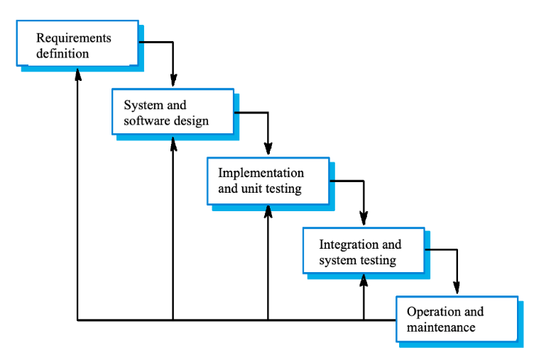
Problems with the waterfall cycle:
Real projects rarely follow a straight line
Requirements are hard to define
High risk at the end

Iterative development迭代开发
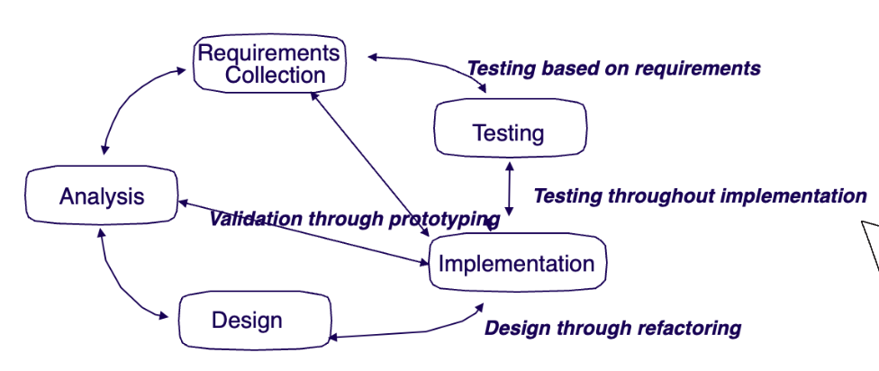
In practice, development is always iterative, and all activities progress in parallel

Iterative & Incremental增量式 Development:
You should plan to repeat analysis, design and coding
Goal: Always have a running version of the system, even if it is not finished yet.
Benefit: You can find errors and validate requirements early

The Unified统一 Process
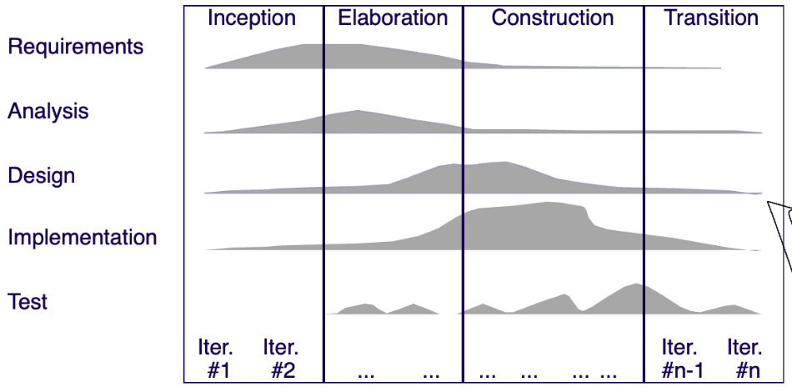
启动、细化、构建和过渡

Boehm’s Spiral Model
This model focuses heavily on Risk Analysis
Risk: Anything that might delay the project or increase costs
Planning -> Risk analysis -> Engineering -> Customers evaluation

Agile Methodology
Agile was create because old methods had too much unnecessary work / documentation
Key Features:
Focus on code, Not just design
Deliver working software quickly
Welcome changing requirements
Agile Methods:
Extreme Programming(XP极限编程): Breaks “User Stories” into small tasks and plans releases based on them.
Scrum: Uses “Sprint Cycle”迭代周期. Each sprint builds a small part of the system.
Kanban: A visual approach. It uses a board with columns like “To DO”, “Doing” and “Done” to manage workflow.
Agile Principles
Customer Involvement: The customer is involved throughout the process.
People not Process: Trust the team’s skills rather than strict rules.
Simplicity: Actively work to eliminate complexity.

Other Management Tools
Six sigma
A method to improve quality by using statistics to find and fix defects.
Lean Six Sigma: Also focuses on eliminating waste.
Critical Path Method(CPM)
A way to model project tasks and find the longest sequence of tasks.
Why it matters: If a task on the “critical path” is delayed, the entire project will be delayed

Conclusion
To succeed in any project, you should:
Set clear milestones and goals.
Communicate regularly with the team.
Involve stakeholders
Monitor progress and be ready to adjust.

