Nail classification for health

Cheung, Ethan, T. H.

1King George V Secondary School, Hong Kong

1Contact: cheunt3@kgv.hk

Abstract— This document gives information of how nail classification of different nail types can be used for health, as nail types can distinguish what possible diseases you may have. For this GEF programme, a limited amount of 10 nail types has been classified. Once classification has occurred, through the inference engine, connected to a User Interface, advice will be given to the user, which will indicate, on a scale, whether their condition is harmless or severe.

1. Introduction

This project is inspired by TensorFlow’s “Powered by TensorFlow: Helping doctors detect respiratory diseases using machine learning” [1], so to do something innovative, using biometric data. Through the use of computer vision, using Convoluted Neural Networks, which uses kernels to compress information of pixels, classification of nails is possible. The dataset of images has been manually cropped and put into their respective classes. Since data from 10 classes is used, one hot encoding is used to train the Convoluted Neural Network model. The model is then attached to a User Interface, which will give advice based on the nail it has classified.

1. Methodology

A step-by-step instruction guide, as to explain how this GEF project has been created.

1. Data Collection

Data has been collected from Google images, using Google’s search feature, allowing data to be compiled to a single dataset. A total of 160 images were used to train the Convoluted Neural Network. Classes included: Acral Lentiginous Melanoma; detecting melanoma cancer [2], Beau’s lines; predicting chronic diseases such as uncontrolled diabetes and peripheral vascular disease [3], Clubbed nails; linked with lung cancer [3], Cyanosis; insufficient oxygen in bloodstream – links with anaemia [4], Koilonychia; links with malnutrition [5], Leukonychia; lacking of calcium, which can cause rickets [6], Normal nails; nothing is wrong, Paronychia; links with stress [7], Psoriasis; shows chronic disease [8], and Yellow nails; thyroid problems [9].

1. Pre-Processing of Data

To begin with, data has been reshaped to images of shape 128x128, where the images are RGB. Afterwards, the values are divided by 255, to make the probabilities range from 0 to 1. Once the images have been pre-processed, the pre-processed images will be split into 8 batches, 20 images per batch, where 4 batches are assigned to training, 3 batches are assigned to the validation set, and 1 batch is used for testing.

1. Creation of Model

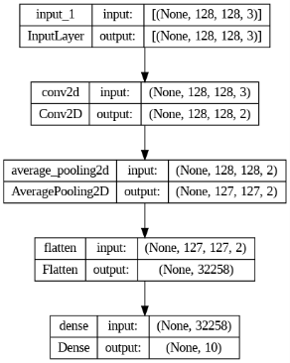

Fig. 1 A image which shows Convoluted Neural Network structure

Fig. 1 shows the Convoluted Neural Network structure, where there is one input layer (inputting image). The input layer is then given to convoluted layer, where it is pooled, by finding the average pooling, having kernel size of 3x3, having a stride of 1. Then the pooled layer will be flattened and then condensed by using the SoftMax activation, which condenses the probabilities into one of the ten classes of the nails. The model is then saved as a HDH5 file, to store the weights and biases of the trained Convoluted Neural Network.

1. Connecting Inference Engine to User Interface

Using the StreamLit API, a simple User Interface can be created, where the Convoluted Neural Network can be loaded, in the form of HDH5, and can be used for nail classification. The user can upload an image of their nail, in the drop-down section, and it will display and predict the class, whilst also giving subsequent advice based on the nail type the Convoluted Neural Network has predicted.

1. Results and discussion

In this section, there will be images and statistics from the project. Furthermore, there will be discussion of how statistics from the project can be improved in accuracy and reliability.

1. Statistics and Figures

Fig. 2 A image which shows Convoluted Neural Network training accuracy



Fig. 3 A image which shows Convoluted Neural Network on test set

Fig. 2 and Fig. 3 shows the accuracy of the trained model. 4 batches of data have been used for training, 3 batches of data have been assigned to a validation set and one batch of data has been used for testing. From these batches, we have obtained a perfect accuracy on our given images. Note that the true accuracy is not known. If more images of nails were tested (given that the images are one of the 10 classes) using this model, then the accuracy would decrease.

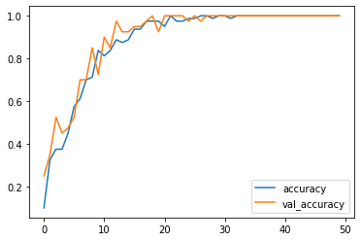Fig. 5 A line graph showing accuracy of the model

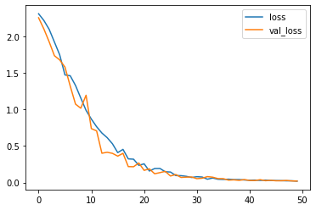

Fig. 6 A line graph showing the loss of the model

Fig. 5 and Fig. 6 shows that the model is not overfitted or underfitted, as the validation accuracy and validation loss almost mask the trend of the accuracy and loss.

1. Further improvements

Data should be augmented, using TensorFlow’s data augmentation feature, which will improve the generalization of the model [10]. Furthermore, more advanced model architectures could be used, such as ViT (Transformers), which is said to quadruple the accuracy [11]. More importantly, a larger dataset of images of nails is needed, as in this GEF project only 160 images were used. More images are needed for each nail class, which will improve the accuracy. Additionally, more patterns of nails are needed to be added, as our model is limited to classifying 10 classes.

1. Conclusions

This field will be improving, having lots of endless possibilities to improve. More research on nails will lead to this idea becoming more viable and more feasible in the near future.

Acknowledgment

Thank you to Dr. Cheung, R. C. C., and his teaching assistants for guidance and funding of this GEF project of nail classification.

References

1. TensorFlow. (2019). Powered by TensorFlow: Helping doctors detect respiratory diseases using machine learning. YouTube. Retrieved February 13, 2023, from https://youtu.be/uGYJuOyIvzs.
2. Hall, K., & Rapini, R. (2022, July 25). Acral lentiginous melanoma - statpearls - NCBI bookshelf. National Library of Medicine. Retrieved February 13, 2023, from https://www.ncbi.nlm.nih.gov/books/NBK559113/
3. Mayo Foundation for Medical Education and Research. (2022, January 20). Slide show: 7 fingernail problems not to ignore. Mayo Clinic. Retrieved February 13,2023, from_https://www.mayoclinic.org/healthy-lifestyle/adult-health/multimedia/nails.
4. NHS. (2020, August 28). Blue skin or lips (cyanosis). NHS choices. Retrieved February 13, 2023, from https://www.nhs.uk/conditions/blue-skin-or-lips-cyanosis/

1. Wilson, D. R. (Ed.). (2019, November 19). Koilonychia: Causes, symptoms, and more. Medical News Today. Retrieved February 13, 2023, from https://www.medicalnewstoday.com/articles/318761
2. Iorizzo, M., Starace, M., & Pasch, M. C. (2022, March 2). Leukonychia: What can white nails tell us? American journal of clinical dermatology. Retrieved February 13, 2023, from https://www.ncbi.nlm.nih.gov/pmc/articles/PMC8809498/
3. Thomas, D. L. (2019, February 27). What are nail fold infections (Paronychia)? News. Retrieved February 13, 2023, from https://www.news-medical.net/health/What-are-Nail-Fold-Infections-(Paronychia).aspx
4. Mayo Foundation for Medical Education and Research. (2022, October 8). Psoriasis. Mayo Clinic. Retrieved February 13, 2023, from https://www.mayoclinic.org/diseases-conditions/psoriasis/symptoms-causes/syc-20355840
5. Watson, K. (2017, August 4). Yellow nails: Causes, treatment and prevention. Healthline. Retrieved February 13, 2023, from https://www.healthline.com/health/yellow-nails
6. Romano, R. (2022, May 19). How data augmentation can improve ML model accuracy. Qwak's Blog. Retrieved February 13, 2023, from https://www.qwak.com/post/how-data-augmentation-can-improve-ml-model-accuracy
7. Boesch, G. (2022, August 23). Vision transformers (VIT) in Image Recognition - 2022 guide. viso.ai. Retrieved February 13, 2023, from https://viso.ai/deep-learning/vision-transformer-vi