**Plan and research:**

My Initial plan for this project is to design an Island for a player to walk around in first person interacting with some features, these features will hopefully include: opening treasure chests; picking up and using items such as fruit and drinking vessels; and solving a puzzle to access other areas of the island. I looked at examples of pirates in media such as the movies franchise “pirates of the Caribbean” the animation series “one piece” and the game “sea of thieves”. Using these already existing examples I came up with a list of objects and items I will need as assets and some interactive moments I would like to have happen on my island, this is pictured below. I have also sketched my idea for how the island should look which is also pictured.

(insert picture of asset and interactive moments list)

(insert image of island sketch)

**Documentation of work:**

I began by working on the required assets I needed to create myself, I created an apple for the fruit, a treasure chest for the box and a pirate themed jug for my drinking vessel. I found modelling quite difficult, but it was made lots easier by using reference images to help make the shape of the items I was creating more accurate. My finished assets are pictured below.

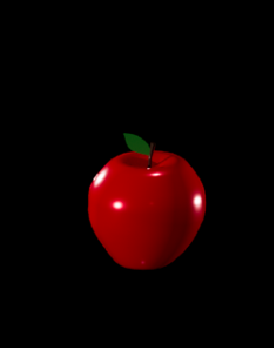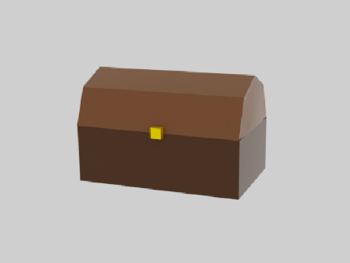

**Unity inventory:**