|  |  |
| --- | --- |
| 8 X-Rays That Show Why Early Detection is Key for Scoliosis | Children's  Healthcare of Atlanta  **Detection of Scoliosis using X-Rays images** | Contributed By -    Teja Dayana – 108121832  M Charishma – 108121079  Harsha Veera - 108121132 |
|  |  |
|  |  |
|  |  |

**Detection of Scoliosis using X-Rays images**

**ABSTRACT:**

Scoliosis is the most common disease which is mainly identified from patient spine X-ray images. It is mainly diagnosed based on sideways curvature image modality. In scoliosis diagnosis detection, currently the treatment for scoliosis is based on spinal assessment manual study which has some limitations like it is very tedious, time-consuming and cost effective. Scoliosis diagnosis is a critical task in the initial stages based on patient history records or on captured patient X-ray spine images. So, our research work is carried out for detecting scoliosis in effective way by analyzing the quality of input X-ray images of the patient suffering from scoliosis. To overcome few limitations and for early-stage predictive analysis detection of scoliosis, we develop a point-based automated method at different regions of spine which provides accurate results.

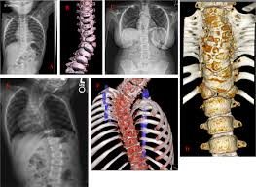 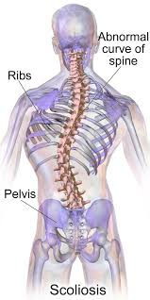

**INTRODUCTION:**

* Scoliosis is represented as 3D (Three-dimensional) in the structure of spine part of human body. One of the most common forms of scoliosis is AIS (Adolescent Idiopathic Scoliosis).
* This scoliosis form mainly begins from early stage and affects 5% of youngsters and the cause of 75% - 80% of scoliosis cannot be identified with certainty which affects our quality-of-life functioning stages [1-3]. Based on the input spine image curve or shape or its structure, scoliosis is classified as Normal shape, CCurve shaped, and S-Curve shaped. Detection of scoliosis in early stages has several methods but they are lacking in predictive analysis of accuracy severity.
* To determine the predictive analysis level of scoliosis severity, medical images like X-ray images are preferred for detecting scoliosis analysis and scoliosis measurement is carried out by calculating the Cobb angle (in degrees). Due to noise and blur in the captured X-ray medical images, there can be measurement error sometimes which reduces the accuracy of our system in detection or prediction of scoliosis.
* So for detecting the scoliosis in early stages, predictive analysis is very essential as an effective and essential machine learning classification algorithms to avoid major surgery and can improve accuracy results Machine Learning algorithms can help us to detect the scoliosis in effective way by calculating accuracy, measurement in Cobb angle.
* To overcome few limitations and for early-stage predictive analysis detection of scoliosis, we develop a point-based automated method at different regions of spine which provides accurate results using various classification algorithms in this research paper.

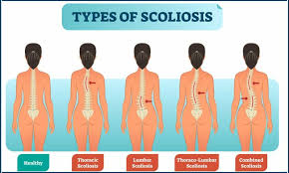

**PROPOSED METHODOLOGY:**

* **Stage 1** – Input Image: In this first stage, sample X-ray medical images of a patient are collected from kaggle. We Input the spine images for further pre-processing.
* **Stage 2** – Pre-processing: In the second stage, preprocessing is carried out on the input images before it is fed to CNN algorithm. Sometimes captured X-ray images may be blurred, or noisy image, so for such input images pre-processing is required. Pre-processing is important for speeding up the training process. As there are many pre-processing techniques such as applying filters like Gaussian filter etc.,

We used four types of image processing techniques before it is fed to the model:

1)Gaussian Blur

2) Median Filter

3) Image Sharpening

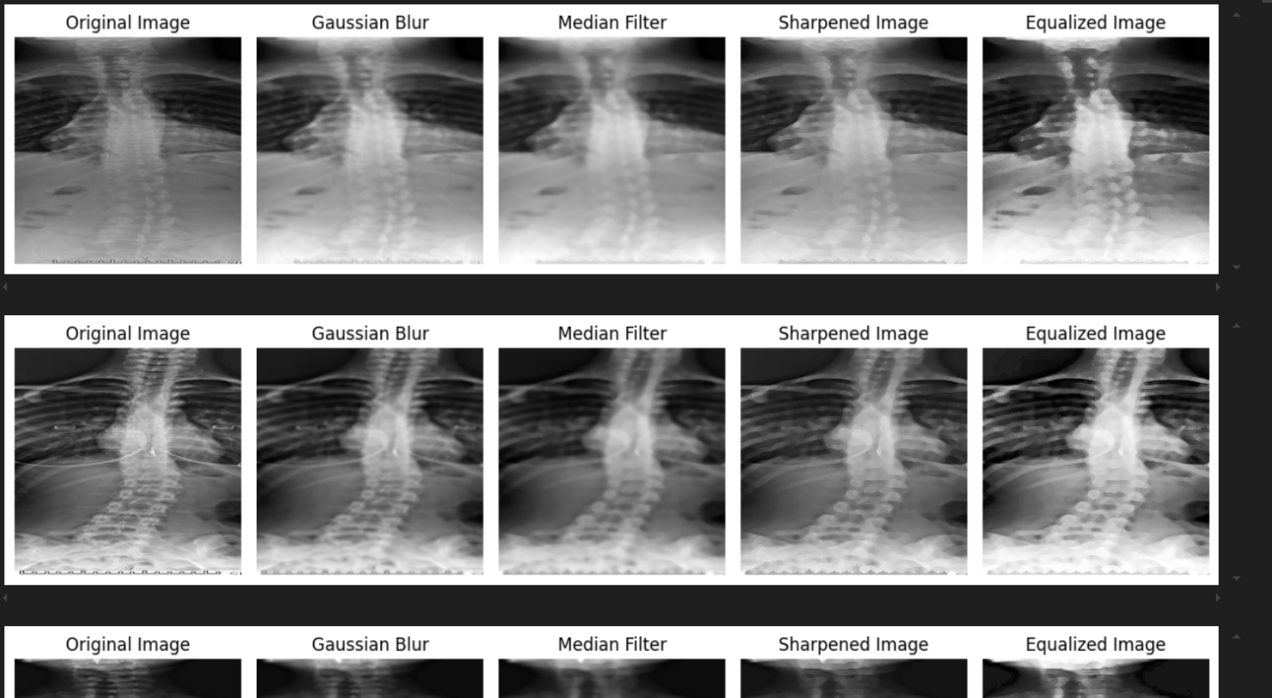4) Histogram Equalization Technique

* **Stage 3** – Training and Testing: In this stage, 80% of training and 30% of testing is carried out for predictive analysis i.e., as predictive model by using machine learning classification algorithms in next stage.
* **Stage 4 -** Now we going to have the algorithm explained which takes care of preprocessing the images and take them as input and all the steps have explained.

**ALOGORITHM:**

1. Initialize Model:

- Create a sequential neural network model.

2. Add Convolutional Layers:

- Add multiple convolutional layers to extract features from input images.

- Use ReLU activation for non-linearity.

3. Add Max Pooling Layers:

- Downsample the feature maps after each convolutional layer to reduce dimensionality and retain important features.

4. Flatten the Output:

- Convert the 2D feature maps into a 1D vector for the fully connected layers.

5. Add Fully Connected Layers:

- Include one or more dense layers to learn complex patterns and relationships.

6. Add Output Layer:

- Add an output layer for binary classification with a sigmoid activation function.

7. Compile Model:

- Define the loss function, optimizer, and evaluation metrics to prepare the model for training.

8. Train the Model:

- Train the model using labeled data to learn from the examples provided.

9. Evaluate Model Performance:

- Assess the accuracy of the model on validation or test data after training.

* **Stage 5** – Performance Metrics: Performance metrics like Accuracy (A) compared to benefit the patients suffering from scoliosis with less time, low cost and by improving the quality of input images.

**Results:**

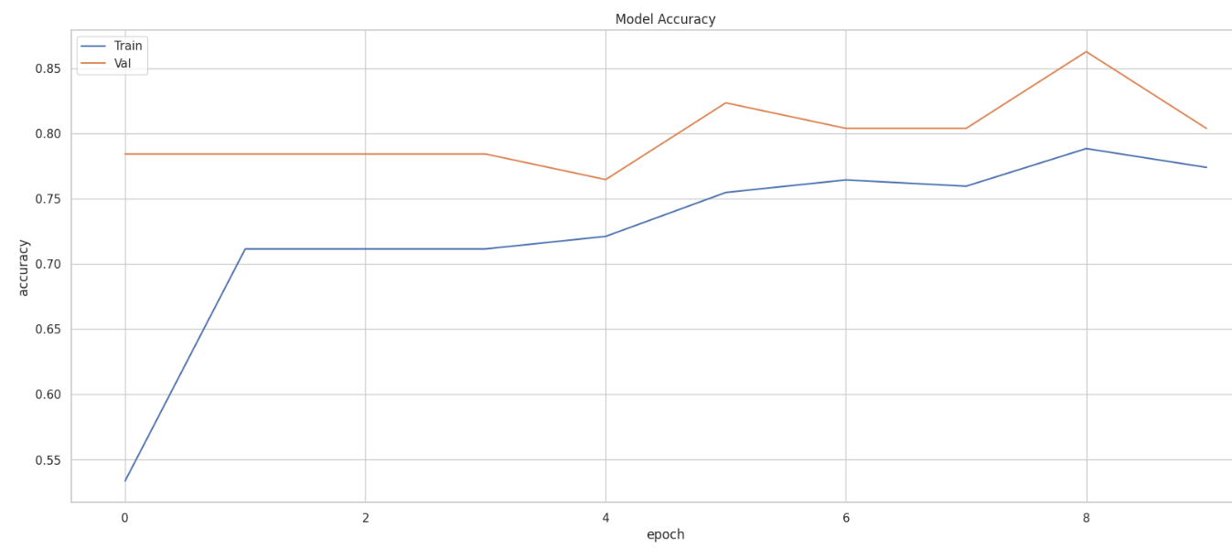

**The confusion matrix is given below:**

**Accuracy obtained: 86.274%**

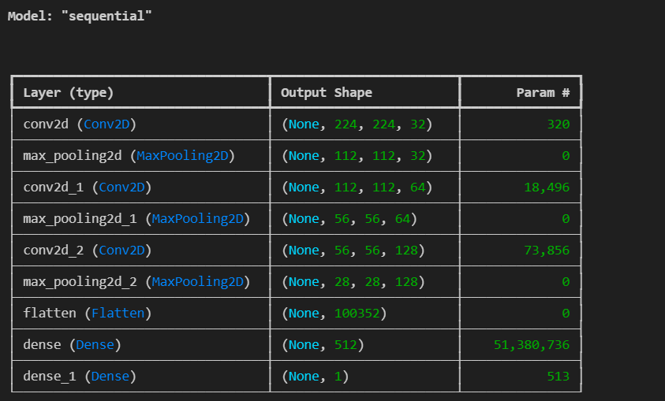**Model Architecture:**

**CONCLUSION:**

Our project concludes that CNN is the best approach with accuracy of 86.274% for implementing technology to detect Scoliosis. These algorithms work well in a wide range of conditions and scenarios. It will be intended to determine various scoliosis related problems with early signs and symptoms which will be very useful in the medical field rather than the old traditional method of radiology where the result might not even be accurate and to avoid an unnecessary lengthy process of screening.

**Further Improvements:**

Still, we will continue research work by applying more machine learning algorithms and deep learning algorithms for achieving better results for detection of scoliosis automatically.

**REFERENCES:**

* C.Satya, B.Sowndarya, “Measurement of Spine Curvature For The Detection And Classification of Scoliosis Using Matlab,” International Journal of Advanced Research Trends In Engineering And Technology (IJARTET) Vol. 3, 2016.
* Aachal Singh, Prathik Shreshtha “Early Stage Detection of Scoliosis Using Machine Learning Algorithms” 2021 International Confernece on Forensics, Analytics, Big Data and Security.