Application design for HealthTrack - a next-generation mobile application for Digital Health Ireland

Student: Ethan Curran
Student number: L00181476
GitHub repository link: https://github.com/Ethanroy16/Cross-Platform-Development
Table of Contents
1. UX design 3
1.1 Navigation Structure 3
1.2 Screen Layouts 4
1.3 Information Hierarchy 4
1.4 Interaction patterns 4
1.5 Input Controls 5
1.6 Feedback Mechanisms 5
1.7 Data Visualisation 6
1.8 Use of colour, icons, fonts and images 6
1.9 Accessibility considerations 6
1. Application architecture 7
2.1 Architectural pattern employed 7
2.2 Shared components 7
2.3 Services and Application State 8
2.4 Data Access 8
2.5 Navigation 8
2.6 Application logic 9
2.7 Separation of Concerns 9
2.8 Maintainability 9
2.9 Cross-Platform Development 9
2. Data model 10
3.1 Proposed Entities 10
3.2 Relational Structure 13
3.3 Data Relationships 13
3.4 Data Persistence 14
3.5 Data Model and Future Development 14
3. Technology selection and implementation approach 14
4.1C# & .NET MAUI 14
4.2 XAML 15
4.3 C# Code-behind 15
4.4 Navigation & UI Components 16
4.5 Data Visualisation 16
4.6 Proposed Data Storage 17
4.7 Implementation Approach 17
4.8 Technology Selection Summary 18
4. Project plan 19
References 20
Academic Integrity: 21
Generative AI acknowledgements 22
General description of Gen AI usage 22

UX design
The HealthTrack application is a simple health and fitness tracking application. The main aim of the user interface is to let users quickly view their health information, record new information, and monitor progress without navigating complicated menus. The design uses a consistent layout, with a colour scheme for every page and a navigation system throughout the application.

1.1 Navigation Structure
The application uses a simple hierarchical navigation structure. The Home screen acts as the main dashboard and provides access to the main areas of the application. A reusable bottom navigation component is used throughout the main screens, providing access to Home, Exercise, Progress, Sleep, Heart Rate and Settings.
Additional screens are accessed when the user needs to perform a more specific task. For example, selecting the Sleep section allows the user to view their sleep information and access the Record Sleep screen. The Profile section can be accessed from the profile icon on the Home screen.
The application uses .NET MAUI navigation to move between pages. PushAsync() is used when opening a new page, and PopAsync() is used when returning to the previous page. This provides a predictable navigation experience. Microsoft describes NavigationPage as providing a hierarchical navigation experience where pages are pushed onto and popped from a navigation stack. The use of a shared bottom navigation component also means that the same navigation structure can be reused across different screens instead of creating a separate navigation bar for every page
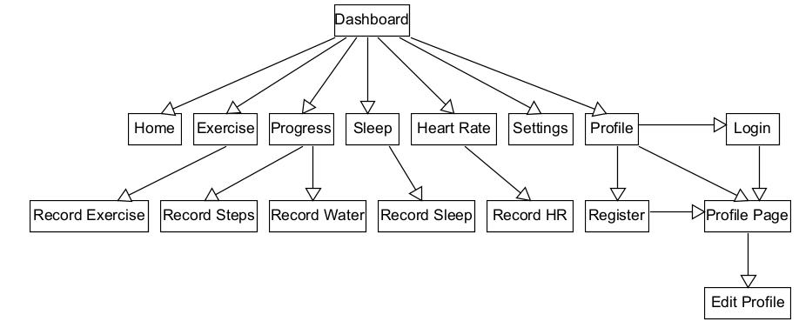
Figure 1: HealthTrack Wireframe & Navigation Structure

1.2 Screen Layouts
The Home screen acts as a dashboard. It displays a greeting, the user’s overall progress, individual health summaries and a weekly steps chart. This lets the user see key information without visiting multiple screens.
The main sections of the application are:
- Home
- Exercise
- Progress
- Sleep
- Heart Rate
- Profile
- Edit Profile
- Settings
- Login
- Register
- Record Sleep
The screens use ScrollView, VerticalStackLayout, Grid, Border, Label, Entry, Picker, Button and Switch controls. These are standard .NET MAUI controls and layouts.
Most pages follow the same basic structure: a page heading, a short description, relevant information or input controls, and navigation at the bottom. This consistency means that users do not need to learn a completely different layout for every screen.

1.3 Information Hierarchy
Information has been organised according to its importance to the user. The most important information sits near the top of each screen and uses larger or bolder text.
For example, the Home screen displays the user’s overall daily progress before displaying the individual health categories. The Steps, Water, Sleep, and Heart Rate cards then provide more detailed information.
The Profile screen follows a similar structure by displaying the user’s name and email first, followed by personal information such as the user’s age, height and weight.
This hierarchy makes the application easier to scan because users can identify the most important information before reading the smaller supporting information.

1.4 Interaction patterns
The application uses familiar interaction patterns throughout. Buttons are used for actions such as saving information, registering an account and editing. Cards on the Home screen can also be selected to access the corresponding health section.
Input fields are used where the user needs to enter information, while Picker controls are used where the user should select from a predefined list. A switch is used for settings such as notifications and dark mode.
For example, the Record Sleep screen uses controls such as date and time inputs, a sleep quality picker, a stepper for night-time awakenings and a switch for recording whether the user had a nap.
These controls were selected because they match the information being entered and reduce unnecessary typing.

1.5 Input Controls
Different controls are used depending on the type of information required.
Entry controls are used for values such as:
- Daily step goals
- Water Goals
- Sleep Goals
- Age
- Height
- Weight
- Email Addresses
- Passwords
Picker controls are used for selections such as activity level and sleep quality. Editor controls are used when the user needs to enter longer notes.
The application also uses validation for the Login and Register screens. For example, the application checks that required fields have been completed and that the two passwords entered during registration match.

1.6 Feedback Mechanisms
The application provides feedback when the user performs important actions. For example, when a user successfully logs in, a message confirms the successful login. Registration also displays a confirmation message when an account is created.
The application also asks the user for confirmation before signing out. This reduces the chance of the user accidentally signing out.
When profile or settings information is saved, a confirmation message is displayed to inform the user that the action has been completed.
These feedback mechanisms are important because they make the result of an interaction clear to the user.

1.7 Data Visualisation
The Home screen includes a weekly steps line chart displaying data from Monday to Sunday. The chart contains seven data points connected by lines to show changes in the user’s activity throughout the week.
Each data point has a visible marker, and the exact number of steps is displayed beside it. This means the chart provides both a visual representation of the trend and the exact underlying value.
The chart was implemented using the .NET MAUI GraphicsView and IDrawable. GraphicsView provides the drawing canvas and allows an IDrawable implementation to draw graphical content using ICanvas.
This approach was selected because the application requires only a relatively simple line chart and therefore does not need a large external charting library for the current prototype.

1.8 Use of colour, icons, fonts and images
Colour is used consistently throughout the application to help distinguish different health areas.
The main colours include:
Home Page == Green, Exercise == Orange, Progress == Blue
Sleep == Purple, Heart Rate == Pink/Red, Profile == Teal
The main application background uses a very light green/grey colour, while white cards separate individual pieces of information.
Icons in the bottom navigation make the different sections easier to recognise. Images are also used for the profile area.
The application uses larger bold headings for page titles and smaller text for descriptions and supporting information. This creates a clear visual hierarchy.

1.9 Accessibility considerations
Accessibility was considered when designing the application. Clear text labels mean users can understand what each input control is for without relying on icons or colour alone.
The application also avoids using colour as the only way to communicate information. For example, the health cards include text labels and numerical values in addition to colour.
The application uses sufficiently large controls and clear spacing between controls to make them easier to select.
.NET MAUI also provides semantic accessibility properties that can be used to provide descriptions and hints for screen readers. These can be used to improve accessibility for users using TalkBack, VoiceOver or Narrator.
Further accessibility testing would be carried out on the final application, particularly for font scaling, colour contrast, keyboard navigation and screen-reader support.

Application architecture
The HealthTrack application is developed using C# and .NET MAUI. The current CA1 prototype uses a simple code-behind architecture, where each ContentPage contains its XAML interface and the C# event-handling logic associated with that page.
The architecture remains straightforward because the current application is a prototype with a relatively small number of screens and simple interactions. Reusable components have been introduced where they provide a clear benefit, such as the shared bottom navigation and the steps chart drawing component.

2.1 Architectural pattern employed
The current prototype does not use a full MVVM architecture. Instead, it uses a simple code-behind approach with individual ContentPage classes.
For example, pages such as Exercise, Sleep, Heart, Profile, and Settings each have their own XAML interface and corresponding C# code-behind file. Event handlers within these files respond to actions such as button presses, navigation and input validation.
This approach was selected because it suits the prototype's current size and purpose. Adding layers such as ViewModels, repositories, and dependency injection would increase the CA1 prototype's complexity without providing a significant benefit at this stage.
However, the architecture has not been designed to prevent future improvements. If HealthTrack were developed into a larger application, MVVM could be introduced to separate the presentation logic from the user interface and make the application easier to maintain as functionality increases.

2.2 Shared components
A reusable BottomNavigation component is used throughout the main application screens. It provides access to Home, Exercise, Progress, Sleep and Heart Rate.
Using a shared component means that the navigation code does not need to be duplicated on every page. Changes to the navigation can therefore be made in one location and applied consistently throughout the application.
The weekly steps chart is also separated into a StepsChartDrawable class. This keeps the drawing code separate from the main page’s navigation and interaction event handlers.
These reusable components provide basic separation of concerns while keeping the overall architecture straightforward.

2.3 Services and Application State
The current prototype does not require a large service layer because it does not connect to external APIs, wearable devices or cloud services.
A simple UserSession class is used to represent the user’s current login state. The Home page checks this state when the profile icon is clicked. Depending on the state, the application opens either the Login page or the Profile page.
This provides the basic session behaviour required by the prototype without introducing unnecessary authentication services.
If the application were developed further, separate services could be introduced for areas such as authentication, notifications and health-data management.

2.4 Data Access
The current CA1 prototype does not use a database. Health information displayed within the prototype is based on sample or prototype values.
This is suitable for the current stage because the prototype demonstrates the user interface, page navigation, and the intended functionality of the HealthTrackingApp.
The completed application would require persistent data storage so that health records remain available after the application is closed. The proposed architecture would therefore introduce a relational database and Entity Framework Core to store and retrieve user information, goals, and health records. This keeps the user interface separate from the underlying database implementation.

2.5 Navigation
Navigation is handled using the .NET MAUI navigation system and a NavigationPage. The application uses PushAsync() when moving to a new page and PopAsync() when returning to the previous page.
The reusable BottomNavigation component provides access to the main areas of the application, while hierarchical navigation is used for secondary screens such as Record Sleep, Edit Profile, Login and Register.
This combination provides a simple navigation structure while allowing the user to move between the main sections and more detailed screens.

2.6 Application logic
Application logic is currently contained within the code-behind files associated with each page.
Examples include:
- Validating required login fields
- Checking that registration passwords match
- Changing the login state
- Displaying confirmation messages
- Processing user input
- Responding to buttons and card interactions.
Keeping this logic close to the page that uses it makes the prototype straightforward to understand and develop

2.7 Separation of Concerns
Although the application does not currently use formal MVVM, it has introduced some separation of responsibilities.
Each application screen has its own page class, while shared functionality such as the bottom navigation is contained within its own reusable component. The steps chart is also separated into its own drawable class.
This prevents unnecessary duplication of common functionality across pages and makes individual components easier to modify.

2.8 Maintainability
The current architecture supports maintainability by keeping individual screens in separate files and using reusable components for functionality that appears across multiple pages.
Consistent naming, layouts and visual styles also make the project easier to understand and modify.
The architecture is intentionally simple for the CA1 prototype, but it provides a suitable foundation for future development. As the application grows, application logic could be moved into ViewModels and services, while database operations could be separated into a dedicated data-access layer.

2.9 Cross-Platform Development
.NET MAUI was selected as it allows the app to be developed using a shared C# and .NET codebase for multiple platforms. This is particularly appropriate for a health and wellbeing application because users may access the application from different devices and OS.
Using .NET MAUI lets you build the application interface in XAML while C# handles the application logic. This supports the project's cross-platform requirement while avoiding the need to create separate applications for each platform.
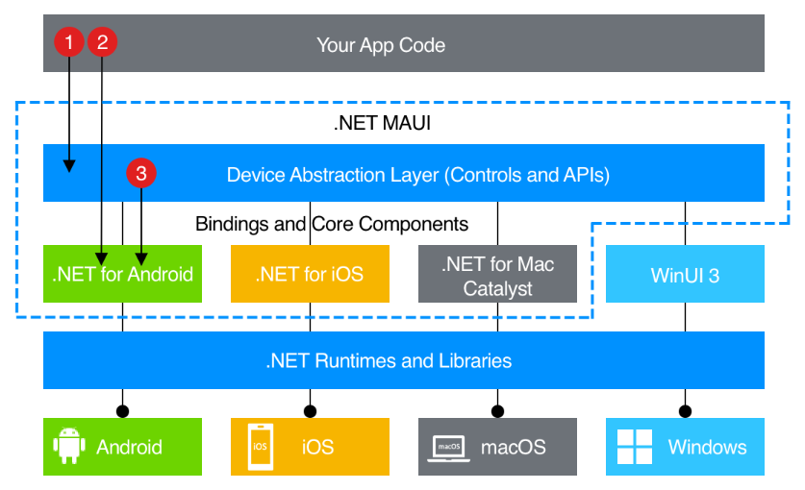
Figure 2: A .NET MAUI Cross-Platform Architecture

Data model
The HealthTrack application will require a relational data model to store user information, health goals and historical health records. The current CA1 prototype does not yet use a database, so this section describes the proposed data structure for the completed application.
The data model is designed around the different types of information users can record with HealthTrack. Each health record is associated with a user so that historical information can be retrieved and used to produce trends and statistics.

3.1 Proposed Entities
User
The User entity stores the user’s profile information and personal health goals.
Attribute | Description
UserID | Unique identifier for the user
FullName | User’s full name
Email | User’s email address
PasswordHash | Stored password representation
Age | User’s age
Height | User’s height
Weight | User’s Weight
ActivityLevel | User’s selected activity level
DailyStepGoal | User’s daily step target
DailyWaterGoal | User’s daily water target
SleepGoal | User’s daily sleep target

Exercise
The Exercise entity stores records of physical data entered by the user
Attribute | Description
ExerciseID | Unique identifier for the exercise record
UserID | ID of the user who created the record
ExerciseType | Type of exercise performed.
Duration | Duration of the chosen exercise
Notes | Additional information about the exercise
ExerciseDate | Date the exercise was performed.
CaloriesBurned | Calories burned during exercise duration

Sleep Record
The SleepRecord entity stores information about the user’s sleep
Attribute | Description
SleepID | Unique ID for the sleep record
UserID | ID of the user who created the record
SleepDate | Date associated with the record
BedTime | Time the user went to bed.
WakeTime | Time the user woke up.
SleepQuality | User’s selected sleep quality
NightAwakenings | No. of times the user woke up during the night.
HadNap | Whether the user had a nap beforehand
CaffeineBeforeBed | Whether Caffeine was consumed
Notes | Additional sleep information

Heart Rate
The HeartRate entity stores individual heart-rate readings
Attribute | Description
HeartRateID | Unique ID for the heart rate record
UserID | ID of the user who created the record
Reading | Recorded heart rate value
ReadingDate | Date of the reading
ReadingTime | Time of the reading

Step Record
The StepRecord entity stores the user’s recorded step count
Attribute | Description
StepRecordID | Unique ID for the step record
UserID | ID of the user who created the record
RecordDate | Date of the step record
StepCount | Number of steps recorded
Notes | Additional Information

Water Record
The WaterRecord entity stores the amount of water consumed by the user
Attribute | Description
WaterRecordID | Unique ID for the water record
UserID | ID of the user who created the record
RecordDate | Date of the water record
AmountLitres | Amount of water consumed in litres
Notes | Additional Information

3.2 Relational Structure
The proposed relational structure centres on the User entity. Each user can have multiple health records across the different health categories.

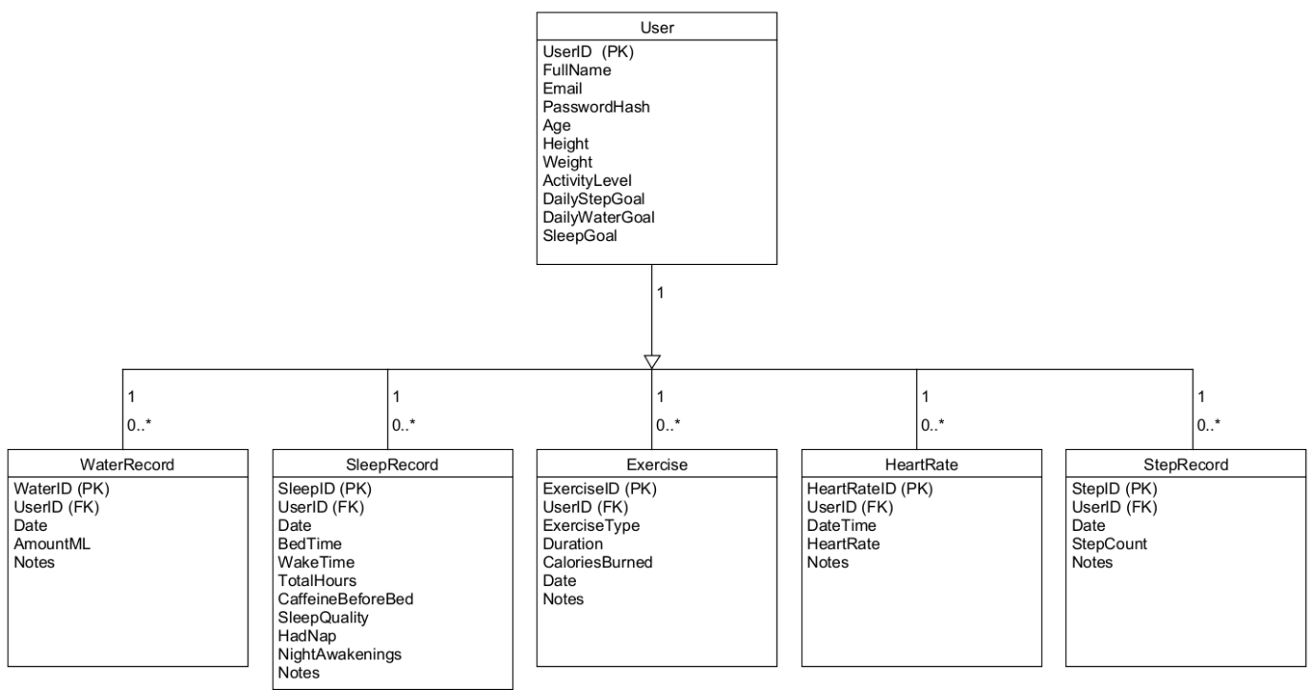
Figure 3: Proposed HealthTrack Relation Data Model
The relationship between User and each health-record entity is 1-*. A single user can therefore have multiple exercise, sleep, heart rate, step and water records. The UserID field is used as a foreign key in each health-record table to associate the record with the appropriate user

3.3 Data Relationships
The proposed relationships allow HealthTrack to maintain historical records rather than only storing the user’s most recent values.
For example, a user could have multiple StepRecord entries for different days. These records could then be retrieved to calculate weekly totals, display the weekly steps chart and identify changes in activity over time.
The same structure can be applied to the other health categories. Multiple sleep records can identify sleep trends, while exercise and heart-rate records can provide historical information and statistics. This structure supports the application's historical-record and trends/statistics requirements.

3.4 Data Persistence
The current prototype uses sample values and does not persist health information to a database. This is appropriate for the CA1 stage because the prototype primarily demonstrates the application’s user experience, navigation, and intended functionality.
For the completed application, the proposed relational structure would allow health records to be stored and retrieved between application sessions.
Entity Framework Core could communicate between the C# application and the relational database. This would allow records to be created, retrieved, updated and deleted as required.
The proposed data flow would be: HealthTrack UI -> Application Logic -> Entity Framework Core -> Relational Database.
This would allow the application to maintain historical health information and provide the data required for future statistics and visualisations

3.5 Data Model and Future Development
The proposed model provides a foundation for expanding HealthTrack beyond the CA1 prototype. Additional entities could be introduced if further functionality is required, while the existing health-record structure allows historical data to be associated with individual users.
The model also supports the application’s planned trends and statistics because records can be retrieved by date and category. This would allow the completed application to generate information such as weekly step trends, exercise duration, sleep patterns, heart-rate history and water consumption.

Technology selection and implementation approach
The HealthTrack application is being developed using C# and .NET MAUI. These technologies were selected because they support cross-platform development using a shared codebase. These choices also allow the application to provide the user interface, navigation, data visualisation, and health-record functionality required by the project.

4.1C# & .NET MAUI
.NET MAUI was selected as the main application framework because it supports cross-platform application development using a shared codebase. This is appropriate for HealthTrack because the application is intended to be available across multiple platforms rather than being developed separately for each OS
C# was selected as the programming language because it integrates directly with .NET MAUI and is used to implement the application’s navigation, user interactions and application logic.
Using C# and .NET MAUI also satisfies the requirement to develop the application using the .NET MAUI framework.

4.2 XAML
XAML creates the user interfaces within HealthTrack. It allows the layout and visual appearance of each page to be defined separately from the C# event-handling logic.
The prototype uses standard .NET MAUI layouts and controls, including:
- Grid
- VerticalStackLayout
- ScrollView
- Border
- Label
- Entry
- Picker
- Button
- Image
- Switch
- GraphicsView
These controls are sufficient to create the forms, information cards, navigation, and dashboard elements required by the HealthTrack wireframe. Using XAML also makes it straightforward to maintain consistent spacing, sizing, colours and layouts across the different screens

4.3 C# Code-behind
C# code-behind handles the interactions and logic associated with each page.
Examples include:
- Navigation between pages
- Validating user input
- Displaying confirmation messages
- Handling button and card selections
- Managing the prototype state login
- Drawing the weekly steps chart
The code-behind approach was selected for the current prototype because the application is relatively small and each screen's required logic is straightforward. This avoids introducing additional complexity while allowing the prototype to be developed and tested efficiently.
For a larger future version of HealthTrack, the application could move toward an MVVM structure to better separate the interface from the application logic.

4.4 Navigation & UI Components
The application uses the .NET MAUI navigation system to move between pages.
A reusable BottomNavigation component is used throughout the main screens. It provides access to:
- Home
- Exercise
- Progress
- Sleep
- Heart Rate
This component was selected instead of creating a separate navigation bar on every page because it provides a consistent navigation experience and reduces duplicated code. Secondary screens such as Record Sleep, Edit Profile, and Login & Register are accessed using hierarchical page navigation.

The application currently uses standard .NET MAUI controls rather than a large third-party UI toolkit. This was chosen because the prototype already has a custom visual design and does not require additional components to demonstrate the required functionality.
The assignment specification identifies third-party UI options such as Material 3 and Uranium UI as possible technologies to investigate. However, standard .NET MAUI controls were considered sufficient for the current prototype.

4.5 Data Visualisation
Data visualisation is an important part of HealthTrack because users need to identify trends in their health information.
The home dashboard contains a weekly steps line chart covering Monday-Sunday. The chart displays seven data points connected by lines, allowing the user to see changes in their activity throughout the week. Each point has a visible marker, and the exact number of steps is displayed beside it. This lets the user see both the overall trend and the exact value.
The chart is implemented using the .NET MAUI GraphicsView control and an IDrawable class. This provides a drawing canvas that can be used to create the chart without requiring an additional charting library.
This approach was selected because the chart required by the current prototype is relatively simple. Using GraphicsView provides enough control over the chart's appearance while keeping external dependencies low.
In the completed application, the chart could be connected to the proposed database so that the displayed values are based on the user’s actual historical step records.

4.6 Proposed Data Storage
The current CA1 prototype does not use persistent database storage. Instead, it uses sample values to demonstrate how the application will look and operate. For the completed application, a relational database is proposed to store user information, goals and historical health records.
Entity Framework Core could be used to allow the C# application to communicate with the database.
This would allow the system to store and retrieve information such as exercise records, sleep records, heart-rate readings, step counts, and water consumption.
It would also allow the data visualisations and statistics to use historical information rather than the sample values currently used by the prototype.

4.7 Implementation Approach
The implementation approach focused on developing the main user journey first, then adding the individual health sections around the dashboard.
The main areas of the prototype include:
- Home dashboard
- Profile
- Exercise
- Progress
- Sleep
- Heart Rate
- Settings
Additional screens such as Record Sleep, Edit Profile, and Login + Register support these interactions within these main areas.
The prototype uses a consistent visual design across the application, with different colours used to identify the main health sections. This allows users to recognise different areas while maintaining a common overall layout.
The current implementation therefore provides the interface and navigation foundation required before persistent data storage and additional functionality.

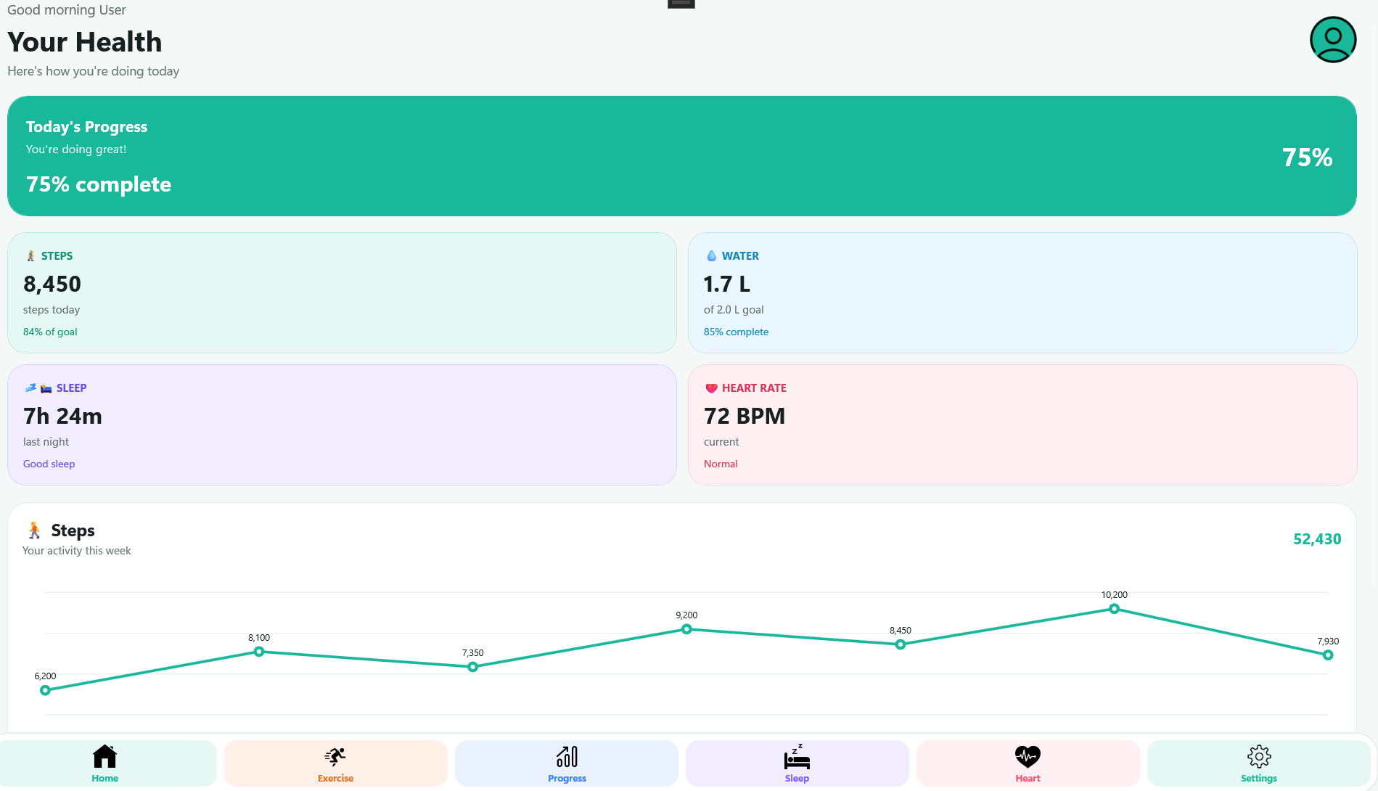
Figure 4: HealthTrack Dashboard Implementation

4.8 Technology Selection Summary
The main technologies selected for HealthTrack are:
Technology | Purpose
C# | Application logic and Event handling
.NET MAUI | Cross-platform application framework
XAML | User interface and page layouts
GraphicsView | Weekly steps data visualisation
IDrawable | Drawing the steps chart
NavigationPage | Hierarchical page navigation
Entity Framework Core | Proposed future database access
Relational Database | Proposed future persistent health storage

These technologies provide a relatively simple implementation approach while still providing a suitable foundation for the completed HealthTrack application.

Project plan
The remaining project work will focus on completing the HealthTrack application following the CA1 submission. The CA1 wireframe, architecture and proposed data model will provide the foundation for the remaining implementation. The planned tasks and milestones are shown below.
Date | Task | Deliverable/Milestone
26 Oct – 1 Nov | Review the CA1 work and prepare the project for further development. Refine the existing application where required. | CA2 development plan and prepared project structure
2 – 8 November | Implement the proposed data storage and connect the application to the data model. | Persistent storage implemented
9 – 15 November | Implement recording and retrieval of health information, including exercise, sleep, heart rate, steps and water. | Health records can be stored and retrieved.
16 – 22 November | Implement user goals and connect recorded information to the user’s progress. | Goals and progress functionality completed.
23 – 29 November | Implement historical records and develop dynamic trends and statistics using stored data. | Historical data and dynamic statistics completed.
30 Nov – 6 Dec | Complete validation, error handling and remaining application functionality | Core HealthTrack functionality completed
7 – 13 December | Test the application across the required platforms and identify and resolve bugs. | Cross-platform testing completed and issues resolved
14 – 20 December | Refine the user interface, accessibility and overall consistency. Complete final documentation and supporting materials | Final application and documentation prepared
Final Submission | Complete final checks, ensure the project builds correctly and submit the completed HealthTrack application and required documentation. | Final HealthTrack submission
The project will be developed incrementally, with each stage building on the previous stage. The main milestone is completing the core HealthTrack functionality before the final testing and refinement period. This will allow sufficient time to identify and resolve any issues that may arise before the final submission.

References
davidortinau (2025a) Build accessible apps with semantic properties - .NET MAUI. Microsoft Learn. Available at: https://learn.microsoft.com/en-us/dotnet/maui/fundamentals/accessibility?view=net-maui-10.0 (Accessed: October 19, 2026).
davidortinau (2025b) Material 3 - .NET MAUI. Microsoft Learn. Available at: https://learn.microsoft.com/en-us/dotnet/maui/user-interface/material-design?view=net-maui-10.0 (Accessed: October 20, 2026).
davidortinau (2025c) NavigationPage - .NET MAUI. Microsoft Learn. Available at: https://learn.microsoft.com/en-us/dotnet/maui/user-interface/pages/navigationpage?view=net-maui-10.0 (Accessed: October 19, 2026).
davidortinau (2025d) What is .NET MAUI? - .NET MAUI. Microsoft Learn. Available at: https://learn.microsoft.com/en-us/dotnet/maui/what-is-maui?view=net-maui-10.0 (Accessed: October 18, 2026).
davidortinau (2025e) XAML - .NET MAUI. Microsoft Learn. Available at: https://learn.microsoft.com/en-us/dotnet/maui/xaml/?view=net-maui-10.0 (Accessed: October 18, 2026).
SamMonoRT (2025) Overview of Entity Framework Core - EF Core. Microsoft Learn. Available at: https://learn.microsoft.com/en-us/ef/core/ (Accessed: October 19, 2026).

Academic Integrity:
ATU has adopted the NAIN (2021) definition of academic integrity that is derived from the ENAI glossary, which states that Academic Integrity is:
“Compliance with ethical and professional principles, standards and practices and a consistent system of values that serves as guidance for making decisions and taking actions in education, research and scholarship.”

Academic misconduct is a serious manner and will be investigated in accordance with the ATU student code.
Academic misconduct includes, but is not limited to:
- Submitting work as your own for assessment, which has been completed partially or entirely by someone else (including a peer, a family member, or other third party).
- Cheating in projects (e.g., collusion; using ‘essay mills’ or similar services to carry out some or all of the assigned work).
- Plagiarism: that is submitting work which is taken from another source without acknowledging the source.
- Falsifying references and documentation.
- Submitting all or part of an assessment which has been generated by AI (Artificial Intelligence) tools and claiming it as your own work.

You are required to familiarise yourself with the academic integrity policy and associated documents which are available on the student hub area of the ATU website.

Generative AI acknowledgements
If you have used Generative AI to assist in the creation of this assignment submission you are required to declare such usage. The unacknowledged, unreferenced and or unauthorised use of tools such as generative artificial intelligence (GenAI) in the generation of this assignment will be considered as academic misconduct.

General description of Gen AI usage
Provide a general description of how you used GenAI to assist you in completing this assignment. For example, did you use it to suggest colour schemes or similar applications to evaluate or did you use it to write prototype code?

For each task/tool that you used to assist you in completing this assignment, provide the following information:
- Name and version of the generative AI system used; e.g. ChatGPT, Claude, GitHub Copilot.
- Publisher (company that made the AI system); e.g. OpenAI
- URL of the AI system.
- Method section:
The methods section should include:
  - If relevant, the prompt(s) used to generate a response in the AI system.
  - The date the output was generated.
  - The output obtained (e.g. a ‘link to chat’ if ChatGPT, or a compilation of all output generated as an appendix).
  - How the output was changed for use or incorporation into a piece of work (e.g. a tracked-changes document or a descriptive paragraph). If an AI tool was used to generate source code, add comments to your source code clearly labelling AI generated code segments.

For a guide on citing generative AI output see: https://style.mla.org/citing-generative-ai-updated-revised/
I used AI for guidance and assistance for this project, my main use of it was to generate the table you see at the bottom of the Home Dashboard. I changed some things slightly in it to make it the way I wanted it to look, but that was definitely my main

- ChatGPT-5.6 Luna
- OpenAI
- ~~ 6th October
- https://chatgpt.com/share/6ada83c0-87e4-83eb-99f1-d80f9d601726
- I changed little bits of it to get what I wanted from it. It’s in the mainpage.xaml & xaml.cs

- GitHub Copilot Chat
- Github/Microsoft
- This was used a couple of times throughout the project to help debug and correct errors that can come from building the application. I provided it with the error messages and used the Copilot suggestions to help identify and resolve issues
- I reviewed the suggested changes and then decided whether to apply them or not.
I do not have any links, as it was in the VS Copilot chat.

