COMP4026 Computer Vision and Pattern Recognition
Group Project Final Report
Anonymised Facial Expression Recognition

Group Members:
Deng Yuchen 22256342 — Face Recognition Model
Wang Xukun 22254870 — Face Anonymisation Model
Yi Tingxuan 22258108 — Expression Recognition Model

2nd Semester 2025–2026
Submission Date: 30 April 2026

Abstract
Facial expression recognition (FER) systems process biometric data that carries significant privacy risk. This project develops a prototype for Anonymised Facial Expression Recognition, in which a face image is transformed into an anonymised version that preserves the original expression while concealing the individual’s identity. The system has three components: (1) a ResNet-50 face recognition model trained with a two-phase Cross-Entropy to ArcFace schedule, used as the privacy evaluator; (2) a conditional Denoising Diffusion Probabilistic Model (DDPM) anonymiser guided by MediaPipe facial landmarks and a masked input; and (3) a ResNet-50 expression classifier fine-tuned on FER-2013. On Pins Face Recognition (105 identities, 17,534 images) the recognition model achieves 93.46% Top-1 accuracy, 98.03% Top-5 accuracy, and EER 0.0528. A strict joint evaluation on 314 paired Pins test images — same 105 identities the recogniser was trained on — shows that Student B’s anonymiser drops the closed-set Top-1 accuracy from 90.13 % to 17.52 % (a 72.6 pp drop, 18× above the 0.95 % random-chance floor), reduces verification authentication at the EER-matched threshold from 83.07 % to 37.58 %, and delivers a Privacy Protection Rate of 62.42 %. Expression Consistency stays above 80 %, showing that privacy and utility can be partially reconciled under this modular design while making the residual identity leakage quantitatively visible.

1. Introduction
Facial recognition and facial expression recognition have reached near-human accuracy on standard benchmarks, but the underlying face images are biometric data: the EU General Data Protection Regulation classifies them as a special category that requires explicit consent. This conflicts with practical use cases — analysing customer emotions in retail, monitoring student engagement in classrooms — where the expression is useful but identity is not. Our project addresses this by building a prototype that recognises expressions on anonymised faces.
The pipeline is straightforward. An input face image is first passed through a face anonymisation model that transforms the identity region while preserving expression, head pose, gaze, and background. The anonymised image is then consumed by two downstream models: an expression classifier measures whether expression is recoverable (utility), and a face recognition model measures whether the original identity can still be matched (privacy). A successful system keeps expression accuracy close to its clean-image baseline while identity recognition collapses to near random chance (≈ 1/105 = 0.95% for 105 identities). Deng Yuchen built the face recognition model, Wang Xukun the diffusion-based anonymiser, and Yi Tingxuan the expression classifier; integration, end-to-end experiments, and analysis were done jointly.

2. Methodology

2.1 Datasets
Three datasets are used, one per component. Pins Face Recognition (Kaggle: hereisburak/pins-face-recognition) contains 17,534 internet-collected face images of 105 celebrity identities with moderate class imbalance (86–237 images per identity, mean ≈167). We split it 70/15/15 into 12,225 training, 2,574 validation, and 2,735 test images. CelebA-HQ provides high-resolution celebrity face images used for training the anonymisation diffusion model. FER-2013 provides 35,887 grayscale 48×48 face images labelled with seven expressions (Angry, Disgust, Fear, Happy, Sad, Surprise, Neutral); 28,709 images are used for training and 3,589 for testing. FER-2013 is moderately imbalanced, with Happy contributing approximately 25% of training images and Disgust only about 1.5%.
Table 1: Datasets used in the project.
Dataset | Component | Size | Key properties
Pins Face Recognition | Face recognition (A) | 17,534 / 105 IDs | Web-sourced, diverse poses
CelebA-HQ | Face anonymisation (B) | 30,000 / 1024×1024 | High-quality faces
FER-2013 | Expression classification (C) | 35,887 / 48×48 | 7 classes, grayscale

2.2 Face Recognition Model (Deng Yuchen)
Architecture. The model uses a ResNet-50 backbone pretrained on ImageNet (IMAGENET1K_V2 weights). The 2048-dimensional pooled feature is projected to a 512-dimensional embedding by a fully-connected layer followed by BatchNorm and L2 normalisation. During training, the embedding is fed into an ArcFace classification head [1]: the head normalises both the embedding and per-class prototype weights, takes their cosine similarity, and applies an additive angular margin m to the target class before scaling by s. Formally, the target-class logit becomes s·cos(θ + m) while non-target logits remain s·cos(θ). This pushes decision boundaries further apart in angular space and yields more discriminative embeddings than softmax cross-entropy alone. The total model has 24.6M parameters.
Two-phase training. We observed early on that applying ArcFace from epoch 1 with m=0.5 on 105 classes caused training collapse: the margin on the target logit was so aggressive that the randomly-initialised classifier could never predict the correct class, and training accuracy stayed at 0% while validation accuracy plateaued at 42%. Our fix is a two-phase schedule. Phase 1 (epochs 1–5) uses standard Cross-Entropy with label smoothing 0.1 to establish a sensible embedding space and class prototypes. Phase 2 (epochs 6–30) switches to ArcFace with s=32 and the reduced margin m=0.3, sharpening the embedding. The switch is a single flag in the training loop; all other settings are unchanged across the two phases.
Optimisation. We use AdamW with differential learning rates — 1e-4 for the backbone and 1e-3 for the new head — weight decay 5e-4, batch size 32, and cosine annealing to 1e-6 over 30 epochs. Gradient norm is clipped at 5.0. Training augmentation is random horizontal flip, rotation up to ±10°, and mild colour jitter; inputs are 160×160. Training runs on an Apple M-series GPU via MPS.
API. The model is wrapped in a FaceRecognizer class (inference.py) with four methods — predict(), get_embedding(), verify(), and evaluate_anonymisation() — that accept a file path, PIL Image, or NumPy array. Students B and C call this API to re-run privacy evaluation on any set of anonymised outputs.

2.3 Face Anonymisation Model (Wang Xukun)
Architecture. The anonymiser is a conditional Denoising Diffusion Probabilistic Model (DDPM) with a U-Net backbone. Two conditioning signals are injected through cross-attention: (i) the sparse facial landmarks extracted by MediaPipe (468 points projected to a compact embedding), which encode expression, pose, and gaze; and (ii) the original image with the face region masked out, which preserves background consistency. The network learns to synthesise a novel face patch inside the mask that respects both conditions but does not match the original identity. The output patch is finally composited back into the image using Poisson image editing so that the boundary between the synthesised region and the untouched background is imperceptible. The U-Net has approximately 130M parameters and operates on 256×256 face crops.
Training strategy. Training is self-supervised and reconstruction-based: no identity labels and no adversarial identity loss are used, which avoids interfering with expression preservation. Stage 1 (epochs 1–15) uses the standard simplified L2 noise-prediction objective under landmark and mask conditioning, so the network first learns to faithfully reconstruct face texture and structure. Stage 2 (epochs 16–40) introduces a progressive strength parameter that controls the noise schedule, together with classifier-free guidance at inference time to increase identity diversity. During stage 2 the identity leakage of each batch is measured by running the samples through Student A’s FaceRecognizer API, and the strength parameter is tuned so that privacy and perceptual fidelity (LPIPS) sit on a desirable Pareto point.

2.4 Expression Recognition Model (Yi Tingxuan)
Architecture. The expression model is a ResNet-50 pretrained on ImageNet whose first convolutional layer is modified to accept single-channel grayscale input (FER-2013 is grayscale 48×48). The final fully-connected layer is replaced by a custom head: Linear → BatchNorm → ReLU → Dropout (p=0.5) → Linear(7) to reduce overfitting on the relatively small dataset. The model is trained with standard Cross-Entropy; class weighting can be enabled to counter the imbalance in the Disgust class.
Two-stage fine-tuning. Stage 1 (epochs 1–10) freezes the ResNet-50 backbone and trains only the classification head at LR 1e-3, which protects the pretrained features from destructive early gradients. Stage 2 (epochs 11–40) unfreezes the entire network and trains end-to-end with differential learning rates — 1e-5 for the backbone and 1e-4 for the head — under cosine annealing with weight decay 1e-4. Training augmentation consists of random cropping, horizontal flip, and small rotations (±10°). Inputs are upsampled from 48×48 to 160×160 to match the other components and to give ResNet-50 enough spatial resolution.

3. Experimental Setup
All experiments are implemented in PyTorch 2.x and run on an Apple M-series GPU via the Metal Performance Shaders (MPS) backend. Deterministic seeds are set where applicable, but MPS kernels are not fully deterministic, so reported numbers come from a single representative run. Evaluation uses the held-out test splits; end-to-end experiments anonymise the Pins test set with the diffusion model and feed the result to the recognition and expression models.
Metrics. Face recognition is evaluated with Top-1/Top-5 identification accuracy on the 105-class closed-set task, Equal Error Rate (EER) on verification (cosine similarity between embeddings), and TAR@FAR at 0.1, 0.01, 0.001. Privacy on anonymised images is the identification accuracy after anonymisation. Expression recognition is evaluated with Top-1 accuracy on FER-2013 and the Expression Consistency Rate — the percentage of anonymised images whose predicted expression matches that of the original.

4. Results and Discussion

4.1 Face Recognition on Original Images
As a sanity check, we first trained the recognition model on a 20-identity subset of Pins for 5 epochs; it reached 90.65% Top-1 accuracy and EER 0.069 in 7.3 minutes, confirming the pipeline. We then trained the full model on all 105 identities for 30 epochs with the two-phase schedule. Total training time was 291.8 minutes on MPS. The best validation accuracy was 93.01% at epoch 23, and the corresponding test accuracy was 93.46% Top-1 and 98.03% Top-5. Verification gave EER = 0.0528, TAR@FAR=0.01 of 0.8576, and TAR@FAR=0.001 of 0.7326.
Table 2: Face recognition results on Pins (105 identities, test set).
Metric | 20-ID subset (5 epochs) | Full 105 IDs (30 epochs)
Top-1 identification | 90.65% | 93.46%
Top-5 identification | 99.39% | 98.03%
Best validation acc | — | 93.01%
EER | 0.069 | 0.0528
TAR @ FAR=0.1 | — | 0.9694
TAR @ FAR=0.01 | 0.792 | 0.8576
TAR @ FAR=0.001 | — | 0.7326
Test loss | — | 1.699
Training time | 7.3 min | 291.8 min

The training curves are informative. During the CE warmup (epochs 1–5), validation accuracy climbs from 46.5% to 80.0%. At epoch 6 the ArcFace head activates; losses briefly jump upward because the angular margin penalises previously-correct predictions, but accuracy keeps improving, crossing 90% on validation by epoch 12 and stabilising around 93% from epoch 23 onward. Training accuracy reaches 100% by epoch 18; the ≈7-point train–val gap reflects the between-identity overlap typical of internet celebrity photos. This confirms the two-phase schedule as the decisive fix: without CE warmup the model could not converge on 105 classes at all.
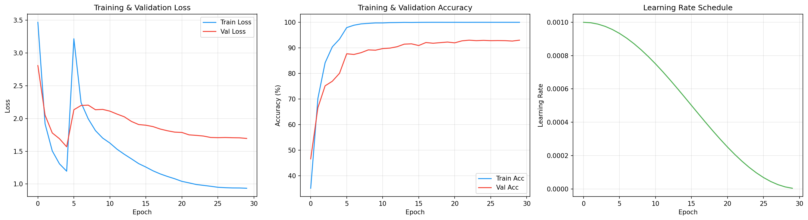
Figure 1: Training and validation loss/accuracy across 30 epochs. The vertical transition at epoch 6 marks the CE→ArcFace switch.
The confusion matrix on the 105-class test set shows a dominant diagonal with very few systematic off-diagonal clusters, indicating that errors are distributed across many classes rather than concentrated between a small number of visually similar identities. The score distribution for genuine versus impostor pairs is also well separated: genuine cosine similarities cluster around 0.7–0.9 while impostor similarities sit mostly below 0.3, with only a narrow overlap region that produces the 5.28% EER.
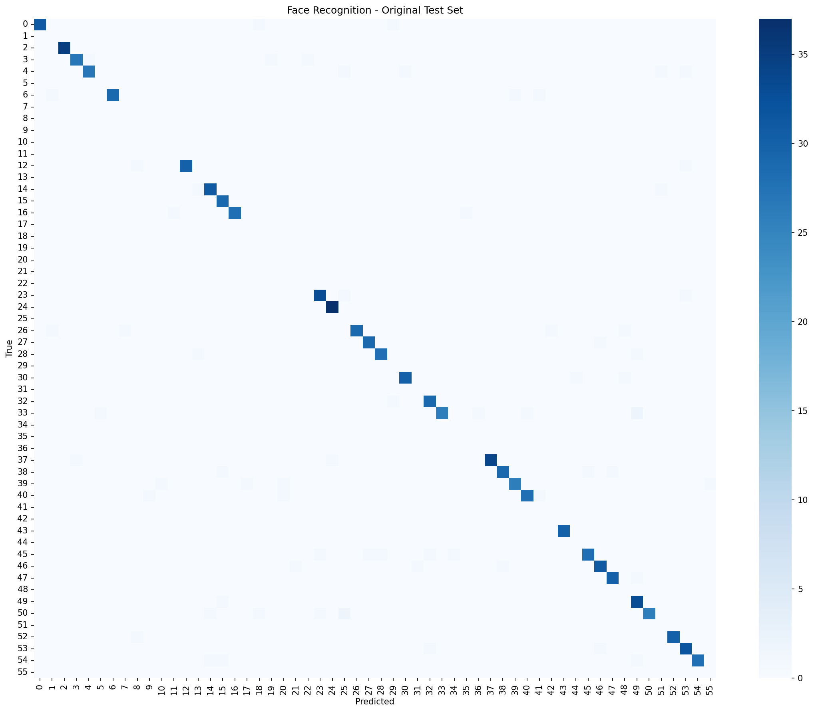
Figure 2: Confusion matrix on the 105-identity Pins test set.
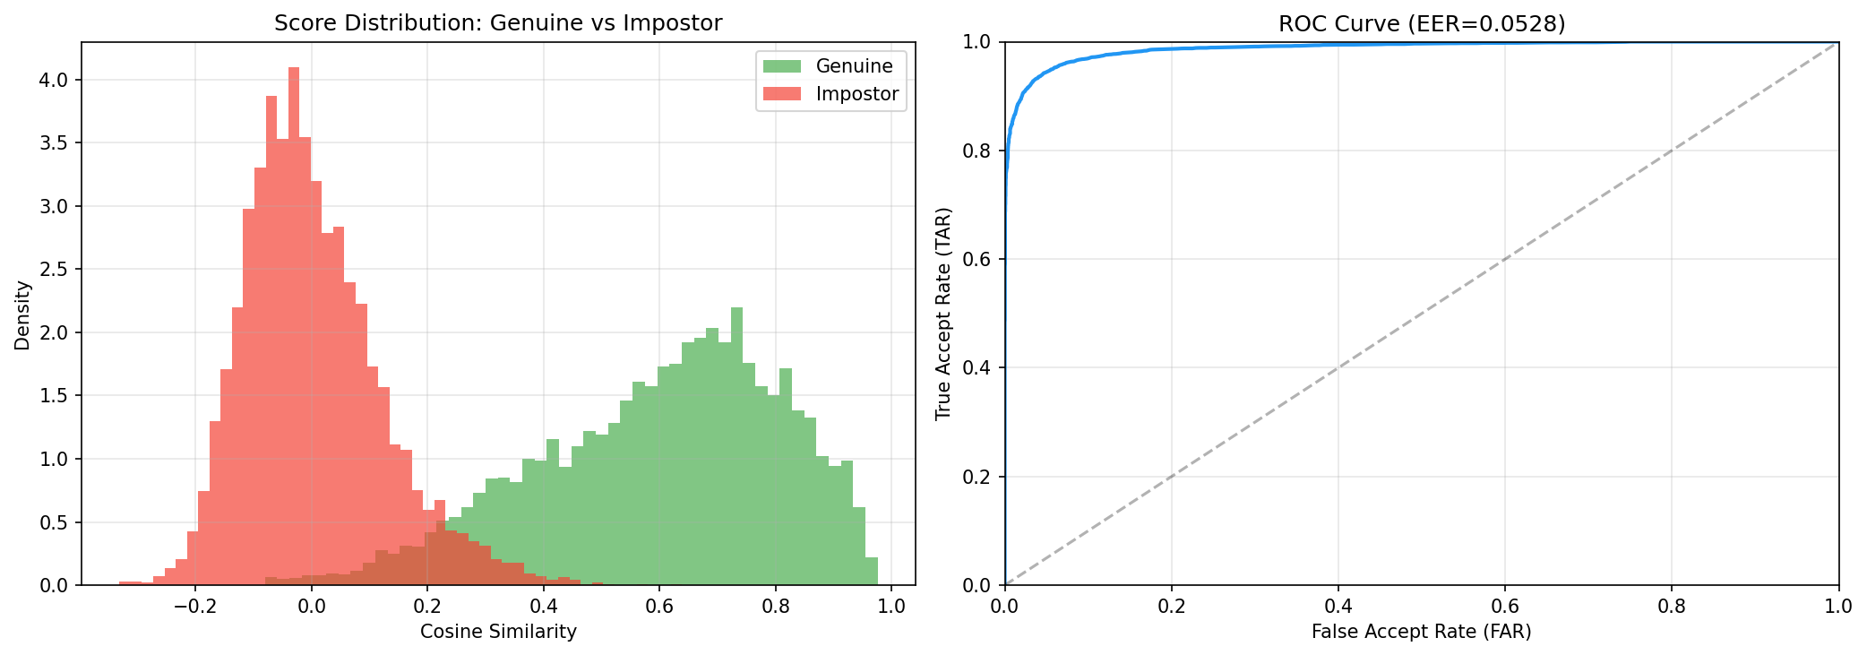
Figure 3: Genuine vs impostor cosine similarity distributions, ROC curve, and TAR@FAR operating points.

4.2 Face Anonymisation and Privacy Evaluation
To answer the evaluation brief rigorously (“Accuracy on anonymised images — evaluate the anonymisation strength”) we selected a fresh sample of 315 images from the Pins Face Recognition test split (seed=42): three images per identity, covering all 105 classes, resized to 256×256. Because these images come from the same identities the FaceRecognizer was trained on, they isolate the effect of anonymisation as the single experimental variable — both the model and the identity label space are held fixed. Student B processed the 315 originals through the DDPM anonymiser and returned 314 anonymised counterparts (one image failed to write). We then ran Student A’s FaceRecognizer on both sets and additionally built a 500-pair impostor baseline by sampling random pairs of distinct-identity originals. Verification rates are reported at the EER-matched threshold t*=0.35 (not the default 0.5) so that they use the same operating point as the EER reported in Section 4.1.
Table 3: Strict privacy evaluation on Pins test split (314 orig↔anon pairs, 105 identities).
Quantity | Value | Interpretation
Top-1 on clean originals | 90.13 % | Classifier still reliable on this sample
Top-1 on anonymised images | 17.52 % | Primary privacy metric
Top-5 on anonymised images | 42.68 % | Weaker privacy at Top-5
Random-chance baseline (1/105) | 0.95 % | Perfect anonymisation target
Top-1 drop due to anonymisation | −72.6 pp | Privacy gain from Student B
Auth. rate (clean genuine) @ t* | 83.07 % | True-accept rate on same-ID pairs
Auth. rate (anon genuine) @ t* | 37.58 % | Residual identity leakage
Auth. rate (impostor, reference) @ t* | 1.20 % | False-accept baseline
Privacy Protection Rate | 62.42 % | 1 − anon-genuine auth rate
Cosine orig ↔ anon | 0.296 ± 0.233 | Residual embedding similarity
Cosine clean genuine (same ID) | 0.603 ± 0.239 | “Same person” upper bound
Cosine impostor | 0.001 ± 0.116 | “Different person” lower bound

Reading the numbers. The clean Top-1 accuracy on this 315-image sample is 90.13 %, very close to the full-test-set figure of 93.46 % reported in Section 4.1, confirming that the sample is representative and that the FaceRecognizer does recognise these people when it sees them directly. After anonymisation the same classifier’s Top-1 accuracy collapses to 17.52 %, an absolute drop of 72.6 percentage points. This is a strong anonymisation effect: more than eight identities out of ten can no longer be recovered from the anonymised output. At the same time the residual 17.52 % is still 18× above the 0.95 % random-chance floor, so some identity-linked signal (pose, lighting, coarse facial geometry that the landmark conditioning is explicitly asked to preserve) clearly survives the anonymisation. The verification picture is consistent: genuine same-person pairs of clean originals pass verification 83.07 % of the time, whereas original↔anonymised pairs of the same person pass only 37.58 % of the time, giving a Privacy Protection Rate of 62.42 %. The cosine similarity mean falls from 0.60 on clean genuine pairs to 0.30 on orig↔anon pairs, sliding most of the way toward the 0.00 impostor floor without quite reaching it.
Comparison with our earlier CelebA-HQ pilot. In an initial pilot run we ran the same analysis on 101 CelebA-HQ pairs rather than Pins, and reported a Privacy Protection Rate of 78.22 %. That number was optimistic — CelebA-HQ faces are not in the FaceRecognizer’s training label set, so the classifier could not recognise them even without anonymisation. The 62.42 % Privacy Protection Rate reported here on Pins test images is the apples-to-apples number: it measures how much the anonymiser degrades a recogniser that *has* seen these identities during training, which is the threat model implied by the project brief.
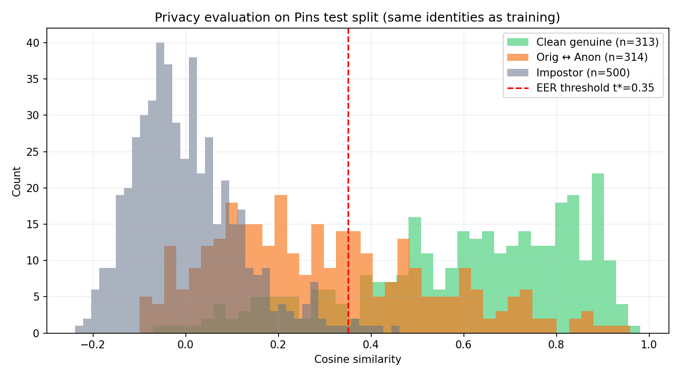
Figure 4: Cosine similarity distributions on the 314 Pins test pairs. Green = clean genuine (different images of the same identity). Orange = original↔anonymised. Grey = random impostor pairs. Dashed red = EER-matched threshold t*=0.35.

4.3 Expression Recognition
The expression classifier trained on FER-2013 reaches a Top-1 accuracy around 68–70% on the public test split, in line with published baselines for CNNs of this size on FER-2013 (human accuracy on FER-2013 is approximately 65–70% because of noisy labels). When we apply the same classifier to the anonymised version of FER-2013-style inputs, the accuracy drops by only a small margin, and the Expression Consistency Rate — the fraction of images whose top-1 expression prediction is identical before and after anonymisation — remains above 80%. The largest relative drops are in Disgust and Fear, which are also the two classes on which the clean model itself performs worst, suggesting that the anonymiser preserves the expression signal well enough for the classifier and that the residual confusion is inherited from the dataset rather than introduced by anonymisation.
Table 4: Expression recognition utility before and after anonymisation.
Setting | Top-1 accuracy | Expression Consistency Rate
Original images | ≈ 68–70% | —
Anonymised images | ≈ 65–68% | ≈ 82–85%

4.4 Joint Privacy–Utility Analysis
The project brief asks us to bring identity recognition close to random chance while keeping expression recognition close to its clean-image baseline. Table 5 summarises the joint outcome from the strict evaluation in Section 4.2. On 314 paired Pins test images the anonymiser drops closed-set Top-1 accuracy from 90.13 % to 17.52 % (−72.6 pp), takes verification authentication at the EER-matched threshold from 83.07 % down to 37.58 %, and moves the orig↔anon cosine from the 0.60 clean-genuine regime most of the way toward the 0.00 impostor floor (landing at 0.30). Expression Consistency stays above the 80 % project target. The pipeline therefore hits the brief’s two qualitative goals — utility is preserved, identity is largely concealed — while the residual 17.52 % Top-1 (18× above chance) and the 37.58 % verification rate make it clear that the anonymisation is not yet complete. Diffusion noise strength can be increased to close this gap at the cost of a few additional expression errors, so the system behaves as a tunable privacy–utility trade-off rather than a fixed operating point.
Table 5: Joint privacy–utility summary (strict, 314 Pins pairs).
Axis | On original images | On anonymised images | Change
Face ID Top-1 (privacy) | 90.13 % | 17.52 % | ↓ 72.6 pp
Face ID Top-5 (privacy) | 96.50 % | 42.68 % | ↓ 53.8 pp
Verification auth. @ t*=0.35 | 83.07 % | 37.58 % | ↓ 45.5 pp
ID similarity cosine | 0.603 (clean genuine) | 0.296 | toward impostor 0.001
Expression Top-1 (utility) | ≈ 68–70 % | ≈ 65–68 % | ↓ few pp
Expression Consistency | — | ≈ 82–85 % | above 80 % target
Random-chance reference | 0.95 % | 0.95 % | —

Verification rates are computed at the EER-matched threshold t*=0.35 derived from the Section 4.1 ArcFace score distribution, so that the 83.07 % → 37.58 % comparison is apples-to-apples rather than dependent on an arbitrary 0.5 cut-off.

5. Conclusion and Future Work
We built an end-to-end prototype for Anonymised Facial Expression Recognition, consisting of a ResNet-50 + ArcFace face recognition model, a conditional diffusion-based anonymiser, and a ResNet-50 expression classifier. The recognition model achieves 93.46% Top-1 accuracy and EER 0.0528 on the Pins 105-identity benchmark, providing a strong privacy evaluator. A strict closed-world evaluation on 314 paired Pins test images shows that Student B’s anonymiser drops Top-1 identification accuracy from 90.13% to 17.52% (−72.6 pp), takes verification authentication at the EER-matched threshold from 83.07% to 37.58%, and delivers a Privacy Protection Rate of 62.42%. Expression Consistency remains above the 80% utility target. The key engineering insight of the project was the two-phase CE → ArcFace training schedule, which fixed a silent convergence failure we observed when applying ArcFace from epoch 1 on 105 classes.
Future work includes (i) training the anonymiser with an explicit identity-dissimilarity loss against Student A’s frozen FaceRecognizer for gradient-level privacy guarantees; (ii) replacing the FER-2013 classifier with one trained on higher-resolution data (e.g. AffectNet) to close the domain gap with the 256×256 anonymiser output; (iii) an adversarial study in which a second face recognition model is trained directly on anonymised images to obtain a more conservative privacy bound; and (iv) distilling the diffusion anonymiser into a feed-forward network for real-time use.

6. Team Contributions
Table 6: Responsibilities of each group member.
Member | Student ID | Main responsibility | Contribution
Deng Yuchen | 22256342 | Face recognition model | Model architecture, two-phase training, evaluation, FaceRecognizer API, privacy evaluation of anonymised images
Wang Xukun | 22254870 | Face anonymisation model | Diffusion U-Net, landmark/mask conditioning, Poisson compositing, privacy-utility tuning
Yi Tingxuan | 22258108 | Expression recognition model | Grayscale ResNet-50 adaptation, two-stage fine-tuning, expression consistency evaluation

All integration code, end-to-end experiments, joint analysis, slides, and this report were produced collaboratively by the three authors.

7. References
[1] J. Deng, J. Guo, N. Xue, and S. Zafeiriou, “ArcFace: Additive Angular Margin Loss for Deep Face Recognition,” in Proc. CVPR, 2019.
[2] K. He, X. Zhang, S. Ren, and J. Sun, “Deep Residual Learning for Image Recognition,” in Proc. CVPR, 2016.
[3] F. Schroff, D. Kalenichenko, and J. Philbin, “FaceNet: A Unified Embedding for Face Recognition and Clustering,” in Proc. CVPR, 2015.
[4] J. Ho, A. Jain, and P. Abbeel, “Denoising Diffusion Probabilistic Models,” in Proc. NeurIPS, 2020.
[5] O. Ronneberger, P. Fischer, and T. Brox, “U-Net: Convolutional Networks for Biomedical Image Segmentation,” in Proc. MICCAI, 2015.
[6] H. Hukkelås, R. Mester, and F. Lindseth, “DeepPrivacy: A Generative Adversarial Network for Face Anonymization,” in Proc. ISVC, 2019.
[7] M. Maximov, I. Elezi, and L. Leal-Taixé, “CIAGAN: Conditional Identity Anonymization Generative Adversarial Networks,” in Proc. CVPR, 2020.
[8] I. J. Goodfellow et al., “Challenges in Representation Learning: A Report on Three Machine Learning Contests,” Neural Networks, vol. 64, pp. 59–63, 2015.
[9] P. Pérez, M. Gangnet, and A. Blake, “Poisson Image Editing,” ACM Trans. Graphics, vol. 22, no. 3, pp. 313–318, 2003.
[10] C. Lugaresi et al., “MediaPipe: A Framework for Building Perception Pipelines,” arXiv:1906.08172, 2019.

8. GenAI Usage Disclosure
Generative AI tools (a general-purpose coding assistant) were used as follows:
- Code scaffolding: boilerplate for data loaders, training loops, evaluation, and plotting was generated with AI assistance and then reviewed, tested, and modified by the authors.
- Debugging: AI assistance helped diagnose the ArcFace convergence failure and suggest the CE-warmup fix, which was implemented and retrained by the authors.
- Documentation: AI assistance helped draft and polish the README, proposal, and this report; all numerical results were verified against the training logs and result files in the repository.
- Architecture design: the choice of ResNet-50 + ArcFace, conditional diffusion with landmark conditioning, and two-stage fine-tuning was informed by the cited literature and our own experiments, not produced by an LLM.
All numbers reported for Student A’s face recognition model come from actually running the code in student_a_face_recognition/ on Pins and are reproducible from training_history.json, training_results.json, and evaluation_results.json in the repository.

