Development of Aluminium-ER5356 alloy build using CMT-WAAM and its Characterization

A Project Report Submitted

in Partial Fulfillment of the Requirements for the Degree of

BACHELOR OF TECHNOLOGY

in Mechanical Engineering
By
Manish Badgal (2019BMEC019)
Avhinash (2019BMEC049)
Anand Singh (2019BMEC068)
Ankit Yadav (2019BMEC090)

Under the guidance
of
Dr. Sandeep Rathee

DEPARTMENT OF MECHANICAL ENGINEERING
NATIONAL INSTITUTE OF TECHNOLOGY SRINAGAR
SRINAGAR, 190006, INDIA
June-2023

CERTIFICATE

This is to certify that the work which is being presenteds in the project titled "Development of Aluminium-ER5356 alloy build using CMT-WAAM and its characterization" a partial of the requirements for the award of the Degree of Bachelor of Technology and submitted in the Mechanical Engineering Department, National Institute of Technology Srinagar, is an authentic record of my own work carried out during a period from July-2022 to June-2023 under the supervision of Dr. Sandeep Rathee, supervisor’s Designation, Mechanical Engineering Department, National Institute of Technology Srinagar.

The matter presented in this project report has not been submitted by me for the award of any other degree of this or any other institute/University.
Date: 25-June-2023
Manish Badgal (2019BMEC019)
Avhinash (2019BMEC049)
Anand Singh (2019BMEC068)
Ankit Yadav (2019BMEC090)

This is to certify that the above statement made by the candidate is correct to the best of
my knowledge.
Dr. Sandeep Rathee Department of Mechanical Engineering

The project Viva-Voice Examination of Name of the Candidate, has been held on 27-June-2022

Signature of Supervisor(s) Signature of External Examiner

DECLARATION

We certify that
a. The work contained in this report is original and has been done by us under the guidance of our supervisor.
b. The work has not been submitted to any other Institute for any degree or diploma.
c. We have followed the guidelines provided by the Department in preparing the report.
d. Whenever we have used materials (data, theoretical analysis, figures, and text) from other sources, we have given due credit to them by citing them in the text of the report and providing their details in the references. Further, we have taken permission from the copyright owners of the sources whenever necessary.

Manish Badgal (2019BMEC019)
Avhinash (2019BMEC049)
Anand Singh (2019BMEC068)
Ankit Yadav (2019BMEC090)

ACKNOWLEDGMENT

We are privileged to honour my sincere thanks to Dr. Sandeep Rathee, our mentor, for giving us an opportunity to do a practical and simulation-based experience through this major project (final year). I offer my deepest gratitude to the Director of the institute, Prof. Sudhakar Yedla and our previous Director Prof. Rakesh Sehgal; Head of Department, Prof. Adnan Qayoum, and staff members of the mechanical engineering department for providing us with the resources and facilities available in the Department. It was their support and guidelines that helped us to prepare this project work.

ABSTRACT

Additive manufacturing is a process of creating physical parts by layering suitable material in layer-by-layer fashion. In AM whole unibody part can be manufactured unlike traditional manufacturing, where a net product is obtained by assembling its different components. Wire arc additive manufacturing falls under the directed energy deposition AM family, where the heat produced by the arc is responsible for the melting and deposition of the material. Cold Metal Transfer is a joining process that falls under the Gas metal arc welding (GMAW). CMT WAAM is the future of manufacturing due to its superior features like high deposition rates, lower heat input and the proficiency to manufacture economical large sized products. A lot of study has been done on WAAM but the comprehensive work on CMT is still going on. This report discusses the basic working principle of CMT, how it is different from other manufacturing techniques, how its process parameters affect the finishing of the sample, the CMT WAAM system setup, microstructural and mechanical properties of CMT WAAMed products. Several materials used in CMT WAAM titanium, nickel-based alloy, aluminum alloys have been covered here and how the WAAMed deposited samples of these materials behaves differently as compared to metal casted counterparts. This article expresses the consideration of CMT-WAAM over others for quality manufacturing and offers a vision for the future of this technology. The work on a novel material Al-Mg ER5356 is done with its deposition using CMT WAAM and its mechanical and microstructural characterization is done.

Content
Page No.

Certificate…………………………………………………………… ii
Declaration………………………….……………………………… iii
Acknowledgment………………………………………………...........iv
Abstract…………………………………………………………….... v
Contents……………………………………………………………… vi
List of figures………………………………………………………… vii List of tables…………………………………………………………. ..x
Abbreviations……………………………………………………...…...xi
Chapter1 Introduction…………………………………………………………… 1
  - CMT-WAAM……………………………………………………... 3
1.1.1 Working Principle…………………………........................... 4
1.1.2 CMT WAAM Setup…………………………………….…... 4
1.1.3 Process Parameters………………………………………….. 6

Chapter2 Literature Review…………………………………………………….. 10
2.1 Materials Used………………. ……………................................... 10
2.1.1 Titanium Alloys……………………………….......................11
2.1.2 Nickel Superalloys…………………………………….……. 13
2.1.3 Aluminium Alloys………………………………………….. 15
2.1.4 Steel………………………………………………..……….. 21
2.1.5 Magnesium…………………………………………………. 27
2.2 Mechanical Properties………………………………………..…. 29
2.2.1 Tensile Strength……………………………………………. 29
2.2.2 Yield Strength……………………………………………… 29
2.2.3 Elongation………………………………………………….. 30
2.2.4 Hardness……………………………………………………. 31
2.3 Microstructural Characterization………………………………... 32
2.4 Applications of CMT WAAM….……………………………… . 34

Chapter 3 Experimental Procedure…………………………………………….... 36
3.1 Methodology……………………………………………………. 36
3.2 CMT-WAAM Experimental Setup……………………………... 37
3.3 Mechanical Testing …………………………………………….. 40
3.4 Corrosion Test...……………………………………………….... 42
3.5 Microhardness…………………………………………………... 42
3.6 Optical Microscopy……………………………….…………….. 43
3.7 Fractography……………………………………………………. 43

Chapter 4 Results and Discussions……………………………………………... 45
4.1 Mechanical and Microstructural Characterization…………..
4.1.1 Mechanical Testing ………………………………………. 45
4.1.2 Corrosion Test ……………………………………………. 48
4.1.3 Microhardness …………………………………………….. 49
4.1.4 Optical Microscopy ……………………………………… 52
4.1.5 Fractography………………………………………….…… 57

Chapter 5 Conclusions ………………………………………………………… 58

References …………………………………………………………. 59
List of Figures
Fig. 1.1 - Classification of AM.
Fig. 1.2 - Publications in CMT WAAM (SCOPUS)
Fig. 1.3 - CMT WAAM System
Fig. 1.4 - Schematic diagram of CMT-WAAM system
Fig. 1.5 - Interpass Time vs Travel Speed [14]
Fig. 2.1 - Percentage of Filler Material Used
Fig. 2.2 - Percentage of Substrate Material Used
Fig. 2.3 - 3D metallographs, element mapping and phase mapping
Fig. 2.4 - Schematic diagram of welding process of Al/Ni using CMT
Fig. 3.1 - CMT WAAM
Fig. 3.2 - Build of Al5356
Fig. 3.3 - Dimensions of different samples
Fig. 3.4 - Tensile sample
Fig. 4.1 - UTS and YS of different layers
Fig. 4.2 - Stress Strain Curve of Layer 1
Fig. 4.3 - Stress Strain Curve of Layer 2
Fig. 4.4 - Stress Strain Curve of Layer 4
Fig. 4.5 - OM of Surface of Layer 1 at 100X
Fig. 4.6 - OM of Surface of Layer 2 at 100X
Fig. 4.7 - OM of Surface of Layer 3 at 100X
Fig. 4.8 - OM of Surface of Layer 4 at 100X
Fig. 4.9 - OM of Surface of Layer 1 at 200X
Fig. 4.10 - OM of Surface of Layer 2 at 200X
Fig. 4.11 - OM of Surface of Layer 3 at 200X
Fig. 4.12 - OM of Surface of Layer 4 at 200X
Fig. 4.13 - OM of Surface of Layer 1 at 400X
Fig. 4.14 - OM of Surface of Layer 2 at 400X
Fig. 4.15 - OM of Surface of Layer 3 at 400X
Fig. 4.16 - OM of Surface of Layer 4 at 400X
Fig. 4.17 - OM of Cross-section of layer 1 at 100X
Fig. 4.18 - OM of Cross-section of layer 2 at 100X
Fig. 4.19 - OM of Cross-section of layer 3 at 100X
Fig. 4.20 - OM of Cross-section of layer 4 at 100X
Fig. 4.21 - OM of Cross-section of layer 1 at 200X
Fig. 4.22 - OM of Cross-section of layer 2 at 200X
Fig. 4.23 - OM of Cross-section of layer 3 at 200X
Fig. 4.24 - OM of Cross-section of layer 4 at 200X
Fig. 4.25 - OM of Cross-section of layer 1 at 400X
Fig. 4.26 - OM of Cross-section of layer 2 at 400X
Fig. 4.27 - OM of Cross-section of layer 3 at 400X
Fig. 4.28 - OM of Cross-section of layer 4 at 400X
List of Tables
Table 1.1 - Effect of Process Parameters
Table 2.1 – Literature Review of Ti alloys
Table 2.2 - Literature Review of Ni alloys
Table 2.3 - Literature Review of Al alloys
Table 2.4 - Literature Review of Steel
Table 2.5 - Literature Review of Mg alloys
Table 3.1 - Chemical composition of Al5356 wire by weight percentage
Table 3.2 - Process Parameters used for different layers
Table 3.3 - Dimensions of different tensile specimens
Table 4.1 - Mechanical Properties of different layers
Table 4.2 - Readings of Microhardness for different layers
Table 4.3 - Readings of Microhardness for different cross-sections
Table 4.4 – Corrosion of samples in Basic Medium
Table 4.5 - Corrosion of samples in Acidic Medium

Abbreviations
AM- Additive Manufacturing, ASTM- American Society for Testing and Materials,
CMT- Cold Metal transfer, WAAM- Wire Arc Additive Manufacturing,
PBF- Powder Bed Fusion, DED- Directed Energy Deposition,
GTAW- Gas Tungsten Arc Welding, GMAW- Gas Metal Arc Welding,
PAW- Plasma Arc Welding, WFR- Wire Feed Rate,
HAZ- Heat Affected Zone, OM- Optical Microscope,
EBSD- Electron Backscatter Diffraction, EDS- Energy-dispersive X-ray spectroscopy,
SEM- Scanning Electron Microscope, VP - Vat photo Polymerization,
BJ - Binder Jetting, MJ - Material Jetting,
ME - Material Extrusion, PBF - Powder Bed Fusion,
SL - Sheet Lamination BTF - Buy to Fly ratio
MIG - Metal Inert Gas TIG - Tungsten inert gas
YS - Yield Strength UTS - Ultimate Tensile Strength SG - Shielding Gas F - Feed rate SD - Substrate dimension WFS - Wire feed speed TS - Travel speed D - Diameter I – Current V - Voltage

CHAPTER 1
INTRODUCTION
Additive Manufacturing (AM) is commonly known with a misnomer 3D Printing. In 1989, Binder Jetting was developed at the Massachusetts Institute of technology by Michal J. Cima and his co-workers with the name of 3D Printing which was later licenced by various companies including ZCorp and Ex one. AM was started in 1987 with the Stereolithography technique in which thin layers of Ultraviolet light sensitive polymers were solidified with the help of a laser. It started with the name of 3D printing and became so popular that till today people misnamed it as 3D Printing. In today’s world, AM has been found to be the most developing form of manufacturing technique and can be predicted as the major component for the future manufacturing industries. AM works among different types of materials from polymers to ceramics. AM usually consists of depositing the material in thin layers and this layer-by-layer fashion leads to the formation of a 3D object. With the help of layer-by-layer deposition of a material, complex components can be manufactured easily which was a tough assignment in subtractive manufacturing. With the help of AM, a near net shape object can be manufactured leading to improved Buy-to-Fly ratio (BTF). AM has also reduced the overall cost of manufacturing with very low wastage of material. There are many ways to deposit the material on which the AM can be classified. As per ASTM, AM is classified into seven different categories. Out of which PBF and DED are usually used for the deposition of metals as a raw material. In DED, material is heated, melted, and solidified in the form of a component whose properties depend upon microstructure and the formation of layers. In DED, different heat sources are used like electron beam, laser beam or arc to heat or melt the material.
Among all the AM technologies, WAAM is a novel technique which can find its great applications in metallic industries. WAAM is a DED technique consisting of a filler wire, which is melted to provide the shape of the desired component by using a layer-by-layer approach. Deposition rate in AM by using Laser Beam or electron beam can be up to 2-10g/min whereas in WAAM it can reach up to 50-130g/min [1]. WAAM deposits the material at the needed place only, which leads to low material loss and cost saving. The components or products manufactured with WAAM have better mechanical properties, composition and density as compared to components that are manufactured with the help of subtractive manufacturing techniques. WAAM can also be used to repair the components or structures like bridges, turbine blades, die, etc. by depositing the material in the worn out sections of the component [2]. To melt the feed wire, an electric arc is used as a heat source in WAAM. This electric arc is generated through a welding unit. WAAM is mainly classified into three categories based on the type of welding technique used: (a) Gas Tungsten Arc Welding (GTAW) based WAAM (b) Gas Metal Arc Welding (GMAW) based WAAM (c) Plasma Arc Welding (PAW) based WAAM. GMAW is further classified into Cold Metal Transfer (CMT) and Tandem Gas Metal Arc Welding.
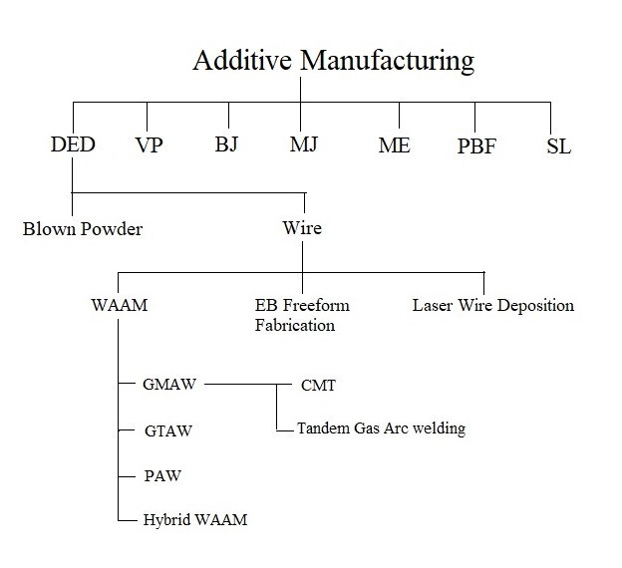
Figure 1.1 Classification of AM.

This review paper evaluates the existing published research papers based on CMT-WAAM. It consists of an elaborate discussion on CMT from its history to the current development which includes: introduction, classification, merits over other WAAM methods, and applications. The setup of CMT WAAM along with its various parts, its working principle and the various parameters that play a vital role during the process are explained as well. The overview of various materials on which CMT-WAAM is performed such as titanium and its alloys, the nickel-based superalloys, aluminium and its alloys, steels and magnesium alloys are presented, followed by the mechanical properties and microstructural characterization of CMT WAAMed samples and concluded at the end with its future prospects.

  - CMT WAAM
Fronius Company developed CMT in Austria in 2004 [3]. CMT WAAM is one of the types of GMAW in which a mechanical droplet cutting method is used. Hence, results in accurate deposition of material at low heat input. It is a spatter free process with high surface finish and high deposition efficiency with high solidification rate due to which it is the most preferred technique over MIG or GMAW, TIG or GTAW [3]. The CMT technique is referred as Cold when compared to the other welding techniques because hot and cold phase varies continuously (high and low voltage and current), resulting in making it relatively less hot [4].
Figure 2 represents the number of research papers published till 2021 on CMT based Wire arc additive manufacturing.

Figure 1.2 Publications in CMT WAAM (SCOPUS)

    - Working Principle
The working principle of CMT is based on the Short-Circuiting process. It works at low current and voltage which signifies low heat input. It uses the to and fro motion of a torch to deposit a droplet on the substrate ultimately leads to a spatter free bead with good structural integrity. In this operation, the torch contains the filler wire with an initiated arc. Due to the arc, the melting of the wire takes place and melted wire moves towards the pool of the bead. Arc extinguishes and short-circuit takes place when the arc touches the melt pool. At this movement the drop of the melted filler wire gets detached from the wire. After this, it retracts and the arc is initiated again and this cycle is repeated again [5].
    - CMT WAAM SETUP
Fig 3 represents the schematic diagram of different parts of the CMT-WAAM system which comprises of welding unit, wire feeder, welding torch, shielding gas, robotic arm, etc.
In Figure 4, all the components of CMT based WAAM setup is shown. Majorly a 6-axis robotic arm is used to deposit bead in the required direction and location. Wire feeder controls the wire feed speed, which is different for different feed materials or it has to be adjusted with respect to other process parameters in order to obtain good quality product. The feed wire ejected from the wire feeder goes into the robotic arm through cables up to the CMT torch. Shielding gas also plays an important role while deposition, so continuous supply of gas is required with particular flow rate. This gas is transferred from gas cylinder to the CMT welding torch and comes in action under the deposition period. The rest of the parameters like current, voltage, travel speed is controlled using CMT welder and this is responsible for the association of charge to the substrate plate and filler wire. All these important components should be operated on optimal values in order to produce a good quality sample. If any of the component’s value deviates from the optimal values, it will definitely result in deviations or defects in terms of dimensional accuracy, tensile strength and microstructural properties.
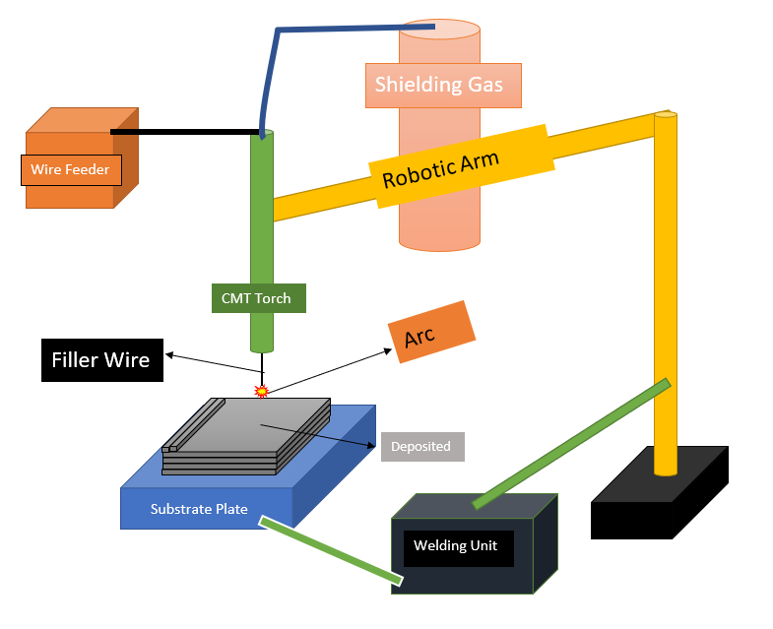
Figure 1.3 Schematic diagram of CMT-WAAM system
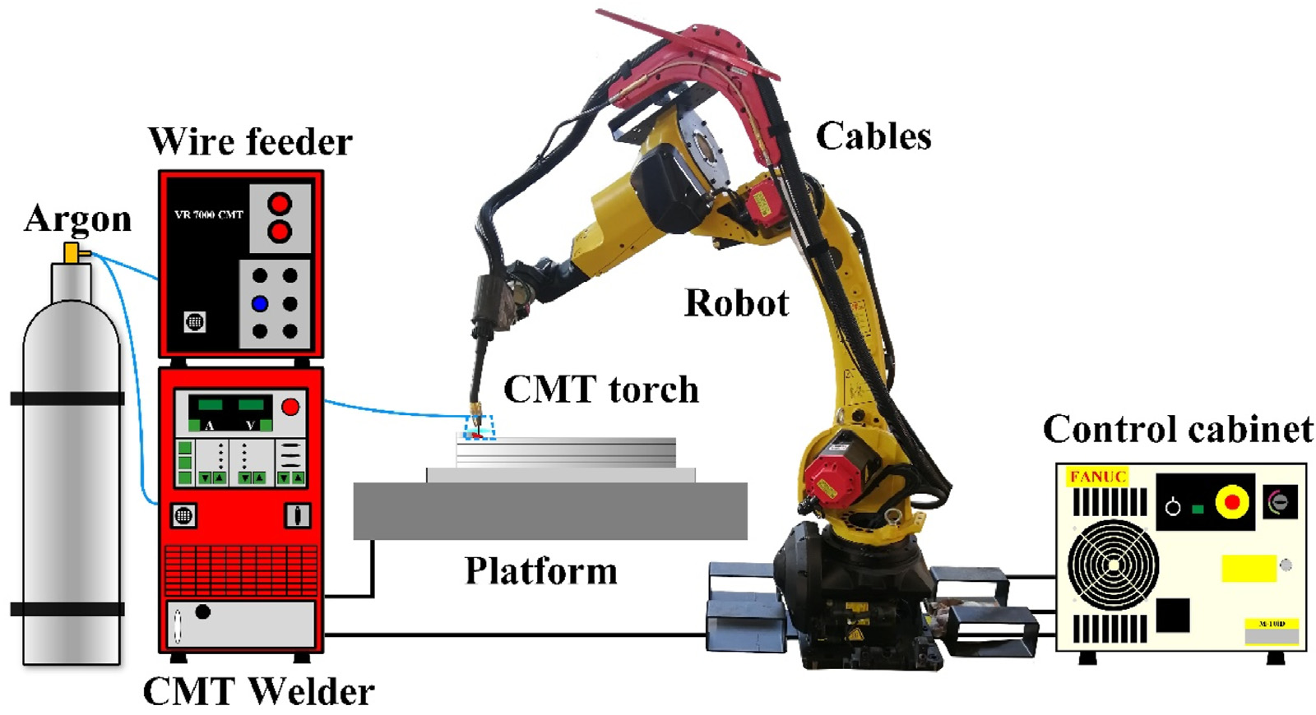

Figure 1.4 CMT WAAM System[6]

    - Process Parameters

For manufacturing a defect free and stable component through a CMT-WAAM process various process parameters plays a major role which includes Current, Arc Voltage, Wire Feed Rate, Travel Speed and Shielding Gas. These parameters affect the heat input during the deposition and result can be seen on the quality of the deposited component [7]. An excessive amount of heat input can deteriorate the geometry and microstructure of the previously deposited beads whereas the low heat input maintains uniform surface and geometry of the bead [8] and also reduces the porosity level in the component [9].

      - Wire Feed Rate
Wire Feed Rate (WFR) is a measure of feed wire consumption rate during deposition. WFR is directly proportional to the heat input [9]. It can affect the geometry of the bead, dilution, hardness and length of heat affected zone (HAZ). These factors also influence the susceptibility of a welded component towards cracking. Therefore, increasing the WFR will increase the Heat Input. At higher WFR, larger size beads are deposited on the substrate. Also, it increases the length of HAZ and grain size in HAZ. The WFR also controls the waiting time and deposition time of the droplets. For Al5Si, the discontinuous deposition is generated when feeding rate is below 10m/min and at higher feed rate, the feed wire cannot deaccelerate after contacting with bead and wire gets sticked to the bead leading to the discontinuous formation of the bead [10].

      - Current
Arc Current is another process parameter of a welding process which affects the roughness of bead. It controls bead geometry, electrode wire burn off rate and depth of fusion [11]. At higher arc current, the depth penetration of the weld also increases which results in the formation of stronger welded joints [12]. The heat is developed because of the Joule effect during short circuit phase when a current is below minimal value of short circuit current which solidifies the wire tip when it makes contact with substrate surface. When the short circuit is high, the deposition of bead is irregular [10].

      - Voltage
The electric potential difference between the welding wire and weld pool determines the phase of the fusion zone of the bead. Depth of penetration is controlled by arc voltage. At high voltage, the weld produced is relatively flatter and wider with less penetration. On increasing the arc voltage, the penetration first increases upto a certain limit known as optimum limit and beyond the optimum limit, penetration decreases with increase in arc voltage [13].

      - Travel Speed
Travel Speed (TS) is another parameter which determines the geometry of the bead. On increasing the TS, the height of the bead increases leading to the increase in width and vice-versa. High TS also leads to an increase in power used to increase the local temperature of the melt pool. This increase in temperature decreases the wetting angle which alters geometric variations [14].
Figure 5 demonstrates that the increase in travel speed leads to a height reduction and a width increment. When interpass time is fixed at 5 s, and the travel speed values vary from 5mm/s to 10mm/s and 15 mm/s, the wall height is reduced by 7% and 12% respectively. Also, when the interpass time is 60 s, the wall height is reduced by 3% and 7% respectively. With the variation in travel speed, the weld bead shape also varies [14].
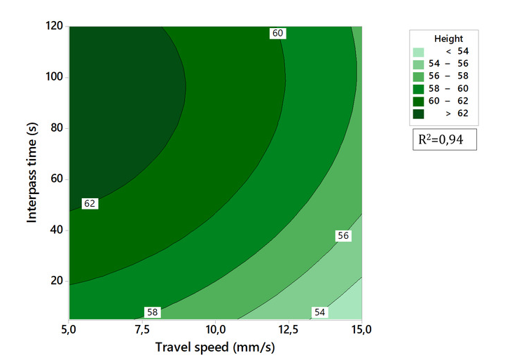
Figure 1.5 Interpass Time vs Travel Speed [14]
      - Shielding Gas
To prevent the contamination of weld pool during deposition, an adequate amount of shielding gas is required. It prevent the weld pool from different defects like weld cracking, porosity and also from forming certain nitrides and oxides [15]. A high flow of shielding gas also leads to poor penetration and due to which entrapped atmospheric gases like oxygen, nitrogen and water vapour leads to porosity in the component. Generally, shielding gas is supplied through welding torch but for the deposition of materials like maraging steel and Ti-6Al-4V, which have high tendency to contaminate during WAAM; a special arrangement is made for shielding gas [16]. A shielding device is developed for the deposition of Ti-6Al-4V material in WAAM, which provides laminar flow of shield gas with better shielding conditions than conventional shielding conditions [17]. The composition of the shielding gas is also a major factor in selecting the shielding gas to prevent magnetic arc blow [18]. Due to insufficient oxide availability on surface of melt pool, an oxidizing doped shielding gas is used which increases travel speed and penetration and decreases surface tension.
Table 1.1 Effect of Process Parameters
Parameters | Effect on the additive part | Reference | Materials
Wire feed rate | High wire feed rate results in discontinuous beads  Wire feed rate is directly proportional to heat input | [19]  [20] | Aluminium
Current | The depth penetration increases with increase in arc current. | [12] | Mild steel E6011
Voltage | Depth of penetration increases up to certain limit then decreases with increase of voltage. | [13] | Aluminium alloy
Travel speed | Bead height is directly proportional to travel speed | [14] | Stainless steel ER316LSi
Shielding gas | High flow rate of shielding gas leads to porosity. | [16] | Ti-6Al-4V
CHAPTER 2
LITERATURE REVIEW
2.1 Material Used
CMT WAAM uses different types of materials for the fabrication of a component like metals, ceramics, alloys, or superalloys, etc. The material in the WAAM process is used as filler material and the substrate plate which can be of same material as of filler material or can be of different material. It uses the material in the form of wires which is available in the form of spools. This section reviews the different types of materials that are used in CMT WAAM process with particular emphasis on process parameters, and mechanical properties exhibited by a manufactured part. Fig 4 represents the percentage of the different type of filler material used in different researches and Fig 5 represents the percentage of the type of the different substrate materials. Fig 6 represents the no. of publications in CMT WAAM till 2021.

Figure 2.1 Percentage of Filler Material Used

Figure 2.2 Percentage of Substrate Material Used

2.1.1 Titanium Alloys
Titanium (Ti) alloys are the most popular and extensively used alloys in the field of AM with the CMT process. Strength to weight ratio and material cost is high for Ti alloys [21]. It has high fatigue resistance with good corrosion resistance and formability [22]. Many WAAM operations use Ti alloys for making large size complex structures which is a high business opportunity for the WAAM industry [21]. Ti alloys find its most application in the aerospace industry used to fabricate body parts due to its lightweight property [21]. It is also used in defence and nuclear power field operations. Ti alloys exist in two phases: α phase and β phase. Hcp lattice structure can be seen in α phase which is relatively brittle and has high strength. Bcc lattice structure can be seen in the β phase which has high ductility and average yield strength (σ_{0.2}=860 MPa).
On the basis of α and β phase combinations, Ti alloys can be classified into five categories: α Ti alloys, near α Ti alloys, β Ti alloys, near β Ti alloys and α+β Ti alloys [23]. Out of the available Ti alloys, Ti6Al4V is the commonly used Ti alloy for experiments because of its large use in biomedical applications [22]. The Ti alloys manufactured by WAAM generally have larger elongation and low strength in the vertical direction than deposition direction [23] and the microstructure of which depends upon the thermal properties of the layer during fabrication [24]. The summary of different Ti alloys which are investigated under CMT WAAM with different process parameters, properties, with concluding remarks are given in Table 2.1.
Table 2.1
Author | Filler/Substrate Material | Process | Process Parameters | Remarks
Gou et al. 2019[25] | Ti-6Al-4V/ Ti-6Al-4 V | CMT | SG=Ar  F=20 L/min.  SD=200 × 50 × 4 mm3  WFS=7.0 m/min  TS=0.3m/min. | The Ti-6Al-4V wall had been manufactured using CMT WAAM. The 900 °C-4 h-FC and 1200 °C-2 h-FC heat treatment results in the increase of average hardness and elongation respectively but decrease in tensile strength.
Tian et al. 2019[26] | Ti-6Al-4V & AlSi5/ Ti-6Al-4V plate | CMT | SD=200mm X 50mm X 4mm.  TS = 0.3 m/min.  Displacement rate=0.5mm/min.  WFS (Ti alloy) =7.2 m/min.  WFS (Al alloy) =4 m/min.  SG = Ar  F = 20 L/min. | A component of dissimilar alloy is manufactured using Ti-6Al-4V and AlSi5, where a propagation of crack can be seen in the interface layer, whose hardness value is between Ti and Al alloys with the brittle fracture mode.
Gou et al. 2022[27] | Ti6Al4V | CMT WAAM and CMT + WAAM | D=1.2mm  TS= 0.3 m/min  WFS = 8 m/min  SG = Ar | Effects of CMT on ultra machining are investigated.  For CMT + P, heat input is higher than CMT mode but CMT mode specimen is of higher strength.  Machined surface quality depends on the surface hardness, if it’s high surface quality will be good.
Zhou. et al. 2022[28] | Ti-6Al-4V/ Ti-6Al-4V | CMT and CMT+P | TS = 5 mm/sec.  Wire extension = 10 mm.  SG = 99.99% Ar  F = 20 L/min. | Hybrid short circuit transition and globular transition had been used in CMT and CMT+P modes, which leads to the increase in current value, size and spread ability of the molten pool. Hence, the morphology of the sample got affected.

    - Nickel Superalloys
Nickel (Ni) based Superalloys are high performance alloys that exhibit high toughness and strength at high temperature and they are corrosive resistant too [20]. Ni based superalloys are popular along with Ti alloys in AM processes. Using Traditional methods, the cost of fabricating Ni alloys is too high. Generally above 550°C temperature, it shows high strength and oxidation resistance [21]. These alloys are generally used in Aerospace (in engines combustion and turbine sections [20]), Aeronautical, petrochemical, and chemical industries [21]. The widely used Ni alloys are IN625, IN718 and IN825 [20]. Davim et al. studied the geometry of the laser cladded Ni layers on steel substrate [29, 30]. In Ni based Superalloy, the solidification is expected to begin from the primary dendrites which are vertically aligned from the fusion boundary [31]. Even a small amount of heat input affects the finer dendrite microstructure [32]. Intergranular Liquation occurs in the Heat Affected Zone (HAZ) which is the main cause of HAZ intergranular micro fissuring in Ni based superalloys but does not cause any problem during CMT cladding of an alloy [33]. CMT process is found to have outstanding potential in the cladding and repairing the manufactured components of Ni based alloys. For IN718 at low dilution, defect free clads are produced with CMT process [34]. The summary of different Ni alloys which are investigated under CMT WAAM with different process parameters, properties, with concluding remarks are given in Table 2.2.
Table 3.2
Author | Filler/Substrate Material | Process | Process Parameters | Remarks
Senthil et al. 2022 [35] | Inconel 825/ Inconel 825 | CMT WAAM and Casting | D= 1.2 mm.  SD=160 mm x 120 mm x 20 mm. | CMT WAAMed sample outperforms the cast sample in terms of tensile strength, yield strength and % elongation. The microhardness is higher near the substrate and decreases at the top.
Liu et al. 2022 [36] | NiTi alloy/ Ni Alloy | CMT WAAM | SD=200mmX100mmX10mm  TS=20, 30, 40cm/min  WFS=3-8m/min  Arc length=15 mm  SG=Ar  F=20L/min  Post flow duration=90s | Extensive defects can be seen on the morphology of the NiTi wall and with the increment of wall height- microhardness, critical stress, % elongation also increases.
Wang et al. 2021 [37] | Inconel 625/ Q345 Steel Plates | CMT-WAAM | SD=210mm×100mm×10 mm  I=105 A  V=12.5 V  TS=4 mm/s  WFS=5 m/min  Distance between torch and workpiece=15 mm  Contact angle=90◦  Dwell time between layers=60 s  Magnetic field intensity=20 m T  SG=80 % Ar and 20 % CO2  F=25 L/min | Due to the magnetic field, the size of the dendrites decreases but microhardness, tensile properties and elongation of the Inconel 625 alloy deposited with magnetic fields were higher than those without magnetic fields.
Kindermann et al. 2022 [38] | Inconel 718/ Low carbon mild steel | CMT WAAM | WFS= 6 m/min.  SD = 295 mm x 150 mm x 10 mm.  TS=1m/min.  I=143A.  V=15.3V.  Average Arc power = 3 KW.  Heat I/P ~ 0.18 KJ/mm.  CSG=Ar  F=15l/min.  Torch to work distance=15 mm. | Yield strength, ductility and microhardness were similar to its wrought counterpart. In order to minimize defect formation, thermal stresses and process parameters should be minimized and optimized.
Zhang et al. 2022 [39] | NiTi/Ti | CMT WAAM | WFS=4.0m/min.  SG=Ar  F=20L/min.  TS=0.35m/min.  I=107 A.  V=10 V.  Arc length=10-15mm.  Post flow duration = 60 sec. | As per the uniaxial tensile test the ultimate strength decreases and elongation increases when the sampling direction changes from horizontal to vertical. In the middle region no pores and cracks were found.
Jiang et al. 2022 [40] | Ni690 + (no addition or 0.5 wt% TiC, or 1.0 wt% TiC), FM-52M. /Q345B steel plate | CMT WAAM | WFS= 5 m/min.  TS=120 mm/min.  Wave width = 10 mm  SG=Ar  F=15 L/min. | Effect of variation of TiC content on the mechanical properties, microstructure and corrosion resistance of Ni690 single wall components is revealed. In both directions, the mechanical properties of the WAAM 1.0TiC Ni690 component were better than the WAAM Ni690 component.

    - Aluminium Alloys
Aluminium (Al) is the third abounding element in earth’s crust [21]. It is the most attractive and economical metal [4]. Therefore it is the most commonly used material in engineering with high corrosion resistance property, high thermal conductivity and high strength to weight ratio [41]. Al has large scale applications in industries like aerospace, military, transport, electricity, marine, etc [4]. Elements like Cu, Mg, Mn, Zn, Li, etc. are alloyed with pure Al because in its pure form it has poor mechanical properties [42]. For the fabrication of smaller and simple geometry components, Conventional Machining process is preferred for Al as it is cost efficient whereas for fabricating large sized and complex shaped components, WAAM process is preferred [43]. In the WAAM process several grades like Al-Cu (2xxx), Al-Si (4xxx) and Al-Mg (5xxx) are studied for fabrication [44]. WAAM is less used for fabricating some Al alloys of series Al-6xxx, Al-7xxx because the melt pool of these metals is generally unstable and frequent defects are found in it. In order to enhance the mechanical properties of these materials, post heat treatment is required [43]. Strength of Al 2xxx, 6xxx and 7xxx is increased by Precipitation hardening while others are increased by cold working [45]. A thin wall with porosity problem of ER4043 alloy was deposited using CMT WAAM which was found to be defect free with porosity problem [46]. CMT WAAM saves a lot of energy during fabrication which makes it a most competent process for Al alloys [44]. The summary of different Al alloys which are investigated under CMT WAAM with different process parameters, properties, with concluding remarks are given in Table 2.3.
Table 2.4
Author | Filler/Substrate Material | Process | Process Parameters | Remarks
Li et al. 2016 [47] | AlSi5/ Ti TA2 and Al Alloy 6061-T6 | CMT Welding | Rectangular strips=100x100mm2.  WS=0.6 m/min  SG=100% argon  F=15 L/min  WS=4.8,5.0,5.2, 5.3, 5.4 m/min | Uniform welds and good spread ability of the weld metal can be seen at 5.3-5.4m/min WFS but becomes unstable and full of spatter when the WFS is further increased. The optimum joint strength of Al–Ti was way higher than the Ti-Al joint.
Ortega et al. 2017 [48] | ER4043 (Al–Si alloy)/ 1050 Al Alloy | CMT WAAM | Iwait=50-70 A(50,70)  Vd=20-37 m/min(20,25,35,37)  Isc=40 A  D boostup=300 A m/s  T boostup=0.1 ms  I boost=150 A  t boost=2-9 ms (2,5,9)  D boostdown=300 A m/s  Average power=708-1666W (708,1039,1470,1666) | In order to improve the geometrical accuracy, parametric study was done by the optimization of process parameters.
Nie et al. 2018 [49] | 4043 Al-alloy/6061 Al plate | CMT + Advance WAAM (C1368 Adv) | SD = 200 mm × 100 mm × 5 mm  I = 58–99 A,  V = 6.9–19.1 V,  WFS = 4.2 m/min;  welding speed = 6 mm/s  pre-flow = 0.5 s,  gas post-flow = 0.5 s;  Arc starting = 130%,  time-arc starting (ts) = 0.5 s;  Arc ending = 50%,  time-arc ending (te) = 0.5 s;  WS = Ar | CMT + Advance WAAM is more efficient and shows good mechanical properties of 4043 aluminium alloy. Mechanical properties of the horizontal direction are relatively better than vertical direction.
Chen et al. 2018 [50] | ER4043 Al alloy/6061-T6 Al alloy | CMT-WAAM | I=127,158A,  V = 15.3,16.8V,  WFS = 6,7 m/min; | Unstable forming of Al alloy can be seen while increasing the WFS because it directly affects the forming value of W and H. Arc length also plays an important role in the stability of additive forming.
Ryan et al. 2018 [51] | AA2319 | CMT-P, CMT-PDAV, CMT-Adv | D=1.2mm  WFS = 3.5,4.5,6 m/min;  TS=0.3, 0.6m/min  WFS to TS Ratio: 0.1,0.4,0.7  SG=Ar  F=20L/min | The hydrogen content will definitely increase the pores and surface finish will also get affected.
Ortega et al. 2019 (1743-2936) [52] | 4043 aluminium alloy (Al– 5%Si)/ Pure Al plate | CMT WAAM | D=1.2mm  I=70A  V=35,37.5V | Two different solidification defects were found- pores and cracking defects. Two sets of process parameter were analysed, leading different average power.
Fang et al. 2019 [53] | Al-6.3%Cu alloy (ER2319 Al alloy)/2219-T87 | CMT WAAM | work distance=15mm,  WFS=4 m/min,  TS=0.5 m/min,  SG=Ar  F=22 L/min. | A Tri dimensional transient FEA model was established and validated by experiment for the CMT-PDVA additive manufacturing of ER2319 aluminium alloy.
Zhang et al. 2019 [54] | ER5183/ H111-5083 aluminium alloy | CMT WAAM | WFS=6 m/min  Substrate Dimension = 300mm×125mm×5mm  SG=Ar  F=25L/min  Distance b/w tip & substrate=10 mm | Group of thin layer walls were manufactured using VP-CMT which had very few pores with equiaxed grains.
Chakkravarthy & Jerome (2020) [55] | ER 4043 | CMT WAAM | D=1.2 mm  WFS= 3 m/min.  V=8V.  I=80 A  Torch angle = (10 and 15) degree  Arc gap = 10 mm  Number of layers (w x h) = (5 x 15). | It can be observed that, as compared to orientation, texture and microstructural configuration the sliding direction plays a significant impact on wear for Al4043 alloy.
Gu et al. 2020 [56] | 2319 (Al-Cu6.3) Al alloy/2219-T87 Al alloy | CMT WAAM, CMT-PA , MIG-P | SD=300mmX100mmX10mm  TS=0.6 m/min.  Interlayer cooling time=1min .  SG=Ar  F=25 L/min.  Contact tip to workpiece distance=15mm.  Pre-heating Temp=(80-100) °C  Arc = CMT-PA.  WFS = 12 , 7, 9, 6m/min.  H I/P = 144.6 , 317.3J/mm. | The structural interfaces are dominated by columnar and fine equiaxed interfaces. After the T6 heat treatment, a homogeneous distribution of mechanical properties can be seen in the entire WAAM part containing the substrate.
Campatelli et al. 2020 [57] | ER4043 | CMT and CMT-mix | I=32,133A  V=11.1,18.5V  WFS=1.8,6m/min  TS=300mm/min | In this paper, a comparative analysis had been done between CMT and CMT mix-drive in terms of microstructure, mechanical properties and electrical energy demands.
Pramod et al. 2020 (1905–1919) [58] | ER4043/ AA6061- T6 cylinder | CMT | Welding current (WC), A: 77  Welding voltage (WV),: 11.3 V  Rotational speed (RS), rpm: 2.5  Wire feed speed, m/min: 4.1  Heat input (HI), kJ/mm: 0.041  welding speed: 1138 mm/min  •SG=Ar  •F=20L/min | In this paper, WAAM cylinder has been manufactured and its metallurgical, mechanical and FE analysis shows few pores, high tensile strength at 45 degrees and microstructure of columnar and equiaxed dendrites.
Liu et al. 2020 [59] | 4043 Al alloy & ERCuSi28L/ Cu-T2 | CMT Process | I=112A  V=11.1V  TS=0.35m/min  WFS=1.2,5.2m/min  Dwell time=60s | Here, CMT has been used to make Cu-Al-Si alloy and how its mechanical, microstructural properties behave when subjected to deep cryogenic treatment.
Geng et al. 2021 [60] | ER 5356 | CMT WAAM | D=1.2 mm  I=168 A  V=16.9V  WFS=7.5 m/min  TS=0.6 m/min | This paper discusses the effects of EBST irradiations on microstructure, phase composition and tensile strength. The results show that 10J/ cm ² of electron beam density gives the required results.
Vishnukumar et al. 2021 [61] | ER4043/ AA5052 | CMT, CMT+P | SD=160mmX150mmX5mm  I=58,66A,  V = 11.8,15.8V,  WS=450,500 mm/min  WFS = 6,7 m/min;  SG=Ar  F=20L/min  H I/P = 93,98 J/mm  Deposition rate=0.51,0.71 Kg/hr | The corrosion performance and microstructure of ER4043 was examined, which was deposited on AA5052 using CMT and CMT+P process. This paper proposed that WAAM has a potential for repairing in marine applications.
Rauch et al. 2021 [62] | ER2319/2017A | CMT-Pulse, CMT-Advanced, CMT-Pulse Advanced. | WS = 600 mm/min.  Inter layer cooling time = 10 sec.  Contact tip to work distance = 15 mm.  SG=Ar  F = 20 L/min  Wire feed speed = 8,7,6 m/min  WFS by TS ratio = 10. | The investigation of oscillation deposition strategy on 2913 Al sample by WAAM and VMG advanced arc mode has been done, to know the effects on porosity, microstructure and mechanical properties in details.
Nagasai et al. 2022 [63] | ER5356/6061 alloy | CMT | SD=250mmX250mmX10 mm  I=105A  V = 13 V  WFS = 6.4 m/min  TS= 250mm/min  WG=Ar | A cylindrical component of ER70S-6 was formed using CMT and GMAW WAAM to identify which process exhibits superior UTS, YS, hardness and toughness. Even the grain size is finer in CMT WAAM.
Chen et al. 2022 [64] | ER2319/ AA2219 alloy | CMT+SP | WFS = 3.8 m/min;  TS=0.5m/s;  High current time correction=6  Low energy period = 6.0  Low energy regulation = 6.0  Duty cycle (%) = 60  WFS = 3.0 m/min  Mean WFS=3.8 m/min | A highly symmetric profile was made by CMT mix synchro-pulsed process and how the microstructure, mechanical properties, morphology differs when compared to CMT-P process with same parameters.

    - Steel
Steel is made up of Iron and Carbon and it is of four types: Carbon Steel, Alloy Steel, Stainless Steel and Tool Steel. Different grades of steel exist based on the presence of a percentage of elements like Chromium, Nickel, Molybdenum, Carbon, Vanadium, Silicon or Manganese. Steel is a versatile material which exists in different forms like plates, bars, sections, etc. Steel has a wide range of applications from a construction industry to automotive and aerospace industries. The existence of steel can be seen in every building and infrastructure [65]. To improve mechanical properties, corrosion resistance and to stabilize the austenite phase nitrogen can be used as an alloying element.[66]. Therefore, High Nitrogen Steel also known as Nitrogen Austenitic Stainless Steel and is widely used in medical, weapons, cryogenic and aviation industries [67]. WAAM is the most suitable process for the fabrication of steel components because of its high deposition rate [68], low cost [69], and ultimate build size [24]. For steel, the deposition rate with the help of WAAM is 4-9 Kg/hr while it is 50g/hr with PBF [70]. In the printing direction, the tensile strength and yield strength for the manufactured component does not vary whereas the ductility of the component is affected by the shape and size of dimples in the printing direction which were distributed regularly and had a uniform size for inclined samples than those with other directions [65]. In CMT-WAAM the cycle time decreases and an effect on the droplet transfer can be observed due to the incrementation in WFS [67]. Beads' tensile strength and microhardness increases with the increase of heat input [71]. The summary of different types and grades of steel which are investigated under CMT WAAM with different process parameters, properties, with concluding remarks are given in Table 2.4.

Table 2.5
Author | Filler/Substrate Material | Process | Process Parameters | Remarks
González et al. 2017 [72] | AWSER70S-6/ S235JR Steel Plates (substrate) | CMT welding technology and CNC milling machine. | SG = CO2 (15%) & Ar(85%)  Torch Gap = 7 to 10mm.  WS = 200 – 800 mm/min.  I = 27 A and 100 A.  No. of layers(n)=10-40 layers | An oversized sample has been made using CMT technology with the integration of CNC milling machine and it is a cost-effective solution for developing new components.
Posch et al. 2017 [73] | Stainless steel filler wire | GMAW.  CMT-WAAM | WFS=4.2 m/min  WS=36 cm/min  I=145A  V=11.9V  CMT frequency=100 Hz. | This paper shows, how CMT process is more effective in depositing the thinner beads of stainless steel as compared to GMAW process.
Rodriguez et al. 2018 [74] | 316L stainless steel grade from Praxair/316L alloy | CMT and TIG  WAAM | WFS=8-10 m/min  I=150,200,220A  V=14.2,26.8,23.3,26.2V  WFS=8,10m/min  TS=0.6,1  SG=Ar  F=16L/min  Arc Length=10mm | Top TIG and CMT are feasible to manufacture a bead-by-bead stainless steel part but exhibits anisotropy in mechanical properties.
Rajeev et al. 2019 [75] | Stellite 6 filler wire/ AISI H13 steel | CMT Welding | I=165A  V=12.5V  WFS=6.5m/min  WA=304.8m/min  Nozzle to plate distance=12mm  F=18LPM  Torch angle=90° | This research paper shows, how the correction parameters effect the characteristics of deposition in CMT WAAM.
Wang et al. 2020 [76] | 316L stainless steel wire/ stainless steel plate | CMT WAAM | D=1mm  SD=200mm×200mm×8mm  I=150 A  V=14.1 V  WFS=11 m/ min  Scanning speed=0.7 m/min | Study on tensile properties and microstructure of 316L component manufactured using CMT WAAM has been done. It was observed that crack initiation takes place in austenite matrix.
Lehmann et al. 2020 [77] | AWS ER70S-6 | CMT WAAM | SD=152.4×152.4×6.35mm3  SG=75% Ar and 25% CO2  F =40 CFH  WFS = 1.52-2.29 m/min  TS = 0.30-0.38 m/min | A material-based process identification and optimization of robotic CMT WAAM. Identification of factors influencing quality of component in terms of geometrical and metallurgical consistency.
Cadiou et al. 2020 [78] | 304 stainless steel/304 stainless steel | CMT WAAM | SD=130mmX12mmX50mm  D=1mm  T =300K  I=25 A.  Tinit =293  KTS=30cm/min  F=15L/min  WFS=3.5m/min | With the simulation of transient 3D model-heat transfer, electromagnetic and fluid flow in the melt pool and the plasma has been investigated.
Zhu et al. 2021 [79] | SS410 | CMT WAAM | SG = 97.5% Ar & 2.5% CO2  F = 20 L/min  WFS = 5 m/min  Scanning Speed = 0.2 m/min  Inter pass dweel time = 60s  Inter layer dweel time = 300s . Overlap Ratio = 39.6% | This paper shows that during the deposition of SS410, ᵟ Ferrite could be eliminated without any need of post treatment.
Zhong et al. 2021 [80] | ER316L/ SS316LN | CMT WAAM | WFS= 4.98 m/min.  Scanning speed=5mm/sec.  V = 15.6 V.  I = 160 A.  SG=Ar+CO2(4:1)  F = 25 L/min. | Slicing algorithm combined with CMT WAAM have a great potential to manufacture large and complex parts like SS316 nuclear nozzles with low manufacturing cost and higher efficiency.
Chen et al. 2021 (109325) [81] | Commercial 316 L | CMT WAAM | I= 144 A.  V = 19 V.  WFS= 5 m/min.  Scan rate = 6 mm/sec  SG=98.5% Argon + 1.5% oxygen  F= 20 L/min. | Under dynamic compressions, how the flow and microstructural evolution of 316 Stainless steel takes place when manufactured using CMT WAAM.
Senthil et al. 2021 [82] | Inconel 825 & SS316L/ Inconel 825 | CMT WAAM | wall= 140x 120x 16 mm3  I=146 A, 113 A.  WFS=5000, 3800mm/min  TS=150 mm/mi  F=13 L/min | An innovative CMT based WAAM mode was used to made FGM wall of Inconel 825-SS316L. This wall was mechanically and metallurgically observed using SEM and EDS.
Yan et al. 2021 [83] | ER50-6/ Q235 mild steel | CMT WAAM | dimension=400x300x8mm3  WFS=3-5 m/min.  Step over distance = 1-2 mm.  TS=8mm/sec.  SG=80%Ar + 20%CO2  F= 15 L/min. | Here, the investigation has taken place on transfer behaviour of the CMT process in the step-over deposition mode. Wall width is the function of WFS, and by increasing the step-over distance, inclined angle increases significantly.
Huan et al. 2022 [84] | SHPPIY®718 welding wire/ Low carbon steel | CMTCMT MIX + Synchropulse (CSP) process for WAAM | F=30 L/min  High current time correction 0  Low energy period 6.0  Low energy regulation -6.0Duty cycle (%) 60  Peak arc length correction -3.0  Valley arc length correction -1.5  frequency (HZ) 1.8 | At high WFS, how CMT WAAM and CSP WAAM of Inconel 718 alloy are different in terms of beat geometric characteristics, formability and droplet transfer behaviour.
Koli et al. 2022 [85] | SS308L austenitic stainless steel/ SS304 | CMT WAAM | I=120-160A  WS=4-8mm/s.  SG=Ar  F=16-20L/min. | This paper discusses the δ-ferrite phase morphology and microstructural analysis based on heat input and number of layers manufactured using CMT-WAAM.
Nagasai et al. 2022 [86] | 308 L austenitic stainless steel (SS)/ 304 stainless steel | GMAW and CMT | WFS=5000 mm/min.  I=132A  V=14.6V  F=15L/min  Rotational speed = 280 mm/min.  Heat I/P=0.308 KJ/min | Sample was free of major cracks, pores and defects. The average UTS, EL and hardness of CMT cylinders were more than GMAW cylinders.
Priarone et al. 2022 [87] | AWS ER 308L Si Steel/ AISI 304 steel | CMT WAAM | SD=170 mm dia and 20 mm thick  Water Flow rate = 2L/min  Water flows Pressure = 4 bar.  Stick-out distance = 14 mm.  Arc correction = -0.5.  Dynamic correction = -1.0.  SG=Ar + 2.5% CO2  F=14L/min | Material deposition efficiency and energy consumption got affected by the variation of WFS and TS. The production of the feedstock material and finishing operation could result in significant variation of the downstream and upstream energy requirements.
Zhao et al. 2022 [88] | ERNiCrMo-3 (Inconel 625) and ERNiCrMo-4 (Hastelloy C-276)/ 304 Stainless Steel | CMT Welding | I=150-155A  V = 38V  WS=530 mm/min  WFS=650 mm/min  SG=Ar  F=25 L/min. | As compared to 304 substrate, Hastelloy C-276 coating and Inconel 625 showed higher corrosion, wear and cavitation erosion resistance.
Koli et al. 2022 [89] | SS308L material/ SS304 substrate plate | CMT WAAM process | I=120-160A  WS=4-8mm/s  F=16-20l/min | Average yield strength of steel manufactured using CMT WAAMed component was more than conventionally manufactured steel. Residual compressive stresses are there.
Cai et al. 2022 [71] | GER-95/ G115 Steel | CMT+P Welding | SD=200mmX90mmX15mm  Pulse Ratio=1/15  nH=0.7  Preheating Temp.=200-250°C  SG = 97.5% Ar & 2.5% CO2 | Weldability problem has been solved using CMT+P welding. No harmful δ-ferrite phase. With the increase of heat input- microhardness and tensile strength increases.
Panchenko et al. 2022 [90] | Aristorod 69 | CMT and C-GMAW WAAM | SG=Ar  F=16–18 L/min | Both C-GMAW and CMT modes results in formation of no-diffusion upper zone and the lower tempered zone. C-GMAW leads to the formation of homogenization.

    - Magnesium
Magnesium (Mg) is the lightest structural material [91] having high stiffness and specific strength with good damping and electromagnetic shielding properties [92]. Mg is known as the best alloy of the 21st century[93] having lowest density (i.e. 1.738g/cm³) among the engineering materials. Mg alloys finds its most of the applications in aerospace, automotive [94, 95], biomedical, and energy sectors [91]. Using Mg instead of Al and steel alloys, the weight of the aircrafts and automotives can be reduced [96]. Mg is a heat sensitive material due to which the defects like coarse grains, pores or hot cracks can be easily found in a WAAM manufactured component [97]. The use of Mg alloys is limited because the strength and corrosion resistance of Mg alloys is not significant when compared with Ti and Al alloys. To improve the mechanical properties of Mg alloys, various processes have been introduced like casting with ultrasonic vibration [98], laser surface treatment [99], machining with liquid nitrogen cooling [100]. New types of wires Mg-Zn and Mg-RE series should be developed so that properties of Mg alloys can be improved [92]. For AZ31 Mg wire, for the stable deposition of a material, the wire feed speed should not be more than 5m/min for DC-CMT whereas it should not be more than 4m/min for Pulsed CMT. Under Pulsed CMT, at 4m/min wire feed speed, a good clad appearance with favourable contact angle can be achieved [101]. The summary of different types and grades of Mg which are investigated under CMT WAAM with different process parameters, properties, with concluding remarks are given in Table 2.5.

Table 2.6
Author | Filler/Substrate Material | Process | Process Parameters | Remarks
Bi et al. 2020 (128185) [102] | AZ91 Mg alloy/ AZ91 alloy | CMT WAAM | SD=250mmX150mmX6mm.  WFS = 12 m/min.  TS = 0.6 m/min.  SG = Ar  F = 15 L/min  Inter-layer cooling time = 3 min. | A AZ91 component is manufactured using CMT-WAAM without any obvious defects and well joined interlayers. The multi-layer structure of the sample consists of different sized equiaxed grains. The CMT WAAM manufactured component shows better performance in comparison to the conventional cast alloy.
Yang et al. 2020 [103] | AZ31 Wire/ Rolled plate of AZ31 |  | SPD=250mmX40mmX8mm  I=70-180A,  TS=0.6m/min  WFS=2.5m/min  SG=Ar  F=15L/min. | The AZ31 component is manufactured using CMT WAAM consisting columnar dendritic arrays. The tensile properties show anisotropic behaviour and the average values of YS, EL, and UTS of building direction specimens are clearly better than the travel direction specimens.
Wang et al. 2021 [104] | AZ31 Wire/ AZ31 Mg Alloy | CMT-WAAM | D=1.2mm  SD=150mm×50mm×2.3mm  WFS=7m/min  SG=Ar  F=18 L/min  TS=0.6 m/min  Tube-to-workpiece distance=12 mm. | In the build direction YS was higher (125.9 MPa) than in the deposition direction (85.4 MPa). However, the UTS and elongation in the deposition direction (225.7 MPa, 28.3%) was higher than that in the build direction (210.5 MPa, 17.2 %).

  - Mechanical Properties

2.2.1 Tensile strength:
Geng et al. 2021 observed improvement in the tensile strength of the fabricated Al-Mg alloy samples to a certain level because of the reduction of pores and microcracks developed during WAAM-CMT by electron beam irradiation and because of the sample’s finer grain structure [105], Zhang et al. in 2022 observed a decrease in yield strength and ultimate strength because of the grain size and particle state, and an increase in elongation was observed when the sampling direction changed from horizontal to vertical during the uniaxial tensile tests because of the presence of lower grain boundaries along the vertical direction [106]. Gu et al. in 2020 observed that after the T6 heat treatment, UTS of the deposited walls increased by 63% (MIG-P) and 68% (CMT-PA) and elongation decreased by 38% (MIG-P) and 36% (CMT-PA) implying that whether its CMT-PA T6 treated interface or MIG-P T6 treated interface, its plasticity, and strength fulfils the industrial criteria[56]. Rauch et al. found that in the deposition of the thin wall by TIG [107], the tensile values of vertical coupons were more than in horizontal coupons, it is due to the less pore distribution in the tensile direction [62]. Chen et al. observed that the average tensile strength of the CMT+SP AA2219 alloy samples is greater than that of CMT+P samples because the CMT+SP samples have lower distribution density and size of pores compared to CMT+P samples due to which the mechanical properties of WAAM-ed AA2219 alloys got reduced significantly [64, 108].

    - Yield Strength
Zhang et al. in 2022 observed a decrease in yield strength was observed in the uniaxial tensile results of the NiTi alloy samples when the sampling direction was changed from horizontal to vertical direction because of the presence of lower grain boundaries along the vertical direction[106]. The mean value of YS for the as-deposited wall which were fractured on the WAAM alloy side was 120-125 MPa and the YS of the CMT-PA and MIG-P deposited walls increased after the T6 heat treatment by 154 % and 167 %[56]. The average value of YS for the WAAM deposited Al2319 alloy was higher compared to the O-tempered Wrought Al2219 alloy due to the less pore distribution in the tensile direction [62]. WAAMed Inconel 825 has higher yield strength than the cast Inconel 825 sample at both elevated and room temperatures and the vertical samples have lower YS than horizontal samples because the grain growth being columnar [35].

    - Elongation
Increase in elongation takes place from 2.4% to 5.0% during the change in sampling direction from horizontal to vertical. This difference in NiTi alloy was the result of precipitation behaviour and the grain structure. Along the vertical direction, the distribution of columnar structures, few grain boundaries and less resistance to deformation can be seen which leads to increase of elongation [106]. The WAAMed Inconel 825 sample had a higher % elongation compared to the cast Inconel 825 sample. Columnar grain growth is the reason for higher percentage elongation of vertical samples as compared to the horizontal samples and the growth of columnar grains were their due to the cooling through substrate and the layer beneath it. At temperature of 550 °C gains elongation can be observed[35]. The mean value of elongation for the as-deposited wall fractured on the WAAM alloy side was 13.5-15% and after the T6 heat treatment, the elongation of CMT-PA deposited wall decreases by 36% and MIG-P deposited wall decreases by 38%[56]. After the tensile results the elongation of the WAAM deposited Al2319 alloy was equal to (9 ± 1.3%), which was not higher than O-tempered alloy [62]. The elongation of the fabricated Al-Mg cylindrical component was (48.06 ± 1.13%) in the lower and upper zones, respectively showing isotropic nature of tensile properties [109].

    - Hardness
In the deposition zone the average hardness is 286 HV, diffusion of Ti from the substrate is the main reason for the affected zone and thus, the distribution of hardness is not uniform. The hardness is distributed with some fluctuations in the vertical direction across the deposition zone and the reason for fluctuations is mainly because of the interlayer and intralayer hardness. The micro hardness values were higher at the bottom because of the presence of finer grains close to the substrate (276 HV) and are lower at the top (256 HV) due to the coarse grains [35]. A coarse microstructure was seen for the WAAMed 2319 Al block structure using oscillatory strategy because of its slow cooling rate [62]. In the as-deposited WAAM cylinder, the microhardness decreases from 58 to 46 HV from bottom to top layer. The decrement in the microhardness was due to the presence of coarse grains, pores and variation in heating between additive layers. The microhardness in the bottom layers was higher than those middle and top layers due to the formation of equiaxed dendrite in the bottom layer[58]. The microhardness of the AD sample ranges between 492 ~ 565 HV, and the average value is 531 HV [110] . The microhardness distribution is uneven near the interface. The average hardness for the Al alloy, Ti alloy and interface layer were ~55 HV, 340 HV and 195 HV, respectively. Near the interface layer microhardness of Ti alloy remains constant but Al alloy hardness slightly increases due to the formation of Ti(Al_{1-x}Si_{x})₃ [111]. The average microhardness values 75.1 ± 2.5 HV0.1 and 77.2 ± 2.5 HV0.1, were recorded along the transverse and longitudinal direction of AZ91 components fabricated by the CMT-based WAAM system specimens respectively, which indicates the stable microhardness distribution characterization[112].

  - Microstructural Characterization:
Lehmann et al. in 2020 used Optical microscopy through a Hirox KH-8700 up to magnifications of ×1000 on the material AWS ER70S-6 and found out that the dimensions of the grain are approx. equal in all directions when compact wall width control is present[113]. Kindermann et al. in 2022 used a Keyence VHX-5000 digital microscope having image stitching abilities with a magnification of 200x on the material Inconel 718. After acquiring a resolution of 0.948 pixels/μm it was found that the microstructure of CMT-WAAMed material comprises mainly Laves phases, NbC and TiN particles in as-deposited state and these particles form precipitate in the interdendritic region[114]. Zhu et al. in 2021 used an OLYMPUS BX51M optical microscope (OM) and found that by using suitable processing parameters in CMT-WAAM the usual micro-defect in d-ferrite precipitation of SS410 can be resolved. The AD microstructure consists of a large amount of lath martensite and a low content of punctate austenite[110]. Koli et al.in 2022 used Leica DM LM optical microscope on SS308L austenitic stainless steel to analyse the microstructure and found that:
- There are two interface zones present on either side of each layer. The top interface zone consists the columnar, vermicular, lathy, and serrated ferrite morphology domination and the bottom interface zone has columnar, lathy ferrite morphology, and acicular domination. The fusion line only consists of globular ferrite morphology while lathy and vermicular ferrite morphology are detected in the centre of each layer.
- δ-ferrite and micro-inclusions increases and γ-austenite concentration declines with increase in heat input as lathy ferrite changes into faceted morphology and the vermicular into globular ferrite morphology in δ-ferrite.
- As vermicular ferrite morphology converts into globular ferrite morphology, grain growth occurs[115].
Nagasai Et al. in 2022 used a light optical microscope on ER5356 material to analyse the microstructure of various zones of fabricated cylindrical component and found that because of the alternate superimposing of layers the microstructural changes (inner-layer coarse grain and inner-layer fine grain) take place in the deposited beads. A scanning electron microscope (SEM) was used to analyse the microstructure of various zones of fabricated ER5356 cylindrical component and it was found that the microstructural features are uniform in upper and lower zones of Al–Mg cylindrical component[109].

In Fig. 7 a and b represents OM, EBSD and EDS observations found in central and overlap zones of AD components at present processing parameters. The overlap and central zone are martensite not having d-ferrite (OM), which shows that an increased heat input eliminates d-ferrite. Also, through EBSD the visible white spots are found to be evenly dispersed austenite in martensite. The amount of martensite in both overlap zone and central zone surpasses 96%, while the remaining low amount is austenite. Because of insufficient martensite transformation austenite emerges at room temperature[116].
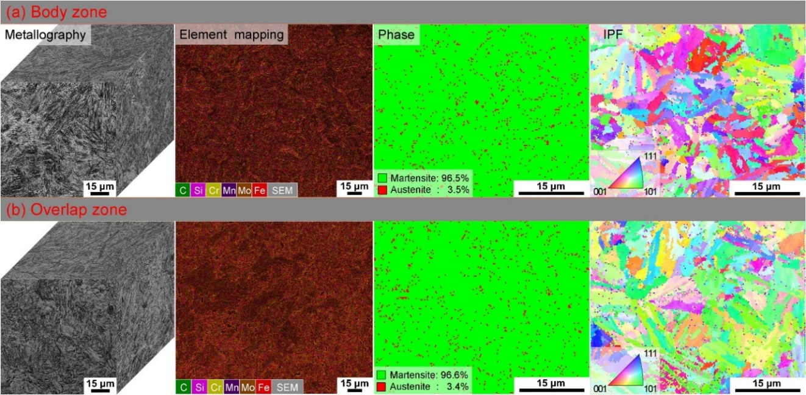
Figure 2.3 3D metallographs, element mapping, phase mapping and inverse pole figure (IPF) of the central zone (a) and overlap zone (b) in the as-deposited samples [110]

  - Applications of CMT-WAAM
The use of CMT is increasing in manufacturing industries which can be mainly seen in four applications [117]:
- Welding of Sensitive Materials:-
CMT is preferred to weld Al sheets, earlier which was not that efficient with other techniques due to decrease in strength of bead and HAZ [117]. It is also used to weld high strength sheets like Zinc Coated Steel in which defects like porosity were found [118].

- Welding of different metals:-
Volume fraction in CMT is low which plays an important role in determining the strength of a joint [117]. Therefore, CMT can be used to join the sheets of different materials like Al/Ni [119] and Al/Steel for the assembly of vehicle body [120].
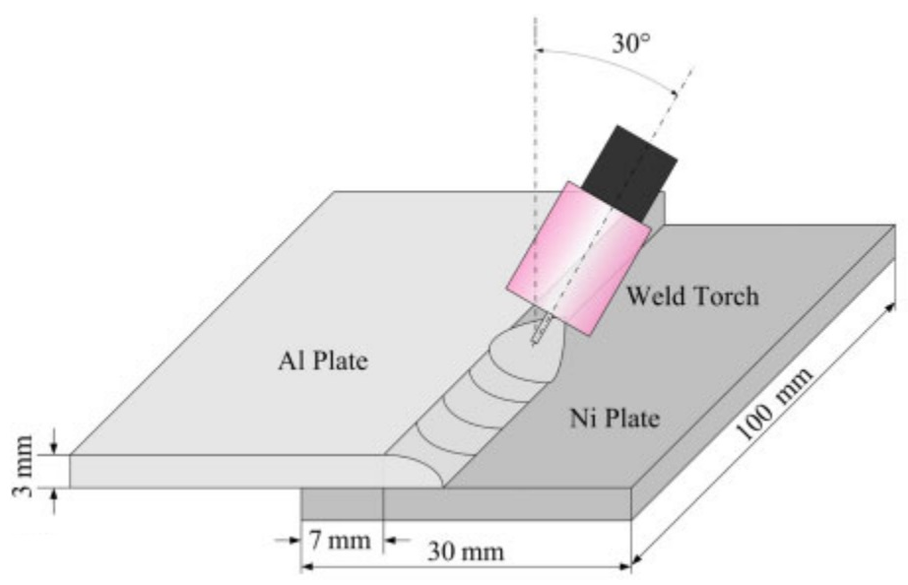
Figure 2.4 Schematic diagram of welding process of Al/Ni using CMT[119]

- Cladding:-
Cladding refers to the formation of a thin layer of metal over a material. CMT provides a large control over the dilution which provides low crack susceptibility composition in the quasi-Binary layer of Al-Cu.

- WAAM:- Due to excellent characteristics of an arc and flexibility of a process, CMT also finds its application in the WAAM industry which is a part of the AM process. Here, it is used to manufacture large structural components [121].
CHAPTER 3
Experimental procedure
A build of Al5356 was deposited using CMT – WAAM with the dimensions 115x30x30mm³ and the composition of Al5356 is shown in table 1. The CMT – WAAM system was composed of arc and motion control systems, CMT welding power supply, wire feeder, Kawasaki 6-axis robotic arm and figure 1 shows the CMT WAAM setup. Firstly, the spindle of Al5356 has to fitted in wire feeder and then the feed wire is connected to CMT torch via cables. while managing feed wire in CMT torch, the feed wire should be 1.5mm out. The 99.99% pure Argon gas with a flow rate of 16L/min was used as the shielding gas, its end outlet is at CMT torch which releases gas while deposition. The substrate of pure Al was clamped onto the fixed clamping table. Welding unit is connected to feed wire and clamping table to make it positive and negative electrode respectively. The used welding unit it Fronius TPS 400i, which automatically sets the process parameters like current and voltage for the selected feed wire at suitable or given WFS. Our sample was built using WFS as 7.3m/min, current as 105A and voltage as 14.1V. The travel speed and robotic arm was controlled by controller show in figure 1. The optimization of the bead geometry was observed at different process parameters by varying the travel speed as shown in table 2.
With the help of controller, the CMT torch was bought closer to the substrate plate and the distance between feed wire and substrate plate was 3mm. The point from which the deposition starts can be termed as an absolute point and the further deposition of beads and layers are done with taking reference as an absolute point. Firstly, a straight-line bead of 115mm was deposited and then a leap time of 5mins was provided. This interpass time was provided after each bead deposition. After interpass time of 5 mins, a new bead was deposited in same direction and parallel to the previous bead of same length, meanwhile in those 5mins our bead will get enough time to cool down. This deposition process of beads will be same up to four beads. For the second layer, the CMT torch was bought above first bead and the distance between the 1st layer and the feed was 3mm. Rest of the beads and layers are deposited in the same manner with taking table 2 mentioned process parameters into consideration and total of layers were deposited.
After several days, the build shown in figure 2 was cut using wire EDM as per the dimensions mentioned in figure 3.

Si | Fe | Cu | Mn | Mg | Cr | Zn | Ti | Be | Al
0.05 | 0.11 | 0.001 | 0.16 | 4.8 | 0.12 | 0.001 | 0.081 | 0.0001 | Bal
Table 3. 1 Chemical composition of Al5356 wire by weight percentage
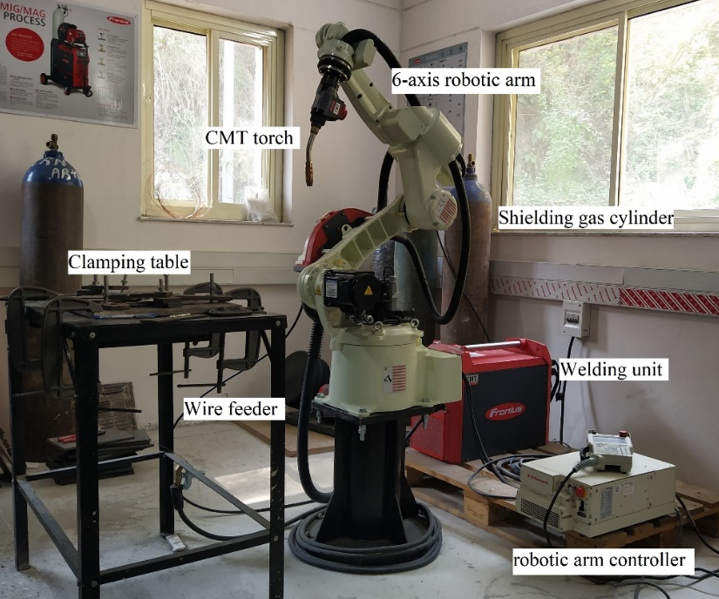
Figure 3. 1 CMT WAAM
S.No. | I | V | WFR (m/min) | TS (cm/min) | Height (mm)
1. | 105A | 14.1V | 7.3 | 25 | 5.3
2. | 105A | 14.1V | 7.3 | 25 | 8.6
3. | 105A | 14.1V | 7.3 | 30 | 12
4. | 105A | 14.1V | 7.3 | 30 | 5.3
Table 3. 2 Process Parameters used for different layers

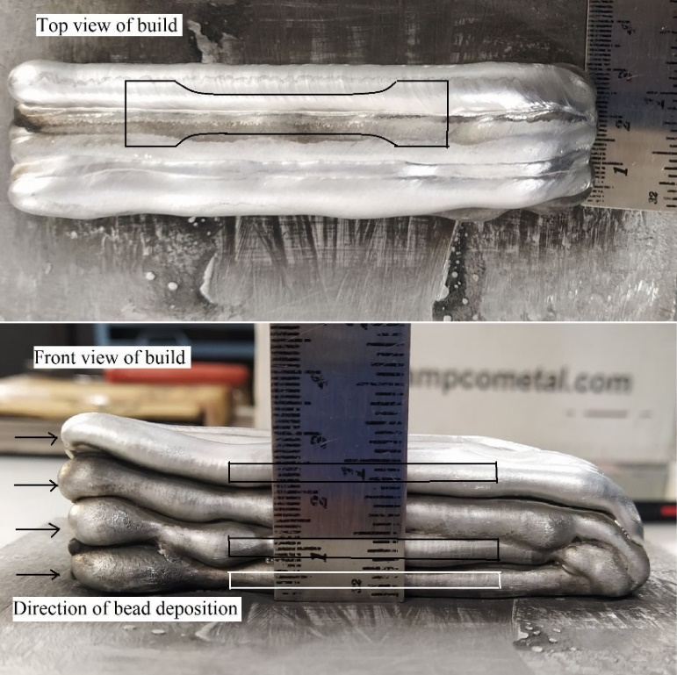
Figure 3. 2 Build of Al5356

3.1 Mechanical Properties Characterization
The experimental procedure involved the utilization of smooth and notch tensile specimens, with their corresponding dimensions illustrated in Fig.3.5. These specimens were carefully extracted from both the lower, middle and upper zones of the test material as shown in Fig 3.9. To assess the tensile properties, a FLB-Tinius Olsen Universal Testing Machine(UTM) with a maximum load capacity of 100 kN was employed. The yield strength of the material was determined by employing the 0.2% offset technique, based on the engineering stress curve. Additionally, the strain was calculated using a gauge length of 25 mm. In order to ensure statistical validity, three tensile samples were tested in both the lower, middle and upper zones, and the average values were subsequently reported.
By employing this comprehensive testing approach, encompassing tensile, a thorough analysis of the mechanical properties of the material in different zones of the component was achieved. This information not only ensures the reliability and accuracy of the experimental results but also contributes valuable insights into the overall performance and behaviour of the manufactured build under various loading conditions. Tensile samples were cut by wire EDM parallel to the deposition direction. Out of the deposited build, three tensile samples were obtained of different layers with same dimensions as shown in the figure3.3 .
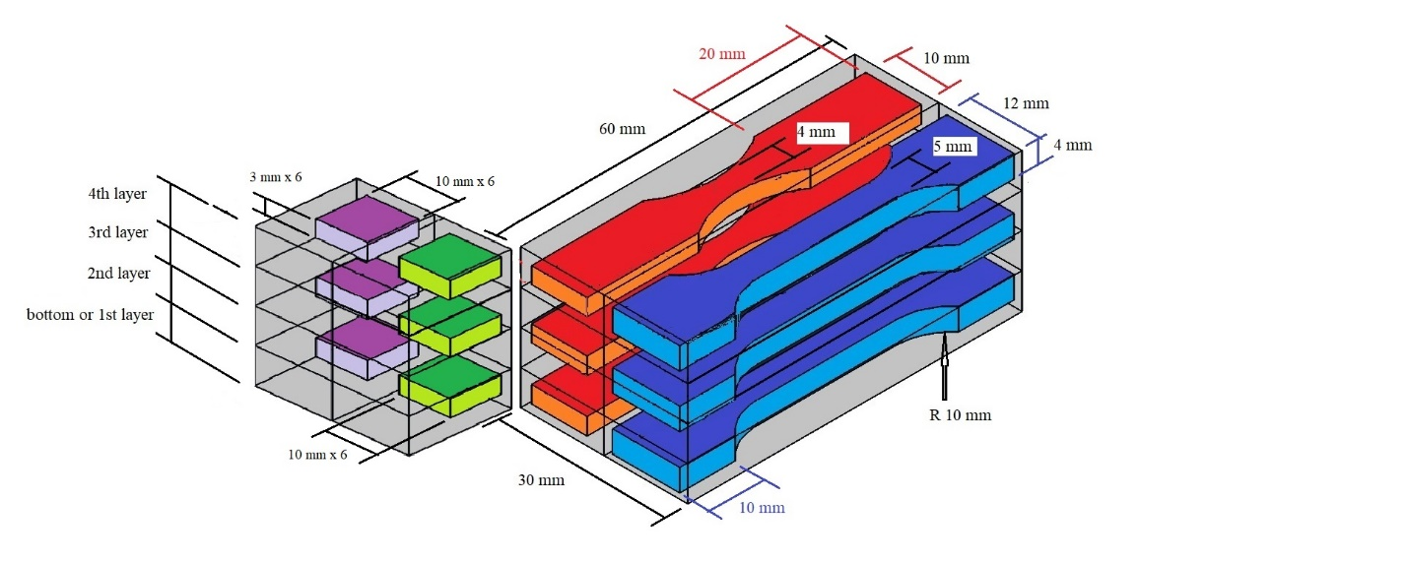
Figure 3. 3 Dimensions of different samples
Before clamping samples to the UTM, they were polished lightly to remove rough edges and ridges. One by one samples were clamped on UTM by keeping all the parameters same. These parameters are mentioned in table 3.3.
Parameters | Layer 1 | Layer 2 | Layer 4
Thickness (mm) | 2.85 | 2.9 | 3.05
Width (mm) | 4.65 | 4.8 | 4.8
Gauge length (mm) | 25 | 25 | 25
Speed (mm/min) | 2 | 2 | 2
Table 3. 3 Dimensions of different tensile specimens
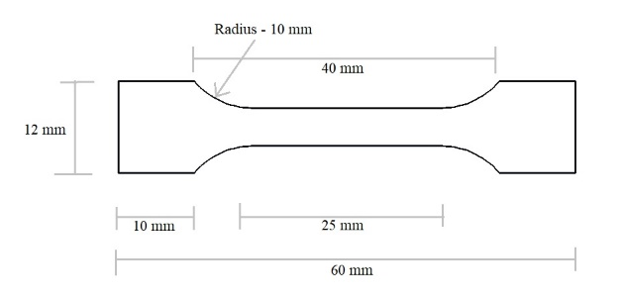
Figure 3. 4 Tensile sample

3.2 Corrosion Test
We have performed two types of corrosion tests on our WAAMed Al5356 material. One corrosion test was performed to determine the corrosion resistance of our build against basic medium and the other test was performed to determine the resistance against acidic medium. For testing basic corrosion test, a salt solution of 20.96g NaCl in 100ml of water was used. For testing acidic medium corrosion test, an acidic solution of 5ml HCl and 95 ml of water was used. A regular weight measurement of sample is performed in order to obtain weight loss. A weight loss method technique is used to determine the corrosion rate of the sample against different mediums.
3.3 Microhardness
The microhardness test began by preparing the sample from the component. The samples were extracted from the WAAM component at specific locations for both the tensile test and microhardness evaluation. The sample was mounted securely using epoxy or a suitable mounting material. It is then carefully ground and polished to achieve a smooth and flat surface. Once prepared, the sample is placed on a microhardness testing machine, and a controlled load is applied using a diamond or tungsten carbide indenter. The Vickers hardness tester was utilized, applying a dwell load of 500 g for a duration of 15 seconds. The size of the resulting indentation is measured, and the microhardness value is noted from the machine. The test is repeated on multiple areas of the sample to ensure accurate and representative results. The obtained microhardness values provide insights into the hardness distribution and variations within the WAAMed component.

3.4 Optical Microscopy
To evaluate the microstructure of vertical
transversal weld joint cross sections, samples were prepared
using 60–1200 grid grinding paper and polished with 1 µm
Al
2
O
3
compound. To reveal the grain structure for optical
microscopy (OM) the polished samples were etched using
Weck’s Reagent (4 g KMnO
4
, 1 g NaOH, 100 ml DI
Water). The grain sizes were determined using the Average
Grain Intercept (AGI) method. To eliminate surfac
To evaluate the microstructure of CMT-Waamed build samples. Samples were prepared from each layer and their cross sections; samples were prepared using 100-2500 grid grinding paper and Aluminium powder. To reveal the grain structure for optical microscopy (OM) the polished samples were etched using Keller’s Reagent (2.5ml HNO3, 1.5ml HCl, 1.5ml HF, 95 ml DI Water).

3.5 Fractography
Fractography involves the examination of fracture surfaces to understand the relationship between the microstructure and the mechanisms of crack initiation and propagation, ultimately identifying the root cause of the fracture. It is a crucial tool for failure analysts investigating failures in plastic products. However, the interpretation of fractographic images can be challenging due to material variability, loading conditions, and environmental factors. Additionally, certain features of interest may be obscured by other materials or damaged by erosion or wear. In such cases, a library of reference images and case studies becomes an invaluable resource for interpretation.
The primary goals in fractographic analysis are to locate the fracture origin, determine the direction of crack propagation, and identify the fracture mechanism. This is achieved by carefully examining the markings present on the fracture surface, such as rib markings and hackles, as mentioned earlier. It is important to note that most failures result from multiple contributing factors rather than a single cause. To perform fractographic analysis on various tensile samples from different layers, scanning electron microscopy (SEM) is typically employed

CHAPTER 4
Methodology
4.1.2 Methodology
- Literature Review about the topic
- Selection of the noble material
- Deposition of the material at different process parameters
- Selection of the optimized process parameters
- Deposition of the build at optimized process parameters
- Cutting of the different samples from the build for determining mechanical and microstructural characterization.
- Polishing of the samples with the help of polishing machine
- Determining Mechanical Properties of the samples from different layers with the help of UTM.
- Selection of the Etchant and its preparation for etching the samples.
- Optical Microscopy of the samples
- Corrosion Testing of the samples through weight loss method
- Determine microhardness of the samples
- Performing Fractography using SEM

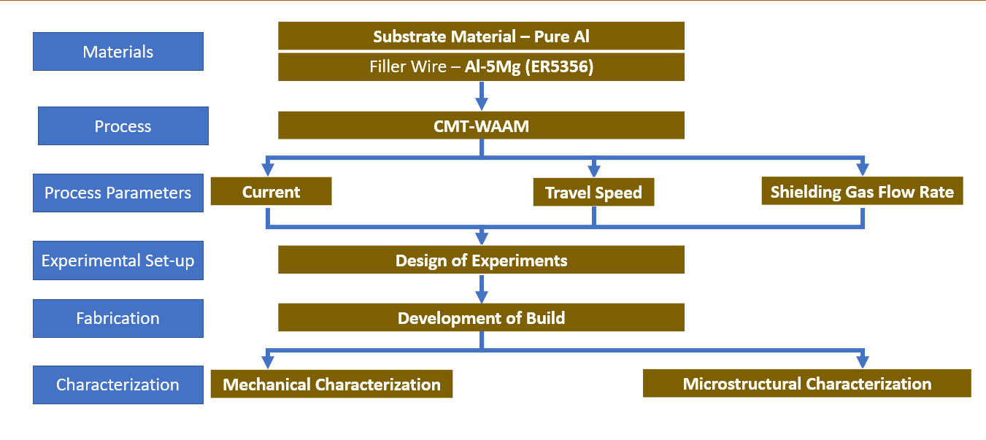

CHAPTER-5
Result and Discussion

5.1 Mechanical properties
Table 5.1 shows the mechanical properties of the three different layers of the CMT WAAMed ER5356 build. UTS refers to the ultimate tensile strength, while YS refers to the yield strength. Fig 5.1, 5.2, and 5.3 shows the stress strain curve of the different three layers of the build. As shown in table 5.1, the UTS, YS and Elongation of the build sample ranges from approximately 244 MPa–257 MPa, 36.65 MPa–55.28 MPa and 30.2%-34.8% respectively. The YS was calculated using 0.2% offset criteria which is based on engineering stress- strain curve. They are founded to be 15148 MPa, 13719 MPa, 13781 MPa for layer 1, 2 and 3 respectively. The UTS, YS and elongation of the different layers of the build are mentioned in the table 4.1 and fig 4.2.
Table 5. 1 Mechanical Properties of different layers
Layer | Maximum Force(KN) | UTS(MPa) | YS(MPa) | Elongation(%) | E(MPa) | Break at Distance(mm)
Layer 1 | 3.25 | 245 | 42.2 | 30.2 | 15148 | 7.56
Layer 2 | 3.58 | 257 | 55.28 | 34.5 | 13719 | 8.63
Layer 4 | 3.58 | 244 | 36.65 | 34.8 | 13781 | 8.69

Figure 5. 1 UTS and YS of different layers

Figure 5. 2 Stress Strain Curve of Layer 1

Figure 5. 3 Stress Strain Curve of Layer 2

Figure 5. 4 Stress Strain Curve of Layer 4

5.2 Corrosion Test
For the corrosion test against salt, brine solution was used to submerge sample. After every 24 hours the weight of the sample was examined to determine the weight reduction. The NaCl brine solution used for corrosion testing, gives favourable results in terms of corrosion resistance. No weight loss has been observed over the period of 30 days. The samples 1 and 2 had been observed after every 24 hours, with no reduction in weight. The weight of the samples remains 1.55g and 1.16g before and after the corrosion test. Therefore no corrosion is found in basic medium.
The weight of the sample 3 and sample 4 used in acidic corrosion test were 0.768g and 0.713g, their surface areas are 3.2823 cm² and 3.1328 cm² respectively. After submerging them in 5% HCl solution, their weight reduces day by day. The corrosion rate is given by the equation 1. Where K is a constant having value of 8.76 x 10⁴, $m_{i}-m_{(i-1)}$ is the change in weight of sample at two instances and $t_{i}-t_{(i-1)}$is the duration between two instances. The readings of the sample submerged in HCl solution is presented in table 3. After conducting experiment for 10 days, the average corrosion rate of same 1 and sample 2 is founded to be 1.4456 x 10⁻³ and 1.2815 x 10⁻³ mm/yr respectively. Therefore the average corrosion rate for the build is found to be 1.36355 x 10⁻³ mm/yr.
$CR=\frac{K.(m_{i}-m_{(i+1)})}{A.{(t}_{i}-t_{(i+1)})}$ (1)

In Basic Medium
Table 5. 2 Corrosion of samples in Basic Medium
Day | Weight of Sample 1 | Weight of Sample 2 | Corrosion rate (CR) of sample 1 (mm/yr.) | Corrosion rate (CR) of sample 2 (mm/yr.)
Day 0 | 1.55 g | 1.16 g | No Weight Loss | No Weight Loss
Day 5 | 1.55 g | 1.16 g | No Weight Loss | No Weight Loss
Day 10 | 1.55 g | 1.16 g | No Weight Loss | No Weight Loss
Day 15 | 1.55 g | 1.16 g | No Weight Loss | No Weight Loss
Day 20 | 1.55 g | 1.16 g | No Weight Loss | No Weight Loss
Day 25 | 1.55 g | 1.16 g | No Weight Loss | No Weight Loss
Day 30 | 1.55 g | 1.16 g | No Weight Loss | No Weight Loss

In Acidic Medium
Table 5. 3 Corrosion of samples in Acidic Medium
Day | Weight of Sample 3 | Weight of Sample 4 | Corrosion rate (CR) of sample 3 (mm/yr.) | Corrosion rate (CR) of sample 4 (mm/yr.)
Day 0 | 0.768 g | 0.713 g | - | -
Day 1 | 0.766 g | 0.711 g | 2.224 x 10⁻³ | 2.330 x 10⁻³
Day 2 | 0.764 g | 0.710 g | 2.224 x 10⁻³ | 1.165 x 10⁻³
Day 3 | 0.763 g | 0.709 g | 1.112 x 10⁻³ | 1.165 x 10⁻³
Day 4 | 0.761 g | 0.708 g | 2.224 x 10⁻³ | 1.165 x 10⁻³
Day 5 | 0.760 g | 0.707 g | 1.112 x 10⁻³ | 1.165 x 10⁻³
Day 6 | 0.759 g | 0.706 g | 1.112 x 10⁻³ | 1.165 x 10⁻³
Day 7 | 0.758 g | 0.705 g | 1.112 x 10⁻³ | 1.165 x 10⁻³
Day 8 | 0.757 g | 0.704 g | 1.112 x 10⁻³ | 1.165 x 10⁻³
Day 9 | 0.756 g | 0.703 g | 1.112 x 10⁻³ | 1.165 x 10⁻³
Day 10 | 0.755 g | 0.702 g | 1.112 x 10⁻³ | 1.165 x 10⁻³
Average CR | - | - | 1.4456 x 10⁻³ | 1.2815 x 10⁻³

5.3 Microhardness
The hardness value distribution in the examined structures is depicted in Figure 10. The samples from different layers and cross-sections were taken for micro-hardness test. The very little variation of hardness value across the structures can be attributed to the heterogeneous microstructure resulting from the thermal fluctuations experienced during the layer-by-layer deposition process. The average hardness values for samples different layers are 74.972 ± 2.642HV, 74.915 ± 2.625HV, 74.822 ± 3.902HV, 73.768 ± 2.862HV and the average hardness values for samples different layer’s cross-sections are 78.156 ± 4.386HV, 76.267 ± 4.497HV, 79.883 ± 3.227HV, 78.503 ± 3.083HV, respectively. Therefore the average hardness of the build was found to be 76.41HV.
Table 5.29 presents the average microhardness values of the layer 1, layer 2, layer 3, and layer 4. Table 5.30 presents the average microhardness values of the cross-sections from layer 1, layer 2, layer 3, and layer 4.

Table 5. 4 Readings of Microhardness for different layers
S.No. | Sample No. 1 (Layer 1) | Sample No. 2 (Layer 2) | Sample No. 3 (Layer 3) | Sample No. 4 (Layer 4)
1. | 77.52 | 74.72 | 76.25 | 70.93
2. | 74.22 | 75.50 | 75.97 | 74.53
3. | 72.33 | 77.54 | 76.14 | 73.44
4. | 74.49 | 73.58 | 75.44 | 75.48
5. | 76.12 | 74.03 | 75.95 | 75.31
6. | 74.49 | 73.09 | 70.92 | 73.11
7. | 75.65 | 75.49 | 72.39 | 73.48
8. | 75.69 | 76.22 | 74.53 | 71.82
9. | 72.77 | 74.33 | 76.54 | 76.63
10. | 76.44 | 74.65 | 74.09 | 72.95
Average Hardness | 74.972 | 74.915 | 74.822 | 73.768

Table 5. 5 Readings of Microhardness for different cross-sections
S.No. | Sample No. 5 (Layer 1) | Sample No. 6 (Layer 2) | Sample No. 7 (Layer 3) | Sample No. 8 (Layer 4)
1. | 80.05 | 79.43 | 79.50 | 78.59
2. | 78.14 | 74.39 | 77.76 | 81.25
3. | 78.61 | 77.30 | 82.28 | 79.57
4. | 78.95 | 71.77 | 83.11 | 80.05
5. | 77.67 | 77.38 | 79.20 | 78.61
6. | 80.43 | 78.09 | 78.63 | 81.35
7. | 75.69 | 75.14 | 80.05 | 77.36
8. | 79.71 | 78.05 | 80.54 | 76.60
9. | 78.54 | 76.61 | 79.93 | 76.23
10. | 73.77 | 74.51 | 77.83 | 75.42
Average Hardess | 78.156 | 76.267 | 79.883 | 78.503

5.4 Optical Microscopy

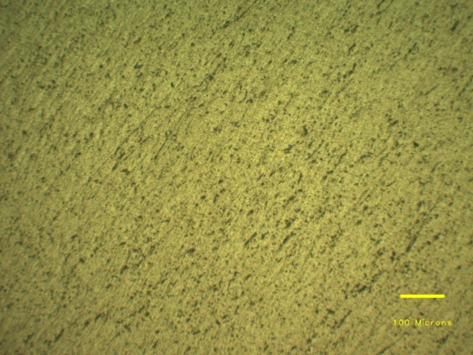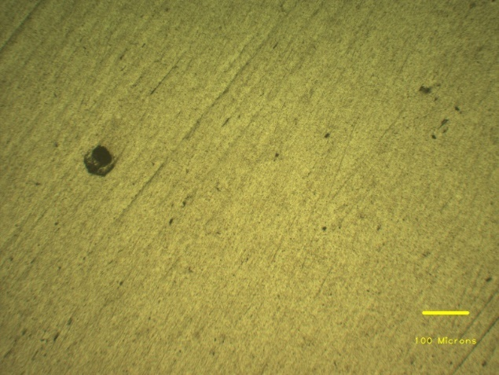
Figure 5. 5 OM of Surface of Layer 1 at 100X Figure 5. 6 OM of Surface of Layer 2 at 100X
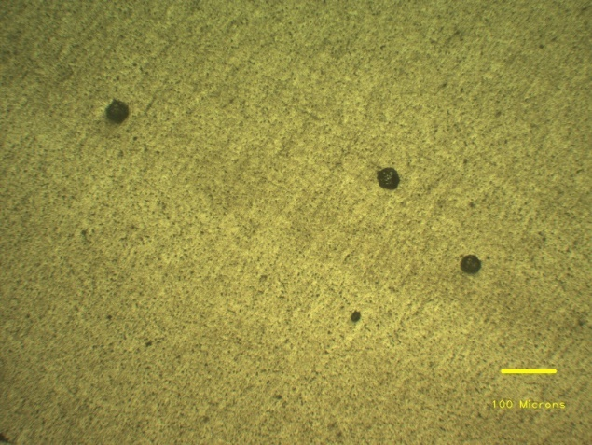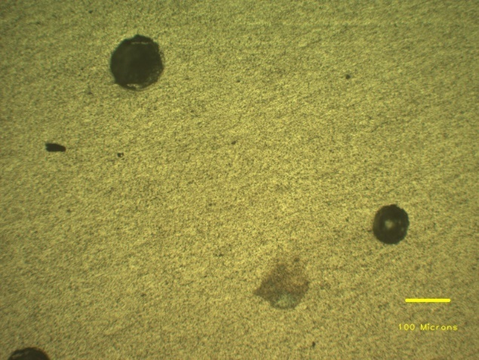
Figure 5. 7 OM of Surface of Layer 3 at 100X Figure 5. 8 OM of Surface of Layer 4 at 100X
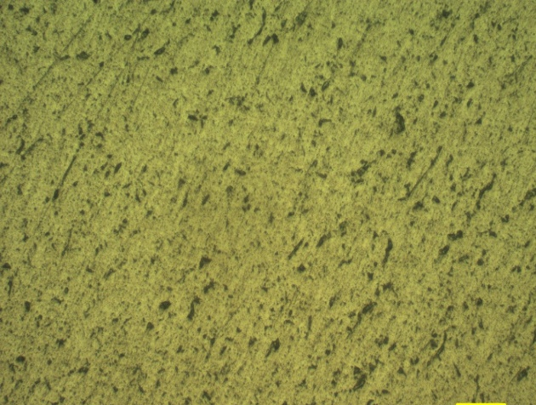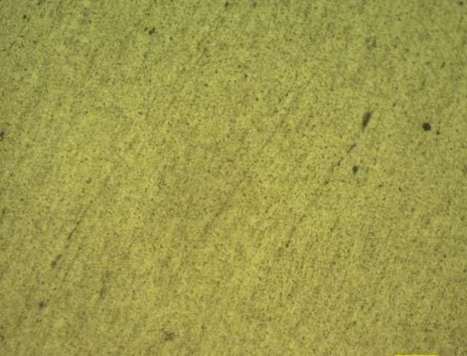
Figure 5. 9 OM of Surface of Layer 1 at 200X Figure 5. 10 OM of Surface of Layer 2 at 200X

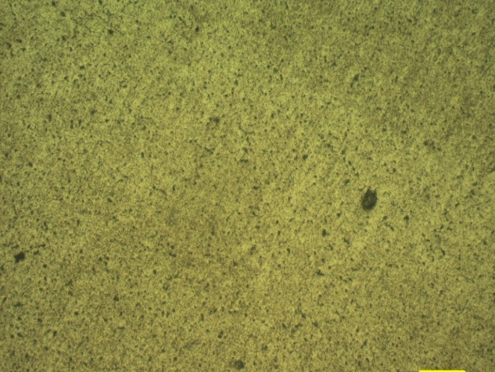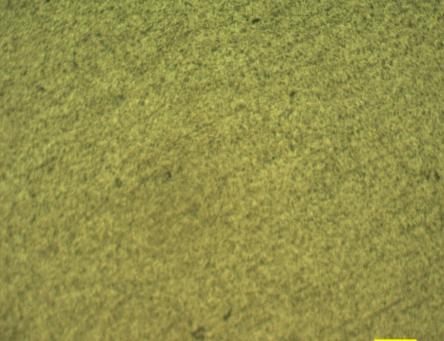
Figure 5. 11 OM of Surface of Layer 3 at 200X Figure 5. 12 OM of Surface of Layer 4 at 200X
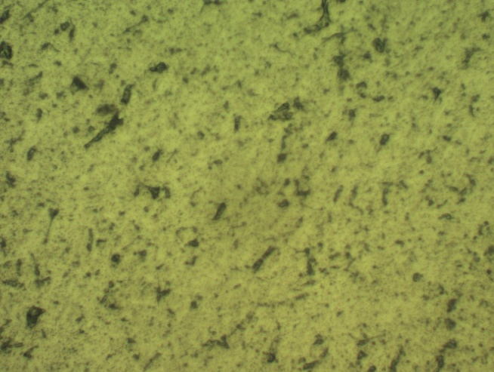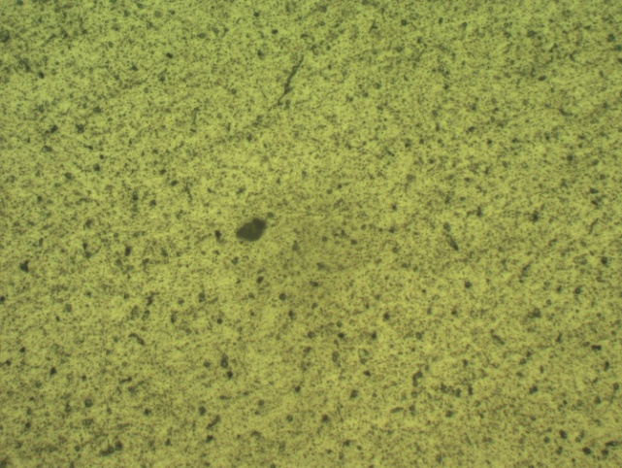
Figure 5. 13 OM of Surface of Layer 1 at 400X Figure 5. 14 OM of Surface of Layer 2 at 400X
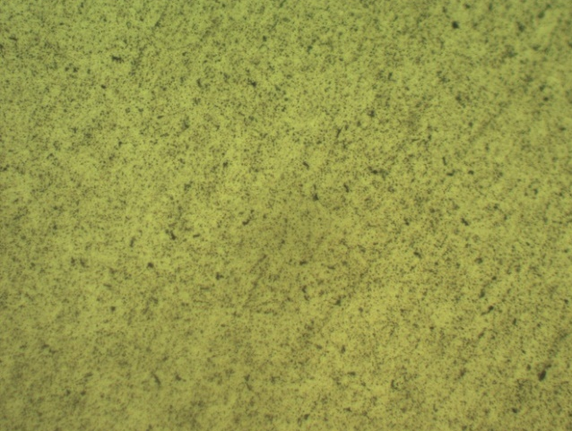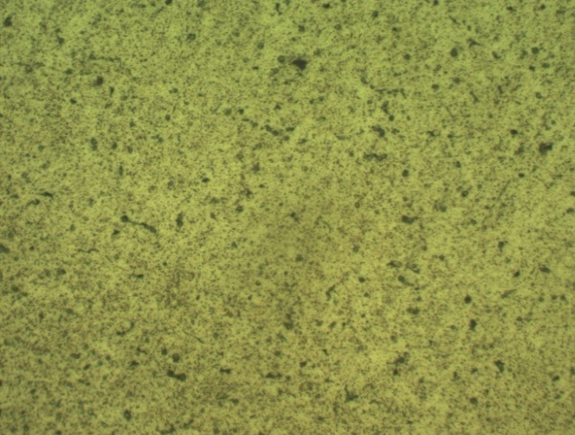
Figure 5. 15 OM of Surface of Layer 3 at 400X Figure 5. 16 OM of Surface of Layer 4 at 400X

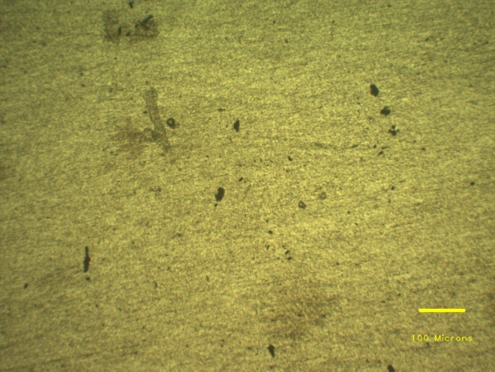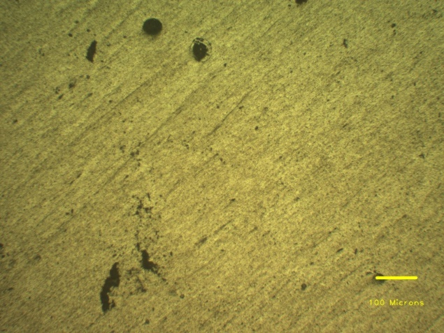
Figure 5. 17 OM of Cross-section of layer 1 at 100X Figure 5. 18 OM of Cross-section of layer 2 at 100X
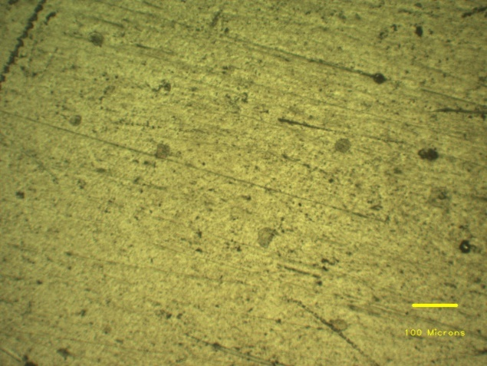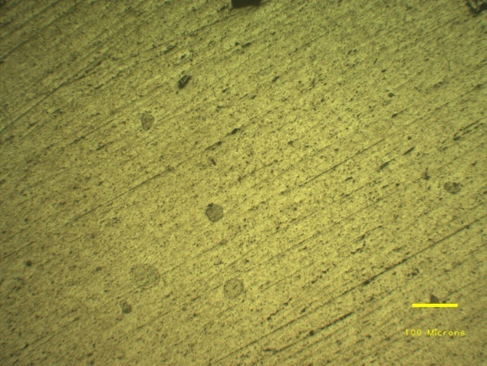
Figure 5. 19 OM of Cross-section of layer 3 at 100X Figure 5. 20 OM of Cross-section of layer 4 at 100X
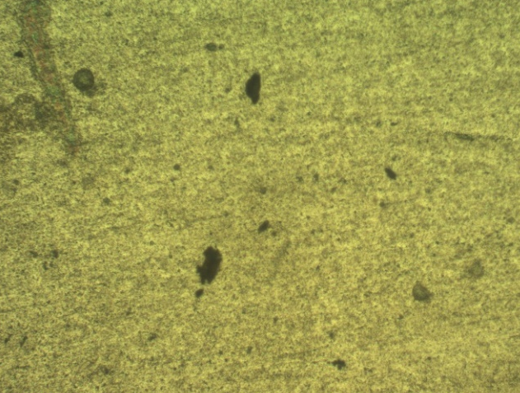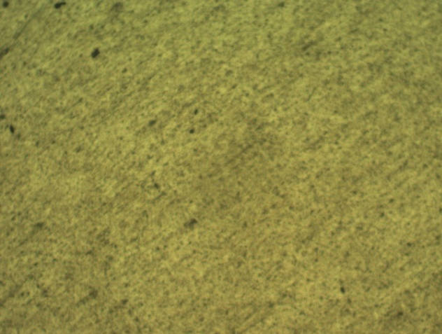
Figure 5. 21 OM of Cross-section of layer 1 at 200X Figure 5. 22 OM of Cross-section of layer 2 at 200X
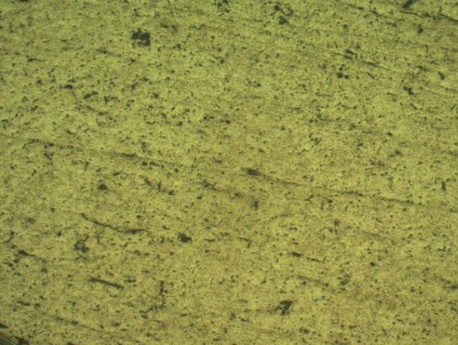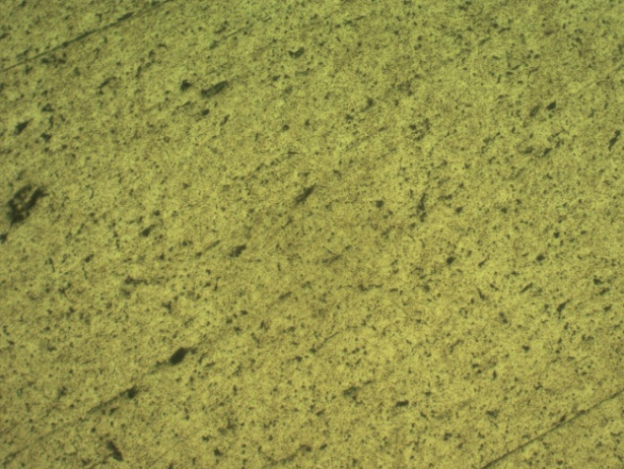
Figure 5. 23 OM of Cross-section of layer 3 at 200X Figure 5. 24 OM of Cross-section of layer 4 at 200X
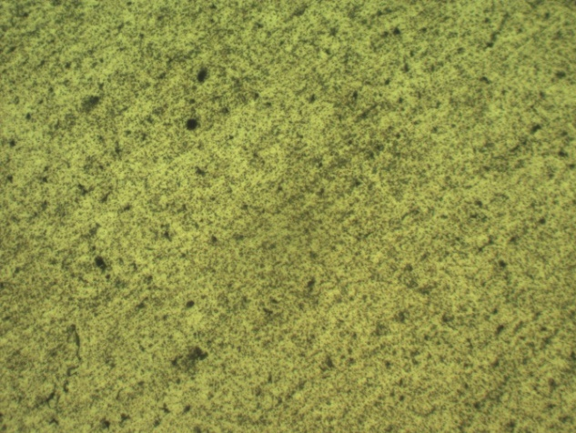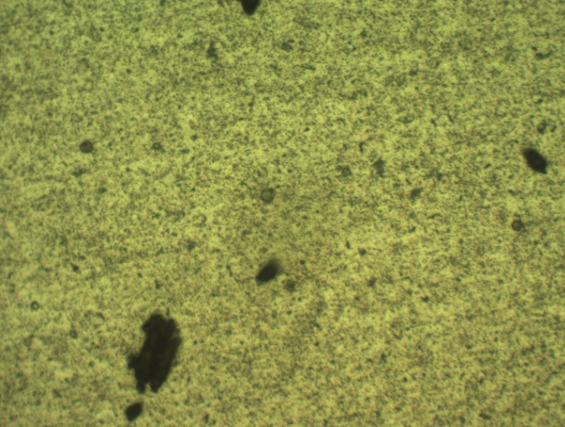
Figure 5. 25 OM of Cross-section of layer 1 at 400X Figure 5. 26 OM of Cross-section of layer 2 at 400X
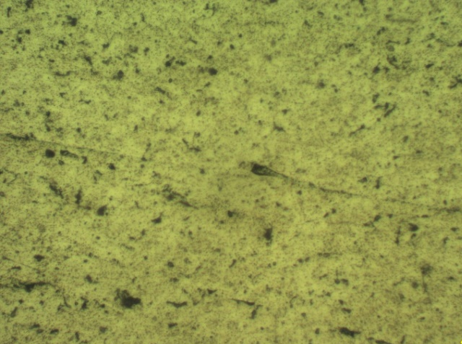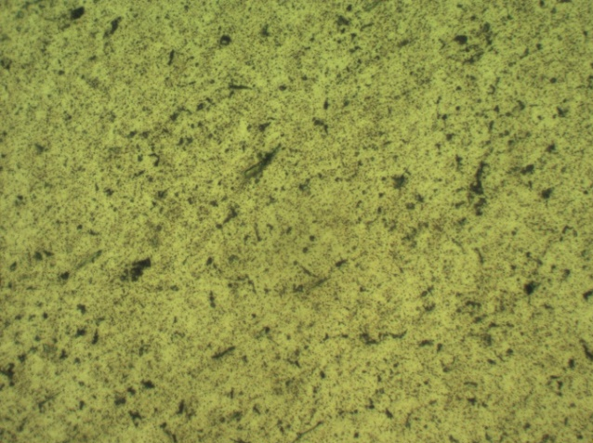
Figure 5. 27 OM of Cross-section of layer 3 at 400X Figure 5. 28 OM of Cross-section of layer 4 at 400X

The layers were initially observed by an optical microscopy and the microstructure of surface of the layers and its cross-section are shown in Figure 5.4-5.27. Aluminum alloys have a high thermal conductivity, therefore the welding heat can quickly spread to HAZ, resulting in the microstructure of this zone being completely different from that of base metal. Pores are the primary defects observed in the as-deposited state of 5356-Al. The distribution of these pores across different layers can be seen in figures 5.5 to 5.16, while their distribution on various cross-sections of the layers is shown in figures 5.17 to 5.28. In thin walls fabricated using CMT WAAM, it has been observed that there are no visible cracks but a significant presence of circular pores. Previous studies by Zhu et al. and Han et al. have shown that these pores found in fusion-welded aluminum alloys are filled with hydrogen, indicating that the pores formed during WAAM are hydrogen-related. The solubility of hydrogen in aluminum differs between its solid and liquid states. During solidification, the solubility of hydrogen decreases. However, in the solidification process of the melt pool, the surface solidifies first, trapping hydrogen in the center of the pool, preventing its escape and leading to the formation of hydrogen pores. Furthermore, the continuous heating of the melt pool causes the grains to grow into coarse crystals. The presence of coarse grain structures hinders the upward movement of hydrogen, resulting in its entrapment within the structure and the development of pores. Hydrogen can originate from various sources, including contaminated wire and substrate. Additionally, hydrogen present in the shielding gas and the surrounding environment can also have an impact on the quality of WAAM products. It is important to address and control the factors contributing to hydrogen absorption and retention during the WAAM process to minimize the occurrence of hydrogen-related pores and ensure the production of high-quality components. Similar distribution characteristics were found to have a detrimental effect on the tensile properties in the vertical direction of 2219-Al in our previous research. Therefore, it is necessary to investigate whether this distribution will also affect the mechanical properties of 5356-Al through subsequent tensile testing. In terms of pore quantities, Sample 1 demonstrates a lower number of pores on its observed surface compared to Sample 2 and Sample 3. This difference can be attributed to the varying deposition parameters employed in fabricating these samples. In the case of Sample 1, a slower deposition velocity was used, resulting in a longer existence of the molten pool. Consequently, this extended duration provides more opportunities for hydrogen to escape, thus reducing the occurrence of pores.

5.5 Fractography
The failure patterns of the tensile tested specimens are characterized by SEM, as shown in Figure 8. It can be also observed that the failure was the result of shear failure
CHAPTER-6
Conclusion
The CMT-WAAM system was utilized to manufacture a component made of Al-Mg alloy. An investigation was conducted to analyze the microstructural features and mechanical properties of both the lower, middle and upper zones of the component. The findings of the study are summarized as follows:
- The CMT-WAAM technique demonstrates excellent suitability for the production of major components using aluminum alloy. The Al-Mg component manufactured through the CMT-WAAM process exhibited minimal significant defects.
- The additively manufactured Al-Mg component displayed similar mechanical properties in the transverse direction, with comparable values of yield strength (YS), ultimate tensile strength (UTS) (45.8 ± 9.48MPa, 250.5 ± 6.5 MPa, respectively). The average hardness of the build was found to be 76.41HV.
- The microstructural variations observed in the deposited beads. A porosity was observed in the sample due to trapping of hydrogen which can be decreased by decreasing the deposition velocity of the build. However, the CMT-based WAAM technique ensures uniform microstructural characteristics in both the lower, middle and upper zones of the Al-Mg component.
- The corrosion rate of the WAAMed samples is observed to be equal to 1.36355 x 10⁻³ mm/yr. in the HCl solution while no weight loss was observed in the NaCl solution.
- The crack propagation in tensile sample was having a shear failure. The images through SEM shown the fractography__________________.

References
1. Ding, D., Pan, Z.,Cuiuri, D.,Li, H., A tool-path generation strategy for wire and arc additive manufacturing. International Journal of Advanced Manufacturing Technology, 2014. 73: p. 173-183.
2. Singh, S., Sharma, S. k.,Rathod, D. W., A review on process planning strategies and challenges of WAAM. Materials Today: Proceedings, 2021. 47: p. 6564-6575.
3. Srinivasan, D., Sevvel, P., Solomon, I.J., Tanushkumaar, P., A review on Cold Metal Transfer (CMT) technology of welding. Materials Today: Proceedings, 2022. 64: p. 108-115.
4. Derekar, K.S., A review of wire arc additive manufacturing and advances in wire arc additive manufacturing of aluminium. Materials Science and Technology, 2018. 34(8): p. 895-916.
5. Girinath, B., Shanmugam, N. S., Sathiyanarayanan, C., Studies on influence of torch orientation on microstructure, mechanical properties and formability of AA5052 CMT welded blanks. Archives of Civil and Mechanical Engineering, 2020. 20(1): p. 15.
6. Liu, G., Zhou,S., Lin,P., Zong,X., and Z. Chen, Zhang,Z., Ren,L., Analysis of microstructure, mechanical properties, and wear performance of NiTi alloy fabricated by cold metal transfer based wire arc additive manufacturing. Journal of Materials Research and Technology, 2022. 20: p. 246-259.
7. Wu, B., Ding,D. , Pan,Z. , Cuiuri,D. , Li,H. , Han,J. , Fei,Z., Effects of heat accumulation on the arc characteristics and metal transfer behavior in Wire Arc Additive Manufacturing of Ti6Al4V. Journal of Materials Processing Technology, 2017. 250: p. 304-312.
8. P. Wang, H.Z., H. Zhu, Q. Li, M. Feng, Wire-arc additive manufacturing of AZ31 magnesium alloy fabricated by cold metal transfer heat source: Processing, microstructure, and mechanical behavior. Journal of Materials Processing Technology, 2021. 288: p. 116895.
9. B. Tomar, S.S., T. Nath, A review on wire arc additive manufacturing: Processing parameters, defects, quality improvement and recent advances. Materials Today Communications, 2022. 31: p. 103739.
10. Gomez Ortega, A., Corona Galvan, L., Deschaux-Beaume, F., Mezrag, B., Rouquette, S., Effect of process parameters on the quality of aluminium alloy Al5Si deposits in wire and arc additive manufacturing using a cold metal transfer process. Science and Technology of Welding and Joining, 2018. 23(4): p. 316-332.
11. G.K. Mohanta, A.K.S., The effect of Welding Parameters on Mild Steel by MMAW. IOP Conference Series: Materials Science and Engineering, 2018. 410(1): p. 012015.
12. S.P. Tewari, A.G., J. Prakash, Effect of welding parameters on the weldability of material. International Journal of Engineering Science and Technology, 2010. 2(4): p. 512-516.
13. Ortega A.G., G.L., Deschaux-Beaume, F., Rouquette S. Effect of welding parameters on the quality of multilayer deposition of aluminum alloy. 2020.
14. Belhadj, M., Kromer, R., Werda, S., Darnis, P., Effect of Cold Metal Transfer-Based Wire Arc Additive Manufacturing parameters on geometry and machining allowance. 2022.
15. Lancaster, J.F., Copyright, in Metallurgy of Welding (Sixth Edition), J.F. Lancaster, Editor. 1999, Woodhead Publishing. p. iv.
16. Xu, X., Ganguly, S., Ding, J., Guo, S., Williams, S., Martina, F., Microstructural evolution and mechanical properties of maraging steel produced by wire+arc additive manufacture process. Materials Characterization, 2018. 143: p. 152-162.
17. Ding, J., Colegrove, P., Martina, F., Williams, S., Wiktorowicz, R., Palt, M. R., Development of a laminar flow local shielding device for wire+arc additive manufacture. Journal of Materials Processing Technology, 2015. 226: p. 99-105.
18. Modenesi, P.J., Nixon, J. H., Arc instability phenomena in GMA welding. Weld. J., 1994. 73(9): p. 219-224.
19. G. Ortega, A., C. Galvan, L., Deschaux-Beaume, F., Mezrag, B., Rouquette, S., Effect of process parameters on the quality of aluminium alloy Al5Si deposits in wire and arc additive manufacturing using a cold metal transfer process. Science and Technology of Welding and Joining, 2018. 23(4): p. 316-332.
20. Tomar, B., Shiva,S., Nath,T., A review on wire arc additive manufacturing: Processing parameters, defects, quality improvement and recent advances. Materials Today Communications, 2022. 31: p. 103739.
21. Wu, B., Pan, Z, Ding, D, Cuiuri, D, Li, H, Xu, J, Norrish, J, A review of the wire arc additive manufacturing of metals: properties, defects and quality improvement. Journal of Manufacturing Processes, 2018. 35: p. 127-139.
22. Srivastava, M., Rathee,S., Patel,V., and A. Kumar, Koppad,P.G., A review of various materials for additive manufacturing: Recent trends and processing issues. Journal of Materials Research and Technology, 2022. 21: p. 2612-2641.
23. Lin, Z., Song,K., Yu,X., A review on wire and arc additive manufacturing of titanium alloy. Journal of Manufacturing Processes, 2021. 70: p. 24-45.
24. Williams, S.W., Martina,F., Addison,A. C., Ding,J., Pardal,G., Colegrove,P., Wire + Arc Additive Manufacturing. Materials Science and Technology, 2016. 32(7): p. 641-647.
25. Ying, G.J.S.J.H.S.T.Y.L., Microstructure and mechanical properties of as-built and heat-treated Ti-6Al-4V alloy prepared by cold metal transfer additive manufacturing. Journal of Manufacturing Processes, 2019. 42: p. 41-50.
26. Jian, T.Y.S.J.H.S.W.Z.G., Microstructure and mechanical properties of wire and arc additive manufactured Ti-6Al-4V and AlSi5 dissimilar alloys using cold metal transfer welding. Journal of Manufacturing Processes, 2019. 46: p. 337-344.
27. Feng, G.J.W.Z.H.S.S.J.L.Z.Y.C.B.Y.L.W., Effect of cold metal transfer mode on the microstructure and machinability of Ti–6Al–4V alloy fabricated by wire and arc additive manufacturing in ultra-precision machining. Journal of Materials Research and Technology, 2022. 21: p. 1581-1594.
28. Xinpeng, Z.S.X.H.N.J.Y.G.Q.L.G., Metal transfer behavior during CMT-based Wire Arc Additive Manufacturing of Ti-6Al-4V alloy. Journal of Manufacturing Processes, 2022. 82: p. 159-173.
29. Benoit, A., Jobez,S., Paillard,P., Klosek,V., Baudin,T., Study of Inconel 718 weldability using MIG CMT process. Science and Technology of Welding and Joining, 2011. 16(6): p. 477-482.
30. Davim, J.P., Oliveira,C., Cardoso,A., Predicting the geometric form of clad in laser cladding by powder using multiple regression analysis (MRA). Materials & Design, 2008. 29(2): p. 554-557.
31. Ola, O.T., Ojo,O.A., Chaturvedi,M.C., Laser arc hybrid weld microstructure in nickel based IN738 superalloy. Materials Science and Technology, 2013. 29(4): p. 426-438.
32. Flemings, M.C., Solidification processing. Metallurgical Transactions, 1974. 5(10): p. 2121-2134.
33. Ojo, O.A., Richards,N.L., Chaturvedi,M.C., Study of the fusion zone and heat-affected zone microstructures in tungsten inert gas-welded INCONEL 738LC superalloy. Metallurgical and Materials Transactions A, 2006. 37(2): p. 421-433.
34. Ola, O.T., Doern,F.E., A study of cold metal transfer clads in nickel-base INCONEL 718 superalloy. Materials & Design, 2014. 57: p. 51-59.
35. Senthil, T.S., Puviyarasan, M., and S. Ramesh Babu, Senthil S., Mechanical characterization of wire arc additive manufactured and cast Inconel 825: A comparative study. Materials Today: Proceedings, 2022. 62: p. 973-976.
36. Luquan, L.G.Z.S.L.P.Z.X.C.Z.Z.Z.R., Analysis of microstructure, mechanical properties, and wear performance of NiTi alloy fabricated by cold metal transfer based wire arc additive manufacturing. Journal of Materials Research and Technology, 2022. 20: p. 246-259.
37. Wang, Y., Chen, X., Shen, Q., Su, C., Zhang, Y., Jayalakshmi, S., Singh, R. A., Effect of magnetic Field on the microstructure and mechanical properties of inconel 625 superalloy fabricated by wire arc additive manufacturing. Journal of Manufacturing Processes, 2021. 64: p. 10-19.
38. Kindermann R. M.; Roy, M.J.M.R.F.J.A., Effects of microstructural heterogeneity and structural defects on the mechanical behaviour of wire + arc additively manufactured Inconel 718 components. Materials Science and Engineering: A, 2022. 839: p. 142826.
39. Ke, Z.M.F.X.W.Y.J.X.C.T.X.N.H., High superelasticity NiTi fabricated by cold metal transfer based wire arc additive manufacturing. Materials Science and Engineering: A, 2022. 840: p. 143001.
40. Wenbin, J.X.D.X.L.C.W.D.H., Improvement of mechanical properties and corrosion resistance for wire arc additive manufactured nickel alloy 690 by adding TiC particles. Journal of Alloys and Compounds, 2022. 928: p. 167198.
41. Rams, J., Wrought Aluminum Alloys, in Encyclopedia of Materials: Metals and Alloys, F.G. Caballero, Editor. 2022, Elsevier: Oxford. p. 132-140.
42. Agrawal, B.K., Introduction to engineering materials. 1988: Tata McGraw-Hill Education.
43. Brice, C., Shenoy,R., Kral,M., Buchannan,K., Precipitation behavior of aluminum alloy 2139 fabricated using additive manufacturing. Materials Science and Engineering: A, 2015. 648: p. 9-14.
44. Tawfik, M.M., Nemat-Alla,M.M., Dewidar,M.M., Enhancing the properties of aluminum alloys fabricated using wire + arc additive manufacturing technique - A review. Journal of Materials Research and Technology, 2021. 13: p. 754-768.
45. Zhou, S., Wu,K., Yang,G., Wu,B., Qin,L., Wu,H., Yang,C., Microstructure and mechanical properties of wire arc additively manufactured 205A high strength aluminum alloy: The comparison of as-deposited and T6 heat-treated samples. Materials Characterization, 2022. 189: p. 111990.
46. Saad, G., Fayek,S.A., Fawzy,A., Soliman,H.N., Mohammed,G., Deformation characteristics of Al-4043 alloy. Materials Science and Engineering: A, 2010. 527(4): p. 904-910.
47. Jicai, L.J.S.Q.L.Y.C.C.F., Cold Metal Transfer Welding–Brazing of Pure Titanium TA2 to Aluminum Alloy 6061-T6 Advanced Engineering Materials, 2017. 19(2): p. 1600494.
48. S., G.O.A.C.G.L.D.-B.F.M.B.R., Effect of process parameters on the quality of aluminium alloy Al5Si deposits in wire and arc additive manufacturing using a cold metal transfer process. Science and Technology of Welding and Joining, 2018. 23(4): p. 316-332.
49. Nie, Y., Zhang, P., Wu, X., Li, G., Yan, H., Yu, Z., Rapid prototyping of 4043 Al-alloy parts by cold metal transfer. Science and Technology of Welding and Joining, 2018. 23(6): p. 527-535.
50. Xizhang Chen; Su Chuanchu; Wang Yangfan; Siddiquee Arshad Noor; Sergey Konovalov; Jayalakshmi, S.S.R.A., Cold Metal Transfer (CMT) Based Wire and Arc Additive Manufacture (WAAM) System. Journal of Surface Investigation: X-ray, Synchrotron and Neutron Techniques, 2018. 12(6): p. 1278-1284.
51. J., R.E.M.S.T.J.W.J.F.W.M., The influence of build parameters and wire batch on porosity of wire and arc additive manufactured aluminium alloy 2319. Journal of Materials Processing Technology, 2018. 262: p. 577-584.
52. Mehdi;, O.A.G.C.G.L.S., M.K.S.S.R. Sébastien;, and D.-B. Frédéric, Characterisation of 4043 aluminium alloy deposits obtained by wire and arc additive manufacturing using a Cold Metal Transfer process. Science and Technology of Welding and Joining, 2019. 24(6): p. 538-547.
53. Bingheng, F.X.Z.L.Y.J.B.H.Z.L.H.K.L., Effect of characteristic substrate parameters on the deposition geometry of CMT additive manufactured Al-6.3%Cu alloy. Applied Thermal Engineering, 2019. 162: p. 114302.
54. Chao;, Z.B.W., W.Z.Z. Laiqi;, and G. Qiang, Microstructure and properties of Al alloy ER5183 deposited by variable polarity cold metal transfer. Journal of Materials Processing Technology, 2019. 267: p. 167-176.
55. S., C.V.J., Fabrication of preferentially oriented Al4043 alloy and its wear anisotropy. Materials Letters, 2020. 280: p. 128578.
56. Gu, J., Yang, S., Gao, M., Bai, J., Liu, K., Influence of deposition strategy of structural interface on microstructures and mechanical properties of additively manufactured Al alloy. Additive Manufacturing, 2020. 34: p. 101370.
57. Giuseppe, C.G.C.D.B.A.F.L.G.N.I., Microstructural, mechanical and energy demand characterization of alternative WAAM techniques for Al-alloy parts production. CIRP Journal of Manufacturing Science and Technology, 2020. 31: p. 492-499.
58. Pramod, R., Kumar, S. M., Girinath, B., Kannan, A. R., Kumar, N. P., Shanmugam, N. S., Fabrication, characterisation, and finite element analysis of cold metal transfer–based wire and arc additive–manufactured aluminium alloy 4043 cylinder. Welding in the World, 2020. 64(11): p. 1905-1919.
59. Sergey, L.K.C.X.S.Q.P.Z.S.R.A.J.S.K., Microstructural evolution and mechanical properties of deep cryogenic treated Cu–Al–Si alloy fabricated by Cold Metal Transfer (CMT) process. Materials Characterization, 2020. 159: p. 110011.
60. Irina;, G.Y.P. and K.S.C.X.I. Yurii, Effect of electron beam energy densities on the surface morphology and tensile property of additively manufactured Al-Mg alloy. Nuclear Instruments and Methods in Physics Research Section B: Beam Interactions with Materials and Atoms, 2021. 498: p. 15-22.
61. A., V.M.P.R.R.K., Wire arc additive manufacturing for repairing aluminium structures in marine applications. Materials Letters, 2021. 299: p. 130112.
62. Rauch, M., Nwankpa, U. V., Hascoet, J.Y., Investigation of deposition strategy on wire and arc additive manufacturing of aluminium components. Journal of Advanced Joining Processes, 2021. 4: p. 100074.
63. Bellamkonda;, P.N., M. Sudersanan;, and B. Visvalingam, Characterisation of Al–Mg Alloy Cylindrical Component Made by Wire Arc Additive Manufacturing Using Cold Metal Transfer Arc Welding Process. Transactions of the Indian Institute of Metals, 2022. 75(8): p. 2019-2030.
64. Chen X., W.X., Huan P., Hu Z., Wu Z., Zhang B., Nagaumi H., Effect of Cold Metal Transfer Mix Synchro-Pulse Process on the Overall Morphology, Microstructure and Mechanical Properties of Wire+ Arc Additively Manufactured AA2219 Alloy. Metals and Materials International, 2023. 29(2): p. 552-563.
65. Tankova, T., Andrade,D., Branco,R., Zhu,C., Rodrigues,D., Silva,L., Characterization of robotized CMT-WAAM carbon steel. Journal of Constructional Steel Research, 2022. 199: p. 107624.
66. Simmons, J.W., Overview: High-nitrogen alloying of stainless steels. Materials Science and Engineering A, 1996. 207(2): p. 159-169.
67. He, S., Yang,D., Huang,Y., Wang,K., Effect of the current waveform on the droplet transfer in CMT welding high-nitrogen steel. Journal of Manufacturing Processes, 2022. 75: p. 41-48.
68. Evans, S.I., Wang,J., Qin,J., He,Y., Shepherd,P., Ding,J., A review of WAAM for steel construction – Manufacturing, material and geometric properties, design, and future directions. Structures, 2022. 44: p. 1506-1522.
69. Buchanan, C., Wan,W., Gardner,L. Testing of wire and arc additively manufactured stainless steel material and cross-sections. in Ninth Int. Conf. on Advances in Steel Structures (ICASS2018), 5–7 December, Hong Kong, China. 2018.
70. Buchanan, C., Gardner,L., Metal 3D printing in construction: A review of methods, research, applications, opportunities and challenges. Engineering Structures, 2019. 180: p. 332-348.
71. Cai, H., Xu, L., Zhao, L., Han, Y., Pang, H., Chen, W., Cold metal transfer plus pulse (CMT+P) welding of G115 steel: Mechanisms, microstructure, and mechanical properties. Materials Science and Engineering: A, 2022. 843: p. 143156.
72. A., G.J.R.I.P.-C.J.L.D.J.L.P., Additive manufacturing with GMAW welding and CMT technology. Procedia Manufacturing, 2017. 13: p. 840-847.
73. Kerstin;, P.G.C. and C. Harald, Material properties of CMT—metal additive manufactured duplex stainless steel blade-like geometries. Welding in the World, 2017. 61(5): p. 873-882.
74. Rodriguez, N., Vázquez, L., Huarte, I., Arruti, E., Tabernero, I., Alvarez, P., Wire and arc additive manufacturing: a comparison between CMT and TopTIG processes applied to stainless steel. Welding in the World, 2018. 62(5): p. 1083-1096.
75. R., R.G.P.K.M.B.S., Effect of correction parameters on deposition characteristics in cold metal transfer welding. Materials and Manufacturing Processes, 2019. 34(11): p. 1205-1216.
76. Wang, C., Liu, T. G., Zhu, P., Lu, Y. H., Shoji, T., Study on microstructure and tensile properties of 316L stainless steel fabricated by CMT wire and arc additive manufacturing. Materials Science and Engineering: A, 2020. 796: p. 140006.
77. Akshay;, L.T.J. and J.Y.S.H.W.T.H.H.Q.A. Jawad, Concurrent geometry- and material-based process identification and optimization for robotic CMT-based wire arc additive manufacturing. Materials & Design, 2020. 194: p. 108841.
78. M.;, C.S.C.M.C. and B.W.L.m. P., 3D heat transfer, fluid flow and electromagnetic model for cold metal transfer wire arc additive manufacturing (Cmt-Waam). Additive Manufacturing, 2020. 36: p. 101541.
79. Sihua, Z.B.L.J.L.Y.Z.Y.S.Q.C., Additively manufactured δ-ferrite-free 410 stainless steel with desirable performance. Materials Letters, 2021. 293: p. 129579.
80. Zhong, Y., Zheng, Z., Li, J., Wang, C., Fabrication of 316L nuclear nozzles on the main pipeline with large curvature by CMT wire arc additive manufacturing and self-developed slicing algorithm. Materials Science and Engineering: A, 2021. 820: p. 141539.
81. Kehong, C.J.W.H.Z.X.P.Y.K.J.W., Flow behavior and microstructure evolution during dynamic deformation of 316 L stainless steel fabricated by wire and arc additive manufacturing. Materials & Design, 2021. 198: p. 109325.
82. V., S.T.S.R.B.S.P.M.D., Mechanical and microstructural characterization of functionally graded Inconel 825 - SS316L fabricated using wire arc additive manufacturing. Journal of Materials Research and Technology, 2021. 15: p. 661-669.
83. Xinqiang;, Y.Z.Z.Y.J.F.C.S.L.F.C.W.M., Metal transfer behaviour of CMT-based step-over deposition in fabricating slant features. Journal of Manufacturing Processes, 2021. 71: p. 147-155.
84. Xia, H.P.-C.W.X.-N.Z.Q.-Y.D.H.-S.C.X.-M.C.Y.W., Study on droplet transition behavior, bead geometric characteristics and formability of wire + arc additively manufactured Inconel 718 alloy by using CMT MIX+ Synchropulse process. Journal of Materials Research and Technology, 2022. 17: p. 1831-1841.
85. S.;, K.Y.A. and R.P. V., Influence of heat input on the evolution of δ-ferrite grain morphology of SS308L fabricated using WAAM-CMT. Materials Characterization, 2022. 194: p. 112363.
86. V., N.B.P.M.S.B., Mechanical properties and microstructural characteristics of wire arc additive manufactured 308 L stainless steel cylindrical components made by gas metal arc and cold metal transfer arc welding processes. Journal of Materials Processing Technology, 2022. 307: p. 117655.
87. Luca, P.P.C.C.A.R.S.A.S., Effects of deposition parameters on cumulative energy demand for Cold Metal Transfer additive manufacturing processes. CIRP Annals, 2022. 71(1): p. 17-20.
88. L., Z.T.Z.S.W.Z.Y.Z.C.H.Z.D.X.W.N.W.W.C., Cavitation erosion/corrosion synergy and wear behaviors of nickel-based alloy coatings on 304 stainless steel prepared by cold metal transfer. Wear, 2022. 510-511: p. 204510.
89. Koli, Y., Arora, S., Ahmad, S., Priya, Y. N., Khan, Z.A., Investigations and Multi-response Optimization of Wire Arc Additive Manufacturing Cold Metal Transfer Process Parameters for Fabrication of SS308L Samples. Journal of Materials Engineering and Performance, 2023. 32(5): p. 2463-2475.
90. Panchenko, O., Kladov, I., Kurushkin, D., Zhabrev, L., Ryl'kov, E., Zamozdra, M., Effect of thermal history on microstructure evolution and mechanical properties in wire arc additive manufacturing of HSLA steel functionally graded components. Materials Science and Engineering: A, 2022. 851: p. 143569.
91. Song, J., Chen,J., Xiong,X., Peng,X., Chen,D., Pan,F., Research advances of magnesium and magnesium alloys worldwide in 2021. Journal of Magnesium and Alloys, 2022. 10(4): p. 863-898.
92. Yi, H., Wang,Q., Cao,H., Wire-arc directed energy deposition of magnesium alloys: microstructure, properties and quality optimization strategies. Journal of Materials Research and Technology, 2022. 20: p. 627-649.
93. Xu, T., Yang,Y., Peng,X., Song,J., Pan,F., Overview of advancement and development trend on magnesium alloy. Journal of Magnesium and Alloys, 2019. 7(3): p. 536-544.
94. Yang, Y., Xiong,X., Chen,J., Peng,X., Chen,D., Pan,F., Research advances in magnesium and magnesium alloys worldwide in 2020. Journal of Magnesium and Alloys, 2021. 9(3): p. 705-747.
95. Luo, K., Zhang,L., Wu,G., Liu,W., Ding,W., Effect of Y and Gd content on the microstructure and mechanical properties of Mg–Y–RE alloys. Journal of Magnesium and Alloys, 2019. 7(2): p. 345-354.
96. Zhang, X., Chen,Y., Hu,J., Recent advances in the development of aerospace materials. Progress in Aerospace Sciences, 2018. 97: p. 22-34.
97. Yuan, T., Luo,Z., Kou,S., Grain refining of magnesium welds by arc oscillation. Acta Materialia, 2016. 116: p. 166-176.
98. Chaturvedi, V., Sharma,A., Pandel,U., Effect of mechanical vibrations on grain refinement of AZ91 Mg alloy. Materials Research Express, 2017. 4(4): p. 046501.
99. Taltavull, C., Torres,B., López,A.J., Rodrigo,P., Otero,E., Rams,J., Selective laser surface melting of a magnesium-aluminium alloy. Materials Letters, 2012. 85: p. 98-101.
100. Pu, Z., Outeiro,J.C., Batista,A.C., Dillon,O.W., Puleo,D.A., Jawahir,I.S., Enhanced surface integrity of AZ31B Mg alloy by cryogenic machining towards improved functional performance of machined components. International Journal of Machine Tools and Manufacture, 2012. 56: p. 17-27.
101. Hu, S., Zhang,H., Wang,Z., Liang,Y., Liu,Y., The arc characteristics of cold metal transfer welding with AZ31 magnesium alloy wire. Journal of Manufacturing Processes, 2016. 24: p. 298-306.
102. Shengsun;, B.J.S.J.H. and Z.Y.Y.F.B. Xianzheng, Microstructure and mechanical properties of AZ91 Mg alloy fabricated by cold metal transfer additive manufacturing. Materials Letters, 2020. 276: p. 128185.
103. Fencheng;, Y.X.L.J.W.Z.L.X.L. and H.W.L. Enquan, Microstructure and mechanical properties of wire and arc additive manufactured AZ31 magnesium alloy using cold metal transfer process. Materials Science and Engineering: A, 2020. 774: p. 138942.
104. Hanzheng;, W.P.Z. and Z.H.L.Q.F. Mengnan, Wire-arc additive manufacturing of AZ31 magnesium alloy fabricated by cold metal transfer heat source: Processing, microstructure, and mechanical behavior. Journal of Materials Processing Technology, 2021. 288: p. 116895.
105. Geng, Y., Panchenko,I., Konovalov,S., Chen,X., Ivanov,Y., Effect of electron beam energy densities on the surface morphology and tensile property of additively manufactured Al-Mg alloy. Nuclear Instruments and Methods in Physics Research Section B: Beam Interactions with Materials and Atoms, 2021. 498: p. 15-22.
106. Zhang, M., Fang, X., Wang, Y., Jiang, X., Chang, T., Xi, N., Huang, K., High superelasticity NiTi fabricated by cold metal transfer based wire arc additive manufacturing. Materials Science and Engineering: A, 2022. 840: p. 143001.
107. Bai, J.Y., Yang, C.L., Lin, S.B., Dong, B.L., Fan, C. L., Mechanical properties of 2219-Al components produced by additive manufacturing with TIG. The International Journal of Advanced Manufacturing Technology, 2016. 86(1): p. 479-485.
108. Zhang, C., Gao, M., Zeng, X., Effect of microstructural characteristics on high cycle fatigue properties of laser-arc hybrid welded AA6082 aluminum alloy. Journal of Materials Processing Technology, 2016. 231: p. 479-487.
109. Prasanna Nagasai, B., Malarvizhi, S., Balasubramanian, V., Characterisation of Al–Mg Alloy Cylindrical Component Made by Wire Arc Additive Manufacturing Using Cold Metal Transfer Arc Welding Process. Transactions of the Indian Institute of Metals, 2022. 75(8): p. 2019-2030.
110. Zhu, B., Lin, J., Lei, Y., Zhang, Y., Sun, Q., Cheng, S., Additively manufactured δ-ferrite-free 410 stainless steel with desirable performance. Materials Letters, 2021. 293: p. 129579.
111. Tian, Y., Shen, J., Hu, S., Wang, Z., Gou, J., Microstructure and mechanical properties of wire and arc additive manufactured Ti-6Al-4V and AlSi5 dissimilar alloys using cold metal transfer welding. Journal of Manufacturing Processes, 2019. 46: p. 337-344.
112. Bi, J., Shen, J., Hu, S., Zhen, Y., Yin, F., Bu, X., Microstructure and mechanical properties of AZ91 Mg alloy fabricated by cold metal transfer additive manufacturing. Materials Letters, 2020. 276: p. 128185.
113. Lehmann, T., Jain, A., Jain, Y., Stainer, H., Wolfe, T., Henein, H., Qureshi, A. J., Concurrent geometry- and material-based process identification and optimization for robotic CMT-based wire arc additive manufacturing. Materials & Design, 2020. 194: p. 108841.
114. Kindermann, R.M., Roy, M. J., Morana, R., Francis, J. A., Effects of microstructural heterogeneity and structural defects on the mechanical behaviour of wire + arc additively manufactured Inconel 718 components. Materials Science and Engineering: A, 2022. 839: p. 142826.
115. Koli, Y., Aravindan, S., Rao, P. V., Influence of heat input on the evolution of δ-ferrite grain morphology of SS308L fabricated using WAAM-CMT. Materials Characterization, 2022. 194: p. 112363.
116. Mao, C., Liu, C., Yu, L., Li, H., Liu, Y., Discontinuous lath martensite transformation and its relationship with annealing twin of parent austenite and cooling rate in low carbon RAFM steel. Materials & Design, 2021. 197: p. 109252.
117. Wang, P., Hu, S., Shen, J., Liang, Y., Characterization the contribution and limitation of the characteristic processing parameters in cold metal transfer deposition of an Al alloy. Journal of Materials Processing Technology, 2017. 245: p. 122-133.
118. Elrefaey, A., Effectiveness of cold metal transfer process for welding 7075 aluminium alloys. Science and Technology of Welding and Joining, 2015. 20: p. 280-285.
119. Liu, Y.B., Sun, Q., Sang, H.B., Feng, J.C., Microstructure and mechanical properties of cold metal transfer welded aluminium/nickel lap joints. Science and Technology of Welding and Joining, 2015. 20: p. 1362171815Y.000.
120. Lin, J., Ma, N., Lei, Y., Murakawa, H., Shear strength of CMT brazed lap joints between aluminum and zinc-coated steel. Journal of Materials Processing Technology, 2013. 213: p. 1303-1310.
121. Almeida, P.M.S., Williams, S.W. INNOVATIVE PROCESS MODEL OF TI-6 AL-4 V ADDITIVE LAYER MANUFACTURING USING COLD METAL TRANSFER ( CMT ). 2010.
122. Baufeld, B., Brandl, E.,van der Biest, O.,, Wire based additive layer manufacturing: Comparison of microstructure and mechanical properties of Ti–6Al–4V components fabricated by laser-beam deposition and shaped metal deposition. Journal of Materials Processing Technology, 2011. 211(6): p. 1146-1158.
123. Colegrove, P., Donoghue, J.,Martina, F.,Gu, J.,Prangnell, P.,Hönnige, J.,, Application of bulk deformation methods for microstructural and material property improvement and residual stress and distortion control in additively manufactured components. Scripta Materialia, 2017. 135: p. 111-118.
124. Huang, J., Ye, X.,Xu, Z.,, Effect of Cold Rolling on Microstructure and Mechanical Properties of AISI 301LN Metastable Austenitic Stainless Steels. Journal of Iron and Steel Research, International, 2012. 19(10): p. 59-63.
125. Martina, F., Colegrove, P.,Williams, S W.,Meyer, J.,, Microstructure of Interpass Rolled Wire + Arc Additive Manufacturing Ti-6Al-4V Components. Metallurgical and Materials Transactions A, 2015. 46(12): p. 6103-6118.
126. Martina, F. and M. Roy, Paul C, SWW.,. Residual Stress Reduction in High Pressure Interpass Rolled. in Solid Freeform Fabrication Proceedings. 2014.
127. S., W., Wire + arc additive manufacture, in https://waammat.com/documents. 2017.
128. Wu, B., Pan, Z.,Ding, D.,Cuiuri, D.,Li, H.,Fei, Z.,, The effects of forced interpass cooling on the material properties of wire arc additively manufactured Ti6Al4V alloy. Journal of Materials Processing Technology, 2018. 258: p. 97-105.
129. Cheng, X., Fisher, J W.,Prask, H J.,Gnäupel-Herold, T.,Yen, Ben T. and S. Roy, Residual stress modification by post-weld treatment and its beneficial effect on fatigue strength of welded structures. International Journal of Fatigue, 2003. 25(9): p. 1259-1269.
130. Li, G., Qu, S.,Xie, M.,Li, X.,, Effect of ultrasonic surface rolling at low temperatures on surface layer microstructure and properties of HIP Ti-6Al-4V alloy. Surface and Coatings Technology, 2017. 316: p. 75-84.
131. Malaki, M., Ding, H.,, A review of ultrasonic peening treatment. Materials & Design, 2015. 87: p. 1072-1086.
132. Xu, N., Shen, J.,Hu, S.,Li, T.,Tian, Y.,Sun, C.,, Effect of ultrasonic peening treatment on microstructure and properties of CMT additive-manufactured Ti6Al4V/Al6.21Cu dissimilar alloys with Nb interlayer. Materials Letters, 2022. 308: p. 131179.

THANK YOU

