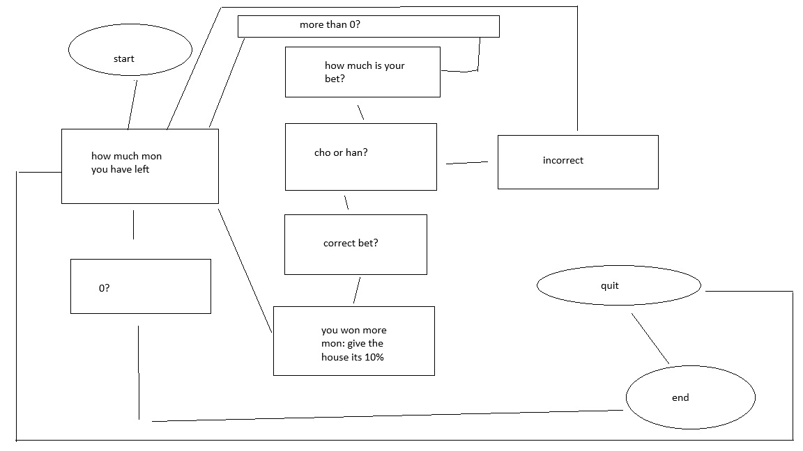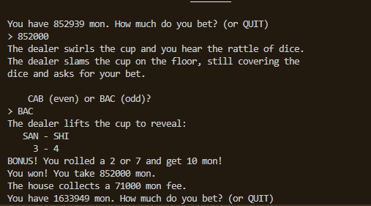
I got seriously lucky I lost all of it immediately after this screenshot was taken but I enjoyed this assignment.

