Shear4 dataset
ACP_plot
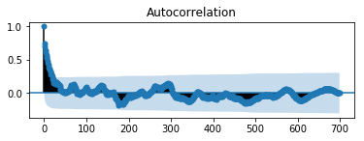

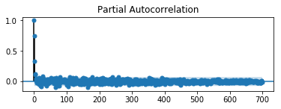
PACF_plot

to check the performance of the ARIMA model on the data, a good check is to review residual forecast errors. In an ideal time series or statistical world, residual errors should be Gaussian with unity meriance. However, we checked by plotting a histogram plot and came up with figure...

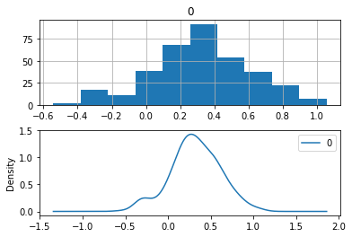

although the plot is Gaussian-like distribution with a long tail, we see that the prediction is biased. Furthert o uncover and improve the model, a power-based transform of the raw data before modeling might be useful
Since we are having bias in our prediction, it is also a good practice to check for any kind of autocorrelation in the residual errors. For data modeling, it would suggest that the model has opportunity to model temporal structures.
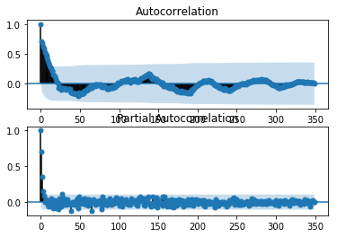

The result from the figure above is similar to fig… meaning that the autocorrelation in the data has been captured by ARIMA model.
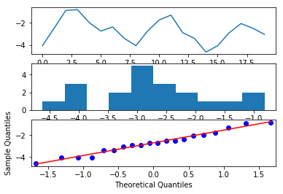

The prediction
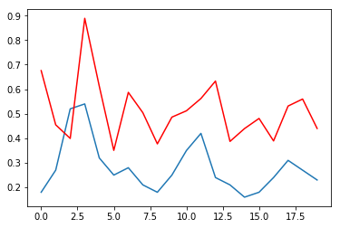
RMSE = 35%
pdq = (0,0,2)

pdq = (0,0,1)

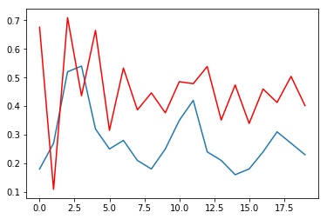

(0,0,1)
MAE

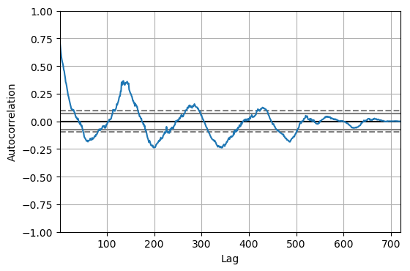
when you gave dataset as above, what do you?

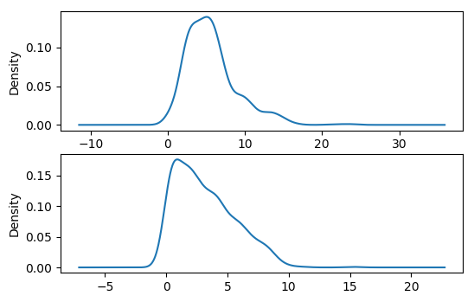

Comapring the Min and Max wind speed at Hiegth 49m using density_plot
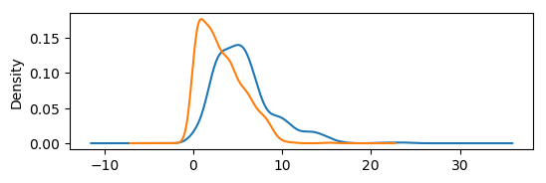
The mean windspeed at H49 and its SD wind speed Data

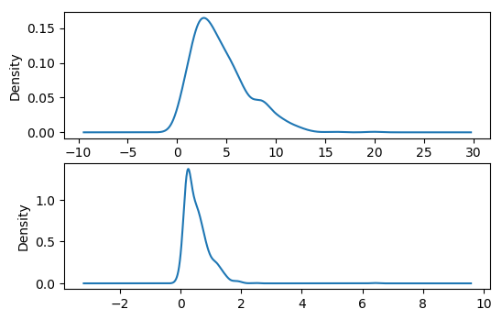
Data Analysis on shear1
used usable to select data that has the datacolumns and values that are not hiegths of the Turbine
filtered out the Mean49 to check the average wind speed
count 720.000000
mean 4.409764
std 2.801777
min 0.350000
25% 2.290000
50% 3.835000
75% 5.887500
max 19.970000

with Max wind speed upto 19.97, I see it as an outlier so I have to filter it out using print((usable.Mean49 <= 10.96).describe()) and I got
#
Name: Mean49, dtype: float64
count 720
unique 2
top True
freq 704
from here, we were able to say that 14 of the data points are outliers and 2 are of the same value, 19.97

