

ELS STUDY BUDDY DATABASE

Ozan Umut Güney, 200302109

Ethem Kesim, 210302205

Emre Çubuk, 220302393

Contents

1. **Project Overview** 1

**2. Methodology** 2

2.1 Tables 2

2.2 Relationships 5

2.3 Er Diagram 5

**3. Conclusion** 6

## 1. **Project Overview**

The ELS Study Buddy Database is designed to manage and organize the resources, classrooms, language levels, professors, students, and tutors associated with an English Language School (ELS). The database comprises several tables, each serving a specific purpose within the school's ecosystem.

## **2. Methodology**

### 2.1 Tables

1. books

Purpose: To store information about the books used in the study programs.

Columns:

* book_id (int, Primary Key): Unique identifier for each book.
* title (varchar(100)): Title of the book.
* language_level_id (int, Foreign Key): References the language level associated with the book.

metin, yazı tipi, ekran görüntüsü, makbuz içeren bir resim

Yapay zeka tarafından oluşturulan içerik yanlış olabilir.

1. classrooms

* Purpose: To store details about the classrooms available for use.
* Columns:
* classroom_id (int, Primary Key): Unique identifier for each classroom.
* capacity (int): The capacity of the classroom in terms of student accommodation.

metin, yazı tipi, ekran görüntüsü, çizgi içeren bir resim

Yapay zeka tarafından oluşturulan içerik yanlış olabilir.

1. languagelevel

* Purpose: To define the different language proficiency levels.
* Columns:
* language_level_id (int, Primary Key): Unique identifier for each language level.
* level_name (varchar(100)): Name or description of the language level (e.g., Beginner, Intermediate, Advanced).

metin, yazı tipi, ekran görüntüsü, çizgi içeren bir resim

Yapay zeka tarafından oluşturulan içerik yanlış olabilir.

1. professors

* Purpose: To store information about the professors teaching at the school.
* Columns:
* professor_id (int, Primary Key): Unique identifier for each professor.
* FirstName (varchar(100)): First name of the professor.
* MiddleName (varchar(100)): Middle name of the professor.
* LastName (varchar(100)): Last name of the professor.
* Email (varchar(100)): Email of professor.
* Phone (varchar(100)): Phone of professor.
* Adress (varchar(100)): Adress of professor.

metin, ekran görüntüsü, yazı tipi, sayı, numara içeren bir resim

Yapay zeka tarafından oluşturulan içerik yanlış olabilir.

1. students

* Purpose: To store information about the students enrolled in the school.
* Columns:
* student_id (int, Primary Key): Unique identifier for each student.
* FirstName (varchar(100)): First name of the student.
* MiddleName (varchar(100)): Middle name of the student.
* LastName (varchar(100)): Last name of the student.
* Email (varchar(100)): Email of student.
* Phone (varchar(100)): Phone of student.
* Address (varchar(100)): Address of student.
* language_level_id (int, Foreign Key): References the language level associated with the students.

metin, ekran görüntüsü, yazı tipi, sayı, numara içeren bir resim

Yapay zeka tarafından oluşturulan içerik yanlış olabilir.

1. tutors

* Purpose: To store information about the tutors who assist students with their studies.
* Columns:
* tutor_id (int, Primary Key): Unique identifier for each tutor.
* FirstName (varchar(100)): First name of the tutor.
* MiddleName (varchar(100)): Middle name of the tutor.
* LastName (varchar(100)): Last name of the tutor.
* Email (varchar(100)): Email of tutor.
* Phone (varchar(100)): Phone of tutor.
* Address (varchar(100)): Address of tutor.
* language_level_id (int, Foreign Key): References the language level associated with the tutors.

**metin, ekran görüntüsü, yazı tipi, sayı, numara içeren bir resim

Yapay zeka tarafından oluşturulan içerik yanlış olabilir.**

### 2.2 Relationships

* The books table is related to the languagelevel table through the language_level_id.
* The professors table is related to the languagelevel table through the language_level_id.
* The students table is related to the languagelevel table through the language_level_id.
* The tutors table is related to the languagelevel table through the language_level_id.

### 2.3 Er Diagram

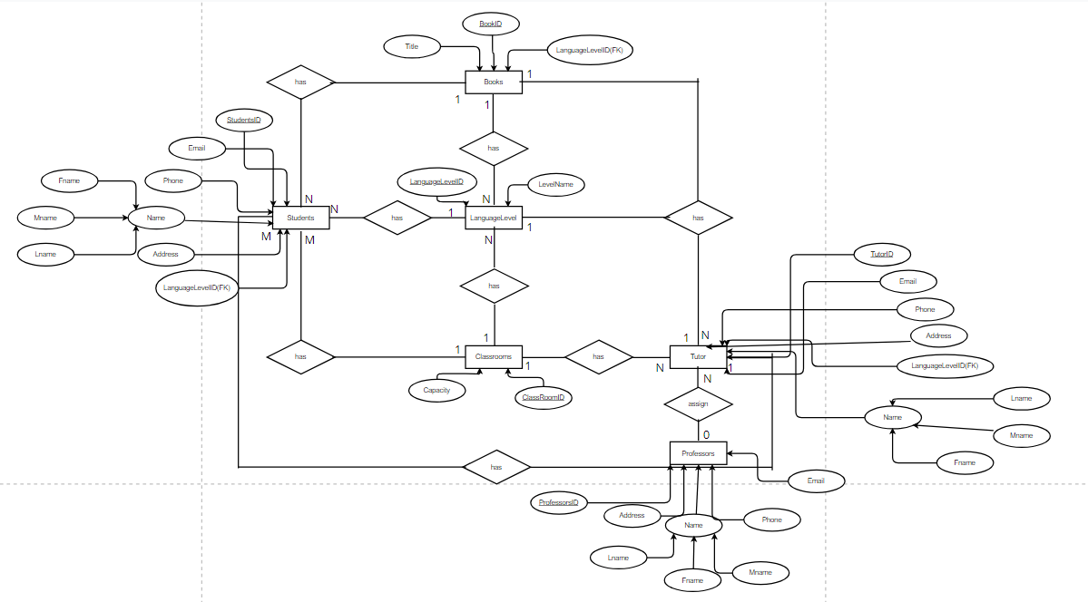

## **3. Conclusion**

This database schema helps in managing the educational resources efficiently, organizing classroom allocations, and tracking both student progress and professor and tutor assignments within the IUS English Language School.