Operating System Project03 Report

生機碩一 R09631007 吳乙澤

1. **Motivation**
   1. **The Problem**

The goal of project number three is to run the /test/matmult.c and /test/sort.c concurrently, get the correct result, and don’t use the method that simply modify the memory size in machine.h. Before dealing with the memory management problem, I run the malmult.c and sort.c firstly. Look at the following figures, I get assertion failed and Aborted (core dumped) error message. I need to use memory management methods to make the two programs output correct answers, 7220 and 1.

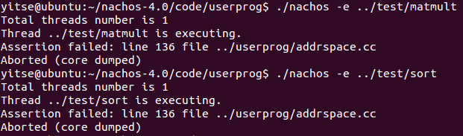



Assertion failed and Aborted (core dumped) error

* 1. **My plan to deal with the problem**

I plan to use the documents from the teaching assistant, google browser, and OS textbook to make virtual memory management and implement FIFO algorithm to do page replacement. The below URL I found, including GitHub and personal blogs, can help me complete the project.

1. <https://hackmd.io/@2xu_sb9JT2KDaAH-UKS7PA/rkhnLKuuP#/>
2. <https://github.com/lyctw/OS2018_NachOS/blob/master/Lab3_Memory_management/README.md>
3. <https://github.com/srijanshetty/nachos-memory-management>
4. <http://140.118.125.216/homework/99/OS/homework/homework3/B9715053-hw3-1/random.html>
5. <http://neuron.csie.ntust.edu.tw/homework/99/OS/homework/homework3/A9715020_hw3-1/the4.htm>
6. <http://neuron.csie.ntust.edu.tw/homework/99/OS/homework/homework3/B9732005-hw3-1/focus.html>
7. **Implementation**
   1. **The way I implement to solve the problem**

According to the documents, in order to make NachOS support virtual memory function, I modify the codes in machine and usrprog folder. I changed some code files, including userkernel.h, userkernel.cc, machine.h, addrspace.h, addrspace.cc, translate.h and translate.cc to implement virtual memory management.

* 1. **Important code segments and comments**

Look at the following figures, the figures show some code segments. I add a new variable named vm_Disk in Userkernel.h to store extra pages. Then, modify machine.h, addrspace.h and addrspace.cc to solve the main memory lack problem.

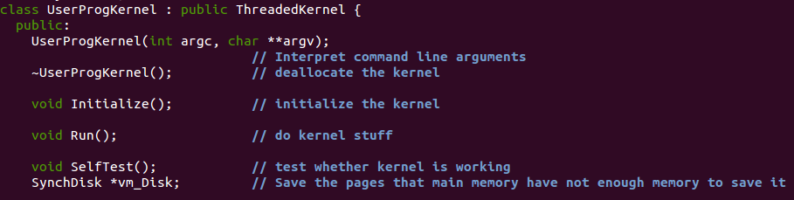  
userkernel.h

After adding virtual memory, I revise translate.cc to implement FIFO algorithm. According to FIFO algorithm contents, I write the below code segments. It’s the key point to swap out the first arriving page and add the next page in frame.

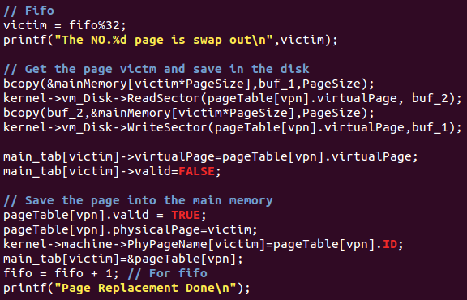

translate.h

1. **Result**
   1. **Experiment result and some discussion**

After my efforts, I still can’t run the /test/matmult.c and /test/sort.c concurrently and get the correct result. Look at the following figures, I got a error message, Segmentation fault, as same as I encounter in the project number two. After one month passed, I learn the theory of segmentation. However, I can’t solve it so that I download the NachOS again and modify the program files I mention in 2.1.

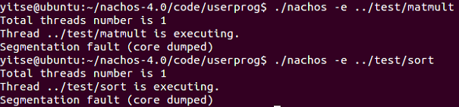



Segmentation fault error

In addition, after I modify the NachOS programs, another error occurred, unexcepted user mode exception2. Though I have not the ability to solve it, the programs print “Page Fault!!!” and “Number = 11 page swap out” message. In my opinion, my completion rate is at least 40%.

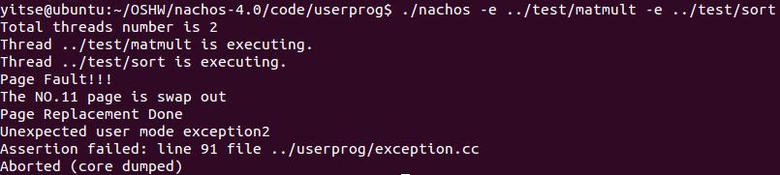

Unexcepted user mode exception2 and assertion failed error

* 1. **Extra effort or observation**

The final test is around the corner, so I start to do the last two years exams downloaded from the professor website. After completing the project, not only do I learn the basic memory management theory, but I also practice the virtual memory management, such as page table and page replacement algorithm.