Week 4 – Problem #2

Let C be a circle of radius 1, and let D be a diameter of C. Let P be the set of all points inside or on C which are closer to D than to the circumference of C. What is the area of P?

First, the area of P is identical regardless of the specific diameter chosen, so we can choose the orientation of D as convenient. Using polar coordinates, let D be represented by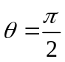. Likewise, in this system, let C be represented by r = 1.

Let A be any point within the first quadrant within or on C described by 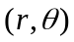. The minimum distance between A and D is equal to the x coordinate of that point, found by 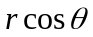, since the x axis is perpendicular to . The minimum distance between A and the circumference of C is the length of the line passing through the origin and A between A and where it intersects C. Between the origin and the circumference of C, the length of the line is 1, and the distance between the origin and A is given by r, so the distance between A and C equals 1 – r.

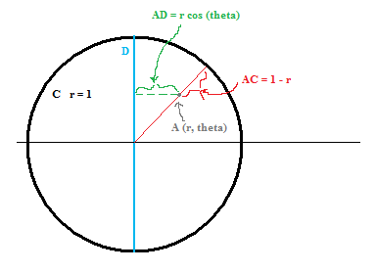

Let the function 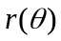return the line of all points inside C equidistant from D and the circumference of C within the first quadrant.

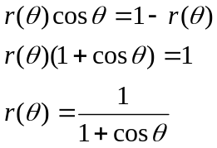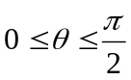

The area of P within the first quadrant is therefore 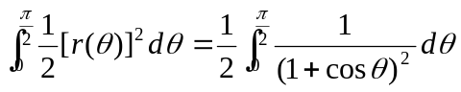. By symmetry, the area in the first quadrant is equal to the area in each other quadrant, therefore the area of P is four times the area in the first quadrant = 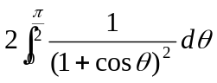.

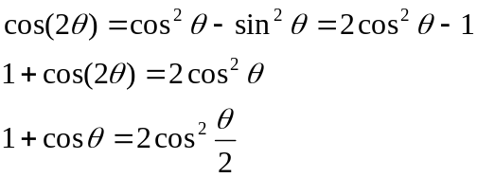

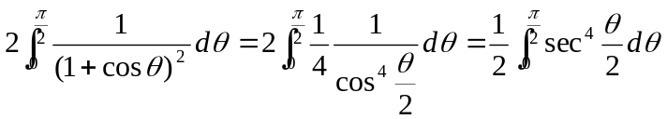

Using 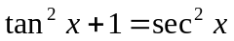:

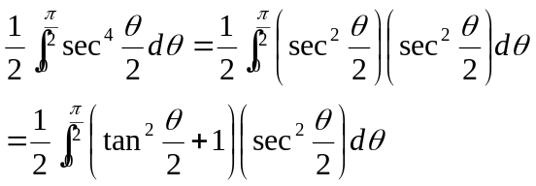

Let 