<body>

<form id="form1" runat="server">

<div>

<%-- Repeater – элемент управления способный привязываться к данным и создающий

разметку путем повторения указанных шаблонов для каждого элемента списка.--%>

<asp:Repeater ID="Repeater1" runat="server" >

<%-- Шаблон, описывающий один элемент списка --%>

<ItemTemplate>

<%--Container.DataItem - один элемент источника данных, в данном случае типа string--%>

<%# Container.DataItem %>

<br />

</ItemTemplate>

</asp:Repeater>

</div>

</form>

</body>

protected void Page_Load(object sender, EventArgs e)

{

string[] arr = new string[5];

arr[0] = "Item 1";

arr[1] = "Item 2";

arr[2] = "Item 3";

arr[3] = "Item 4";

arr[4] = "Item 5";

Repeater1.DataSource = arr;

Repeater1.DataBind();

}

***

<body>

<form id="form1" runat="server">

<div>

<asp:Repeater ID="Repeater1" runat="server">

<ItemTemplate>

<%# Eval("FirstName") %>&nbsp;<%# Eval("LastName") %>

<br />

Phone: <%#Eval("PhoneNumber") %><br />

Email: <%#Eval("Email") %>

<hr />

</ItemTemplate>

</asp:Repeater>

</div>

</form>

</body>

protected void Page_Load(object sender, EventArgs e)

{

Repeater1.DataSource = CustomersDatabase.Customers;

Repeater1.DataBind();

}

Класс

public static class CustomersDatabase

{

private static List<Customer> _customers = null;

public static List<Customer> Customers

{

get

{

if (_customers == null)

{

_customers = new List<Customer>();

Customer temp = new Customer();

temp.FirstName = "Ivan";

temp.LastName = "Ivanov";

temp.PhoneNumber = "111-22-33";

temp.Email = "i.ivanov@example.com";

_customers.Add(temp);

temp = new Customer();

temp.FirstName = "Petr";

temp.LastName = "Petrov";

temp.PhoneNumber = "123-45-67";

temp.Email = "petrov@example.com";

_customers.Add(temp);

temp = new Customer();

temp.FirstName = "Fedor";

temp.LastName = "Fedorov";

temp.PhoneNumber = "999-88-77";

temp.Email = "fedor@example.com";

_customers.Add(temp);

temp = new Customer();

temp.FirstName = "Sergei";

temp.LastName = "Sergeev";

temp.PhoneNumber = "555-88-55";

temp.Email = "sergei_sergeev@example.com";

_customers.Add(temp);

}

return _customers;

}

}

}

public struct Customer

{

public string FirstName { get; set; }

public string LastName { get; set; }

public string PhoneNumber { get; set; }

public string Email { get; set; }

}

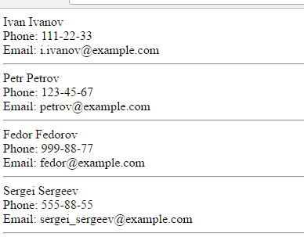

***

<body>

<form id="form1" runat="server">

<div>

<asp:Repeater ID="Repeater1" runat="server">

<%--Шаблон заголовка (используется один раз)--%>

<HeaderTemplate>

<h1>Список пользователей</h1>

</HeaderTemplate>

<%--Шаблон четных элементов списка--%>

<AlternatingItemTemplate>

<div style="background-color:LightGreen">

<%# Eval("FirstName") %> <%# Eval("LastName") %>

<br />

Phone: <%#Eval("PhoneNumber") %><br />

Email: <%#Eval("Email") %>

</div>

</AlternatingItemTemplate>

<%--Шаблон разделителя элементов списка--%>

<SeparatorTemplate>

<hr />

</SeparatorTemplate>

<%--Шаблон нечетных элементов списка--%>

<ItemTemplate>

<%# Eval("FirstName") %> <%# Eval("LastName") %>

<br />

Phone: <%#Eval("PhoneNumber") %><br />

Email: <%#Eval("Email") %>

</ItemTemplate>

<%--Шаблон подписи Repeater (используется один раз)--%>

<FooterTemplate>

<br />

<br />

<br />

<small><a href="mailto:admin@example.com">Связь с администратором</a></small>

</FooterTemplate>

</asp:Repeater>

</div>

</form>

protected void Page_Load(object sender, EventArgs e)

{

Repeater1.DataSource = CustomersDatabase.Customers;

Repeater1.DataBind();

}

***

<body>

<form id="form1" runat="server">

<div>

<asp:Repeater ID="Repeater1" runat="server">

<HeaderTemplate>

<%--Заголовок таблицы--%>

<table border="1" cellpadding="4">

<tr>

<th>First Name</th>

<th>Last Name</th>

<th>Phone</th>

<th>Email</th>

</tr>

</HeaderTemplate>

<ItemTemplate>

<%--Содержимое таблицы--%>

<tr>

<td><%#Eval("FirstName") %></td>

<td><%#Eval("LastName") %></td>

<td><%#Eval("PhoneNumber") %></td>

<td><%#Eval("Email") %></td>

</tr>

</ItemTemplate>

<FooterTemplate>

</table>

</FooterTemplate>

</asp:Repeater>

</div>

</form>

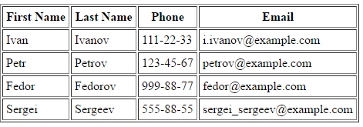

***

GridView

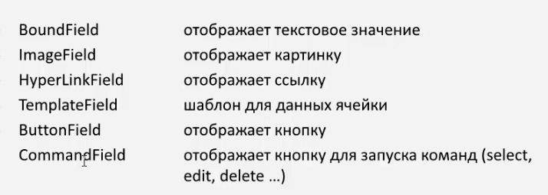

<body>

<form id="form1" runat="server">

<div>

<asp:GridView ID="GridView1" runat="server" AutoGenerateColumns="true">

</asp:GridView>

</div>

</form>

</body>

protected void Page_Load(object sender, EventArgs e)

{

GridView1.DataSource = BrowsersDatabase.Browsers;

GridView1.DataBind();

}

Класс

public static class BrowsersDatabase

{

private static List<BrowserInfo> _browsers = null;

public static List<BrowserInfo> Browsers

{

get

{

if (_browsers == null)

{

_browsers = new List<BrowserInfo>();

BrowserInfo info;

info = new BrowserInfo();

info.ID = 1;

info.Name = "Google Chrome";

info.ImagePath = "/Images/chrome.png";

info.Url = "http://www.google.ru/chrome";

_browsers.Add(info);

info = new BrowserInfo();

info.ID = 2;

info.Name = "Microsoft Internet Explorer";

info.ImagePath = "/Images/internet_explorer.png";

info.Url = "http://windows.microsoft.com/ru-RU/internet-explorer/products/ie/home";

_browsers.Add(info);

info = new BrowserInfo();

info.ID = 3;

info.Name = "Mozilla Firefox";

info.ImagePath = "/Images/mozilla.png";

info.Url = "http://www.mozilla.org/en-US/firefox/new/";

_browsers.Add(info);

info = new BrowserInfo();

info.ID = 4;

info.Name = "Opera";

info.ImagePath = "/Images/opera.png";

info.Url = "http://www.opera.com/download/";

_browsers.Add(info);

info = new BrowserInfo();

info.ID = 5;

info.Name = "Safari";

info.ImagePath = "/Images/safari.png";

info.Url = "http://www.apple.com/safari/download/";

_browsers.Add(info);

}

return _browsers;

}

}

}

public struct BrowserInfo

{

public int ID { get; set; }

public string Name { get; set; }

public string ImagePath { get; set; }

public string Url { get; set; }

}

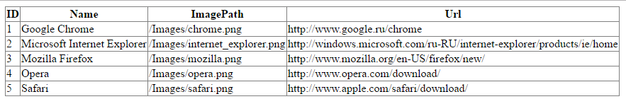

***

<body>

<form id="form1" runat="server">

<div>

<asp:GridView ID="GridView1" runat="server" AutoGenerateColumns="false">

<Columns>

<asp:BoundField DataField="Name" HeaderText="Название браузера" />

<asp:BoundField DataField="ImagePath" HeaderText="Путь к логотипу" />

<asp:BoundField DataField="Url" HeaderText="Ссылка для скачивания" />

</Columns>

</asp:GridView>

</div>

</form>

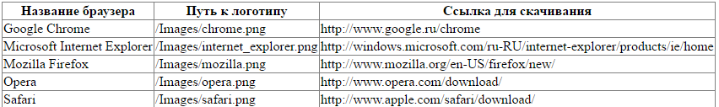

***

<body>

<form id="form1" runat="server">

<div>

<asp:GridView ID="GridView1" runat="server" AutoGenerateColumns="false">

<Columns>

<asp:BoundField DataField="ID" HeaderText="ID" />

<asp:BoundField DataField="Name" HeaderText="Название браузера" />

<%--ImageField - колонка для показа изображений--%>

<asp:ImageField DataImageUrlField="ImagePath" HeaderText="Логотип" />

<asp:BoundField DataField="Url" HeaderText="Ссылка для скачивания" />

</Columns>

</asp:GridView>

</div>

</form>

</body>

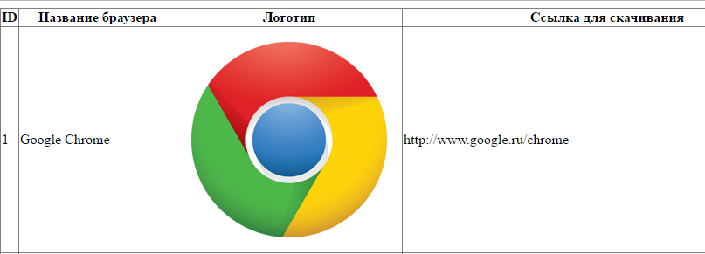

***

<body>

<form id="form1" runat="server">

<div>

<asp:GridView ID="GridView1" runat="server" AutoGenerateColumns="False">

<Columns>

<asp:BoundField DataField="ID" HeaderText="ID" />

<asp:BoundField DataField="Name" HeaderText="Название браузера" />

<asp:ImageField DataImageUrlField="ImagePath" HeaderText="Логотип" />

<%--HyperLinkField - колонка содержащяя ссылки--%>

<asp:HyperLinkField

DataNavigateUrlFields="Url"

DataTextField="Name"

DataTextFormatString="Скачать {0}"

HeaderText="Ссылка для скачивания" />

</Columns>

</asp:GridView>

</div>

</form>

</body>

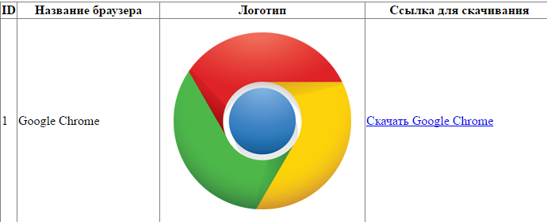

***

</head>

<body>

<form id="form1" runat="server">

<div>

<asp:GridView ID="GridView1" runat="server" AutoGenerateColumns="false">

<Columns>

<asp:BoundField DataField="ID" HeaderText="ID" />

<asp:ImageField DataImageUrlField="ImagePath" HeaderText="Логотип" />

<asp:TemplateField HeaderText="Скачать браузер">

<ItemTemplate>

<h3><%# Eval("Name") %></h3>

<a href='<%# Eval("Url") %>'>скачать</a>

</ItemTemplate>

</asp:TemplateField>

</Columns>

</asp:GridView>

</div>

</form>

</body>

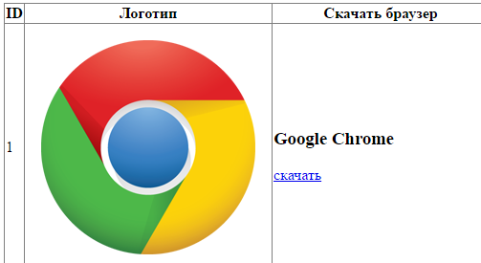

***

GridViewStyles

<body>

<form id="form1" runat="server">

<div>

<asp:GridView

ID="GridView1" runat="server"

AutoGenerateColumns="False"

CellPadding="4"

DataKeyNames="EmployeeID"

DataSourceID="NorthwindDataSource"

ForeColor="#333333"

GridLines="None"

AllowPaging="true"

PageSize="5">

<%--Настройка колонок--%>

<Columns>

<asp:BoundField DataField="EmployeeID" HeaderText="EmployeeID" InsertVisible="False" ReadOnly="True" SortExpression="EmployeeID" />

<asp:BoundField DataField="LastName" HeaderText="LastName" SortExpression="LastName" />

<asp:BoundField DataField="FirstName" HeaderText="FirstName" SortExpression="FirstName" />

<asp:BoundField DataField="Title" HeaderText="Title" SortExpression="Title" />

<asp:BoundField DataField="TitleOfCourtesy" HeaderText="TitleOfCourtesy" SortExpression="TitleOfCourtesy" />

<asp:BoundField DataField="BirthDate" HeaderText="BirthDate" SortExpression="BirthDate" />

<asp:BoundField DataField="Notes" HeaderText="Notes" SortExpression="Notes" />

</Columns>

<%--Настройка стиля--%>

<AlternatingRowStyle BackColor="White" ForeColor="#284775" />

<EditRowStyle BackColor="#999999" />

<FooterStyle BackColor="#5D7B9D" Font-Bold="True" ForeColor="White" />

<HeaderStyle BackColor="#5D7B9D" Font-Bold="True" ForeColor="White" />

<PagerStyle BackColor="#284775" ForeColor="White" HorizontalAlign="Center" />

<RowStyle BackColor="#F7F6F3" ForeColor="#333333" />

<SelectedRowStyle BackColor="#E2DED6" Font-Bold="True" ForeColor="#333333" />

</asp:GridView>

<%--Источник данных--%>

<asp:SqlDataSource ID="NorthwindDataSource" runat="server"

ConnectionString="<%$ ConnectionStrings:NorthwindConnection %>"

SelectCommand="SELECT [EmployeeID], [LastName], [FirstName], [Title], [TitleOfCourtesy], [BirthDate], [Notes] FROM [Employees]">

</asp:SqlDataSource>

</div>

</form>

</body>

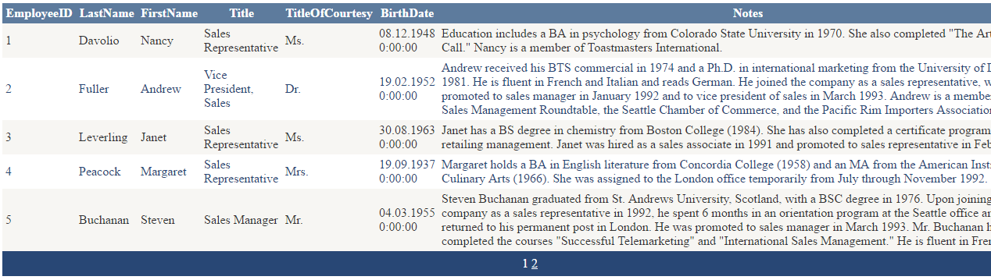

***

</head>

<body>

<form id="form1" runat="server">

<div>

<%--OnRowDataBound - это событие происходит, когда создается часть Grid контрола (заголовок, строка, футер)--%>

<asp:GridView

OnRowDataBound="GridView_OnDataBound"

ID="GridView1" runat="server"

AutoGenerateColumns="False"

CellPadding="4"

DataKeyNames="EmployeeID"

DataSourceID="NorthwindDataSource"

ForeColor="#333333"

GridLines="None" >

<%--Настройка колонок--%>

<Columns>

<asp:BoundField DataField="EmployeeID" HeaderText="EmployeeID" InsertVisible="False" ReadOnly="True" SortExpression="EmployeeID" />

<asp:BoundField DataField="LastName" HeaderText="LastName" SortExpression="LastName" />

<asp:BoundField DataField="FirstName" HeaderText="FirstName" SortExpression="FirstName" />

<asp:BoundField DataField="Title" HeaderText="Title" SortExpression="Title" />

<asp:BoundField DataField="TitleOfCourtesy" HeaderText="TitleOfCourtesy" SortExpression="TitleOfCourtesy" />

<asp:BoundField DataField="BirthDate" HeaderText="BirthDate" SortExpression="BirthDate" />

<asp:BoundField DataField="Notes" HeaderText="Notes" SortExpression="Notes" />

</Columns>

<%--Настройка стиля--%>

<AlternatingRowStyle BackColor="White" ForeColor="#284775" />

<EditRowStyle BackColor="#999999" />

<FooterStyle BackColor="#5D7B9D" Font-Bold="True" ForeColor="White" />

<HeaderStyle BackColor="#5D7B9D" Font-Bold="True" ForeColor="White" />

<PagerStyle BackColor="#284775" ForeColor="White" HorizontalAlign="Center" />

<RowStyle BackColor="#F7F6F3" ForeColor="#333333" />

<SelectedRowStyle BackColor="#E2DED6" Font-Bold="True" ForeColor="#333333" />

</asp:GridView>

<%--Источник данных--%>

<asp:SqlDataSource ID="NorthwindDataSource" runat="server"

ConnectionString="<%$ ConnectionStrings:NorthwindConnection %>"

SelectCommand="SELECT [EmployeeID], [LastName], [FirstName], [Title], [TitleOfCourtesy], [BirthDate], [Notes] FROM [Employees]">

</asp:SqlDataSource>

</div>

</form>

protected void GridView_OnDataBound(object sender, GridViewRowEventArgs e)

{

if (e.Row.RowType == DataControlRowType.DataRow)

{

// DataBinder.Eval - получение значения свойства из указанного объекта.

string title = (string)DataBinder.Eval(e.Row.DataItem, "TitleOfCourtesy");

if (title == "Ms." || title == "Mrs.")

{

e.Row.BackColor = Color.LightPink;

e.Row.ForeColor = Color.Maroon;

}

else if (title == "Mr.")

{

e.Row.BackColor = Color.LightCyan;

e.Row.ForeColor = Color.DarkBlue;

}

}

}

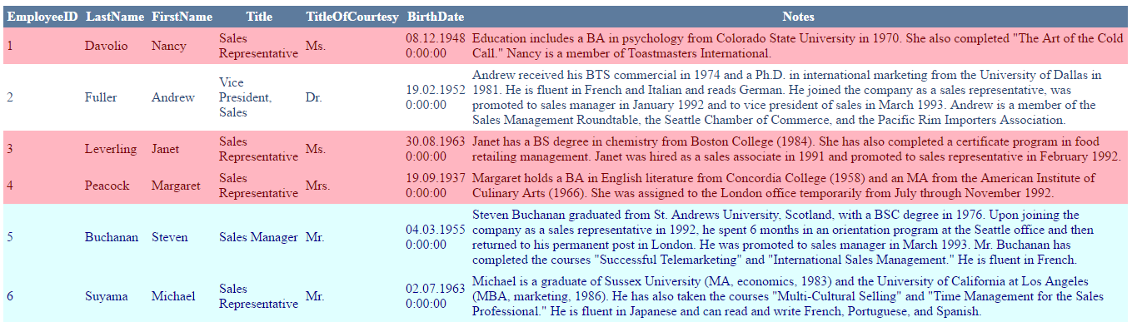

***

<body>

<form id="form1" runat="server">

<div>

<asp:GridView

ID="GridView1" runat="server"

AutoGenerateColumns="False"

CellPadding="4"

DataKeyNames="EmployeeID"

DataSourceID="NorthwindDataSource"

ForeColor="#333333"

GridLines="None" >

<%--Настройка колонок--%>

<Columns>

<asp:CommandField ButtonType="Image" SelectImageUrl="~/Images/arrow.png" ShowSelectButton="true" />

<asp:CommandField ButtonType="Button" SelectText="Выбрать" ShowSelectButton="true" />

<asp:BoundField DataField="EmployeeID" HeaderText="EmployeeID" InsertVisible="False" ReadOnly="True" SortExpression="EmployeeID" />

<asp:BoundField DataField="LastName" HeaderText="LastName" SortExpression="LastName" />

<asp:BoundField DataField="FirstName" HeaderText="FirstName" SortExpression="FirstName" />

<asp:BoundField DataField="Title" HeaderText="Title" SortExpression="Title" />

<asp:BoundField DataField="TitleOfCourtesy" HeaderText="TitleOfCourtesy" SortExpression="TitleOfCourtesy" />

<asp:BoundField DataField="BirthDate" HeaderText="BirthDate" SortExpression="BirthDate" />

</Columns>

<%--Настройка стиля--%>

<AlternatingRowStyle BackColor="White" ForeColor="#284775" />

<EditRowStyle BackColor="#999999" />

<FooterStyle BackColor="#5D7B9D" Font-Bold="True" ForeColor="White" />

<HeaderStyle BackColor="#5D7B9D" Font-Bold="True" ForeColor="White" />

<PagerStyle BackColor="#284775" ForeColor="White" HorizontalAlign="Center" />

<RowStyle BackColor="#F7F6F3" ForeColor="#333333" />

<SelectedRowStyle BackColor="#E2DED6" Font-Bold="True" ForeColor="Red" />

</asp:GridView>

<%--Источник данных--%>

<asp:SqlDataSource ID="NorthwindDataSource" runat="server"

ConnectionString="<%$ ConnectionStrings:NorthwindConnection %>"

SelectCommand="SELECT [EmployeeID], [LastName], [FirstName], [Title], [TitleOfCourtesy], [BirthDate] FROM [Employees]">

</asp:SqlDataSource>

</div>

</form>

</body>

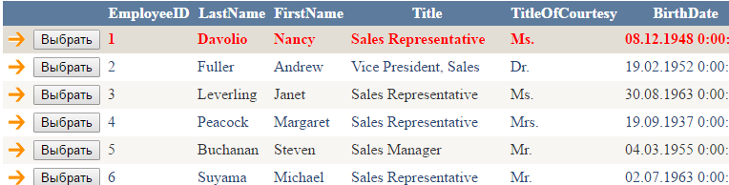

***

<body>

<form id="form1" runat="server">

<div>

<asp:GridView ID="GridView1" runat="server"

OnSelectedIndexChanged="GridView1_SelectedIndexChanged"

AutoGenerateColumns="False" CellPadding="4"

DataKeyNames="EmployeeID" DataSourceID="NorthwindDataSource" ForeColor="#333333"

GridLines="None"

AllowPaging="true" PageSize="5">

<%--Настройка колонок--%>

<Columns>

<asp:CommandField ButtonType="Image" SelectImageUrl="~/Images/arrow.png" ShowSelectButton="true" />

<asp:BoundField DataField="EmployeeID" HeaderText="EmployeeID" InsertVisible="False"

ReadOnly="True" SortExpression="EmployeeID" />

<asp:BoundField DataField="LastName" HeaderText="LastName" SortExpression="LastName" />

<asp:BoundField DataField="FirstName" HeaderText="FirstName" SortExpression="FirstName" />

<asp:BoundField DataField="Title" HeaderText="Title" SortExpression="Title" />

<asp:BoundField DataField="TitleOfCourtesy" HeaderText="TitleOfCourtesy" SortExpression="TitleOfCourtesy" />

<asp:BoundField DataField="BirthDate" HeaderText="BirthDate" SortExpression="BirthDate" />

</Columns>

<%--Настройка стиля--%>

<AlternatingRowStyle BackColor="White" ForeColor="#284775" />

<EditRowStyle BackColor="#999999" />

<FooterStyle BackColor="#5D7B9D" Font-Bold="True" ForeColor="White" />

<HeaderStyle BackColor="#5D7B9D" Font-Bold="True" ForeColor="White" />

<PagerStyle BackColor="#284775" ForeColor="White" HorizontalAlign="Center" />

<RowStyle BackColor="#F7F6F3" ForeColor="#333333" />

<SelectedRowStyle BackColor="#E2DED6" Font-Bold="True" ForeColor="#333333" />

</asp:GridView>

<%--Источник данных--%>

<asp:SqlDataSource ID="NorthwindDataSource" runat="server" ConnectionString="<%$ ConnectionStrings:NorthwindConnection %>"

SelectCommand="SELECT [EmployeeID], [LastName], [FirstName], [Title], [TitleOfCourtesy], [BirthDate] FROM [Employees]"></asp:SqlDataSource>

<asp:Label runat="server" ID="Output"></asp:Label>

</div>

</form>

public partial class _01_SelectedIndexChanged : System.Web.UI.Page

{

protected void GridView1_SelectedIndexChanged(object sender, EventArgs e)

{

// Получение порядкового номера строки.

int index = GridView1.SelectedIndex;

// Ключевое поле извлекается из свойства SelectedDataKey.

int ID = (int)GridView1.SelectedDataKey.Values["EmployeeID"];

// Другие данные можно извлечь непосредственно из коллекции Cells,

// если известно смещение столбца.

string firstName = GridView1.SelectedRow.Cells[2].Text;

string lastName = GridView1.SelectedRow.Cells[3].Text;

Output.Text = string.Format("Индекс выбранной строки {0}<br /> ID элемента {1} <br /> First Name = {2} <br /> Last Name = {3}", index, ID, firstName, lastName);

}

}

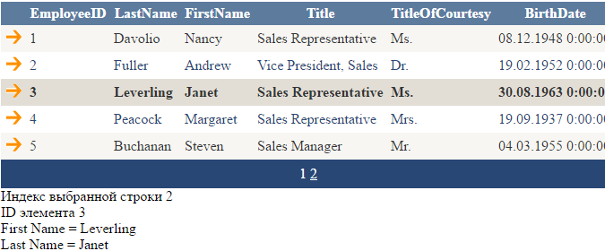

**\*\*\***

<body>

<form id="form1" runat="server">

<div>

<asp:GridView ID="GridView1" runat="server" AutoGenerateColumns="False" CellPadding="4"

DataKeyNames="ProductID" DataSourceID="NorthwindDataSource" ForeColor="#333333"

GridLines="None"

AutoGenerateDeleteButton="True"

AutoGenerateEditButton="True"

AutoGenerateSelectButton="True">

<%--Настройка колонок--%>

<Columns>

<asp:BoundField DataField="ProductID" HeaderText="Product ID" InsertVisible="False" ReadOnly="True" SortExpression="ProductID" />

<asp:BoundField DataField="ProductName" HeaderText="Product Name" SortExpression="ProductName" />

<asp:BoundField DataField="UnitPrice" HeaderText="Unit Price" SortExpression="UnitPrice" />

<asp:BoundField DataField="UnitsOnOrder" HeaderText="Units On Order" SortExpression="UnitsOnOrder" />

<asp:BoundField DataField="QuantityPerUnit" HeaderText="Quantity Per Unit" SortExpression="QuantityPerUnit" />

</Columns>

<%--Настройка стиля--%>

<AlternatingRowStyle BackColor="White" ForeColor="#284775" />

<EditRowStyle BackColor="#999999" />

<FooterStyle BackColor="#5D7B9D" Font-Bold="True" ForeColor="White" />

<HeaderStyle BackColor="#5D7B9D" Font-Bold="True" ForeColor="White" />

<PagerStyle BackColor="#284775" ForeColor="White" HorizontalAlign="Center" />

<RowStyle BackColor="#F7F6F3" ForeColor="#333333" />

<SelectedRowStyle BackColor="#E2DED6" Font-Bold="True" ForeColor="#333333" />

</asp:GridView>

<%--Источник данных--%>

<asp:SqlDataSource ID="NorthwindDataSource" runat="server" ConnectionString="<%$ ConnectionStrings:NorthwindConnection %>"

SelectCommand="SELECT [ProductName], [UnitPrice], [UnitsOnOrder], [QuantityPerUnit], [ProductID] FROM [Products]" DeleteCommand="DELETE FROM [Products] WHERE [ProductID] = @ProductID"

InsertCommand="INSERT INTO [Products] ([ProductName], [UnitPrice], [UnitsOnOrder], [QuantityPerUnit]) VALUES (@ProductName, @UnitPrice, @UnitsOnOrder, @QuantityPerUnit)"

UpdateCommand="UPDATE [Products] SET [ProductName] = @ProductName, [UnitPrice] = @UnitPrice, [UnitsOnOrder] = @UnitsOnOrder, [QuantityPerUnit] = @QuantityPerUnit WHERE [ProductID] = @ProductID">

<DeleteParameters>

<asp:Parameter Name="ProductID" Type="Int32" />

</DeleteParameters>

<InsertParameters>

<asp:Parameter Name="ProductName" Type="String" />

<asp:Parameter Name="UnitPrice" Type="Decimal" />

<asp:Parameter Name="UnitsOnOrder" Type="Int16" />

<asp:Parameter Name="QuantityPerUnit" Type="String" />

</InsertParameters>

<UpdateParameters>

<asp:Parameter Name="ProductName" Type="String" />

<asp:Parameter Name="UnitPrice" Type="Decimal" />

<asp:Parameter Name="UnitsOnOrder" Type="Int16" />

<asp:Parameter Name="QuantityPerUnit" Type="String" />

<asp:Parameter Name="ProductID" Type="Int32" />

</UpdateParameters>

</asp:SqlDataSource>

</div>

</form>

</body>

