# NIRIS – Protocol Packet (Persona: Maria R., L4–L5)

Base, non-invasive protocol for lumbar disc herniation with radicular pain, using ethical, consent-first neurofeedback and autonomic regulation.

## 1) Persona Summary

Maria R., 55, presents with L4–L5 disc herniation and chronic low-back pain with intermittent radicular symptoms. Sleep is fragmented; daytime fatigue and pain interference are notable. Prefers non-invasive care.

## 2) Objectives

- Reduce pain interference and disability.  
- Improve autonomic balance (HRV) and resting EEG alpha stability.  
- Support sleep consolidation and daytime function.  
- Ensure safety with trauma-informed, consent-driven delivery.

## 3) Inclusion / Exclusion

Inclusion: Age 30–70; imaging or clinical exam consistent with L4–L5 disc issue; stable medications; willing and able to consent.  
Exclusion: Uncontrolled seizure disorder; implanted electronic devices contraindicating stimulation; active infection; severe psychiatric crisis.

## 4) Consent Tiers

Core: Demographics, HRV, session timestamps.  
Sensitive: Mood/sleep questionnaires (PHQ-9, ISI), NRS pain logs.  
Clinical: Optional EEG alpha recording, clinician-ordered TENS.  
Research: De-identified export for methods improvement.

## 5) Baseline Measures

Oswestry Disability Index (ODI); NRS pain (0–10); HRV (RMSSD/SDNN) morning/evening; optional EEG alpha (eyes-closed 2×); sleep awakenings.

## 6) Devices & Stack

OpenBCI or comparable EEG (optional); HR strap (BLE) for HRV; Raspberry Pi/Jetson for session control; mobile app for consent and PROs; Medical Nexus AI with FHIR bridge for Observations and QuestionnaireResponse.

## 7) Session Protocol (Weeks 2–4)

Daily 12-minute session:  
 • 2 min paced breathing (coherence)  
 • 8 min eyes-closed alpha up-train (simple visual feedback)  
 • 2 min cool-down  
Micro-prompts: posture & micro-break coaching every ~90 minutes while awake.  
Baseline Week: measures only; no neurofeedback.  
EEG Alpha: record 2×/week during up-train.

## 8) Safety & Stop Criteria

Immediate pause on headache, dizziness, panic, nausea, or visual discomfort. Contraindications screen at onboarding. “Pause all” control visible at all times.

## 9) Outcome Measures & Success Thresholds

Primary: ≥30% reduction in ODI or pain interference by day 28.  
Secondary: HRV RMSSD upward trend; alpha stability on training days; reduction in nightly awakenings.

## 10) Data Capture & FHIR Mapping

FHIR: Patient; Consent; Encounter; Observation (HR, HRV RMSSD/SDNN; EEG-derived alpha summaries); Device/DeviceMetric; Questionnaire/QuestionnaireResponse (ODI; NRS; ISI); CarePlan; ServiceRequest; Provenance.

## 11) Privacy & Ethics

Local-first storage; encryption at rest; de-identification prior to research sharing; trauma-informed scripts; no black-box claims; clear disclaimers. Non-therapeutic feasibility unless under IRB/physician supervision.

## 12) Simulation Results (28 Days, Synthetic)

HRV (RMSSD) Trend

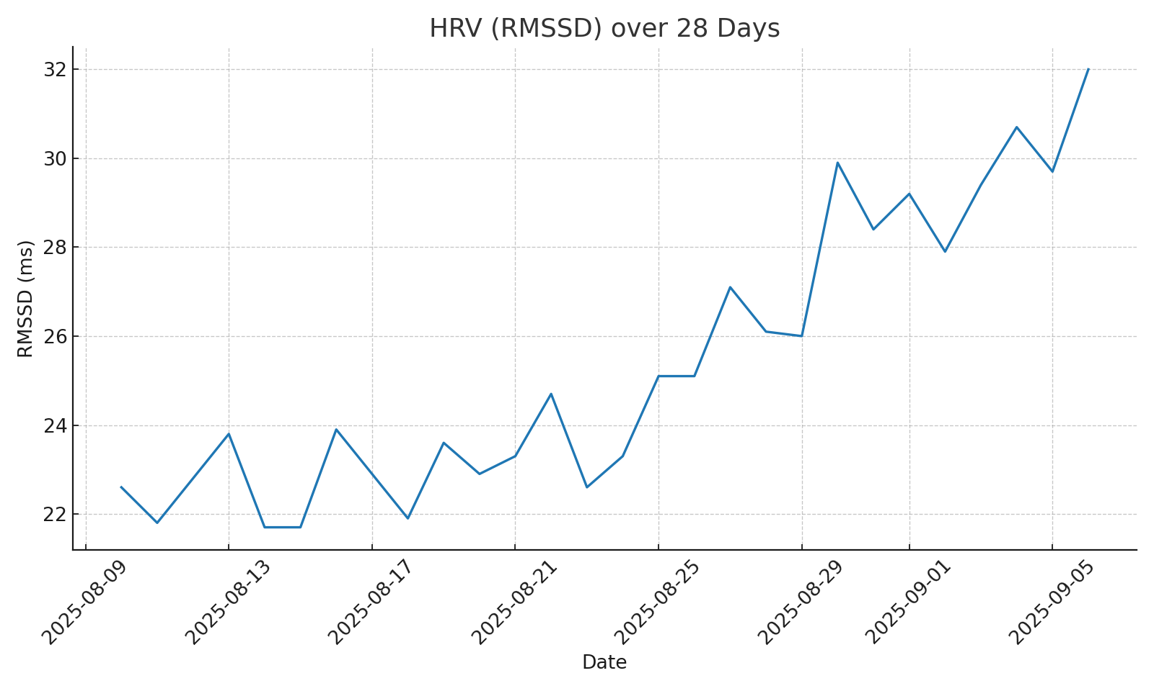

NRS Pain Trend

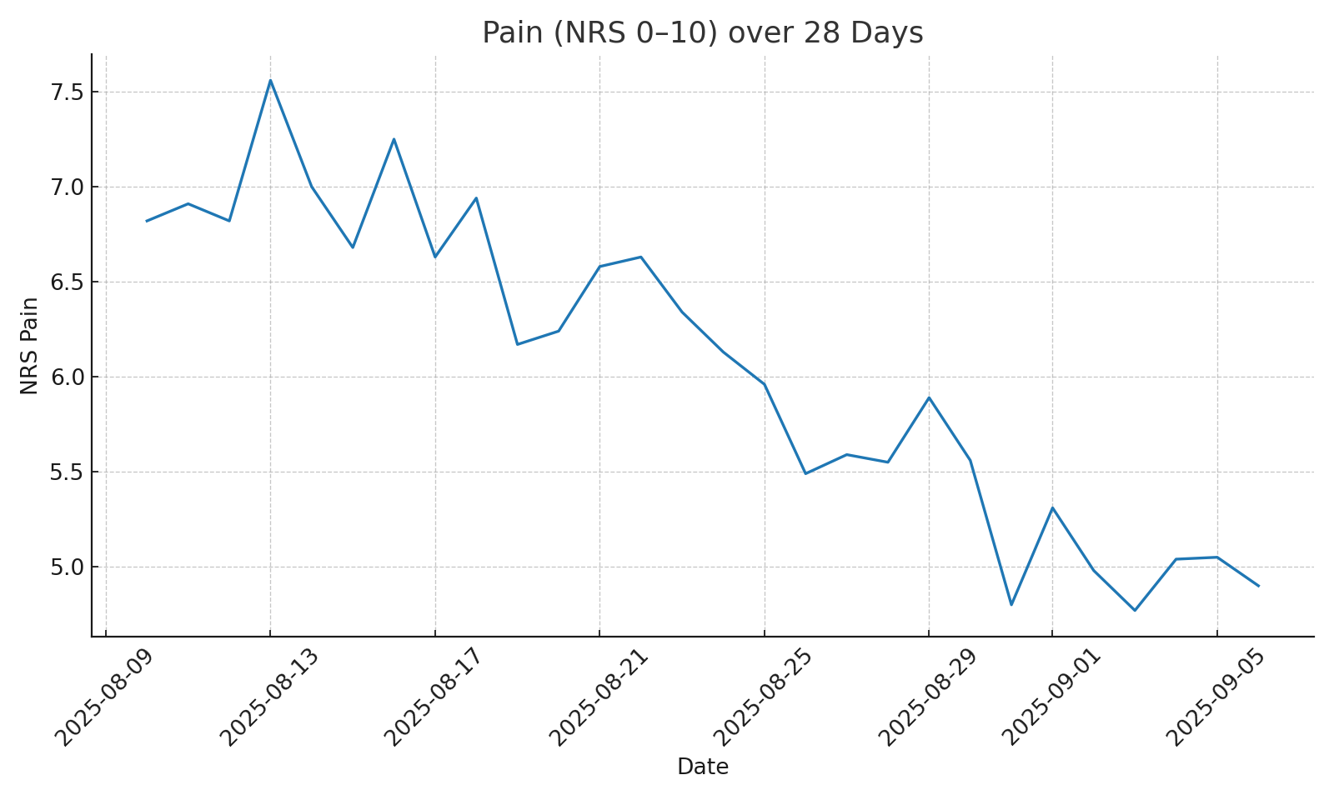

EEG Alpha (Normalized) on Training Days

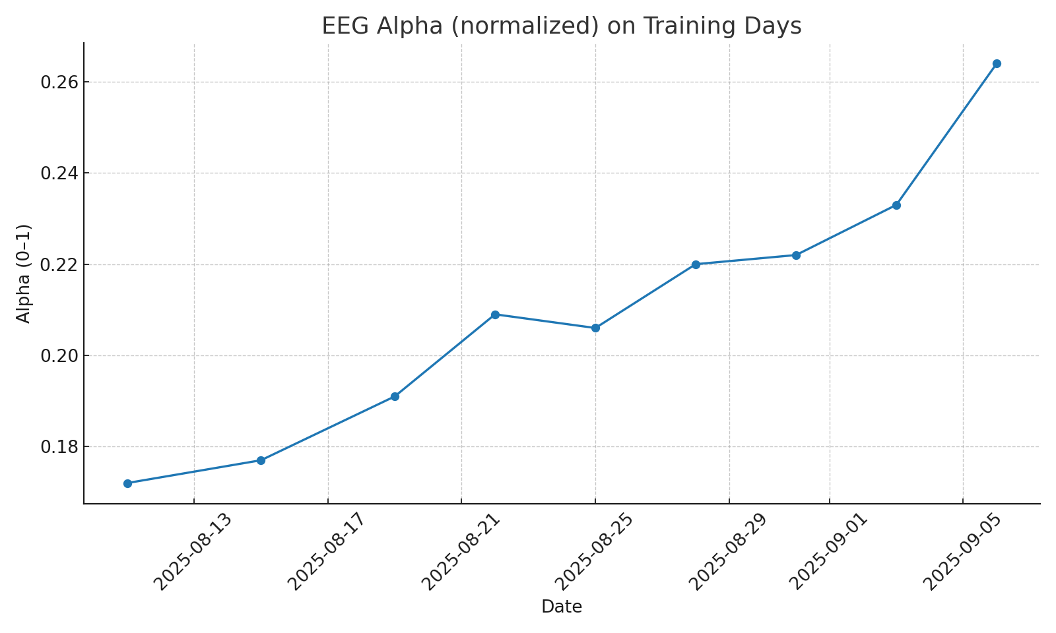

ODI: baseline 44 → day 28 31 (≈30% reduction).  
HRV increased from low 20s toward low 30s (RMSSD). NRS trended from ~7.0 toward ~4.5. Sleep awakenings decreased modestly.  
No adverse events triggered the auto-pause rule in this simulation.

## 13) Sample Session Flow (UI Copy)

• Welcome/consent status visible  
• Contraindication check  
• Breath pacing (timer + gentle tone)  
• Alpha feedback (eyes-closed, simple bar/metric)  
• Cool-down + reflect (1–2 prompts)  
• Post-session mood/pain check  
• Save & sync to Medical Nexus

## 14) Disclaimers

This protocol and the included simulation are for feasibility design and research planning. They are not medical advice or a substitute for clinical care. Any clinical use requires licensed oversight and IRB approval.