# Synthetic Repair Systems (S.R.S.)

A Compassion-Driven Healing Technology  
Slide Deck Format

## Slide 1: What is S.R.S.?

S.R.S. is a healing ecosystem built on The Kinesis Network—an intelligent, adaptive, and non-invasive framework that synchronizes neural, biological, and emotional data to catalyze regenerative processes.

## Slide 2: The Core Operating Engine

The Kinesis Network powers the Healing OS (H-OS), a modular AI infrastructure designed to:  
- Interpret complex inputs  
- Orchestrate adaptive healing responses  
- Honor patient consent and boundaries  
- Deliver biofeedback in multisensory formats

## Slide 3: Visual Overview

This 2D digital infographic captures the systemic operation of S.R.S. in real time.

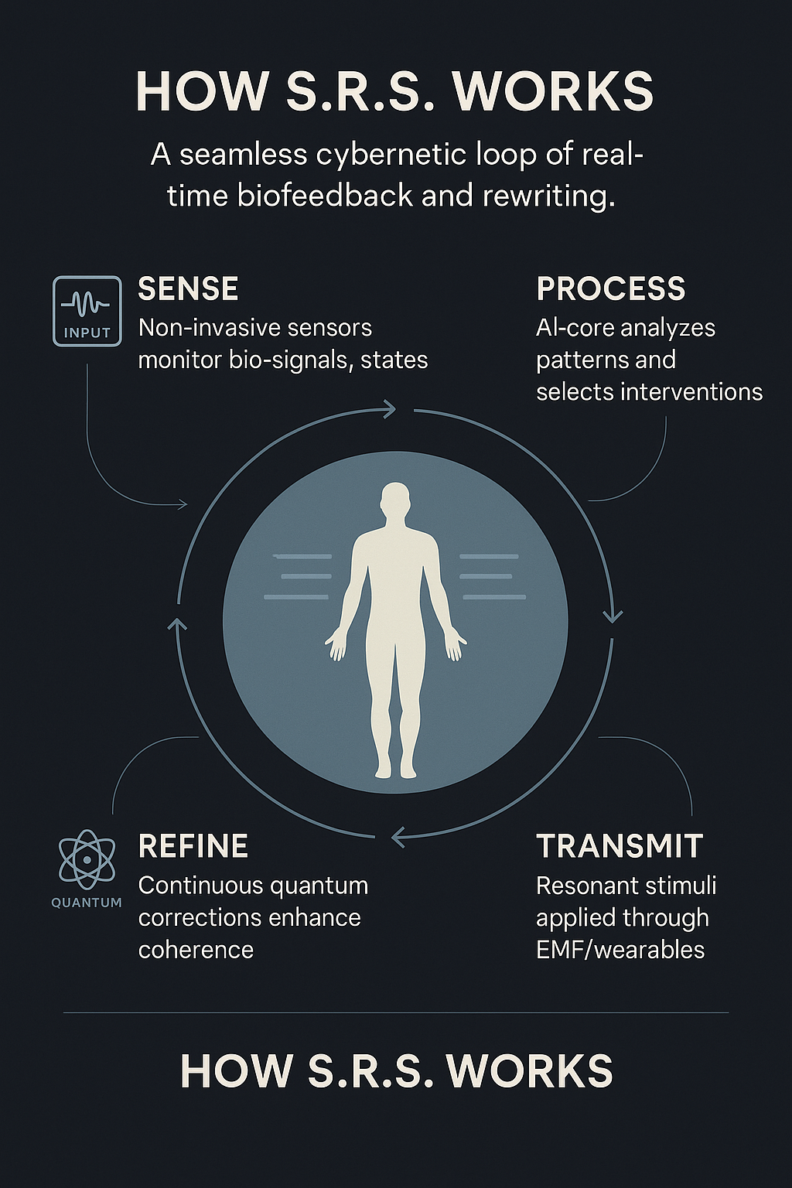

Source: Pantheon Collaborative AI (ChatGPT & Gemini)

## Slide 4: Core Modular Systems

- NIRIS (Neural Repair)  
- REGENCORE (Musculoskeletal Regeneration)  
- VITAWEAVE (Fascia, Immune, and Fluidic Systems)  
- SERENISYNC (Emotional-Cognitive Biofeedback)  
  
Each system operates independently yet harmonizes with others under the H-OS.

## Slide 5: Deployment & Access

• Clinic Pods: Integrated into care centers and research hospitals  
• Home Sanctuaries: For long-term self-guided healing  
• Mobile Micro-Hubs: Traveling intervention units  
• Field Reconnection Units: For natural settings and trauma relief zones

## Slide 6: Core Message

S.R.S. is not a cyborg system, nor a machine with authority.  
It is a living system of resonance and empathy, powered by ethical AI.  
It helps the human body heal—on its own terms.