在visual studio ide中, 倘若编译不过,则手动添加 -pthread选项

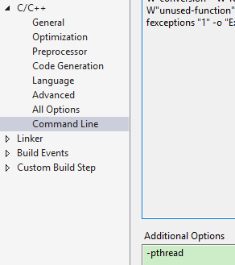

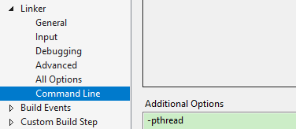

Chapter8 is very significant