Use the MyCrpto by custom network

1. config the custom network

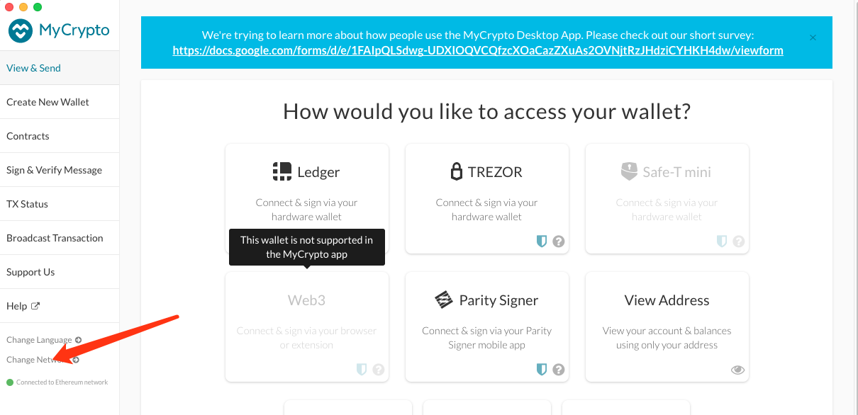

2. Add custom node

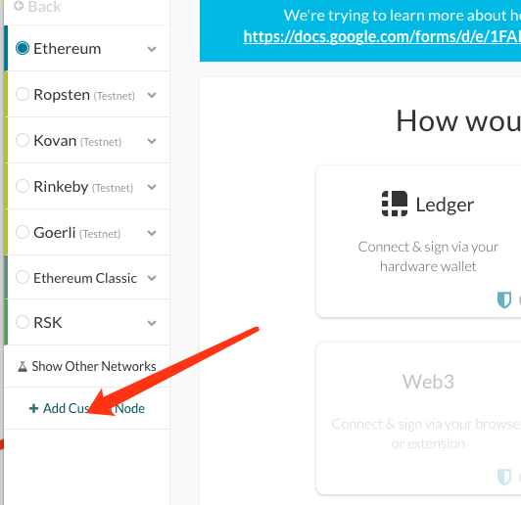

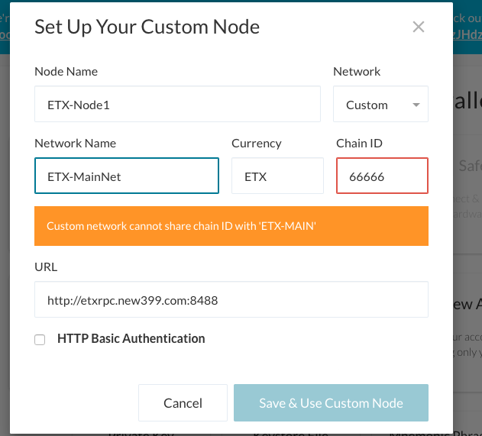

Etx main rpc: http://etxrpc.new399.com:8488

Chain ID : 66666

Fill them and save , go back the main screen to use the wallet .

