**Phishing Detection Chrome Extension**

Idea- Phishing detection using chrome extension

Basic Overview of our extension is-

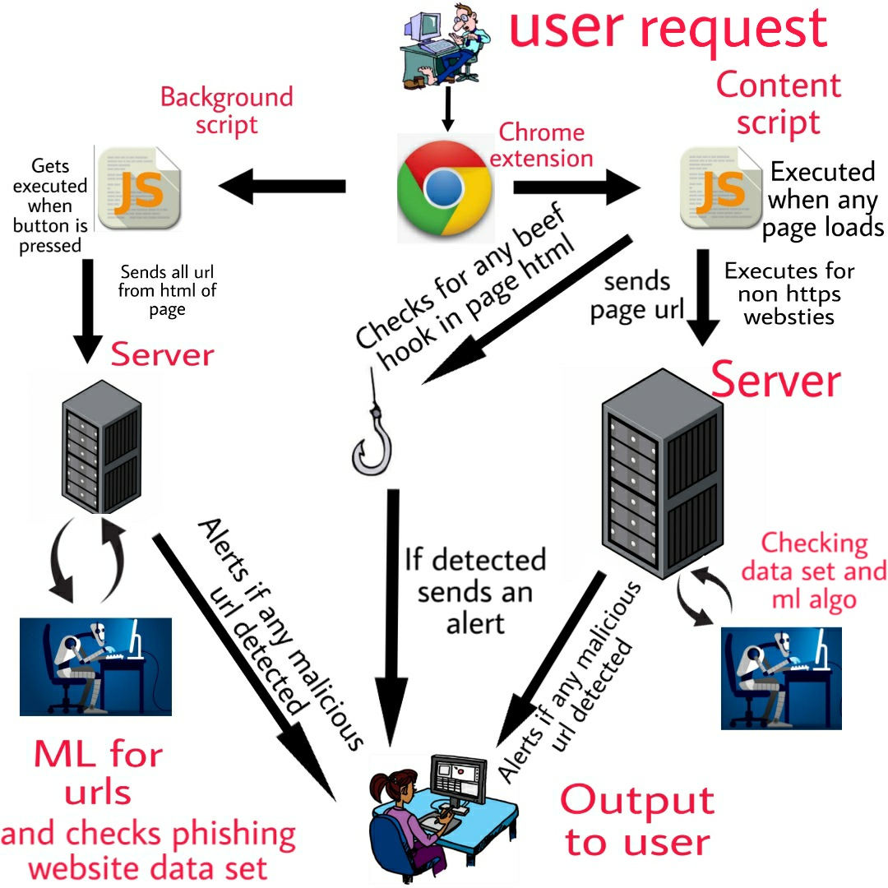

***Working***

*Working of our extension is divided into two major branches that is -*

1. *POPUP Script*
2. *Content Script*

***Content Script***

* *This script will run in the background and gets triggered whenever any site gets loaded .*
* *It is an automatic script.*
* *It sends page url and html code to a backend server .*
* *Server checks for malicious nature of url and tries to detect and any kind of malicious content on the page.*
* *It works on every page we load on our chrome browser.*
* *It works faster in comparison with popup script.*

***POPUP Script***

* *This script when user presses the icon of chrome extension .*
* *This script crawls through the page HTML and extracts all the urls embedded.*
* *Then it runs an Machine Learning algorithm on urls to detect if nature of any url is considered as malicious.*
* *This can be used in spoof email detection as emails are dangerous if they have any find of phishing urls .*
* *Urls are goes through a series of checking which decides whether it is malicious or not.*
* *Firstly is checked if url is present in phishing url database(PhishTank).*
* *Secondly if they are storing any data from the given forms .*
* *Thirdly a ML algorithm which scans urls and predicts its chances of being malicious.*

***Server & Client Communication***

*We have are using a flask server and it will communicate with our chrome extension using api post and get requests.*

*When ever any page is loaded or button in popup script is pressed then our chrome sends post api request to server and then server performs some predefined task and returns the respectable result to the extension ,then extension alerts the user if there is any malicious activity detected .*