Q1- Find out the mail servers of following domain?

Ans-

* Step1-Open cmd in a windows machine
* Step2-Enter the command nslookup in cmd of the windows machine
* Step3- within nslookup type set ype=mx (mx for mail server)
* Step4-type the domain for which output needs to be fetched.

1. Ibm.com

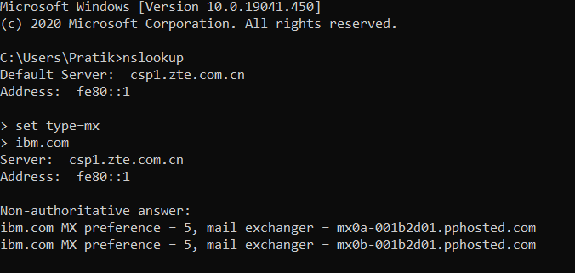

2. wipro.com

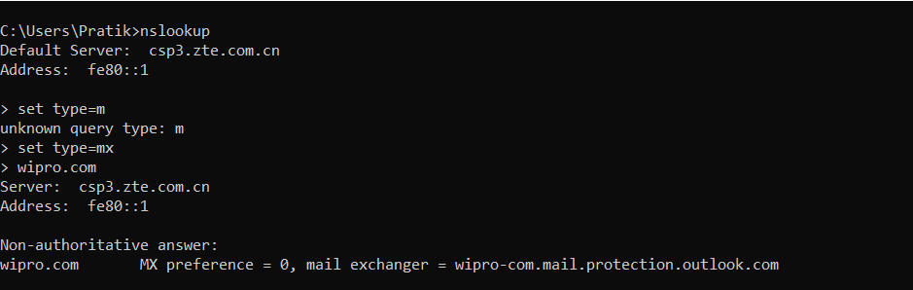

Q2-Find the locations where these email servers are hosted?

ANS- unable to find the answer.

Q3-Scan and find out port numbers open for 203.163.246.23?

ANS- First entered a command nmap 203.163.246.23 but it seemed the host is down.

Again entered a command but used a ping as a probe nmap –Pn 203.163.246.23

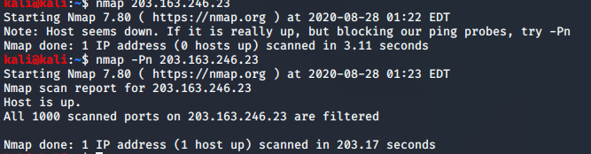

Q4-Install Nessus in a VM and scan your laptop/desktop for CVE?

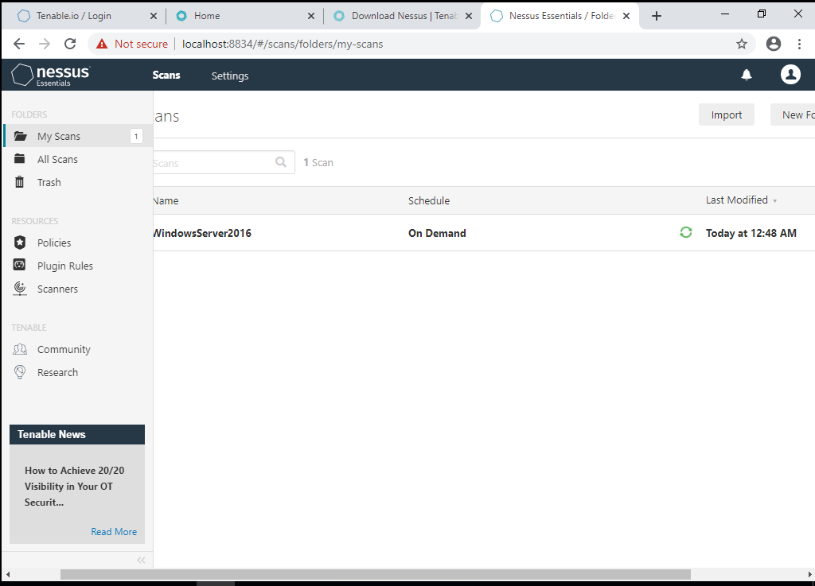

Server with IP 192.168.216.101

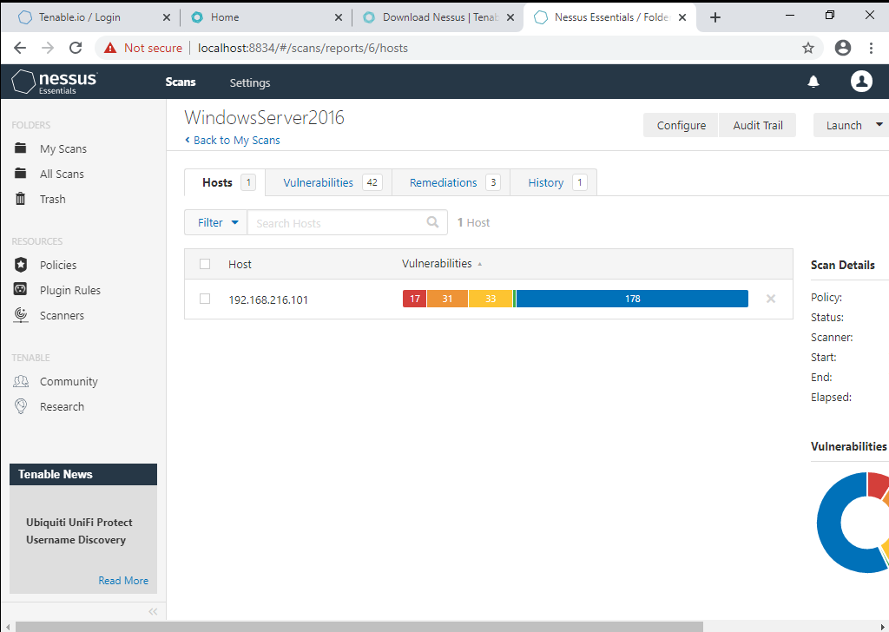

Some of the vulnerabilities found in the scan.

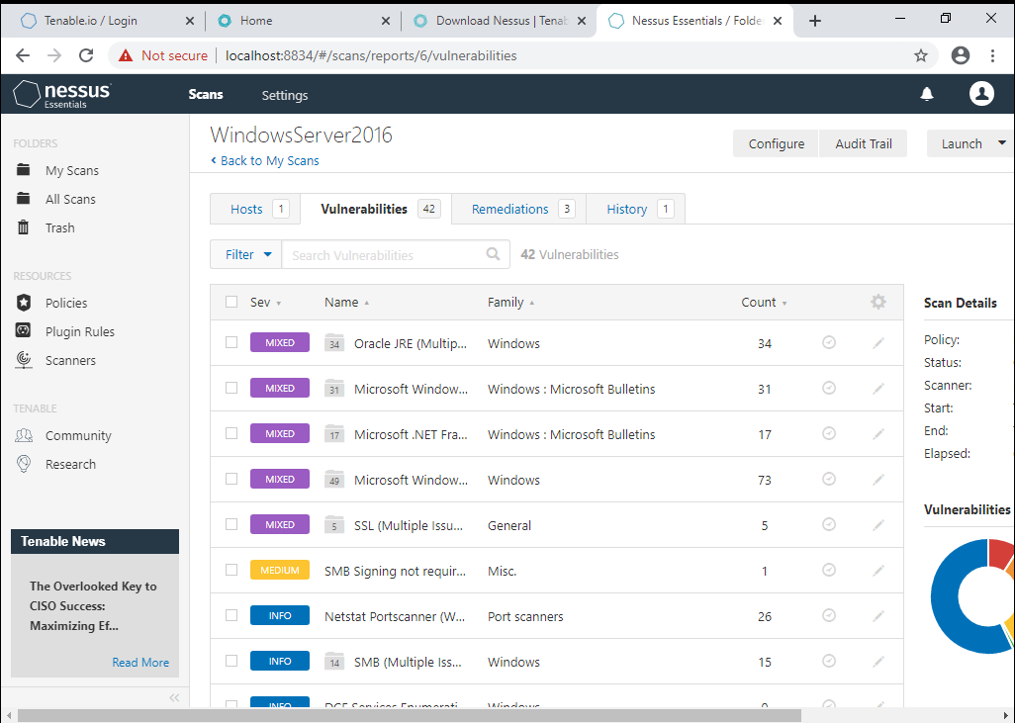

Remediations provided by nessus

