

Veriíed Certiícate Of Nanodegree Program Completion

Programming

Fundamentals

Awarded to

Timket Geta

chew

August 1 5, 2024

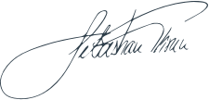

U DAC I TY

part of Accenture

Udacity has conírmed participation of this individual in this

program. Conírm program [conírm.udacity.com/e/1694fba2-4d9](https://confirm.udacity.com/e/1694fba2-4d9b-11ef-9a0e-3b2b7c73e028) [b-11ef-9a0e-3b2b7c73e028](https://confirm.udacity.com/e/1694fba2-4d9b-11ef-9a0e-3b2b7c73e028).

Sebastian Thrun Founder, Udacity