

Machine Learning 1
(015156)
Year 2 (2026/27), Semester 1

SCHOOL OF INFOCOMM TECHNOLOGY
Diploma in Data Science

ASSIGNMENT 1 REPORT

Apr 2026 Semester – Diploma in Data Science (DS)
Deadline for Submission: Sunday, 2 Aug 2026, 2359 Hours

Student Name | Ethlind Leo Yee Qian
Student Number

Penalty for late submission:
  - 10% per day from the due date.
  - NO submission will be accepted after 9 Aug 2026, 23:59 Hours

WARNING

If a student is found to have submitted work not done by him/her, he/she will not be awarded any marks for this assignment. Disciplinary action will also be taken.
Similar action will be taken for the student who allows other student(s) to copy his/her work.

1. Table of Contents
Contents
ASSIGNMENT 1 REPORT 1
1. Table of Contents 2
2. Summary / Overview 3
3. Task 1: Wine Quality (Quality Score Prediction) 5
3.1 Problem Understanding 5
3.2 Data Exploration 5
3.3 Data Cleansing and Transformation 6
3.4 Correlation Analysis 6
3.5 Modeling (At Least Two Supervised Models) 7
3.6 Performance Analysis 8
4. Task 2: Online Retail (Customer Segmentation) 10
4.1 Problem Understanding 10
4.2 Data Exploration and Preparation 10
4.3 Feature Engineering for Clustering 11
4.4 Build TWO Different Clustering Models 11
4.5 Evaluate and Compare the Models 12
4.6 Segment Naming and Interpretation 13
5. Summary and Further Improvements 14
6. AI Declaration 16

2. Summary / Overview
(Word count: 500 words)
This assignment has two machine learning tasks using two different datasets. The first task is about predicting wine quality using supervised learning. The second task is about grouping customers using unsupervised learning. The aim of this assignment is to learn how to prepare data, build machine learning models, compare their performance, and explain the results.

For Task 1, the Wine Quality dataset was used. The business objective is to predict the quality score of white wine by using its chemical properties. The dataset contains features such as fixed acidity, volatile acidity, citric acid, residual sugar, chlorides, sulphates, alcohol and other measurements. The target variable is the wine quality score. Before building the models, the dataset was explored to understand the data. Missing values, duplicate records and outliers were checked. Outliers were removed using the IQR method. A correlation heatmap was also created to understand the relationship between the features and the target variable.

Two supervised learning models were built for this task, which are Linear Regression and Decision Tree Regression. The models were evaluated using Mean Absolute Error (MAE), Root Mean Squared Error (RMSE) and R-squared (R²). Different Decision Tree depths were also tested to improve the model performance. After comparing the results, Linear Regression was selected as the better model because it achieved the lower test RMSE and gave more consistent performance on the testing data.

For Task 2, the Online Retail dataset was used. The business objective is to group customers based on their buying behaviour so that the company can understand different customer groups and plan better marketing strategies. Since this is an unsupervised learning task, there is no target variable. Instead, customer features were created using the RFM method, which includes Recency, Frequency and Monetary value.

Before clustering, missing customer IDs, duplicate records, cancelled invoices and invalid transactions were removed. The RFM features were created and standardised before building the clustering models. Two clustering algorithms were used, which are K-means Clustering and Hierarchical Clustering. The Elbow Method suggested that either 3 or 4 clusters could be suitable. Both were compared using the silhouette score, and 3 clusters were selected because they achieved the higher score. A dendrogram was used for Hierarchical Clustering. The models were compared using the Silhouette Score.

The customers were grouped into three segments. Each segment was given a meaningful name based on the RFM values. Business actions were also suggested for each customer group. After comparing the clustering models, K-means was selected because it achieved the higher Silhouette Score and produced clearer customer groups.

Overall, this assignment shows how machine learning can be used to solve business problems. It also shows the importance of data preparation, model evaluation and interpreting the results before making business decisions.

Word Count: 436

3. Task 1: Wine Quality (Quality Score Prediction)
(Word count: Min 1000 / Max 3000 words)

3.1 Problem Understanding
The aim of this task is to build a machine learning model that can predict the quality score of white wine. Predicting wine quality is useful because it helps wine producers check product quality without relying only on human tasting. A good prediction model can also help reduce time and cost while keeping the quality of the wine consistent.

The dataset used in this task is the White Wine Quality dataset. It contains different chemical properties of white wine, such as fixed acidity, volatile acidity, citric acid, residual sugar, chlorides, sulphates and alcohol. These features are used as the input variables. The target variable is quality, which is the quality score given to each wine sample.

Since the target variable is a numeric value, this is a regression problem. Two supervised learning models were built in this task, which are Linear Regression and Decision Tree Regression. After building the models, their performance was compared using evaluation metrics to find the better model for predicting wine quality.

3.2 Data Exploration
The first step was to explore the dataset to understand its contents. The dataset information and summary statistics were checked to understand the data type and value range of each feature. Missing values and duplicate records were also checked before building the machine learning models.

The summary statistics showed that the features had different ranges of values. Some features, such as residual sugar and total sulfur dioxide, had much larger values than others. This helped identify the need for data cleaning and outlier checking.

A bar chart was created to show the distribution of the wine quality scores. The chart showed that most wines have a quality score between 5 and 7. Very low and very high quality scores appeared less often. This means the dataset is not evenly distributed across all quality levels.

Boxplots were also used to check for outliers in the numerical features. Some variables, such as residual sugar, chlorides and sulphates, contained extreme values. Outliers can affect the performance of some machine learning models, so they needed to be handled before model training.

Overall, the data exploration step helped to understand the dataset and identify problems that needed to be fixed before building the regression models.

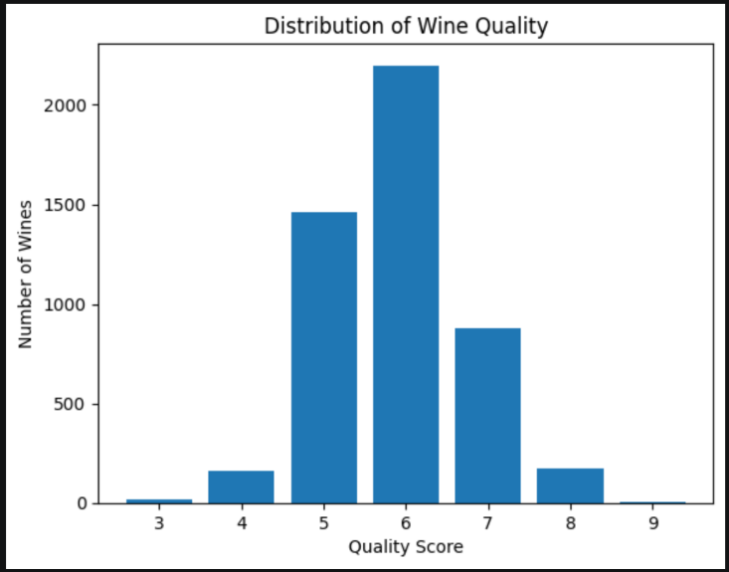
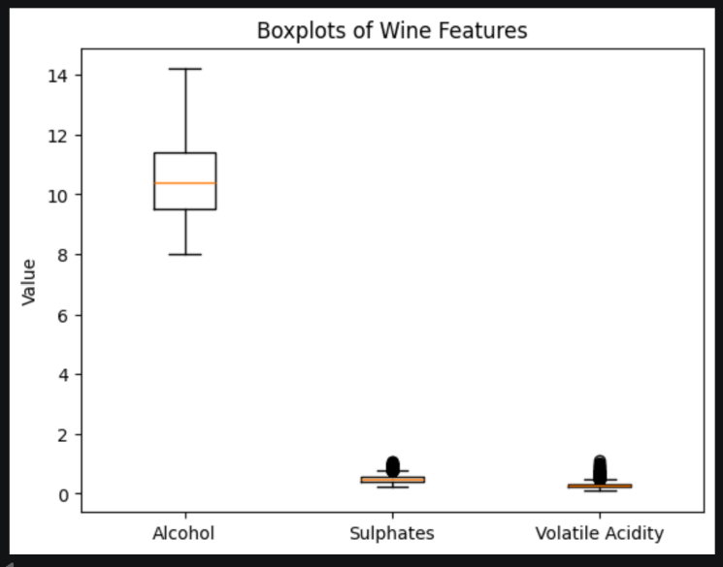
Figure 1: Wine Quality Distribution Chart Figure 2: Boxplots Showing Outliers

3.3 Data Cleansing and Transformation
After exploring the dataset, data cleansing was carried out to prepare the data for machine learning. Missing values and duplicate records were checked first. No missing values or duplicate rows were found, so no rows needed to be removed for these issues.

Next, outliers were handled using the Interquartile Range (IQR) method. Rows with extreme values outside the lower and upper IQR limits were removed from the dataset. This helps reduce the effect of unusual values that may reduce model performance.

The target variable was set as quality, while the remaining columns were used as the input features. The dataset was then divided into training data and testing data. The training data was used to train the models, while the testing data was used to evaluate how well the models performed on unseen data.

These data preparation steps helped improve the quality of the dataset and ensured that the models were trained using clean and reliable data.

3.4 Correlation Analysis
A correlation heatmap was created to study the relationship between the features and wine quality. Alcohol had the strongest positive relationship with quality (0.46), which means wines with higher alcohol content generally received higher quality scores. Density had the strongest negative relationship with quality (-0.35), which means wines with higher density generally received lower quality scores.

Most of the other features had weak relationships with quality because their correlation values were close to zero. The heatmap also showed strong relationships between some input features, such as residual sugar and density (0.81), and alcohol and density (-0.79).

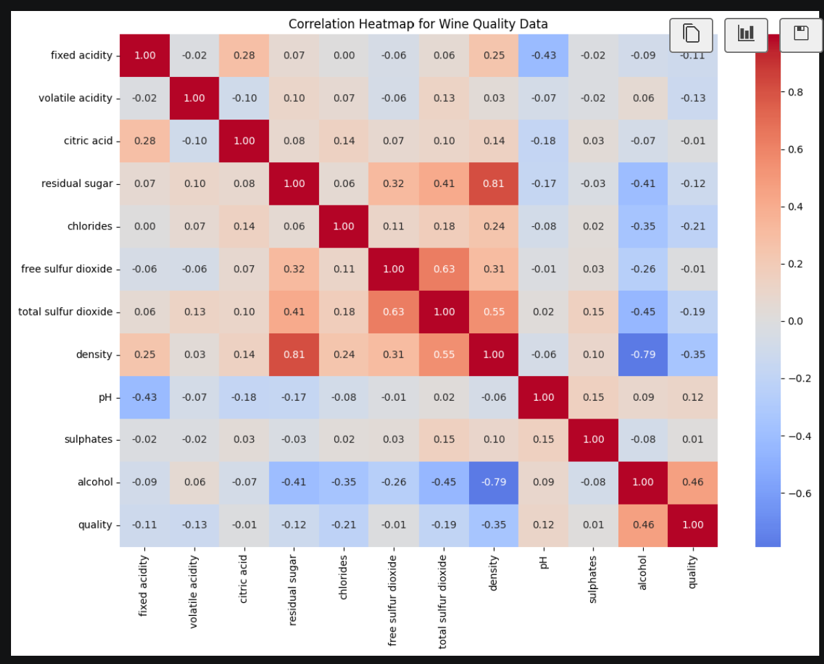
Figure 3: Correlation Heatmap

3.5 Modeling (At Least Two Supervised Models)
Two supervised learning models were built to predict the wine quality score. The models used were Linear Regression and Decision Tree Regression. These two models were selected because they were covered during the Machine Learning practical lessons and are suitable for regression problems.

The first model was Linear Regression. This model finds the relationship between the input features and the target variable. It predicts the quality score by fitting a straight-line relationship between the features and the quality score. Linear Regression is simple, easy to understand and works well when the relationship between the variables is mostly linear.

The second model was Decision Tree Regression. This model makes predictions by splitting the data into smaller groups based on different feature values. It creates a tree structure where each split helps reduce prediction errors. Decision Trees are able to learn more complex relationships between the features and the target variable.

After building both models, their performance was compared using the testing dataset. The Decision Tree model was further improved by testing different maximum depth values. Different depths were compared using RMSE to find the depth that produced the best performance. This tuning step helped reduce overfitting and improve the prediction accuracy of the Decision Tree model.

Both models were trained using the same training data and evaluated using the same testing data so that the comparison would be fair.

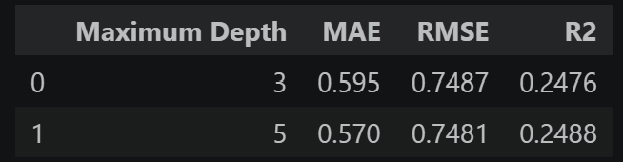
Figure 4: Decision Tree Performance Comparison

3.6 Performance Analysis
The performance of both regression models was evaluated using Mean Absolute Error (MAE), Root Mean Squared Error (RMSE) and R-squared (R²). These evaluation metrics help measure how close the predicted quality scores are to the actual quality scores.

MAE measures the average prediction error. A lower MAE means the predictions are closer to the actual values. RMSE also measures prediction error but gives a larger penalty to bigger errors. A lower RMSE shows better model performance. R² measures how well the model explains the variation in the target variable. A higher R² value means the model fits the data better.

After comparing the results, Linear Regression achieved the lower testing RMSE compared with the Decision Tree Regression model. This means the Linear Regression model produced more accurate predictions on unseen data. Although the Decision Tree model was improved by tuning the maximum depth, its testing RMSE was still slightly higher than the Linear Regression model.

The Decision Tree model performed well on the training data but did not perform as well on the testing data. This suggests that the model may have learned some patterns that were specific to the training data. Linear Regression produced more stable results between the training and testing datasets.

Based on the evaluation results, Linear Regression was selected as the preferred model for predicting wine quality. It achieved the better testing performance and provided more consistent predictions. It is also easier to understand and explain compared with the Decision Tree model.

Overall, both models were able to predict wine quality, but Linear Regression gave the better balance between prediction accuracy and model simplicity. Therefore, it is recommended as the final model for this task.

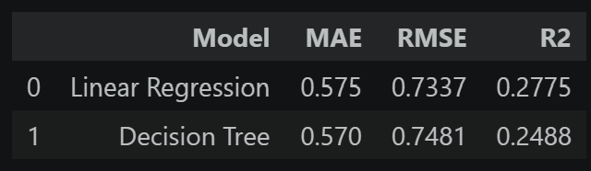
Figure 5: Performance Comparison Between Linear Regression and Decision Tree (Depth 5)

Word Count: 1115

4. Task 2: Online Retail (Customer Segmentation)
(Word count: Min 1000 / Max 3000 words)

4.1 Problem Understanding
The aim of this task is to group customers based on their purchasing behaviour using customer transaction data. Customer segmentation helps businesses understand different types of customers so that they can plan better marketing strategies, improve customer retention and provide more personalised services.

The dataset used in this task is the Online Retail dataset. It contains transaction records such as invoice numbers, product descriptions, quantities, unit prices, invoice dates and customer IDs. Unlike the wine quality dataset, this dataset does not have a target variable because the goal is to discover groups of similar customers instead of predicting an output.

To prepare the data for clustering, customer-level features were created using the RFM method:
- Recency - the number of days since the customer's last purchase.
- Frequency - the number of purchases made by the customer.
- Monetary - the total amount spent by the customer.

These RFM features were then used to build clustering models. Two clustering algorithms, K-means Clustering and Hierarchical Clustering, were used and compared to identify the most suitable customer segments.

4.2 Data Exploration and Preparation
The Online Retail dataset was explored to understand its contents before building the clustering models. The dataset contains customer transaction records, including invoice numbers, product descriptions, quantities, unit prices, invoice dates and customer IDs. The data was first checked to identify any issues that could affect the clustering results.

Several data cleaning steps were carried out to prepare the dataset. Rows with missing CustomerID values were removed because these transactions could not be linked to any customer. Duplicate records were also removed to avoid counting the same transaction more than once. Cancelled transactions, transactions with negative quantities and records with zero or negative unit prices were removed because they did not represent valid purchases.

As shown in Figure 6, the number of rows decreased from 541,909 to 392,692 after the data cleaning process. Removing invalid records helped improve the quality of the dataset and ensured that only valid customer transactions were used for the clustering models.

Overall, the data preparation process produced a clean and reliable dataset, which is important for creating meaningful customer segments.

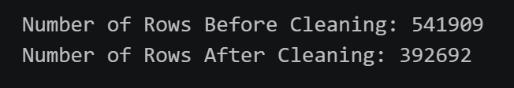
Figure 6: Number of Rows Before and After Data Cleaning

4.3 Feature Engineering for Clustering
Before building the clustering models, new customer features were created using the RFM (Recency, Frequency and Monetary) method. These features summarise each customer's purchasing behaviour and make it easier to group customers with similar buying patterns.

Recency measures the number of days since a customer's last purchase. Customers with lower recency values have made purchases more recently. Frequency measures how many purchases each customer has made. Customers with higher frequency values buy more often. Monetary measures the total amount spent by each customer. Customers with higher monetary values contribute more to the company's sales.

After the RFM features were created, they were standardised before clustering. Standardisation was carried out because the three features have different scales. This ensures that no single feature has a greater influence on the clustering results than the others.

The final RFM dataset was then used as the input for both the K-means Clustering and Hierarchical Clustering models.

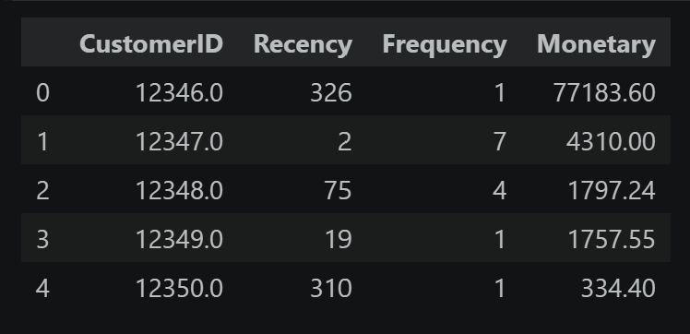
Figure 7: Sample of the RFM Dataset Used for Customer Clustering

4.4 Build TWO Different Clustering Models
Two clustering models were built to group customers based on their RFM features. The models used were K-means Clustering and Hierarchical Clustering. These two models were selected because they were covered during the Machine Learning practical lessons and are suitable for customer segmentation.

The Elbow Method suggested that either 3 or 4 clusters could be suitable. I compared both using the silhouette score. Since the 3-cluster model achieved the higher silhouette score, I selected 3 clusters for the final K-means model.

The second model was Hierarchical Clustering. A dendrogram was created to show how customers were grouped based on their similarity. From the dendrogram, three clusters were also selected for the final Hierarchical Clustering model.

Both models were trained using the same standardised RFM dataset so that the clustering results could be compared fairly.
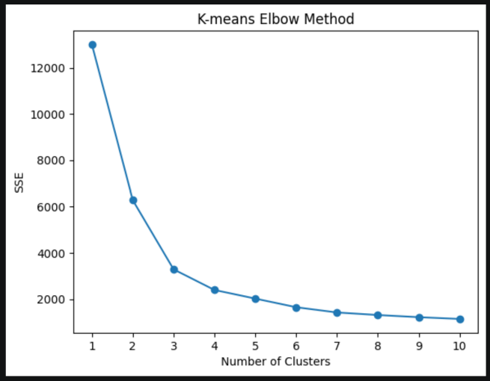
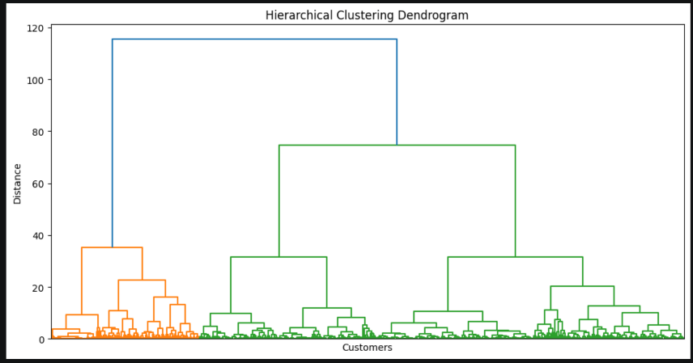
Figure 8: Elbow Method for K-means Clustering Figure 9: Hierarchical Clustering Dendrogram

4.5 Evaluate and Compare the Models
The performance of the two clustering models was evaluated using the Silhouette Score. The Silhouette Score measures how well the customers are grouped into clusters. A higher Silhouette Score indicates that the clusters are more clearly separated and that customers within the same cluster are more similar to one another.

K-means achieved a silhouette score of 0.5095, while Hierarchical Clustering achieved 0.4651. Since a higher silhouette score means better clustering, K-means was selected as the final clustering model.

Based on the evaluation results, K-means Clustering was selected as the preferred model. It produced clearer customer segments and was therefore used for the final customer segmentation and interpretation.

The higher Silhouette Score shows that the K-means model produced clusters that were more compact and better separated. Therefore, it was selected as the final model for customer segmentation.

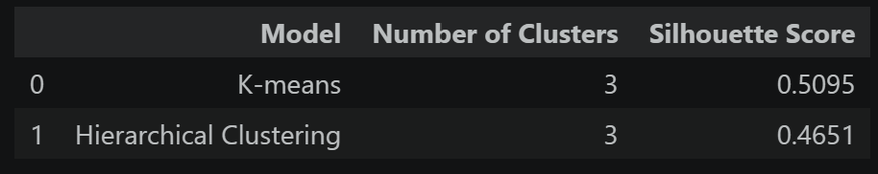
Figure 10: Silhouette Score Comparison Between K-means and Hierarchical Clustering

4.6 Segment Naming and Interpretation
The customer segments created by the K-means Clustering model were analysed using their average Recency, Frequency and Monetary (RFM) values. Based on these values, each cluster was given a meaningful name to describe the customers' purchasing behaviour.

- High-Value Loyal:
These customers buy often, spend the most money and purchased recently. They are the business's best customers. Loyalty rewards and special promotions can help keep them.

- Recent Occasional:
These customers purchased recently but do not buy very often. The business can encourage them to buy again with personalised offers and promotions.

- At-Risk Low-Value:
These customers have not purchased for a long time and spend the least. The business can try to bring them back with reminder emails or discount offers.

Overall, the customer segmentation provides useful insights into different customer groups. By understanding the purchasing behaviour of each segment, the business can develop targeted marketing strategies to improve customer satisfaction and increase sales.

These customer segments can help the business make better decisions. By targeting each group with suitable marketing strategies, the company can improve customer retention, increase sales and build stronger relationships with its customers.

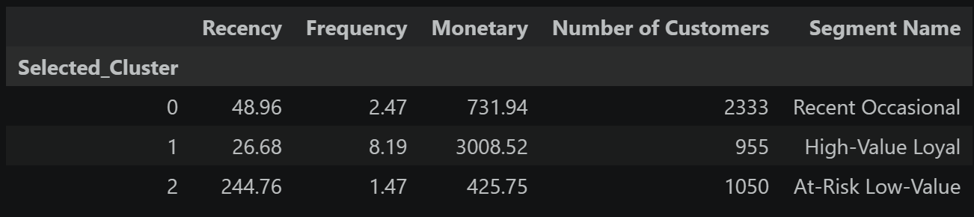
Figure 11: Average RFM Values for the Three Customer Segments

Word Count: 1022

5. Summary and Further Improvements
(Word count: Min 800 / Max 2000 words)
This assignment applied machine learning techniques to solve two different business problems. The first task focused on predicting wine quality using supervised learning, while the second task focused on customer segmentation using unsupervised learning. Both tasks demonstrated the importance of preparing data before building machine learning models. The assignment also showed that selecting suitable models and evaluating their performance are important steps in producing reliable results. By completing both tasks, I gained a better understanding of how machine learning techniques can be applied to real business situations.

For Task 1, the Wine Quality dataset was used to predict the quality score of white wine. The dataset was first explored to understand its structure and identify any issues that needed to be addressed. Missing values, duplicate records and outliers were checked before model building. Outliers were removed using the IQR method to reduce the effect of extreme values. A correlation heatmap was also created to study the relationships between the input features and the target variable. This helped identify which features had stronger relationships with wine quality and provided a better understanding of the dataset before training the models.

Two supervised learning models were built for the prediction task, which were Linear Regression and Decision Tree Regression. Both models were trained using the same training dataset and evaluated using the same testing dataset to ensure a fair comparison. Their performance was measured using Mean Absolute Error (MAE), Root Mean Squared Error (RMSE) and R-squared (R²). GridSearchCV was used to test different Decision Tree settings. The best model was selected based on the lowest RMSE. Although the Decision Tree model achieved a slightly lower MAE, the Linear Regression model produced a lower RMSE and a higher R². These results showed that Linear Regression produced more accurate and consistent predictions on unseen data. Therefore, it was selected as the preferred model for predicting wine quality.

For Task 2, the Online Retail dataset was used to group customers according to their purchasing behaviour. Before building the clustering models, the dataset was cleaned by removing missing customer IDs, duplicate records, cancelled transactions and invalid values. This ensured that only valid customer transactions were included in the analysis. Customer-level features were then created using the RFM method, which consists of Recency, Frequency and Monetary. These features summarise customer purchasing behaviour and are commonly used for customer segmentation. The RFM features were then standardised so that each feature contributed equally during clustering.

Two clustering algorithms were built and compared, namely K-means Clustering and Hierarchical Clustering. The Elbow Method was used to determine a suitable number of clusters for K-means, while a dendrogram was used for Hierarchical Clustering. Both models were evaluated using the Silhouette Score. The K-means model achieved a higher Silhouette Score than the Hierarchical Clustering model, indicating that it produced more compact and better-separated customer groups. Based on these results, K-means Clustering was selected as the preferred model for customer segmentation.

The customer segmentation results provided useful business insights. Three customer groups were identified and named according to their purchasing behaviour. The Recent Occasional Customers group consists of customers who purchased recently but do not buy frequently. The High-Value Loyal Customers group contains customers who purchase often and spend the most money, making them the most valuable customers for the business. The At-Risk Low-Value Customers group includes customers who have not purchased for a long time and spend relatively little. By understanding these customer groups, businesses can create suitable marketing strategies, improve customer retention and encourage repeat purchases.

Although both tasks produced useful results, there are still some limitations. The Wine Quality dataset only contains chemical measurements of the wines. Other factors that may affect wine quality, such as grape variety, production methods, storage conditions and climate, were not included in the dataset. These missing factors may reduce the prediction accuracy of the models. Similarly, the customer segmentation task only used the RFM features. Other customer information, such as location, age, preferred products or shopping preferences, may provide additional insights and produce more detailed customer segments.

There are several ways the models can be improved in future work. For the wine quality prediction task, more advanced regression models such as Random Forest Regression or Gradient Boosting could be tested and compared with the current models. Additional hyperparameter tuning and cross-validation could also improve the reliability and performance of the models. For customer segmentation, different clustering algorithms or additional customer features could be explored to produce more meaningful customer groups. A larger and more up-to-date dataset may also improve the quality of the clustering results.

Overall, this assignment demonstrated how machine learning can be applied to solve real-world business problems using both supervised and unsupervised learning techniques. It highlighted the importance of data exploration, data preparation, model building, model evaluation and result interpretation. Through this assignment, I gained practical experience in applying machine learning methods and learned how different algorithms can be selected based on the business problem. The knowledge and skills gained will be useful for future data science projects and for making better data-driven business decisions.

Word Count: 835

6. AI Declaration
Please complete the Gen-AI Use Declaration on the following page by ticking the appropriate box.

Gen-AI Use Declaration

Students must declare on submission that they used Gen-AI in accordance with the assessment’s restrictions (if any) and that, if Gen-AI use is restricted, they will produce evidence of such use upon request.

Declaration by Students of GENERATIVE AI USE
Please check either ‘Yes’ or ‘No’ to indicate whether you or your team have used Gen-AI for this assignment:
☐ | Yes, I/we declare and acknowledge that  I/we have adopted, verified and adapted Generative Artificial Intelligence (Gen-AI) output for this assessment in accordance with restrictions imposed for this assessment.  (Where Gen-AI is restricted) I/We have and will produce upon request evidence of how I/we used Gen-AI. This includes for example:  - Drafts of work done before & during use of the Gen-AI tools  - History of use of Gen-AI for this assessment on any device including phones, tablets and computers shared with others.
☐ | No, I/we have not used Gen-AI.

