Name: Etienne Arnoult
Natural Language Processing Final Project
Spring 2026

Trump’s Provocative Language on Twitter has no Effect on Public Opinion

GitHub: EtienneArnoult/NLP-Project-2026: analyzing the impact of the emotional valence of Donald Trump's tweets on his approval ratings using R.

1.0: Introduction
It has been well documented that emotionally arousing stimuli are more likely to be encoded into long-term memory (Park 2026). Stimuli that arouse negative emotions are even more likely to be remembered than happy or neutral stimuli (Kern 2005). This effect is best seen on social media platforms where users can repost, share, and send posts between themselves and other users in large networks. In an analysis of 30 million Twitter posts, it was found that high-arousal negative content was posted by biased (left and right-leaning) news outlets more frequently than balanced news stories (Knutson 2024). This content was also reposted and shared significantly more often than balanced stories (Knutson 2024). Negatively arousing content is posted more often to increase social media engagement. The publicity from sharing negative news stories or making negative posts increases the publicity of the publisher. Politicians use this tactic specifically to drum up attention for their campaign and political views. Donald Trump is well known for his personal social media posts and those made by his administration as being emotionally arousing.
P.T. Barnum coined the saying “There’s no such thing as bad PR” in the 19th century. Trump and his administration’s social media posts are polarizing the public to extremes (Iyengar 2025, Tucker 2018). As Trump's current term continues, it has been shown that his approval ratings have been significantly dropping since his inauguration in 2025 (Daniel, 2026). Trump has also increased the use of language with negative valence over time (Daniel 2026). Language used by political figures is usually tightly controlled due to its strong impact on the opinions of the president and their administration. Despite this, there is a literature gap in the linguistic qualities of politicians' speech on social media and its effect on their approval rating.

1.1: Research Question
Did the emotional valence and arousal of the language Trump used on twitter during his first term have an impact on his approval ratings the following day, or did Trumps approval ratings affect his use of valent and arousal language the following day?
1.2: Hypothesis
Trump's use of emotionally arousing and negatively valent language negatively impacted his approval ratings the following day.
1.3: Alternative Hypothesis
Trump’s language on twitter has no impact on his approval ratings. Trumps approval ratings have no impact on his language on twitter.
2.0: Methods
2.1: Data
For this analysis the American Presidency Project polling data for Donald Trump was used (Wholly 1950 -). This analysis will only focus on tweets made during his first term (1/20/17 -.1/8/21). Trump's Twitter will be text-mined to analyze the valence and arousal of his language on social media. All text analyses will be done using R.
2.2: Cleaning
To begin the cleaning process, all retweets were removed due to them containing text that was not posted by Donald Trump. The tweets were then broken into individual words while maintaining the date they were posted. Mentions using the @ symbol, hashtags and links were removed using regular expressions. Contractions were split into two words and put onto separate lines while the date was maintained. Stop words, nonwords, punctuation, and numbers were removed using regular expressions. Data was lemmatized to convert inflectional words back to their dictionary form.
2.3: Sentiment Analysis
Sentiment analysis was conducted on clean data. Valence and arousal scores were calculated for each word. This requires the use of the lookup database we used in class. The variables “emo_arousal_b24_rescale” and “emo_valence_b24_rescale” were used to calculate valence and arousal scores of every word from Trump's tweets. All words that didn't have a valence or arousal score were removed; this encompassed 6.5% of clean data. The score of each word and its emotional valence within these variables were correlated with Donald Trump's average daily approval rating. Granger causality was used to see if the valence and arousal of Trumps language impacted his approval rating the day after they were posted. A reverse analysis was also conducted to see if the daily approval ratings influenced his valent and arousing language on twitter the following day. Approval polling data was difference corrected to fix the non-stationary structure. Variable autoregression (VAR) analysis was used to see the total effect of significant variables from granger causality and the direction of the effect.
3.0: Results
3.1: Correlation
Polls and valence lagged by one day did not significantly correlate R = -0.0224 (p = 0.3963). Daily polling averages and arousal lagged by one day did significantly correlate R = -0.0954 (p < 0.01). Average arousal did significantly correlate with polls lagged by 1 R = -0.0888, (p < 0.01). Average valence did not significantly correlate with polling data lagged by 1 day R = -0.0233, (p = 0.379)
Figure 1: Correlations
A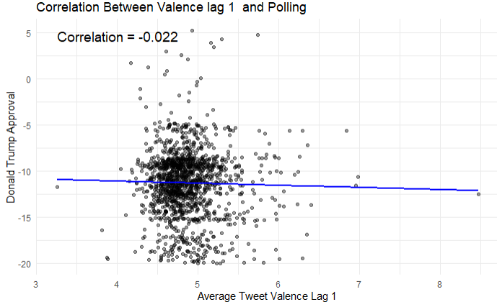 | B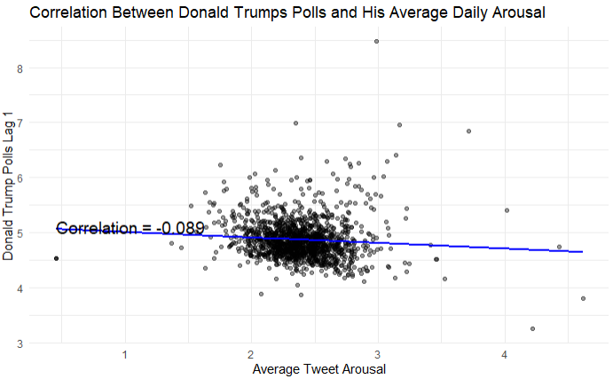
C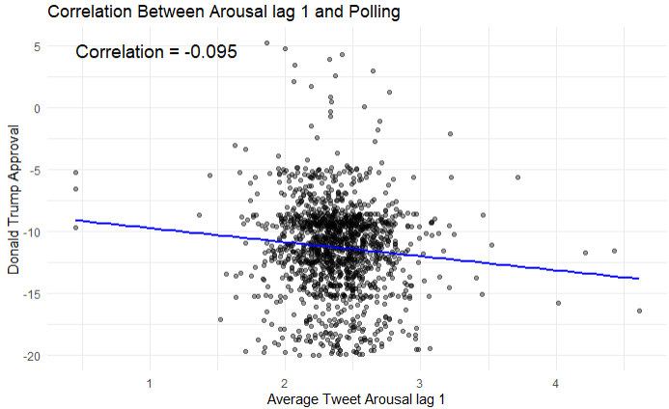 | D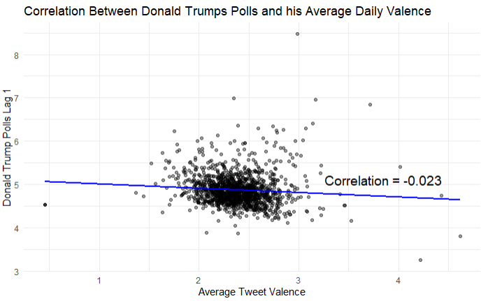
A: Correlation between Average Daily Valence lag = 1 and Daily polls (R = -0.022). B: Correlation between polls lagged by 1 and daily arousal (R = 0.08). C: Correlation between daily tweet valence lag = 1 and polling data (R = -0.095). D: Correlation between polls lag = 1 and average daily arousal (R = -0.023).
3.2: Granger Causality
Donald Trump's polls were a significant predictor of changes in his use of arousing language the following day, F = 10.172 (p < 0.01). However, arousal had no significant predictive effects on polls the following day. F = 0.477 (p = 0.4899). Valence had no predictive effect on polls F = 0.0076 (p = 0.9307); nor did polls have a significant predictive effect on valence used the following day F = 0.503 (p = 0.4783). Granger causality was lagged by one for all data to represent causal effects the day after.
3.3: VAR Modeling:
The significant results of polls being a significant predictor of polls were further investigated using a VAR model. The VAR model shows that differenced polling data had no predictive effect on arousal (β = -0.022, p = 0.75), nor did arousal have any predictive effect on changes in polling data (β = 0.001, p = 0.91).
4.0: Discussion
4.1: Results Discussion
The granger causality for this study was mostly insignificant. Only Trumps polling data had a significant granger causality on his arousal the following day. This shows that his polls could influence his language use on twitter the following day throughout his first term. After correcting for stationarity by differencing, VAR modeling showed an estimated coefficient of 0.022 on the lagged polling data, which qualitatively means that large changes in Donald Trump's poling data produce minuscule changes in daily average arousal. These changes were found to be insignificant. The result from granger causality shows significant short-term changes. However, when the data is evaluated as a model, there is no significant quantitative change in arousal scores by changes in Donald Trump's polls. This conclusion supports the alternative hypothesis that there is no significant relationship between changes in Donald Trump's approval polls and his language on twitter in either direction.

Figure 2: Granger Causality Arrow Plot
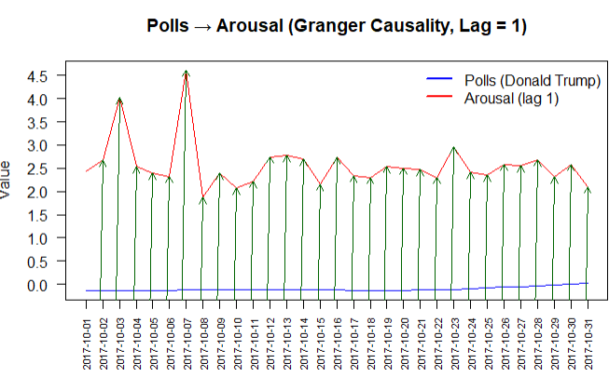Figure 2 shows differenced average daily polls (Donald Trump in blue) and daily arousal scores lagged by 1 (Arousal (lag 1 in red). The arrows show causal changes in polls and it’s effect on arousal scores. This data is taken from October 1st, 2017 – October 31st 2017.
Despite finding significant correlations between arousal and polling data, the R values for these variables are very close to 0. This means that almost none of the variance is explained by the slope of the line of best fit. These insignificant results may be due to the 1400 observations that were used for the calculations. The significance is a potential type 1 error. From the near 0 R value we can see that none of the variables correlate with each other when lagged by 1 day. This means that there is no significant quantitative direction of the granger caused relationships.
4.2: Analysis Issues and Potential Corrections
The insignificant results could be due to a variety of outside factors. The first being the polling data that was used. The dataset chosen is from the American Presidency Project created from UC Santa Barbara. Although this is a fine dataset used to represent the opinions of millions of American it might not be the projections Trump is shown by the white house's internal polling. Unfortunately, there is no way to access that data or to know if he even looked at his approval ratings each day. The polling data used is the best estimation of what Trump may have been shown. Large scale political events were also unaccounted for. This means that the effects of his administration were not accounted for in his polling data. While these events may have been discussed on twitter and impact the daily valence and arousing language; their specific effect is unaccounted for in this analysis.
There is a statistical issue with using polling data for granger causality. Granger causality assumes that the data is linear, stationary, and does not autocorrelate (Granger 1969). Trumps polling data is nonlinear and it autocorrelated since each polling day builds off polls from the following day. Despite differencing, other methods could use nonlinear statistics to model the data. Multiple regression using polynomial functions may find more informative results.
The data was lagged by 1 to represent its predictive and correlative effects on other variables the day after. It is plausible that his tweets could have effects on his poll two or more days after they have been posted. Using Cross Correlation Functions (CCF) can show what the optimal lag would be for granger causality. As an exploratory analysis, I ran cross correlation functions and found that there is no optimal lag for correlation. Within 20 days of lag for both arousal and valence only yield a +/- 0.04 R value. There is no significant correlation in the data no matter the lag.
Figure 3
A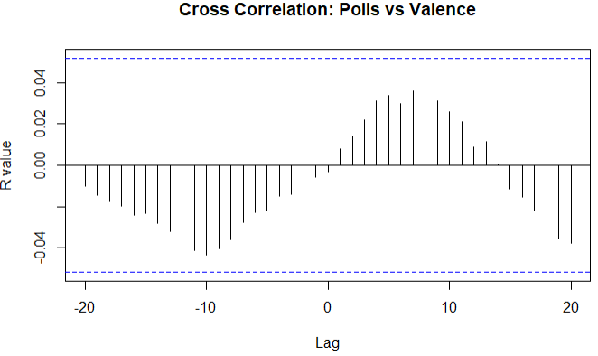 | B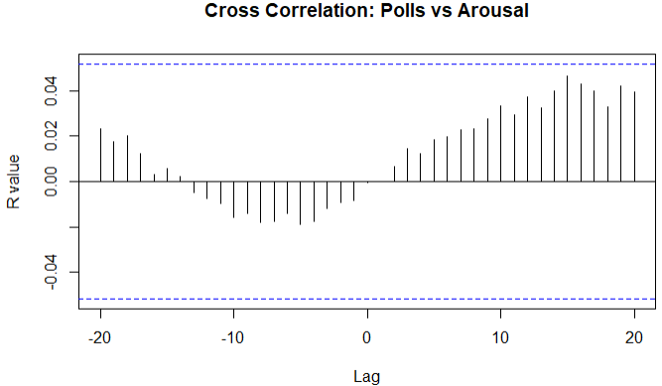
Plot A shows cross correlation functions (CCF) of daily polls and averaged daily valence. The x axis shows the lag while the y axis represents the R coefficient for each lag. Plot B shows the same plot using average daily polls and average daily arousal.
4.2: Future Research
Two variables were chosen from the lookup database: “emo_arousal_b24_rescale” and “emo_valence_b24_rescale”. There are ten other variables, including intensity of happiness, etc. that may have effects. It is possible that Trumps polls had an impact on his language categorized by these other variables. These variables could also have an impact on his daily approval ratings.
Tweet sentiment may affect other important variables in the world besides approval ratings. In a study from 2021, Peder Gjerstad et al, did an analysis on the volatility of the stock market after Trump tweeted. They showed that the stock market declines 30 minutes after Trump posts and if the post contains the words “Tariff” or “Products” these have an increased negative effect on the S&P 500 (Gjerstad 2021). Since Trumps twitter language is already a known factor of stock market decline, it could be possible that the general sentiment of his tweets also has an effect outside of specific keywords. Future research should investigate other variables that could have an impact on Trumps language or vice versa.

References
Daniel, A., Huang, J., Igielnik, R., Lee, J. C., Lemonides, A., Smith, J., Sun, A., & Taylor, R.
(2026, March 17). President Trump approval rating: latest polls. The New York Times. https://www.nytimes.com/interactive/polls/donald-trump-approval-rating-polls.html
Granger, C. W. J. (1969). Investigating Causal Relations by Econometric Models and Cross
spectral Methods. Econometrica, 37(3), 424–438. https://doi.org/10.2307/1912791
Iyengar, S. (2025). Identity Politics, Party Polarization, and the Rise of Donald Trump. In:
Aberbach, J.D., Cain, B.E., King, D., Peele, G. (eds) The Changing Character of the American Right, Volume I. Palgrave Macmillan, Cham. https://doi.org/10.1007/978-3-031-73168-6_4
Robinson, D. (2016, August 9). Text analysis of Trump’s tweets confirms he writes Only the (angrier) Android half. Variance Explained. http://varianceexplained.org/r/trump-tweets/
Kern, R. P., Libkuman, T. M., Otani, H., & Holmes, K. (2005). Emotional stimuli, divided
attention, and memory. Emotion (Washington, D.C.), 5(4), 408–417. https://doi.org/10.1037/1528-3542.5.4.408
Knutson B, Hsu TW, Ko M, Tsai JL (2024) News source bias and sentiment on social media.
PLoS ONE 19(10): e0305148. https://doi.org/10.1371/journal.pone.0305148
Ouyang, Y., Waterman, R.W. (2020). Trump Tweets: A Text Sentiment Analysis. In: Trump,
Twitter, and the American Democracy. The Evolving American Presidency. Palgrave Macmillan, Cham. https://doi.org/10.1007/978-3-030-44242-2_4
Park, J.S., Gollapudi, K., Ke, J. et al. Emotional arousal enhances narrative memories through
functional integration of large-scale brain networks. Nat Hum Behav 10, 370–383 (2026). https://doi.org/10.1038/s41562-025-02315-1
Peder Gjerstad, Peter Filip Meyn, Peter Molnár, Thomas Dowling Næss, Do President Trump's
tweets affect financial markets?, Decision Support Systems, Volume 147, 2021, 113577, ISSN 0167-9236, https://doi.org/10.1016/j.dss.2021.113577
Shearer, E., & Mitchell, A. (2021). News use across social media platforms in 2020.
Tucker, Joshua Aaron and Guess, Andrew and Barbera, Pablo and Vaccari, Cristian and Siegel,
Alexandra and Siegel, Alexandra and Sanovich, Sergey and Stukal, Denis and Nyhan, Brendan, Social Media, Political Polarization, and Political Disinformation: A Review of the Scientific Literature (March 19, 2018). Available at SSRN: https://ssrn.com/abstract=3144139 or http://dx.doi.org/10.2139/ssrn.3144139
Woolley, J. T. (John Turner), 1950–. The American Presidency Project. Santa Barbara, CA:
University of California, 1999.

