Installation:

Installing an app from another source than the Google play store might sound difficult and intimidating but it is quite simple. There are only few steps in order to get this done.

1. Plug your phone in a computer that has an APK (Android Package file).
2. In the notification bar, ensure that your phone is set on MTP or File Transfer mode instead of charging only.
3. Open your device from the file explorer of your computer.
4. Drag and drop your APK to a folder in your device (the location is not important but remember where it is located).
5. Open the setting app on your phone.
6. Go to the Security menu
7. Enable Apps from unknown sources (the phrasing might change from a device to another).
8. Use the file explorer app of your choice (most devices come with a default one).
9. Find the APK.
10. Click on it and click accept the invitation to install it.

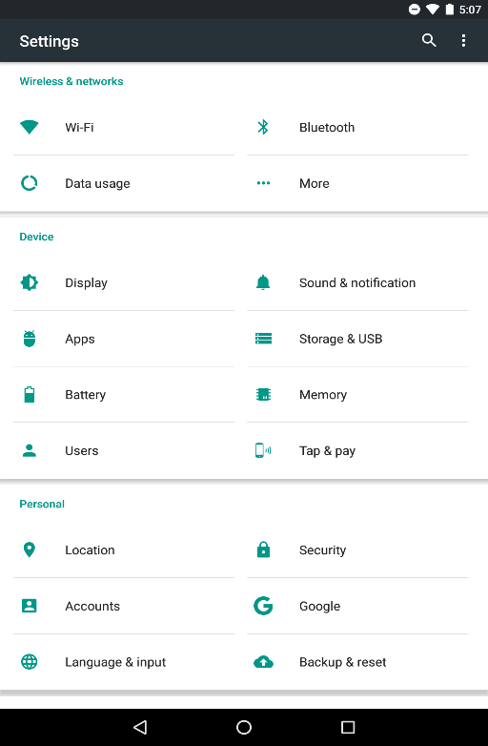

Image Security menu

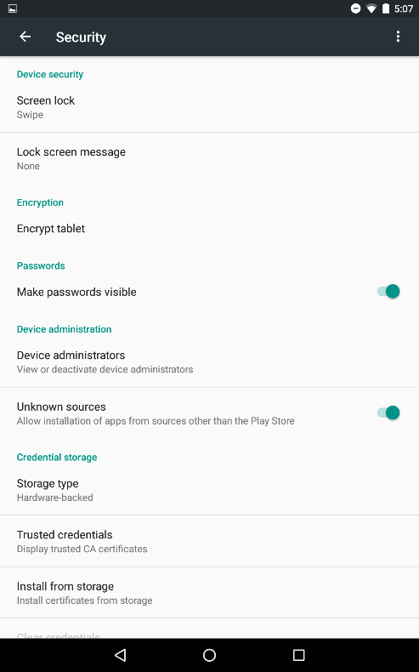

Image 2 Unknown Sources