Moods – App for Champlain Students

By

Amir Osman

Étienne Bérubé

William Perron-Lafleur

Presented to

Mr. Amin Ranj Bar

420-204-RE, Integrative Project in Computer Science and Mathematics, section 00871

Wednesday, February 26th, 2017

Champlain College Saint-Lambert

**Table of Contents**

**Introduction**………………………………………………………………………………1

**Design**……………………………………………………………………………………..4

Analysis……………………………………………………………………………4

Algorithm………………………………………………………………………….4

UML Diagrams………………………………..…………………………………..5

Graphical User Interface……………...……………………………………….…10

Object Design……………….……………………………………………………11

Timeline………………………………………………………………………….12

Software………………………………………………………………………….13

**Features**……………………………………………………………..…………………..14

**Conclusion**………………………………………………………………………………15

**Introduction**

As our final project we want to create a social network on android phones exclusively dedicated for Champlain students. Communication has always been something of paramount importance in the everyday life. During our college experience, we have noticed a lack of utilities to facilitate contacting the persons we care about. There is no way for students to get instant information about their college peers. Therefore, students who are looking to connect with other students are unable to do so to their liking. Considering students spend a lot of time at school, it is undoubted that such application would be extremely relevant and helpful in order for their life at school to be at its best state.

Additionally, we have also noticed that education is an unexploited domain in the programming world, even though education is essentially a domain everyone is involved at some point in their life. Hence, our goal is to make everyone’s experience at schools the best possible. We want people to have an optimal educative experience by providing them with a service that will allow them to facilitate their communication at school. Incidentally, what makes Moods special is that not only will it target the educative area, but also entertainment. Moods will offer students tools to help people study, but ultimately it will allow students to hang out together. Students wanting to eat for instance, will be able to connect with other students that are hungry. Students wanting to play outdoor soccer, will be able to organize an event. Students wanting to relax, will be able to reserve a room to lay back in. Moods has the opportunity to be successful because it provides simple solution to problems students meet at school. Our goal is not to provide something complex to students, as simplicity is complementary to efficacy. This is why each user is going to be able to reach out to other students within a click. We want students to be able to meet their friends and new people in the College more easily by using our application.

The lack of communication between students at school is essentially due to the fact that schools are too big. It is often difficult for people to know where their friends are, what they are doing, who they are with, what’s their schedule, etc. Therefore, the simple idea of meeting up with a friend is difficult, since you absolutely need to have their phone number and to have them use it exactly when you attempt to communicate with them. On the other hand, Moods would solve that problem by allowing students to publish their location and status/mood so that people don’t waste time anymore asking basic questions such as ‘Where are you?’ ‘What are you doing?’ to every single one of their friends. Instantly, the user will be able to see which students are available, what they are doing, and at what location they are (cafeteria, library, computer lab, etc.).

**Design**

Analyze, define, and understand the problem

The major problem is that students' are having trouble connecting quickly with their friends within their college. The main reason why is that they have no way of consulting their peers schedule, thus it is extremely inconvenient as students don't know when they have common breaks with their friends. This prohibits the students from doing things they would prefer doing together, such as studying, eating, learning, relaxing, and the list goes on.

Our application would be the perfect solution to that problem as one of its features involves storing every student’s schedule in database. Using an efficient mathematical algorithm, our tool will be able to perfectly match which students have common breaks. In other words, our users will be able to know who's available when you are to do anything you want, easily. In order to display what is that thing you want, you will be provided a tool to update your mood, thus your friends will know what you are up to.

Additionally, colleges are important in size, thus locating your best friends can most of the times be time-consuming. Therefore, our application would remedy to that problem by providing an option to share your location with your friends, so that they know exactly where you are when they need your presence, in the matter of seconds.

Again, there is an obvious need to simplify the students' social life at college by helping them connect together easily and quickly.

The Algorithm

The mathematic will be behind the scene. The application by itself is not based on any kind of science. The application is a social media, hence does not have a scientific purpose. However, a lot of mathematics is used since the program will have to deal with a lot of lists and arrays. For example, the search algorithm for finding profiles and lists is a binary search. This means that the average efficiency of the algorithm has a Big O notation of log(n). In the worst case scenario, the efficiency is O(n). This means that if the element that the computer is looking for is not in the array, there will be the same amount of comparison as there are elements in the array itself. As explained by the chart below, the time complexity for the binary search is in the excellent tier. Thus, for a big number of user profiles, it is the perfect algorithm for this given situation.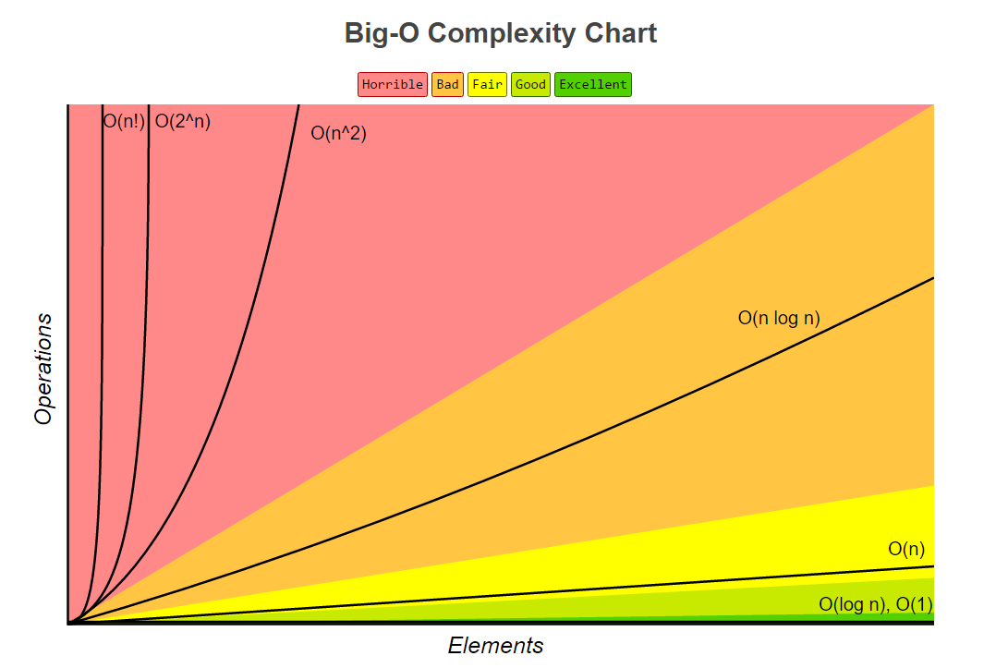

Moreover, this application will also require a lot of sorting of profiles in order to return an adequate list of friends. In general, it is difficult to find a good sorting algorithm. Moreover, our application will require sorting an array with non-primitive data types. Thus, the search algorithm is a normal insertion sort. The time complexity of this sorting method is of n2. Yet, the arrays to sort do not have a considerable size, since one can assume that a user will not have a significant amount of friends, no matter which algorithm is used, the time difference will not be a big one.

UML diagrams

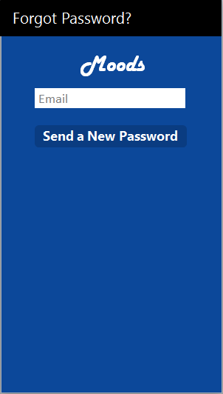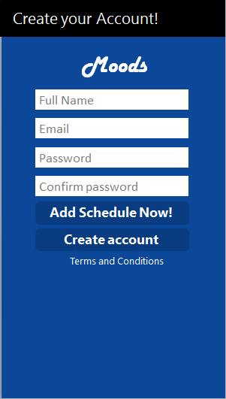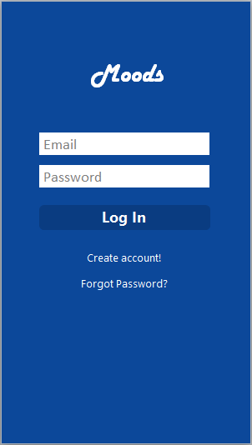

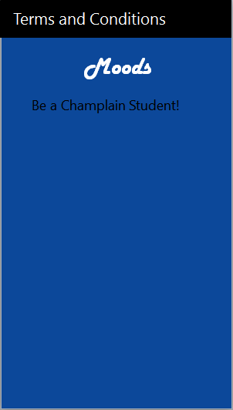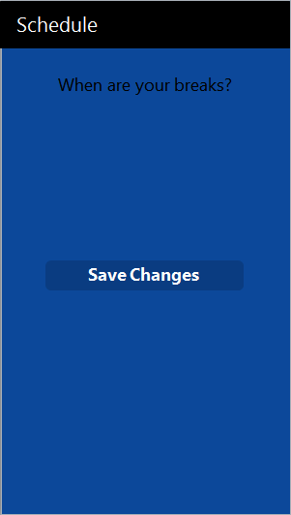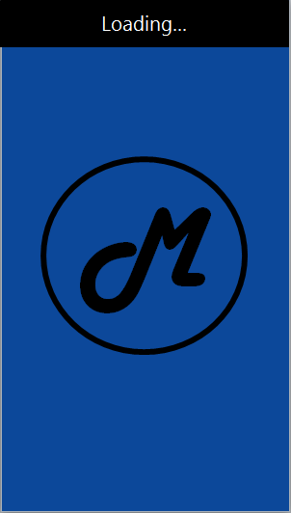

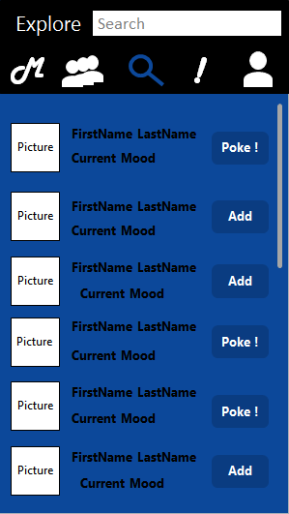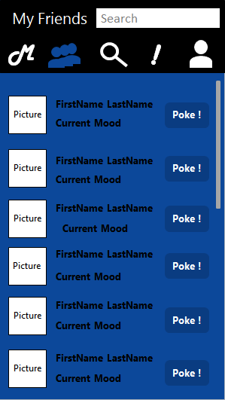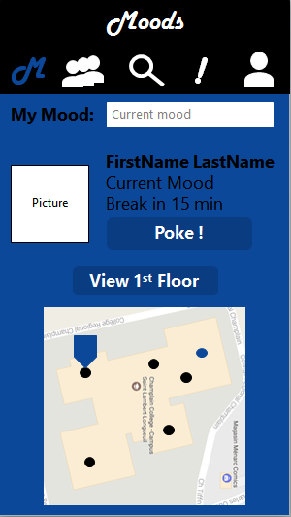

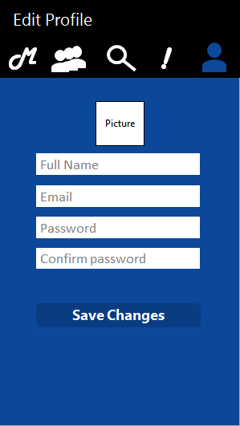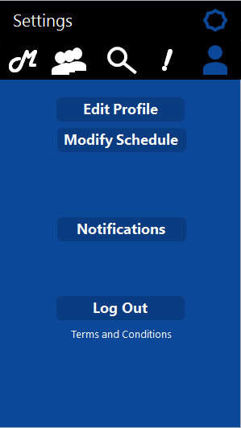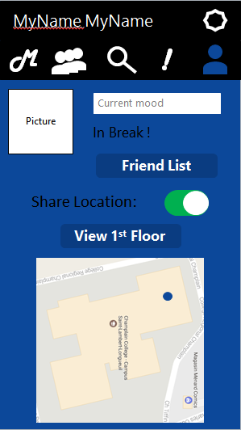

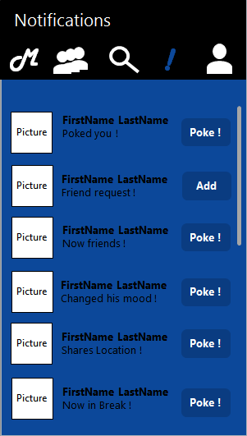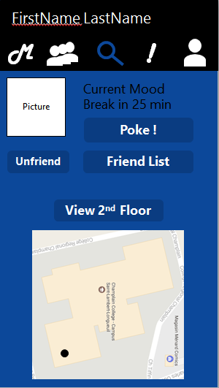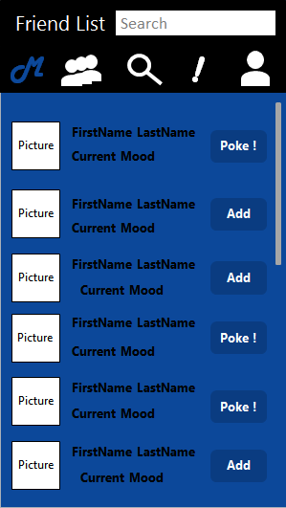

Design of every object in your project



**Software used:**

**Platform:** Android Java

The application is expected to run on Android Devices. All devices using Android Lollipop and above will have an access to the application.

**Menu**: User profile

The user will interact with the application throughout multiple pages and menus. There will be a home page for the user to change his mood and status, yet the rest of the settings will be accessed through the settings page.

**Accounts**: Login Authentication

The users will be able to log from a database. A basic encryption scheme will be used to protect the user’s privacy. Using this database, the application will be able to retrieve the user’s information.

**Code sharing platform:** GitHub

The GitHub platform is used in order to efficiently work on this project. Using this service, one may share his codes and resources in real time with his coworkers.

**Code IDE:** Netbeans & Android Studio

**Netbeans:** This program is used to program the Database and the networking since the coding environment is better for this kind of programming. Android Studio is not made for such programming.

**Android Studio:** Android studio is used in order to manage and program everything that is in relationship with the activities. This program is optimized for a visual environment in order to code XML and Java files efficiently.

**Features**

* Location of users (sends to selected contacts)
  + Uses GPS location from device (API integrated in Android Studio )
* Mood & Statuses (Looking for someone to Eat, Study, Tutor, Lift/Go Home, Chill)
  + Helps you communicate with friends
  + Stored in database (resets every 24h)
* Map of Champlain
  + Drawn by us (JPG format)
    - Ask school for plans
  + May use GoogleMap SDK
* Notifications to cellphones
  + Send if the friends is near or accepted a “poke request”
* Access to vibrations or other phone components
  + Access to GPS
  + Access to Vibrations
* Networking
  + Use SQL databases (SQLite implemented in Android Studio)
  + Store user information on server
    - User name
    - Email
    - Pictures
    - Schedule
  + Store user information on phone
    - ID
    - Temporary mood

**Conclusion**