***Sport Disciplines Conduct, Rules and Regulations***

**AUBG Olympics**

The Bachinovo Marathon

1. **THE ROUTE:**

The predetermined route starts at “Blagoevgrad Aquapark”, reaching the bridge located in “Bachinovo Park” and finishes by crossing the starting line at “Blagoevgrad Aquapark” again. (Total of 3.8 Kilometers)

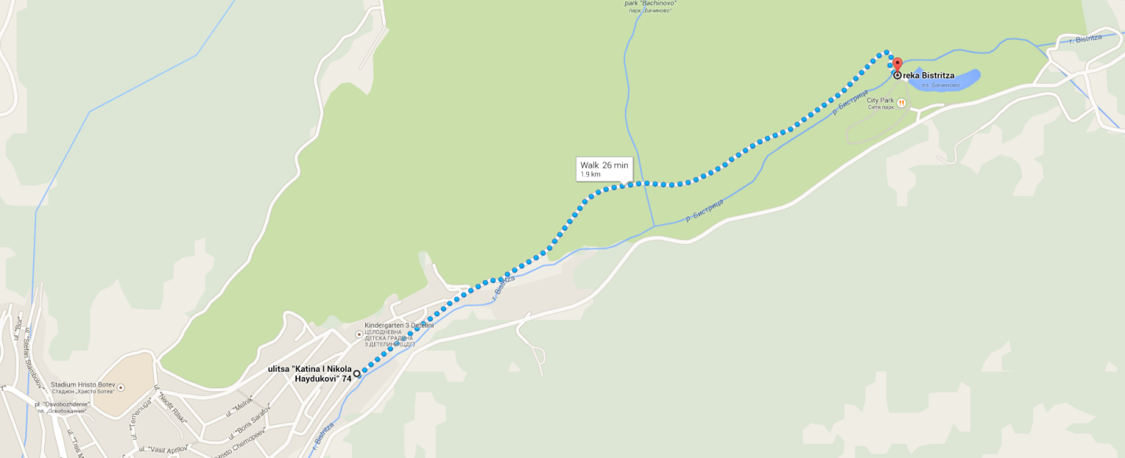

**Starting Point:** 42.027120, 23.108365

**Finish Point:** 42.034882, 23.127270

1. **RULES:**

* There will be a male and female division.
* Participants will be placed in 1-st; 2-nd and 3-rd place based on division and time result.
* There will be only one attempt per person.
* Participants are required to wear numbered badgers/stickers to identify themselves at the finish line (provided by the Olympics crew).
* Participants will start in pairs at the mark of an Olympics crew member. There will be a 30 second interval between each pair of participants.
* Each participant will be timed based on the difference between the his/her starting and finishing time.
* Every participant MUST stay on the predetermined route. Any violation of this rule will result in disqualification.
* There will be an Olympics representative on checkpoint areas along the route in case a participant feels the need for medical attention or tries to deviate from the predetermined route.
* Each participant will be required to reach the Bachinovo Bridge before returning back to the finish line. This will be observed by an Olympics crew member.

1. **RULE ENFORCEMENT:**

* The decisions of the crew members at the location are final.
* Each participant who does show up within 10 minutes of the scheduled time will be disqualified.