**CMSC203 Assignment 2 Implementation (Documentation)**

Class: CMSC203 CRN 46519

 Program: Assignment 2

Instructor: Farnaz Eivazi

 Summary of Description: This program generates a random number and asks the user to guess the number. It prompts the user to enter numbers between 0 and 100, and with each guess, the range of guesses becomes smaller and smaller.

 Due Date: 06/30/2022

 Integrity Pledge: I pledge that I have completed the programming assignment independently.

 I have not copied the code from a student or any source.

**Part1: Pseudo Code:** Here is a pseudo code for Assignment 2 program:

1. **create a random number**
2. **set [lower number] to 0; and [higher number] to 100;**
3. **prompt the user to enter their first guess by displaying “Enter your first guess”**
4. **call on method inputValidation**
5. **[if] the user’s guess is the same as the random number** 
   1. **Display “Congratulations, you guessed correctly”**
   2. **Display “Try again? (yes or no)”**
   3. **[if] the user enters “yes”**
      1. **repeat from step 1**
   4. **[else if] the user enters “no”**
      1. **Display “Thanks for playing...”**
6. **[esle if] the user’s guess is too high compared to the random number**
   1. **Display “Your guess is too high”**
   2. **set [higher number] to the user’s guess**
   3. **Display “Enter your next guess between [lower number] and [higher number]”**
   4. **repeat from step 5**
7. **[esle if] the user’s guess is too low compared to the random number**
   1. **Display “Your guess is too low”**
   2. **set [lower number] to the user’s guess**
   3. **Display “Enter your next guess between [lower number] and [higher number]”**
   4. **repeat from step 5**
8. **[esle]**

**// if the user’s guess is higher than [higher number] or lower than [lower number]**

**Part2: Comprehensive Test Plan**

A good test plan should be comprehensive. This means you should have a few test cases that test when the input is in and out of range, division by 0, incorrect Data type, etc. (Provide valid and invalid input)

| Cases | Input | Expected Output | Actual Output | Did Test Pass? |
| --- | --- | --- | --- | --- |
| Case 1 | 70; 90; 85; no | Enter your first guess  Your guess is too low  Your guess is too high  Thanks for playing... | Enter your first guess  Your guess is too low  Your guess is too high  Thanks for playing... | yes |
| Case 2 | 50; 75; 20; 25; no | Enter your first guess  Your guess is too high  Enter your next guess between [lower number] and [higher number]  Your guess is too low  Thanks for playing... | Enter your first guess  Your guess is too high  Enter your next guess between [lower number] and [higher number]  Your guess is too low  Thanks for playing... | yes |
| Case 3 | 50; 70; 60; 80; 90; 95; 96; no | Enter your first guess  Your guess is too low  Your guess is too low  Enter your next guess between [lower number] and [higher number]  Your guess is too low  Your guess is too low  Your guess is too low  Thanks for playing... | Enter your first guess  Your guess is too low  Your guess is too low  Enter your next guess between [lower number] and [higher number]  Your guess is too low  Your guess is too low  Your guess is too low  Thanks for playing... | yes |
| Case 4 | 50; 25; yes; 50; 75; 80; no | Enter your first guess  Your guess is too high  Enter your first guess  Your guess is too low  Your guess is too low  Thanks for playing... | Enter your first guess  Your guess is too high  Enter your first guess  Your guess is too low  Your guess is too low  Thanks for playing... | yes |

**Part3: Screenshots related to the Test Plan:**

**Case 1**

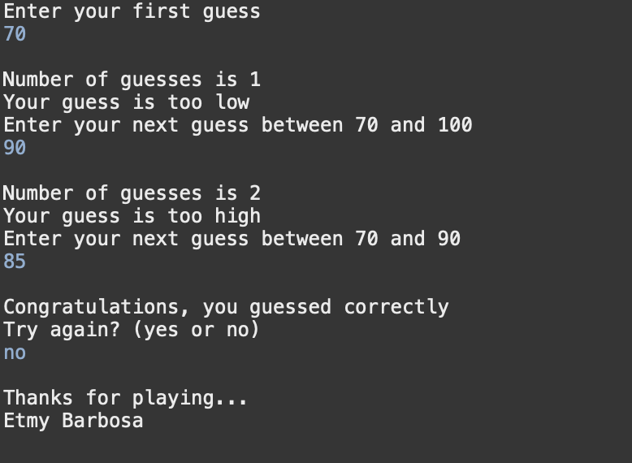

**Case 2**

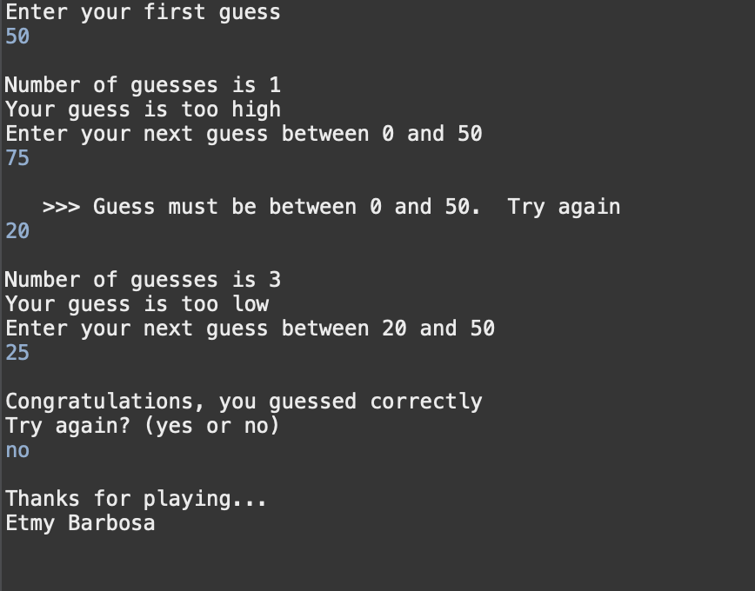

**Case 3**

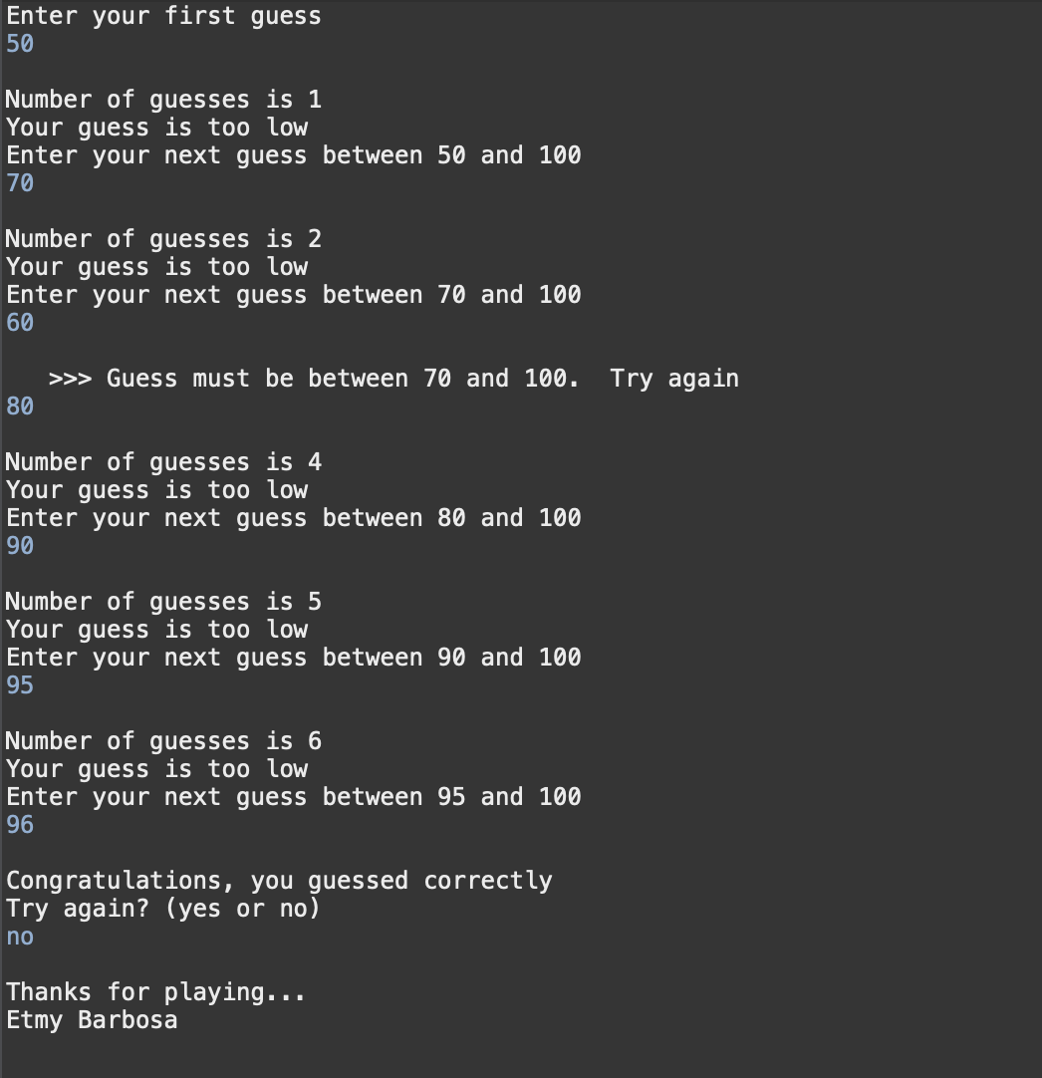

**Case 4**

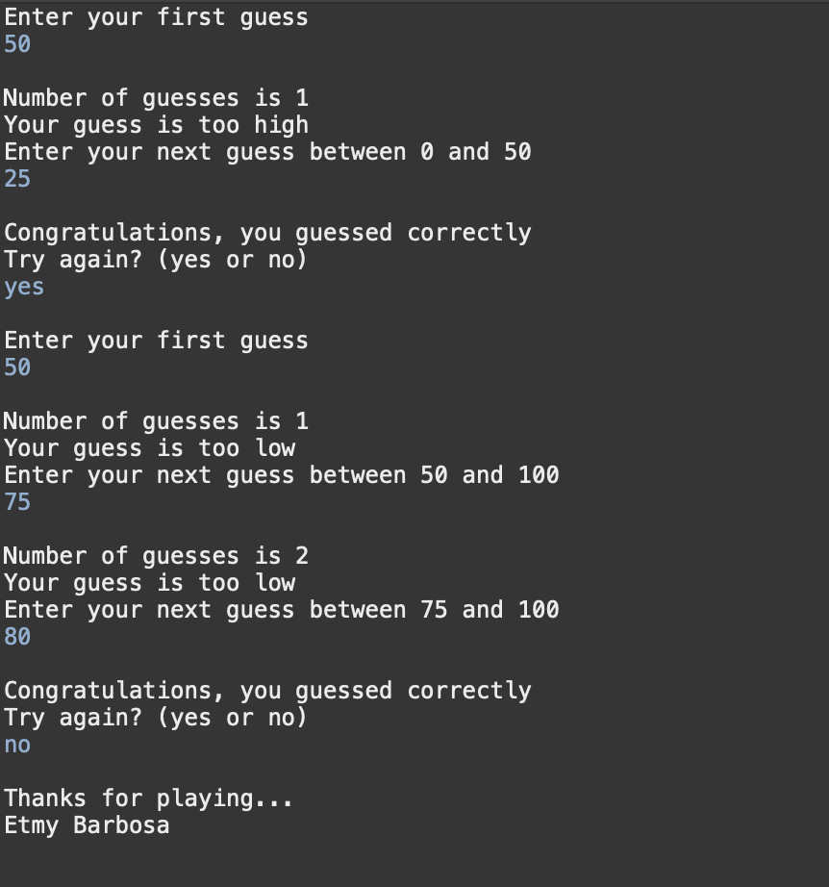

**Lessons Learned** <Provide answers to the questions listed above>**:**

Write about your Learning Experience, highlighting your lessons learned and learning experience from working on this project.

What have you learned?

I have never before tried to use someone’s else methoths in my own code. It was challenging to do, but I think now better the importance of the UML Diagram.

What did you struggle with?

I struggle most with the part of the prograem where it asked the user to “Try again? (yes or no)”. I still don’t understand why other formes that I wrote my code did not work but this one did. However, I still was able to get my dezired output with triel and error. (line 72-80)

What would you do differently on your next project?

On the part I straggled, I should have made a form of documentation about what I had already tried. If I had, maybe I would have spent less time going over it. Maybe even figured out what the bug was exactly.

What parts of this assignment were you successful with, and what parts (if any) were you not successful with?

I think my Pseudo Code was well executed. I was very nervous to start coding, because it looked like a big assignment, but after doing the Pseudo Code, the assignment was less entemidating.

Provide any additional resources/links/videos you used to while working on this assignment/project.

**Check List:** <Provide answers to the column Y/N or N/A >**:**

| **#** |  | **Y/N** | **Comments** |
| --- | --- | --- | --- |
|  | **Assignment files:** |  |  |
|  | * FirstInitialLastName_ Assignment#_Moss.zip | **Yes** |  |
|  | * FirstInitialLastName_Assignment#.docx/.pdf | **Yes** |  |
|  | * Source java files | **Yes** |  |
|  | **Program compiles** | **Yes** |  |
|  | **Program runs with desired outputs related to a Test Plan** | **Yes** |  |
|  | **Documentation file:** |  |  |
|  | * Comprehensive Test Plan | **Yes** |  |
|  | * Screenshots related to the Test Plan | **Yes** |  |
|  | * Screenshots of your GitHub account with submitted Assignment# (if required) | **Yes** |  |
|  | * UML Diagram (if required) | **N/A** | not required on the Grading Rubric |
|  | * Algorithms/Pseudocode (if required) | **Yes** |  |
|  | * Flowchart (if required) | **N/A** | not required on the Grading Rubric |
|  | * Lessons Learned | **Yes** |  |
|  | * Checklist is completed and included in the Documentation | **Yes** |  |