**CMSC203 Java Assignments / Projects (example of the project submission)**

**Part1: Documentation Example**

Class: CMSC203 CRN 46519

 Program: Assignment #3

Instructor: Farnaz Eivazi

 Summary of Description: This program incrips and dicpript text. This program will give the option of using Caesar

 Due Date: 07/14/2022

 Integrity Pledge: I pledge that I have completed the programming assignment independently.

 I have not copied the code from a student or any source.

Etmy Barbosa

**Pseudo Code Example:** Here is an example of pseudo code for a program that requires you to use functions to calculate the volume of a box and the volume of a Sphere.

1. Create a scanner to receive input from the keyboard.
2. Declare four variables to store the following information, in decimal form.
   * Length
   * Width
   * Height
   * Radius

**Comprehensive Test Plan**

A good test plan should be comprehensive. This means you should have a few test cases that test when the input is in and out of range, division by 0, incorrect Data type, etc.(Provide valid and invalid input)

| Cases | Input | Expected Output | Actual Output | Did Test Pass? |
| --- | --- | --- | --- | --- |
| Case 1 | (Hello World,1) | ERROR |  |  |
| Case 2 | (HELLO WORLD,1) |  |  |  |
| Case 3 | ([APPLE, AB) | ERROR |  |  |
| Case 4 | (H%TPSYX, CMSC) | EXAMPLE |  |  |

**Screenshots for each case listed in the Test Plan**

**Case 1:**

**Case 2:**

**Case 3:**

**Case 4:**

**Lessons Learned:**

Write about your Learning Experience, highlighting your lessons learned and learning experience from working on this project.

What have you learned? I've learn more about methods. I’ve inproved my ways of thinking of how to test each individual method and the difference it makes when improving the speed in which I write my code.

What did you struggle with? I actually tragleled with all of the methods. The thing that made it worste was that I didn’t understand the instructions.

What would you do differently on your next project? Next time I’ll do the UML Diagram and Pseudocode first.

What parts of this assignment were you successful with, and what parts (if any) were you not successful with?I’m not sure;

Provide any additional resources/links/videos you used to while working on this assignment/project.

<Provide answers to the questions listed above>

**Check List:**

| **#** |  | **Y/N** | **Comments** |
| --- | --- | --- | --- |
|  | **Assignment files:** |  |  |
|  | * FirstInitialLastName_ Assignment#_Moss.zip | **Yes** |  |
|  | * FirstInitialLastName_Assignment#.docx/.pdf | **Yes** |  |
|  | * Source java files | **Yes** |  |
|  | **Program compiles** | **Yes** |  |
|  | **Program runs with desired outputs related to a Test Plan** | **Yes** |  |
|  | **Documentation file:** |  |  |
|  | * Comprehensive Test Plan | **Yes** |  |
|  | * Screenshots for each Test case listed in the Test Plan | **Yes** |  |
|  | * Screenshots of your GitHub account with submitted Assignment# (if required) | **Yes or No or N/A** |  |
|  | * UML Diagram (if required) | **Yes or No or N/A** |  |
|  | * Algorithms/Pseudocode (if required) | **Yes or No or N/A** |  |
|  | * Flowchart (if required) | **Yes or No or N/A** |  |
|  | * Lessons Learned | **Yes or No** |  |
|  | * Checklist is completed and included in the Documentation | **Yes or No** |  |

**Flow Chart Shapes:**

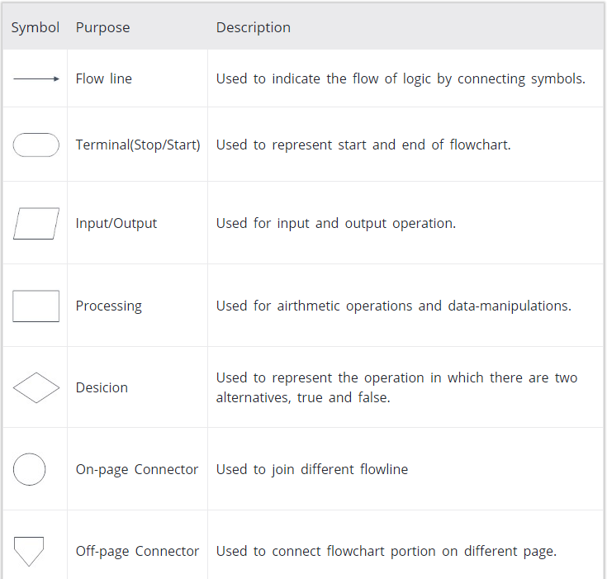

**Flowchart Example (If required):**

**Draw a flowchart to add two numbers entered by the user.**

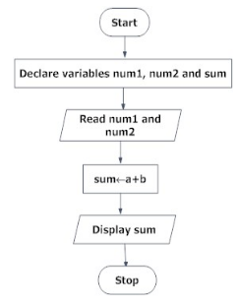

**UML:**

| **Class Name:**  **Practice** |
| --- |
| **+name:String**  **+age:int**  **+weight:double** |
| **+getName():String**  **+setName(name:String):void** |