Design Document for Twin

Group 1_CW_2

Ezra Odole: 33% contribution

-Table relationship diagram

-Swagger UI endpoint

-Block diagram server section

Kai Heng Gan: 33% contribution

-Block Diagram client section

Charles Millar: 33% contribution

-Block Diagram Database Section

Block Diagram Design

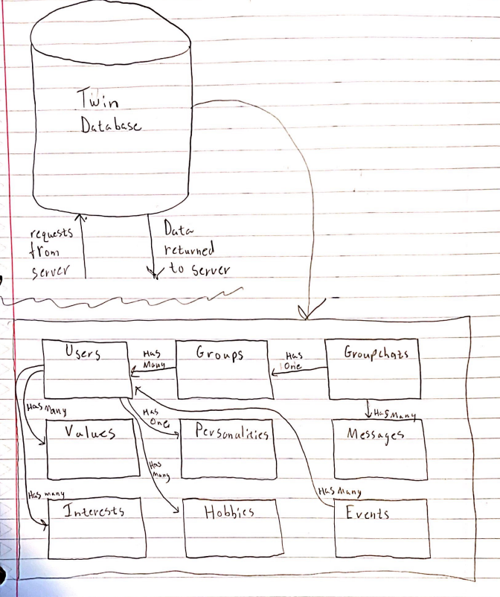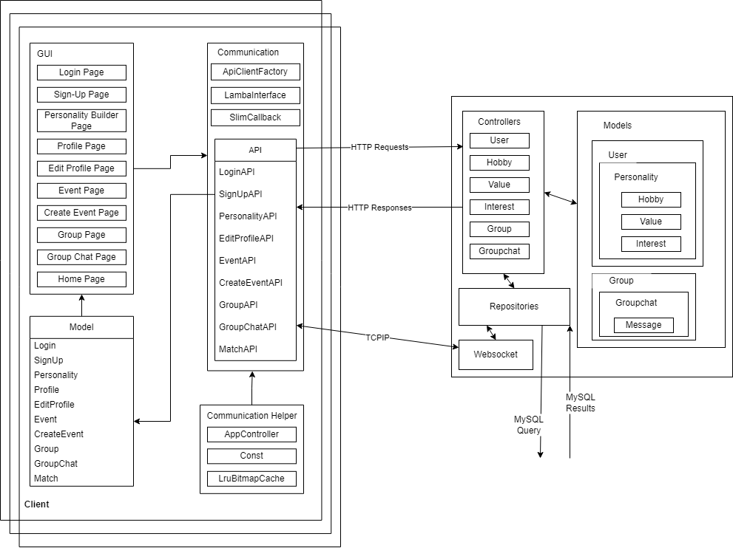

Design Descriptions

Android User GUI (KHG)

Twin will have a user interface that is easier for the users to interact with. The user interface consists of a Login page, Sign Up page, Personality Builder page, Profile page, Edit Profile page, Event page, Create Event page, Group page, Group Chat page, and Hom page. Those are the pages that the users will see and interact with. For the new application-download users of the application, the application will first show the login page. If the users do not have an account, they could click on a hyperlink that indicates “Sign Up.” It will bring the users to the sign-up page. Once the users successfully sign up, the application will then show a personality builder page for the users to create their own profile. When they are done with creating their profile, the application will bring the homepage. There will be three buttons that indicate Group, Event, and Profile. All these three buttons will bring the users to the Group page, Event page, and Profile page, respectively.

Android Communication (KHG)

Twin will be using Android Volley and Retrofit to communicate with the backend to post and request the data to/from the database. In order to post and request data correctly to/from the database, the application required ApiClientFactory, LambaInterface, SlimCallback, APIs, Model, and Communication Helper. All the posting and requesting data will be done through HTTP, except for the group chat. The group chat will be using TCPIP to get and send the data because the TCPIP allows the application to instantly get the latest data. Every HTTP response will be formatted into JSON format and parsed into the respective class in the Model. The parsed data will then be sent to the user interface.

Model (KHG)

Twin will require the Model for the user interface to get and set the data. The Model has 10 models: Login, SignUp, Personality, Profile, EditProfile, Event, CreateEvent, Group, GroupChat, and Match.

Communication Helper (KHG)

The Communication Helper is used to assist Android Communication while communicating with the backend while using Android Volley. It consists of an App Controller, Const, and LruBitmapCache. The App Controller is the one that allows the application to getRequestQueue and addToRequestQueue. The Const is a Java class file that consists of a list of constant variables, such as URLs. The LruBitmapCache is an assistance file that helps with posting and getting an image to/from a URL.

Group Matching (EO)

This process inputs a user and from that user we check with attribute has the largest number of common people. From the attribute with the largest number of users, we randomly select 4 people and put them in a group. This makes certain the group all has at least one thing in common for them to get along over.

User Matching (EO)

This process has two versions. A Best match and a semi random match. The best match works by taking all of the hobbies a user and counting up the common hobbies other users have, giving a list of the users with the most hobbies in common, then returning the top result. Interest and Value commonalities will be similarly tallied. Results will filter previous results, so it doesn’t return the same person. The semi random version takes a user as input, chooses a random trait of theirs, and then chooses a random person from the list of people with that trait. Also filters previous results.

Twin Database (CM)

Users

Store important information about the user. This information includes name, password, gender, and other relevant information for app functionality.

Groups

Groups are users which have been matched together from whichever matching algorithm is used. Groups contain different sizes of user lists depending on group size. The group sizes are small – 4, medium – 8, large – 12, and community – unlimited.

Group Chats

Group Chats are how groups can communicate with each other through the app. A group chat contains a group and a list of message objects.

Messages

Messages are sent in group chats. Each message contains a string being sent (the message), a sender of the message (a user), a time, and a date.

Events

Events are created by users for other users to attend. An event contains a list of users attending, a time, a location, and the name of the event.

Values

Each user has many values which are taken into account during the matching algorithm. A value is an important concept to the user.

Personalities

Each user has a personality which is used during the matching algorithm. A personality is a selection of pre-determined personalities which the user is most similar to.

Interests

Each user has many interests which can be used during the matching algorithm. An interest is a talking point which interests the user. Interests are used to break the ice after groups are matched together.

Hobbies

Each user has many hobbies which can be used during the matching algorithm. A hobby is some sort of activity which the user enjoys doing. If a user is looking to be matched with other users with similar hobbies this will help them do that.

Table Relationships Diagram

<http://localhost:8080/API>

<http://coms-309-015.class.las.iastate.edu:8080/API>

-currently the server is giving 404 errors, but running locally the Swagger works

