1. We did HAProxy, Selenium, DigitalOcean, and Travis CI.
2. The only port exposed is the haproxy container’s port, which is 8010. All other containers’ ports are not exposed. To access the website you need to access port 8010.
3. <https://github.com/EtonMon/cs4501/tree/master/app/haproxy> includes the config files for the haproxy image we’re building (docker-compose up --build)
4. include any sample output (especially for the load balancer, continuous integration, performance test examples)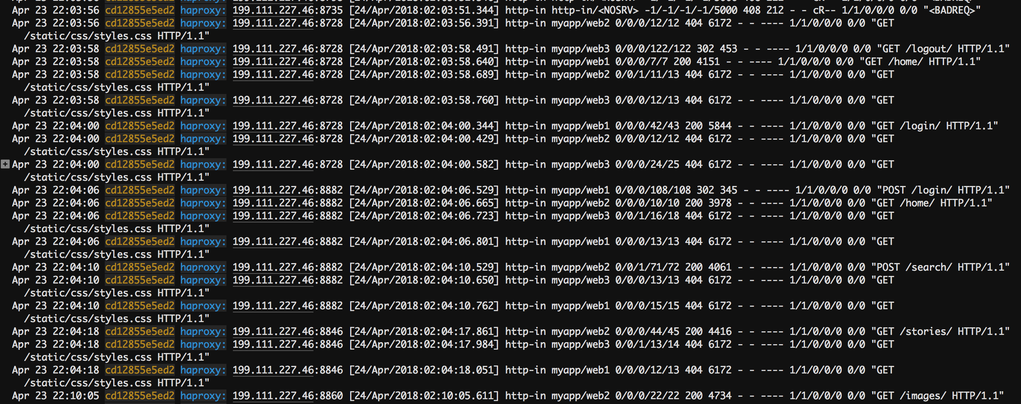
5. include any command lines (such as for running load tests, unit tests or load balancers)

You need to execute:

docker-compose up --build

to build the haproxy image

1. Digital Ocean link: http://104.236.197.94:8010/home/