**Movie Vice App**

Android application which allow users to easily figure out the movies that are compatible and published in App Store.

We use TMDB (T Movie Data Base) to frame the API for the fetching data to the below screens.

**Summary:**

Developed UI/UX and functionality for the

**Home Screen**

**Top part** - Carousel View displaying the Top most Heroes List acted in Movies

**Bottom part** – Contains Genres listed movies like Featured, Action, Adventure, Role Playing, Sports, Racing etc

**Movie Detail Screen**

On Clicking the Movie from Home screen, it navigates to the Movie Detail Page which displays the Movie Image, Title, Votes Count, Ratings count, Star count, Description in detail.

**Search Screen**

Which displays the Genre items and on applying Search, it filters the Genre based on the search filter.

**Search Category Screen**

On clicking genre item in search screen it navigates to this Screen and displays the Movie apps.

**Functionality explanation along with screens**

**Home Screen:**

It has a toolbar with Hamburger menu icon and search icon at the end.

**Carousel View :**

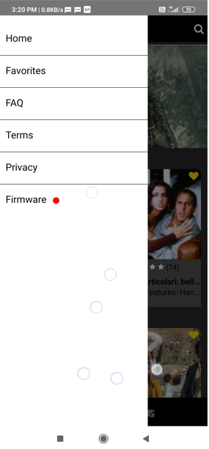 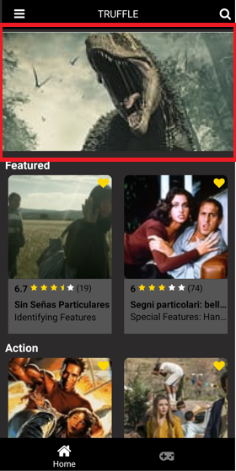

**Middle Component :** Displaying Movies of different Genres as below

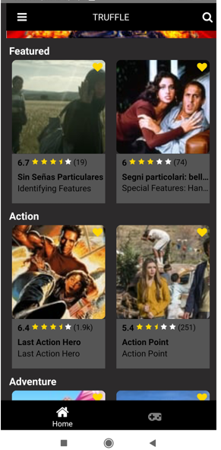 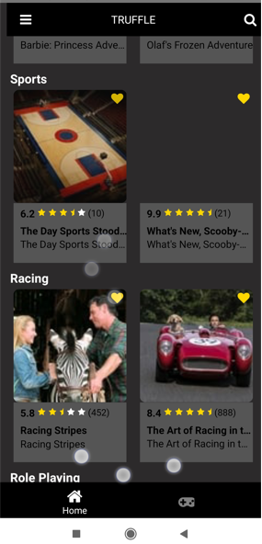

**Movie Details Screen**

On clicking of Movie from Home screen **Carousel** View it navigates to Movie Details Screen and displays as below.

 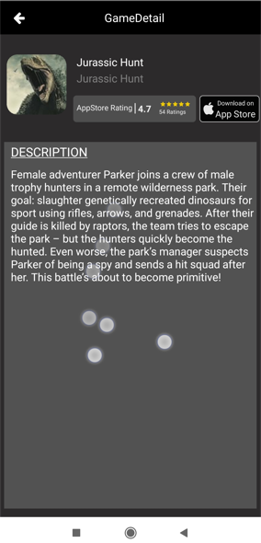

On clicking of Middle Component of Home screen movie, it navigates to the Movie Details screen and displays as below

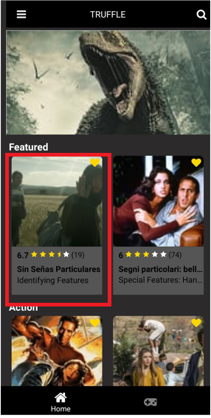 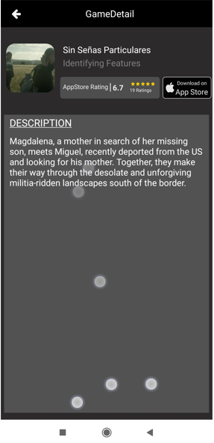

Search screen: Displays Genres list items of movie and on applying filter displays as below

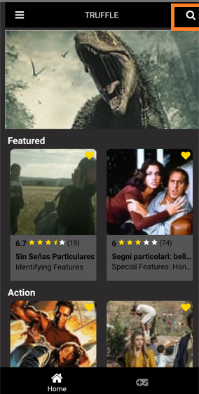 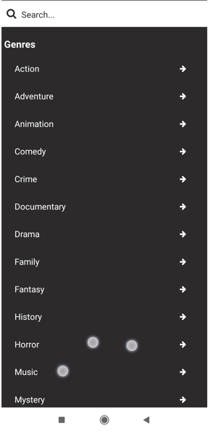

On applying search it filters genres as below

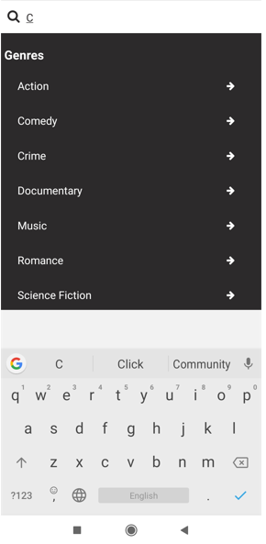

On selecting a particular genre it navigates to **Search Category screen :**

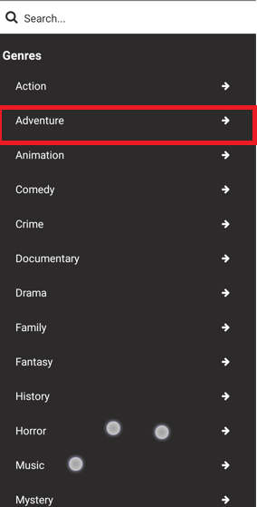 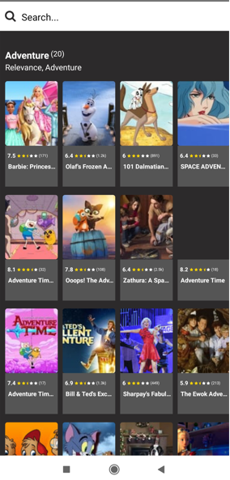

On applying filter in Search Bar of Search Category Screen, Movies of the particular genre gets filtered



This is how the functionality of this app exists