- Inputs
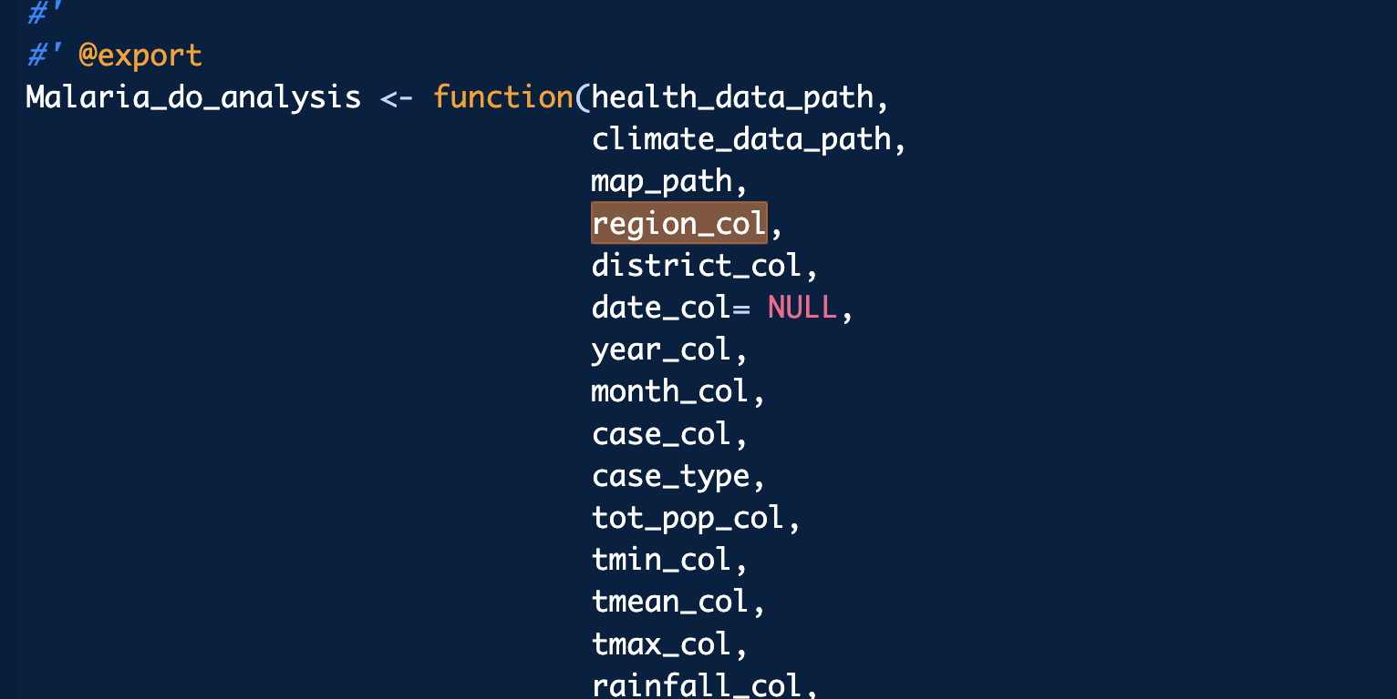
- basis_matrices_choices: choice between tmax and rainfall
- inla_param: c("tmin", "rainfall", "r_humidity")
controls: if base matrix, inla_param should not have it. The same for the rainfall.
- param_term takes the variable of the base matrix.
- Level select between "country", "region" or "district"
- param_threshold = 1
- filter_year = NULL or unique of year in the dataset (multiple selection)
- family = "poisson"
- group_by_year = FALSE
- config = !FALSE
- save_csv = !FALSE
- save_model=!FALSE
- save_fig = !FALSE
- Clickable: combine data (input are from the above config)
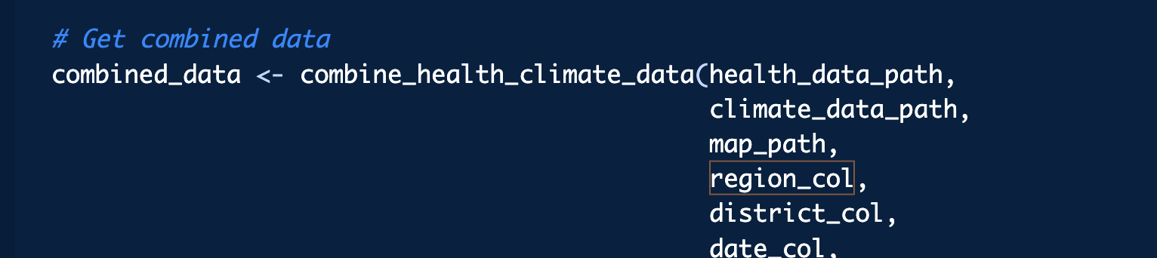
- Clickables to make plots
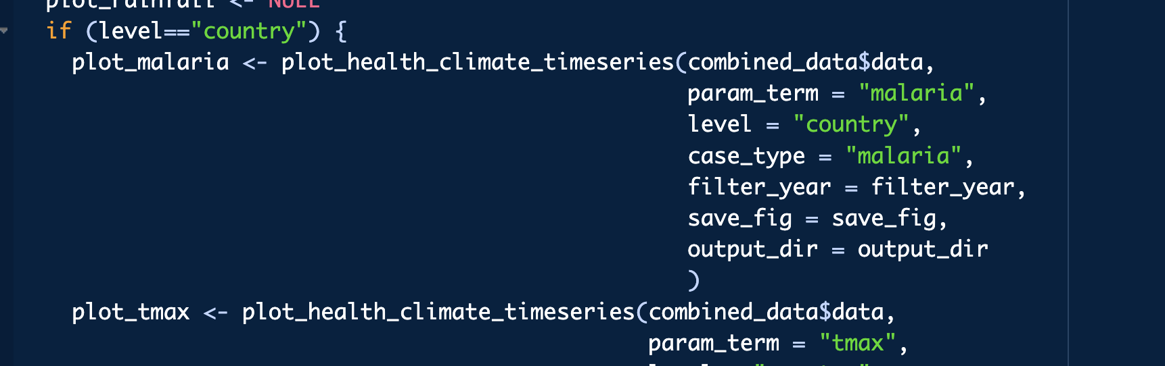

- Select input for the base matrix
