
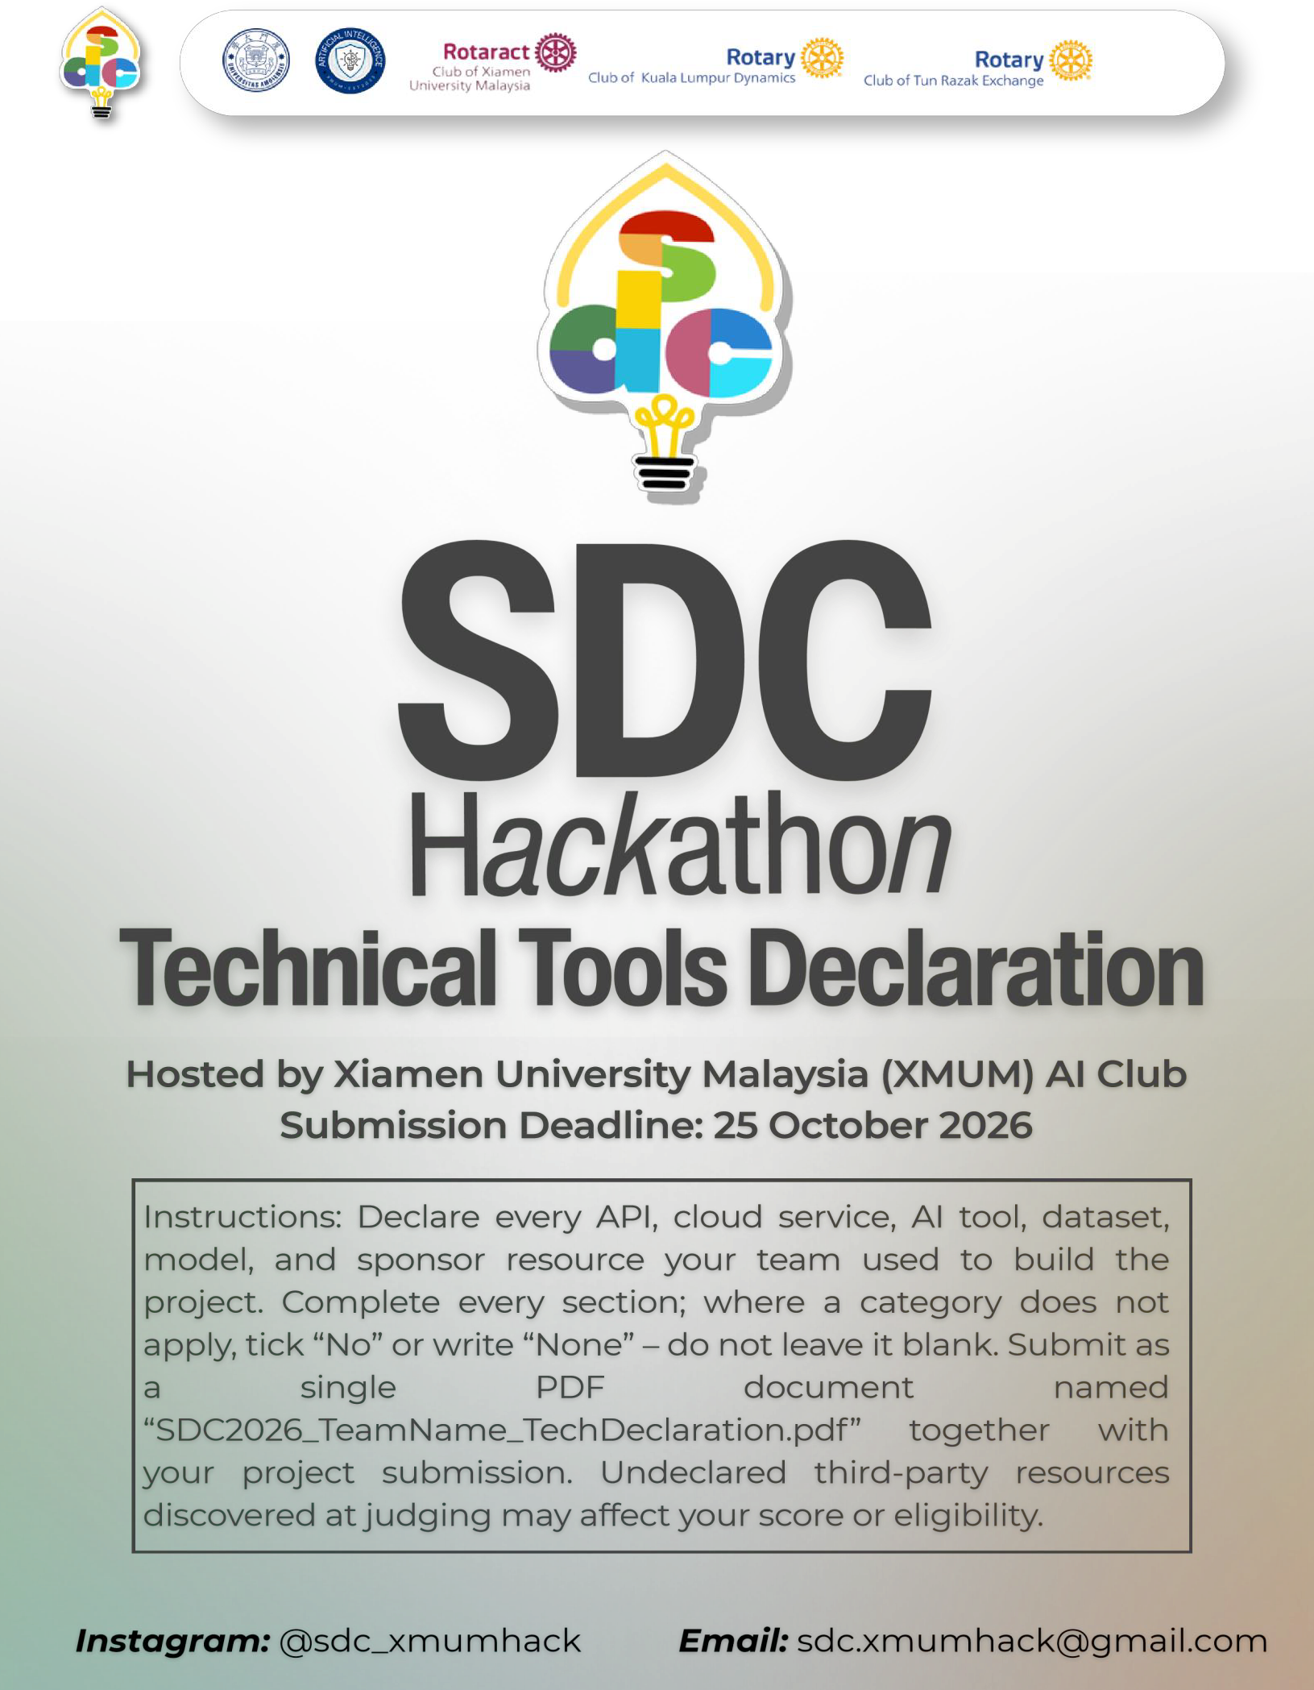

SDC HACKATHON 2026

Technical & Tools Declaration
Hosted by Xiamen University Malaysia (XMUM) AI Club Submission Deadline: 24/10/2026
Instructions: Declare every API, cloud service, AI tool, dataset, model, and sponsor resource your team used to build the project. Complete every section; where a category does not apply, tick “No” or write “None” – do not leave it blank. Submit as a single PDF document named “SDC2026_TeamName_TechDeclaration.pdf” together with your project submission. Undeclared third-party resources discovered at judging may affect your score or eligibility.

Team & Project Overview

Team Name | S.E.E.S
Project / Solution Name | DapurPlan
Name (Leader) | MUHAMMAD AMAL IRFAN BIN SHAHARUDDIN
Email & Phone (Leader) | amalirfanshaha@gmail.com 013-2499539
University Affiliation(s) | Universiti Malaysia Terengganu, Universiti Teknologi MARA
Live Prototype URL | https://DapurPlan.replit.app/
Code Repository URL (public  / access granted to judges) | https://github.com/Etticx/DapurPlan

Architecture & Technology Stack

System Architecture Overview
Describe how the components declared in this document connect end-to-end (e.g., user interface → backend → AI model/API → database → cloud hosting). Attach a system block diagram as an appendix if available.

[Maximum 200 words]
DapurPlan helps a restaurant forecast next-day servings and review ingredient requirements, stock, purchases and preparation plans. The browser uses a Next.js and React interface.
Next.js server routes handle owner/staff sessions, recipe prices, daily sales, expenses, inventory, approvals and activity records, stored in SQLite through better-sqlite3. For forecasts, the Next.js server prepares each menu item's weekday, previous-day sales, sales seven days earlier and seven-day average. It sends these features to our FastAPI service, which loads the saved scikit-learn Random Forest pipeline and returns JSON predictions and model provenance. Preparation quantities are rounded up and remain adjustable by the owner. Approving a plan does not automatically deduct inventory. The current prototype runs locally. Replit is planned for the web app and Runpod for the CPU model service. A bearer-key wrapper and deployment scripts are prepared; public deployment and persistent cloud database setup are pending. No generative-AI API is called by the application.

Languages, Frameworks & Libraries
List the main programming languages, frameworks, and third-party libraries that your team did not create. Open-source use is permitted provided it is declared and properly licensed/attributed.

Name & Version | Purpose in Project | License
TypeScript 5.9.3; JavaScript / Node.js 22.12.0; Python 3.12.8 | Web application, server routes and Python model service. Versions are local development versions. | Apache-2.0; MIT; PSF
Next.js 16.4.2; React / React DOM 19.3.1 | Application framework, interface and server rendering. | MIT
Tailwind CSS / PostCSS plugin  4.3.3; Radix Slot 1.5.0; CVA  0.7.1; clsx 2.1.1; tailwind-  merge 3.7.0 | Styles and reusable UI components. | MIT; CVA:  Apache-2.0

Name & Version | Purpose in Project | License
better-sqlite3 11.10.0; SQLite 3 | Persistent local relational database. SQLite version is bundled with the driver. | MIT; SQLite:  public domain
scikit-learn 1.6.1; pandas 2.2.3;  NumPy 2.1.3; joblib 1.6.0 | Data preparation, Random Forest pipeline and saved model loading. | BSD-3-Clause; retain bundled notices
FastAPI 0.154.0; Uvicorn  0.54.0 | Python HTTP API and ASGI server. | MIT; BSD-3-  Clause
Lucide React 0.468.0; Geist 1.8.1 | Interface icons and fonts. | ISC; SIL Open  Font License
tsx 4.23.15; Git / GitHub | TypeScript test execution, version control and peer review. | MIT; Git: GPL-  2.0; GitHub terms

APIs & Cloud Services

External APIs
List every external API your solution calls (GenAI, maps, payments, messaging, data feeds, etc.). Do not include API keys or secrets in this document.

API & Provider | Purpose in Project | Access Tier (free / paid  / sponsor-provided)
Not applicable | Not applicable | Not applicable
Not applicable | Not applicable | Not applicable
Not applicable | Not applicable | Not applicable

Cloud Platforms & Deployment
List every cloud service used for hosting, storage, databases, authentication, or compute, and indicate how the prototype is deployed.

Service & Provider | Purpose in Project | Plan / Region
Local development computer | Currently runs Next.js, SQLite and FastAPI. | Windows; local only
Replit | Planned hosting for Next.js UI and application backend. Persistent production database setup is pending. | Core  Sponsor credit USD 20 Region = Any
Runpod | Prepared CPU Pod setup for the existing FastAPI forecast model | USD 25 sponsor credit; Ubuntu 24.04; 2 vCPU  / 4 GB RAM planned; region any
GitHub | Source repository, issues, branches and pull-request review. | GitHub account
External database / authentication service | None currently. SQLite and signed local application sessions are implemented; PostgreSQL is not implemented. | Not applicable

AI Tools, Models & Datasets

AI Models Used in the Solution
List every AI model embedded in or called by your application, including pre-trained, fine-tuned, and self-trained models.

Model & Version | Source / Provider | Usage (pre-trained / fine-tuned / self-trained) | License / Terms
DapurPlan sales forecast pipeline; scikit-learn 1.6.1 | Team-trained Random Forest; saved artifact in model/ | Self-trained on synthetic regular-demand sales; one-day-ahead regression. No foundation model or fine-tuning. | Team repository: Apache-2.0; scikit-learn: BSD-3-Clause
Last-week baseline | Team code in forecast_model.py and train_forecast.py | Deterministic comparison and possible retraining fallback; not the currently selected saved model. | Team repository: Apache-2.0
Not applicable | Not applicable | Not applicable | Not applicable
Not applicable | Not applicable | Not applicable | Not applicable
Not applicable | Not applicable | Not applicable | Not applicable

Datasets
List all datasets used for training, fine-tuning, evaluation, or in the running application. State clearly if a dataset contains personal or sensitive data.

Dataset Name | Source / URL | Type (public / private / self-collected / synthetic) | License | Personal Data? (Y/N)
Synthetic restaurant sales, regular scenario, seed 42 | Team generator and training work; report in model/ | Synthetic; model training, chronological validation and evaluation | Team-generated; separate dataset license not recorded | N
Demo daily sales | demo-sales-data.json in web/src/lib/; derived from saved synthetic test actuals | Synthetic demo records with source provenance; excluded from real-data retraining | Team-generated; separate dataset license not recorded | N
Demo recipes, inventory, prices and test fixtures | Team-authored application data and tests in the repository | Synthetic/manual prototype and test inputs; not measured market prices | Team repository: Apache-2.0 | N
Runtime restaurant records | Entered through the application; stored in local SQLite | Operational data and account audit records; no intended customer data.  Optional future training subject to eligibility checks. | Not publicly licensed; controlled by the operator | Y
Not applicable | Not applicable | Not applicable | Not applicable | N/A

AI-Assisted Development Tools
Tools used to help write code, design, content, or documentation (e.g., chat assistants, code completion tools, image generators). Declaring these tools does not reduce your score; undeclared use may.
Did your team use any generative-AI tool to help create code, design, text, or other project material?
0 Yes □ No
If yes, list them below:

Tool & Version | Used For | Extent of Use (minor / moderate / major)
OpenAI ChatGPT / Codex; GPT 6.1 Sol | Code, debugging, tests, ML/data-workflow assistance, deployment guidance and documentation. Not called by the running app. | Major
Co-pilot | Slide making | minor
Not applicable | Not applicable | Not applicable
Not applicable | Not applicable | Not applicable
Not applicable | Not applicable | Not applicable

Briefly describe how your team reviewed, tested, and took responsibility for AI-generated output:

[Maximum 100 words]
We reviewed generated code and calculations, tested the interface manually, and used automated TypeScript and Python tests for sales, costs, inventory, permissions, forecasts and API validation. Model API results were compared with direct predictions from the saved pipeline. We investigated contributor feedback and corrected identified problems. We distinguish synthetic evaluation from real restaurant performance, review changes before merging, and retain responsibility for the submitted code, data and claims. Cloud deployment and the final submission checklist still require team verification.

Sponsor-Provided Resources
Declare any official SDC sponsor-provided GenAI API, cloud credits, tools, mentoring, or data that your team used.
Did your project use any official SDC sponsor-provided resource?
0 Yes □ No
If yes, list them below:

Sponsor | Resource (API / credits / platform / data) | How It Was Used in the Project
Replit | Sponsor-provided Core access and USD 20 credit | Account upgraded; intended web deployment. No live deployment yet.
Runpod | USD 25 sponsor cloud credit | CPU Pod configuration and deployment folder prepared. No Pod launched yet.
Other sponsor resources | None used in the implementation described here | No sponsor GenAI API, mentoring or external dataset is declared as used.
Not applicable | Not applicable | Not applicable

Was the sponsor resource essential to the core functionality of the prototype, or could it be replaced? Explain briefly:

[Maximum 100 words]
The sponsor credits provide a convenient route to hosting, but the forecasting and planning logic does not depend on proprietary sponsor APIs. Next.js can run on another compatible Node.js host, and the FastAPI model service can run on a different CPU server. Both already run locally. Replacing a host would require configuration, persistent storage and connection testing. Sponsor accounts and credits are available; deployment has not yet been launched.

Security, Privacy & Responsible Use

Data Handling & Privacy
What user or personal data does your application collect, store, or send to third-party services (including AI APIs)? How is it protected, and how long is it kept? State “No user data is collected” if applicable.

[Maximum 150 words]
The prototype stores restaurant sales quantities, recipes, ingredient prices, inventory, recorded expenses, forecasts, plans and audit entries in SQLite. Audit entries identify the fixed owner/staff account and time of changes. There is no customer registration or intended collection of customer personal data. Free-text entries should not contain personal or sensitive information. The forecast service receives menu names, weekday and aggregate sales features, not customer identities or the full database. No application data is sent to a generative-AI API. Access uses role checks and signed, HttpOnly session cookies with an eight-hour expiry; production cookies use Secure. The Runpod wrapper requires a private bearer key, to be used over HTTPS. Prototype accounts are fixed demonstrations rather than production identity management. Operational records persist until manually removed; automatic retention/deletion and encryption at rest are not implemented.

Known Limitations & Risks
Identify the main technical limitations of your AI components (e.g., hallucination, bias, rate limits, dependency on a single provider) and any mitigation you have implemented.

[Maximum 150 words]
The saved model is trained and evaluated on team-generated synthetic data. Its test MAE of about 3.09 servings does not establish accuracy, profit improvement or waste reduction in real restaurants. It covers five fixed menu items and requires complete recent sales history. Unexpected events, demand shifts and stock-outs can reduce accuracy. The system rejects invalid or incomplete forecast inputs, checks model compatibility and flags synthetic provenance. Owners review and adjust preparation quantities before approval. Local retraining is available after sufficient complete, non-demo sales history, with chronological validation against a last-week baseline; it has not replaced the current model. Profit estimates depend on correctly entered prices, recipe quantities and recorded expenses; unrecorded expenses are excluded. Runpod availability, credit balance and persistent storage remain deployment risks. The prototype uses public demonstration accounts rather than production-ready authentication.

Compliance & Readiness Checklist
Tick all boxes that apply before submitting.

0 All APIs, cloud services, AI tools, models, and datasets used in the project are declared in this document.
0 All third-party code, datasets, and models are used in accordance with their licenses, and attribution is provided where required.
0 No API keys, passwords, or other credentials are exposed in the code repository, prototype, or this document.
0 Any use of generative-AI tools for development has been disclosed and reviewed by the team.
0 Any use of official SDC sponsor resources has been declared in Section 5.
0 The prototype described here is accessible to judges through the links provided in Section 1.
0 All fields in this template have been completed within the word limits stated.

Declaration
By submitting this document, the team leader confirms that the information provided is complete and accurate to the best of the team's knowledge, and that every API, cloud service, AI tool, dataset, model, and sponsor resource used in the project has been declared.

[Signature] 24/10/2026


