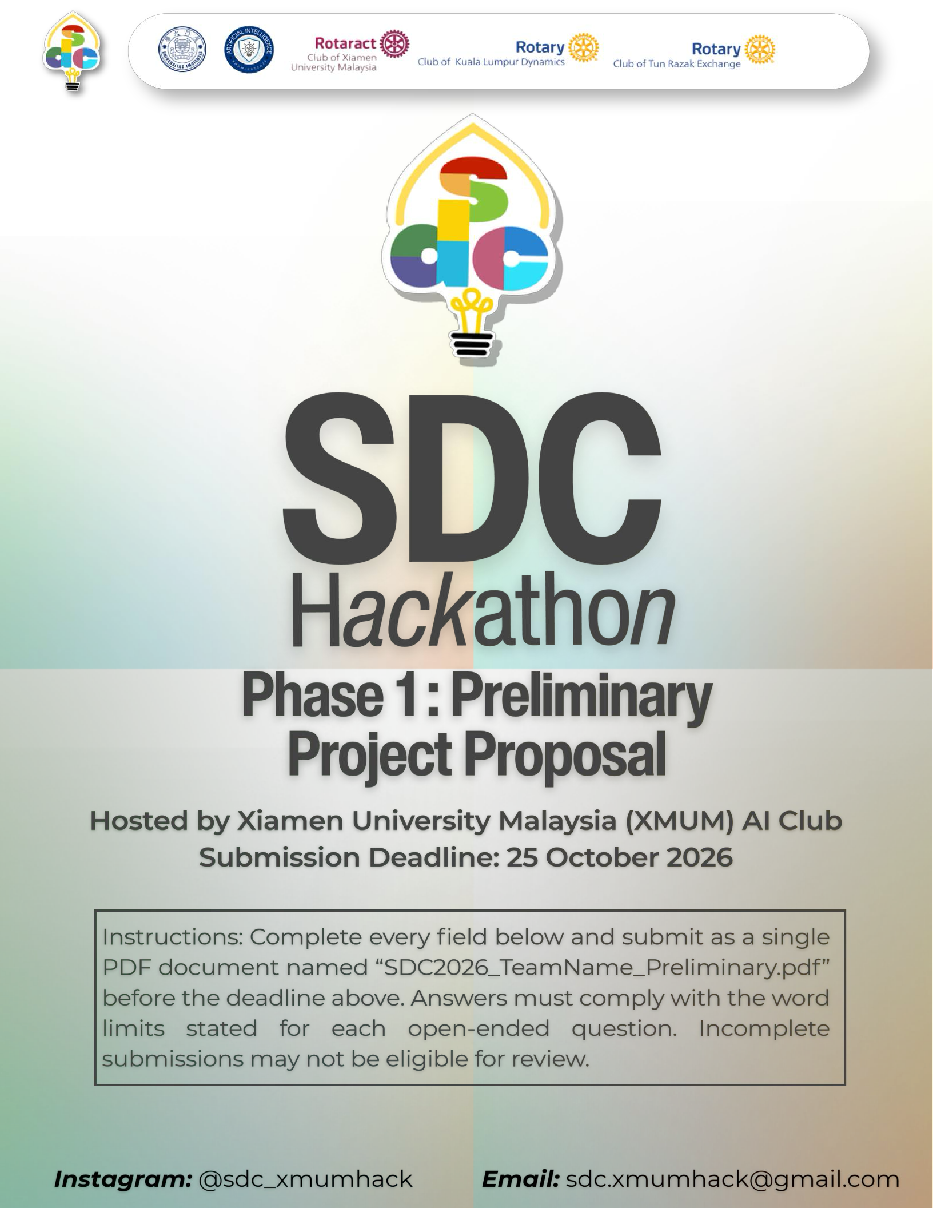


SDC HACKATHON 2026

Phase 1: Preliminary Project Proposal
Hosted by Xiamen University Malaysia (XMUM) AI Club Submission Deadline: 25 October 2026
Instructions: Complete every field below and submit as a single PDF document named “SDC2026_TeamName_Preliminary.pdf” before the deadline above. Answers must comply with the word limits stated for each open-ended question. Incomplete submissions may not be eligible for review.

Team & Project Overview

Team Name | S.E.E.S

Selected Domain | Domain 2

Selected SDG Track (1–17) | 12 - Responsible Consumption and Production

Project / Solution Name | DapurPlan

Name (Leader) | MUHAMMAD AMAL IRFAN BIN SHAHARUDDIN

Email & Phone (Leader) | amalirfanshaha@gmail.com 013-2499539

University Affiliation(s) | Universiti Malaysia Terengganu, Universiti Teknologi MARA

Number of Team Members | 3

Executive Summary & Problem Statement

The Problem Context
Describe the specific, real-world challenge your team is tackling. Who is affected by this problem, and why does it matter? Highlight the critical social, environmental, or economic issues involved.
[Maximum 250 words]
Small food outlets decide how much to prepare before knowing next-day demand. Overestimating leaves unsold food and ties up ingredient spending; underestimating causes stock-outs and lost sales. Owners must also translate menu demand into shared ingredient requirements, usable stock and practical purchase packs. Disconnected records make these decisions harder.
UNEP reports that food services accounted for 28% of global consumer-level food waste in 2022 [2]. Wasted food also represents unnecessary use of production resources. DapurPlan targets owners and staff of small restaurants with a limited menu, supporting consistent preparation decisions and transparent costs. Restaurant-specific waste savings have not been measured; initial validation uses labelled synthetic data.

The Proposed AI Solution
Provide a high-level overview of your proposed application. How does it apply artificial intelligence to solve the problem stated above? Briefly mention the tools or technical skills gained from the SDC Phase 1 workshops (e.g., GenAI APIs, database architecture, cloud hosting) that you intend to leverage.
[Maximum 300 words]
DapurPlan connects daily sales, next-day forecasting, recipes, inventory and owner-approved preparation plans. Staff record sales and stock; the owner reviews costs and purchase suggestions.
A team-trained Random Forest predicts servings for five menu items using weekday, previous-day sales, sales seven days earlier and a seven-day average. Recipes convert planned servings into ingredient requirements. The app checks usable stock, flags expiry concerns and rounds shortages to purchase packs. Owners adjust quantities before approval, which does not deduct stock or place orders.
The local prototype includes expense records, estimated profit, role checks and activity history. Replit web hosting and a Runpod CPU model service are planned. Relevant workshop themes include database design, API integration, responsible AI evaluation and cloud deployment. No GenAI API is required. The current model is synthetic-trained; real restaurant effectiveness remains unverified.

Technical Architecture & Implementation Plan
  - Conceptual Tech Stack
List the technologies, frameworks, APIs, and databases you plan to use to build a functional, deployed prototype. Describe (or attach as an appendix) a simple system block diagram showing how the workshop elements connect into one architecture.
Did your project utilize any official SDC sponsor-provided GenAI API or Cloud Platform? If yes, specify which one and how it is used.
Planned flow: browser → Next.js on Replit → FastAPI on a Runpod CPU Pod → JSON predictions → Next.js → browser. Next.js also accesses the application database.
React, TypeScript and Tailwind CSS provide the interface. Next.js server routes handle sessions and restaurant records; SQLite with better-sqlite3 supplies local persistence. Persistent cloud storage, including a proposed PostgreSQL migration, remains a deployment task.
Python FastAPI serves scikit-learn predictions using pandas, NumPy and joblib. The prepared Runpod wrapper requires a private bearer key over HTTPS. GitHub supports source control and review. No external GenAI API is called.
Sponsor Replit Core access with USD 20 credit and Runpod USD 25 credit are activated. Deployment files are prepared; neither service has launched.

  - Design-Thinking & Deployment Strategy
Explain how your team applied design-thinking methodology to ensure this solution is technically viable, user-friendly, and ready for real deployment by Phase 2.
[Maximum 200 words]
We designed around staff recording operations and an owner reviewing costs and preparation. A fixed menu keeps the workflow testable. Internal prototype reviews and contributor feedback informed changes to pricing, financial explanations and daily entry; restaurant user testing remains planned.
For Phase 2, we will test tasks with intended users and deploy both services. Work includes persistent storage, private secrets, HTTPS, restart checks and end-to-end forecasting tests. Automated tests cover calculations, permissions and invalid inputs. Owners retain approval control. Real operational and waste measurements are needed before claiming restaurant impact.

Preliminary Environmental & SDG Impact Framework
To align with SDC's focus on meaningful global sustainability, establish your project's impact baseline before building the prototype. Use estimated data, published research, or public benchmarks where exact figures are unavailable. Provide the citation of any sources used.
The target, baseline, and KPI you provide here will be used by judges during shortlisting to assess Innovation and Creativity as well as Feasibility of build. Vague or unsupported projections may weaken your case for advancing to Phase 2.
Sources
- United Nations, SDG 12 targets 12.3 and 12.5: https://sdgs.un.org/goals/goal12
- UNEP, Food Waste Index Report 2024: https://www.unep.org/resources/publication/food-waste-index-report-2024
- DapurPlan, model/training_report.json: synthetic regular scenario, seed 42, five menus. Benchmark values are simulation results, not a restaurant field study.

Metric Category | Your Response
Target SDG Sub-Target(s)  Identify the exact UN SDG sub-target your project addresses  e.g., Target 11.6 “Reduce the adverse per-capita environmental impact of cities, focusing on air quality and waste management.” | Primary: SDG Target 12.3, reducing food waste at retail and consumer levels. Supporting: Target 12.5, preventing waste generation [1]. DapurPlan focuses on avoidable over-preparation and ingredient planning in small food-service operations; it does not measure the national SDG indicator.
Current Problem Baseline  What is the starting condition of the problem, expressed as a number?  e.g., “The target infrastructure currently experiences 35% energy inefficiency due to unoptimized scheduling.” | Operational benchmark: the last-week forecast baseline has mean positive error of 2.108 servings per menu per day on the same 72-date synthetic test period (2025-10-21 to 2025-12-31) [3]. This is a forecast-surplus proxy, not measured discarded food. A restaurant-specific baseline in kg has not yet been collected.
Core Measurable KPI  The specific unit you will track  e.g., % reduction in power consumption, processing-latency improvement, or kg of resource waste avoided. | Primary prototype KPI: mean max(predicted servings minus actual sales, 0), in servings per menu per day. Report percentage change against the last-week baseline on identical dates. Guardrail: mean underprediction must not exceed the baseline by more than 5%. A future field pilot will separately weigh avoidable food waste in kg per 100 servings.

Metric Category | Your Response
Phase 2 Impact Target  Your realistic, percentage-based target by the final prototype presentation  e.g., “20% improvement in computational resource use.” | Phase 2 benchmark target: at least 20% lower forecast-surplus proxy than baseline (at most 1.687 servings per menu per day), with mean underprediction at most 2.193. Current synthetic results are 1.528 positive error and 1.561 underprediction, about 27.5% lower surplus proxy [3]. Reproduce the fixed evaluation and full application flow; do not represent this as actual food-waste reduction.

Eligibility & Readiness Checklist
Tick all boxes that apply before submitting.
All team members have completed the mandatory GenAI, Database, and Cloud Deployment upskilling workshops.
/
The project concept addresses a verified real-world problem mapped directly to one or more UN SDGs.
/
The proposed solution targets a functional, deployed application rather than a theoretical business case study.
/

All fields in this template have been completed within the word limits stated.
/

IP & Originality Declaration

Pre-Existing / Prior-Owned Work
Does this submission include any code, design, research, or other work that any team member created or owned before the start of this hackathon?
    - Yes 0 No

If yes, briefly describe what was pre-existing and which team member(s) owned it:

[Team to confirm Yes/No above. If Yes, describe prior work and ownership; otherwise enter None.]

Third-Party Code, Datasets, or Models

Does your project use any third-party code libraries, open-source frameworks, public/private datasets, or pre-trained AI models that your team did not create?
0 Yes □ No

If yes, list them below (open-source use is permitted provided it is declared and properly licensed/attributed):

Name | Type (code/dataset/model) | License
Next.js 16.4.2; React / React DOM 19.3.1 | Code: application framework and interface | MIT
TypeScript 5.9.3; Python  3.12; Node.js 22 | Code: languages and runtime | Apache-2.0; PSF; MIT
Tailwind / PostCSS 4.3.3; Radix Slot; clsx; tailwind-merge; CVA | Code: styles and reusable UI | MIT; CVA: Apache-2.0
better-sqlite3 11.10.0; SQLite | Code: database driver and engine | MIT; public domain
scikit-learn 1.6.1; pandas  2.2.3; NumPy 2.1.3; joblib  1.6.0 | Code: ML and data libraries; no third-party pretrained model | BSD-3-Clause; retain bundled notices
FastAPI 0.154.0; Uvicorn  0.54.0 | Code: model API and server | MIT; BSD-3-Clause

Name | Type (code/dataset/model) | License
Lucide React 0.468.0; Geist  1.8.1; tsx 4.23.15 | Code, icons, font and test tooling | ISC; SIL Open Font License; MIT
UN SDG targets; UNEP Food Waste Index Report 2024 | Published references for problem context and impact framing; not model-training data | Cited sources [1]-[2]; respective provider terms

Employment-Related IP Conflicts

Is any team member currently bound by an employment, internship, or consulting agreement under which their employer could claim ownership of work they create during this hackathon?
    - Yes 0 No

If yes, please describe the nature of the agreement and which member it concerns:

[Team to confirm Yes/No above. If Yes, describe the agreement and member; otherwise enter None.]

Declaration
By submitting this proposal, the team leader confirms that the information provided is accurate to the best of the team's knowledge and that the project will be original work created during the SDC 2026 hackathon period.


[Signature] 24/10/2026

