Process Mining and Intelligence Project  
Emotion Based Music Selection

Ettore Ricci

Francesco Boldrini

Paolo Palumbo

Zahra Omrani

# BPMN modeling

## Process landscape

## Process model

### Prepare session

### Generate learning sets

### Develop classifier

### Classify session

### Evaluate classifier performance

### Configure systems

# Task level modeling

Salary and normalized salary for each position

| **Position** | **Description** | **Salary** | **Normalized Salary** |
| --- | --- | --- | --- |
| Clerk | Handles administrative tasks, organizes documentation, and assists with data entry and labeling. Ensures smooth operations by coordinating communication and managing resources. | $52,000.00 | 1.00 |
| Data analyst | Prepares, analyzes, and visualizes data to extract insights. Collaborates on cleaning datasets, identifying trends, and supporting model validation. | $60,000.00 | 1.15 |
| ML engineer | Builds, tests, and deploys machine learning models, optimizing performance and scalability. Integrates AI solutions into production systems with a focus on efficiency. | $130,000.00 | 2.50 |
| Data scientist | Designs and experiments with AI models, applying advanced techniques to solve project challenges. Collaborates with experts to integrate domain knowledge and refine outputs. | $123,000.00 | 2.37 |
| Domain expert (Neurologist) | Provides medical expertise to guide AI development and validate results. Ensures solutions align with clinical standards and address neurological challenges. | $267,000.00 | 5.13 |
| **Minimum** | | $52,000.00 | 1.00 |

## Segregation system

### Check data balancing

The task is performed by a Data Analyst.

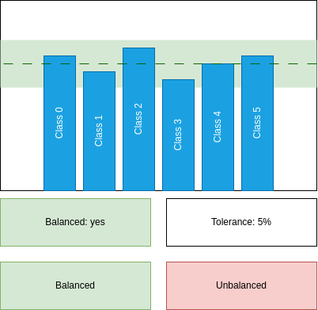

"Check data balancing" mock-up form

Detailed use case for "Check data balancing" task  
O - Occurrence, CL - Cognitive Level, S - Normalized Salary, SC - Step Cost

| **Step** | **O** | **CL** | **S** | **SC** |
| --- | --- | --- | --- | --- |
| **1** **ACTOR** opens "Check data balancing" form. | 1 | 1 | 1.15 | 1.15 |
| **2** **SYSTEM** shows the report. |  |  |  |  |
| **3** **SYSTEM** shows a hint whether the data is balanced or not. |  |  |  |  |
| **4** **ACTOR** checks threshold in the UI. | 1 | 2 | 1.15 | 2.30 |
| **5** **FOR EACH** column in the report: | 5 |  |  |  |
| **5.1** **IF** the column is not within the displayed threshold. | 4 |  |  |  |
| **5.1.1** **THEN** the data is not balanced. | 4 |  |  |  |
| **6.1** **IF** the data is balanced. | 0.2 |  |  |  |
| **6.1.1** **ACTOR** clicks "Balanced" button. | 0.2 | 1 | 1.15 | 0.23 |
| **6.2** **ELSE** | 0.8 |  |  |  |
| **6.2.1** **ACTOR** clicks "Unbalanced" button. | 0.8 | 1 | 1.15 | 0.92 |
| **7** **SYSTEM** shows a confirmation dialog. |  |  |  |  |
| **8** **ACTOR** closes the form. | 1 | 1 | 1.15 | 1.15 |
| Human task cost | | | | 5.75 |

### Check input coverage

The task is performed by a Data Analyst.

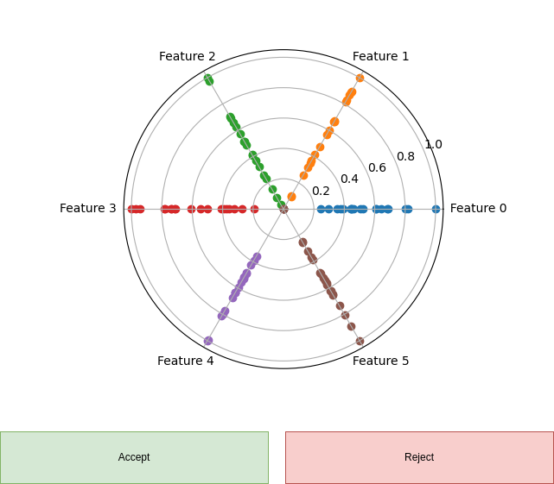

"Check input coverage" mock-up form

Detailed use case for "Check input coverage" task  
O - Occurrence, CL - Cognitive Level, S - Normalized Salary, SC - Step Cost

| **Step** | **O** | **CL** | **S** | **SC** |
| --- | --- | --- | --- | --- |
| **1** **ACTOR** opens "Check input coverage" form. | 1 | 1 | 1.15 | 1.15 |
| **2** **SYSTEM** shows a radar scatter plot of the input distribution. |  |  |  |  |
| **3** **FOR EACH** radius in the radar scatter plot: | 5 |  |  |  |
| **3.1** **IF** the distribution is not uniform as expected. | 3.33 | 4 | 1.15 | 15.32 |
| **3.1.1** **THEN** the input coverage is not satisfied. | 3.33 |  |  |  |
| **4.1** **IF** the input coverage is satisfied. | 0.33 |  |  |  |
| **4.1.1** **ACTOR** clicks "Accept" button. | 0.33 | 1 | 1.15 | 0.38 |
| **4.2** **ELSE** | 0.66 |  |  |  |
| **4.2.1** **ACTOR** clicks "Reject" button. | 0.66 | 1 | 1.15 | 0.77 |
| **5** **SYSTEM** shows a confirmation dialog. |  |  |  |  |
| **6** **ACTOR** closes the form. | 1 | 1 | 1.15 | 1.15 |
| Human task cost | | | | 18.77 |

### Configure Segregation System

This task is performed by a ML Engineer.

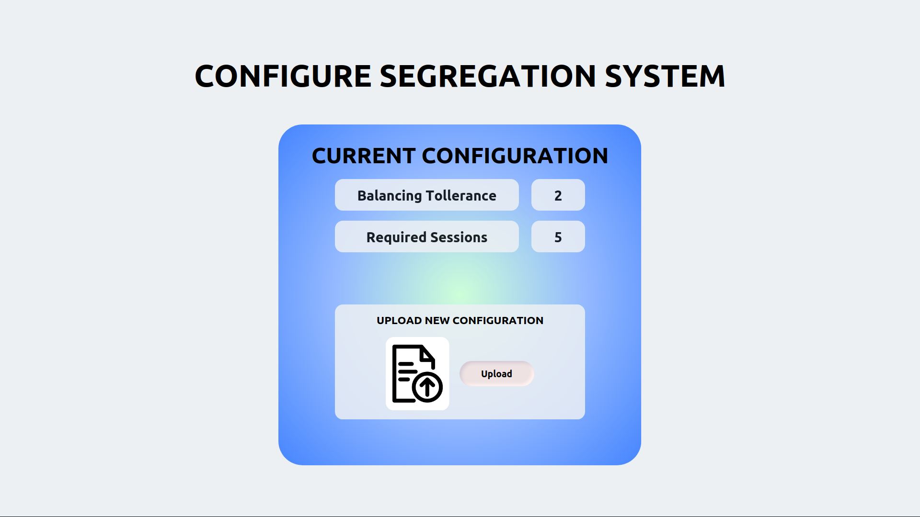

"Configure Segregation System" mock-up form

Detailed use case for "Configure Segregation" task  
O - Occurrence, CL - Cognitive Level, S - Normalized Salary, SC - Step Cost

| **Step** | **O** | **CL** | **S** | **SC** |
| --- | --- | --- | --- | --- |
| **1** **ACTOR** opens the "Configure Segregation System" form. |  |  |  |  |
| **2** **SYSTEM** displays the current configuration and the "Upload" button. |  |  |  |  |
| **3** **ACTOR** push the "Upload" button and upload the configuration file. |  |  |  |  |
| **4** **SYSTEM** shows a confirmation message. |  |  |  |  |
| **5** **ACTOR** closes the form. |  |  |  |  |
| Human task cost | | | |  |

## Development system

### Set iteration number

The task is performed by a ML engineer.

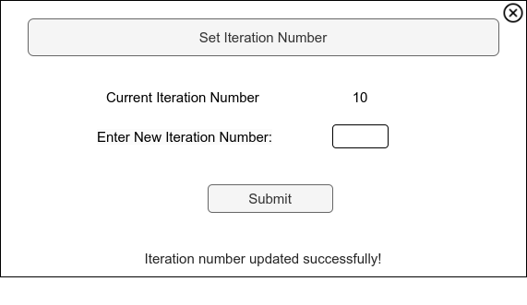

"Set iteration number" mock-up form

Detailed use case for "Set iteration number" task  
O - Occurrence, CL - Cognitive Level, S - Normalized Salary, SC - Step Cost

| **Step** | **O** | **CL** | **S** | **SC** |
| --- | --- | --- | --- | --- |
| **1** **ACTOR** opens "Set Iteration Number" form. | 1 | 1 | 2.5 | 2.5 |
| **2** **SYSTEM** displays the current iteration number. |  |  |  |  |
| **3** **ACTOR** inputs the desired number of iterations. | 1 | 3 | 2.5 | 7.5 |
| **4** **ACTOR** clicks "Submit" button to confirm the iteration number. | 1 | 1 | 2.5 | 2.5 |
| **5** **SYSTEM** shows a confirmation dialog. |  |  |  |  |
| **6** **ACTOR** closes the form. | 1 | 1 | 2.5 | 2.5 |
| Human task cost | | | | 15 |

### Check learning report

The task is performed by a ML engineer.

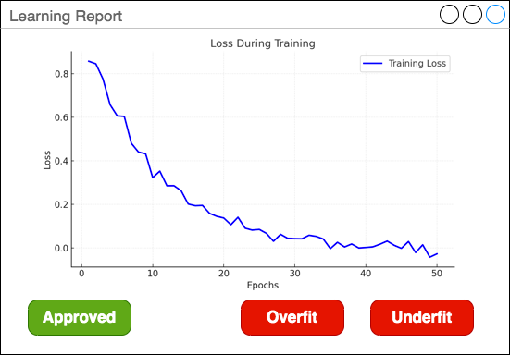

"Check learning report" mock-up form

Detailed use case for "Check training report" task  
O - Occurrence, CL - Cognitive Level, S - Normalized Salary, SC - Step Cost

| **Step** | **O** | **CL** | **S** | **SC** |
| --- | --- | --- | --- | --- |
| **1** **ACTOR** opens "Check training report" form. | 1 | 1 | 2.50 | 2.50 |
| **2** **SYSTEM** shows the training loss curve. |  |  |  |  |
| **3.1** **IF** the loss is flat for at least half of the iterations: | 0.4 | 3 | 2.50 | 3.00 |
| **3.1.1** **THEN** **ACTOR** clicks "Overfit" button. | 0.4 | 1 | 2.50 | 1.00 |
| **3.2** **IF** the loss is not flat at the end of the iterations: | 0.4 | 3 | 2.50 | 3.00 |
| **3.2.1** **THEN** **ACTOR** clicks "Underfit" button. | 0.4 | 1 | 2.50 | 1.00 |
| **3.3** **ELSE** | 0.2 | 3 | 2.50 | 1.50 |
| **3.3.1** **ACTOR** clicks "Approved" button. | 0.2 | 1 | 2.50 | 0.50 |
| **4** **SYSTEM** shows a confirmation dialog. |  |  |  |  |
| **5** **ACTOR** closes the form. | 1 | 1 | 2.50 | 2.50 |
| Human task cost | | | | 15.00 |

### Check validation report

This task is performed by a ML engineer.

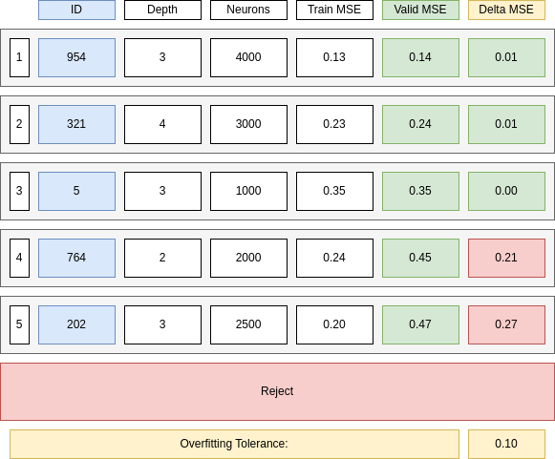

"Check validation report" mock-up form

Detailed use case for "Check validation report" task  
O - Occurrence, CL - Cognitive Level, S - Normalized Salary, SC - Step Cost

| **Step** | **O** | **CL** | **S** | **SC** |
| --- | --- | --- | --- | --- |
| **1** **ACTOR** opens "Check validation report" form. | 1 | 1 | 2.5 | 2.5 |
| **2** **SYSTEM** shows the best 5 models sorted by increasing Validation Loss. |  |  |  |  |
| **3** **FOR EACH** model in the list: | 5 |  |  |  |
| **3.1** **IF** the model Validation Loss minus the Training Loss is less than the Overfitting Tolerance and the Best Model is not selected. | 1 | 2 | 2.5 | 5 |
| **3.1.1** **THEN** select the model as the Best Model. | 1 | 1 | 2.5 | 2.5 |
| **4** **FOR EACH** model in the list: | 4 |  |  |  |
| **4.1** **IF** the model is not the Best Model and the Validation Loss minus the Training Loss is less than the Overfitting Tolerance and the Second Best Model is not selected. | 1 | 2 | 2.5 | 5 |
| **4.1.1** **THEN** select the model as the Second Best Model. | 1 | 1 | 2.5 | 2.5 |
| **5.1** **IF** the Best Model is not selected. | 0.05 | 1 | 2.5 | 0.125 |
| **5.1.1** **ACTOR** clicks "Reject" button. | 0.05 | 1 | 2.5 | 0.125 |
| **5.2** **ELSE IF** the Second Best Model is not selected or the Validation Loss of the Second Best Model is one order of magnitude greater than the Validation Loss of the Best Model. | 0.3 | 3 | 2.5 | 2.25 |
| **5.2.1** **ACTOR** clicks on the Best Model. | 0.3 | 1 | 2.5 | 0.75 |
| **5.3** **ELSE** | 0.65 | 3 | 2.5 | 4.875 |
| **5.3.1** **ACTOR** clicks on the least complex model among the Best Model and the Second Best Model. | 0.65 | 3 | 2.5 | 4.875 |
| **6** **SYSTEM** shows a confirmation dialog. |  |  |  |  |
| **7** **ACTOR** closes the form. | 1 | 1 | 2.5 | 2.5 |
| Human task cost | | | | 32.91 |

### Check test results

This task is performed by a ML engineer.

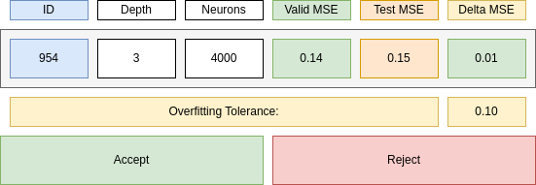

"Check test results" mock-up form

Detailed use case for "Check test results" task  
O - Occurrence, CL - Cognitive Level, S - Normalized Salary, SC - Step Cost

| **Step** | **O** | **CL** | **S** | **SC** |
| --- | --- | --- | --- | --- |
| **1** **ACTOR** opens "Check test results" form. | 1 | 1 | 2.5 | 2.5 |
| **2** **SYSTEM** shows the test results. |  |  |  |  |
| **3** **ACTOR** checks if the difference between the test results and the validation results is within overfitting tolerance. | 1 | 2 | 2.5 | 5 |
| **4.1** **IF** the test results is not satisfactory. | 0.01 |  |  |  |
| **4.1.1** **ACTOR** clicks "Reject" button. | 0.01 | 1 | 2.5 | 0.025 |
| **4.2** **ELSE** | 0.99 |  |  |  |
| **4.2.1** **ACTOR** clicks "Approve" button. | 0.99 | 1 | 2.5 | 2.475 |
| **5** **SYSTEM** shows a confirmation dialog. |  |  |  |  |
| **6** **ACTOR** closes the form. | 1 | 1 | 2.5 | 2.5 |
| Human task cost | | | | 12.5 |

### Configure Development System

This task is performed by a ML Engineer.

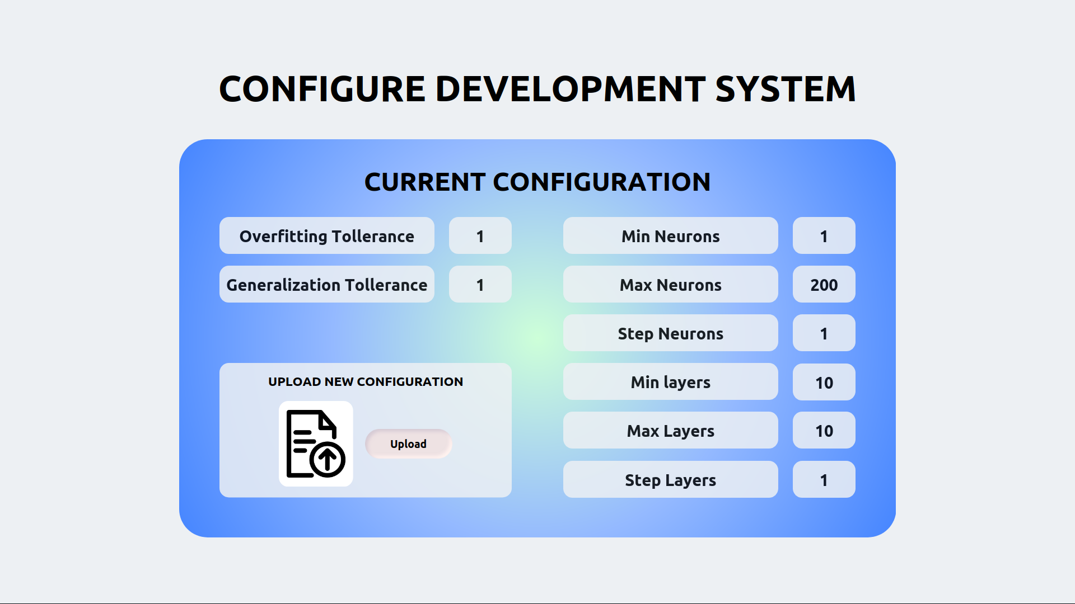

"Configure Development System" mock-up form

Detailed use case for "Configure Development" task  
O - Occurrence, CL - Cognitive Level, S - Normalized Salary, SC - Step Cost

| **Step** | **O** | **CL** | **S** | **SC** |
| --- | --- | --- | --- | --- |
| **1** **ACTOR** opens the "Configure Development System" form. |  |  |  |  |
| **2** **SYSTEM** displays the current configuration and the "Upload" button. |  |  |  |  |
| **3** **ACTOR** push the "Upload" button and upload the configuration file. |  |  |  |  |
| **4** **SYSTEM** shows a confirmation message. |  |  |  |  |
| **5** **ACTOR** closes the form. |  |  |  |  |
| Human task cost | | | |  |

## Evaluation system

### Evaluate classifier performance

This task is performed by a Data Analyst.

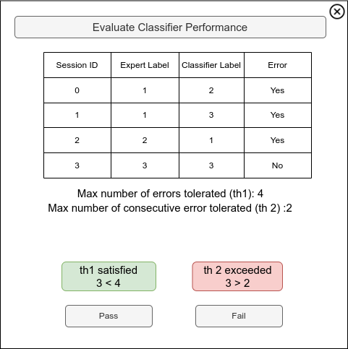

"Evaluate Classifier Performance" mock-up form

Detailed use case for "Evaluate Classifier Performance" task  
O - Occurrence, CL - Cognitive Level, S - Normalized Salary, SC - Step Cost

| **Step** | **O** | **CL** | **S** | **SC** |
| --- | --- | --- | --- | --- |
| **1** **ACTOR** opens the "Evaluate Classifier Performance" form. | 1 | 1 | 1.15 | 1.15 |
| **2** **SYSTEM** displays a table of sessions with Expert Label (ground truth) and Classifier Label (predicted label). The difference between the labels (if any) represents an error. |  |  |  |  |
| **3** **ACTOR** reviews the table. | 1 | 4 | 1.15 | 4.60 |
| **3.1** **IF** the total errors or consecutive errors exceed their respective thresholds: | 1 | 2 | 1.15 | 2.30 |
| **3.1.1** **ACTOR** clicks the "Fail" button. | 0.5 | 1 | 1.5 | 2.30 |
| **3.2** **ELSE** |  |  |  |  |
| **3.2.1** **ACTOR** clicks the "Pass" button. | 0.5 | 1 | 1.5 | 0.575 |
| **4** **SYSTEM** shows a confirmation dialog. |  |  |  |  |
| **5** **ACTOR** closes the form. | 1 | 1 | 1.15 | 1.15 |
| Human task cost | | | | 9.35 |

### Configure Evaluation System

This task is performed by a ML Engineer.

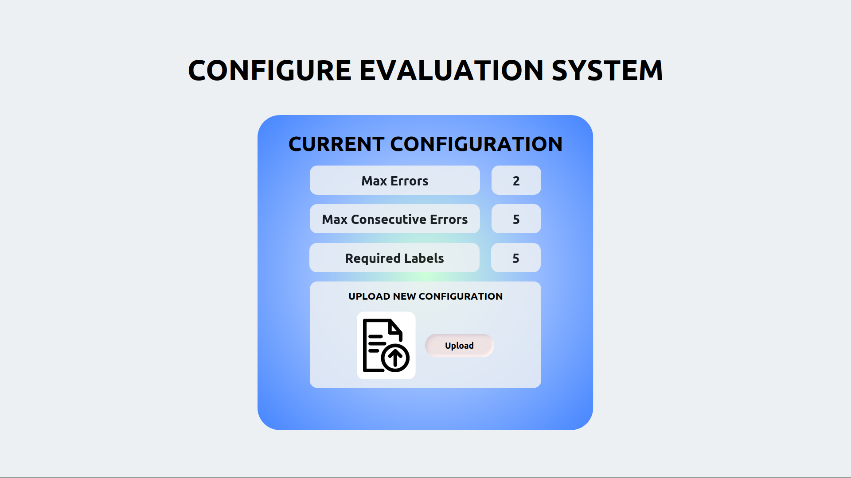

"Configure Evaluation System" mock-up form

Detailed use case for "Configure Evaluation" task  
O - Occurrence, CL - Cognitive Level, S - Normalized Salary, SC - Step Cost

| **Step** | **O** | **CL** | **S** | **SC** |
| --- | --- | --- | --- | --- |
| **1** **ACTOR** opens the "Configure Evaluation System" form. |  |  |  |  |
| **2** **SYSTEM** displays the current configuration and the "Upload" button. |  |  |  |  |
| **3** **ACTOR** push the "Upload" button and upload the configuration file. |  |  |  |  |
| **4** **SYSTEM** shows a confirmation message. |  |  |  |  |
| **5** **ACTOR** closes the form. |  |  |  |  |
| Human task cost | | | |  |

## Client-Side Systems

### Configure Client-Side Systems

This task is performed by a ML Engineer.

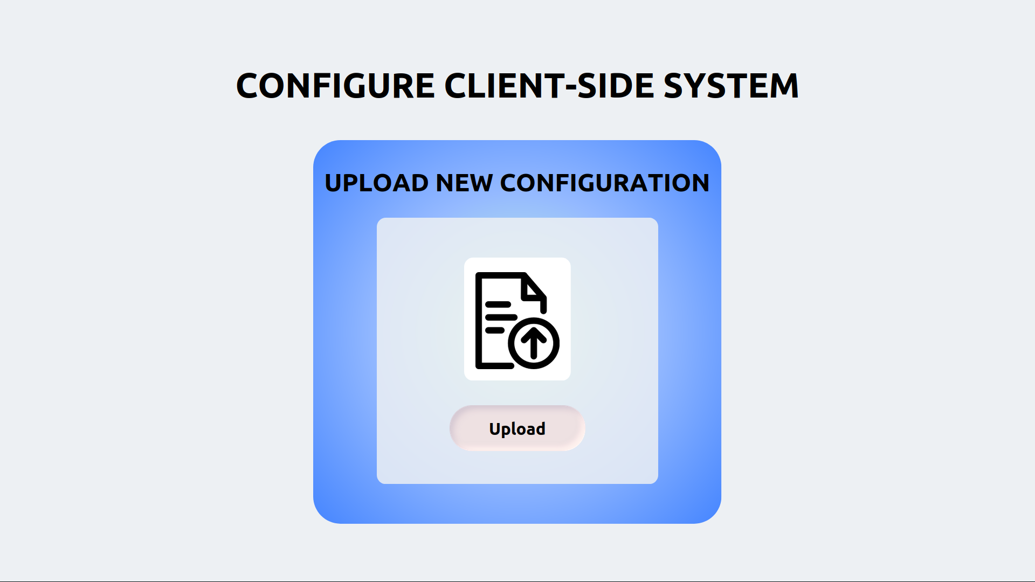

"Configure Client-Side Systems" mock-up form

Detailed use case for "Configure Client-Side Systems" task  
O - Occurrence, CL - Cognitive Level, S - Normalized Salary, SC - Step Cost

| **Step** | **O** | **CL** | **S** | **SC** |
| --- | --- | --- | --- | --- |
| **1** **ACTOR** opens the "Configure Client-Side System" form. |  |  |  |  |
| **2** **SYSTEM** displays the "Upload" button. |  |  |  |  |
| **3** **ACTOR** push the "Upload" button and upload the configuration file. |  |  |  |  |
| **4** **SYSTEM** shows a confirmation message. |  |  |  |  |
| **5** **ACTOR** closes the form. |  |  |  |  |
| Human task cost | | | |  |

## Production System

### Configure Production Systems

This task is performed by a ML Engineer.

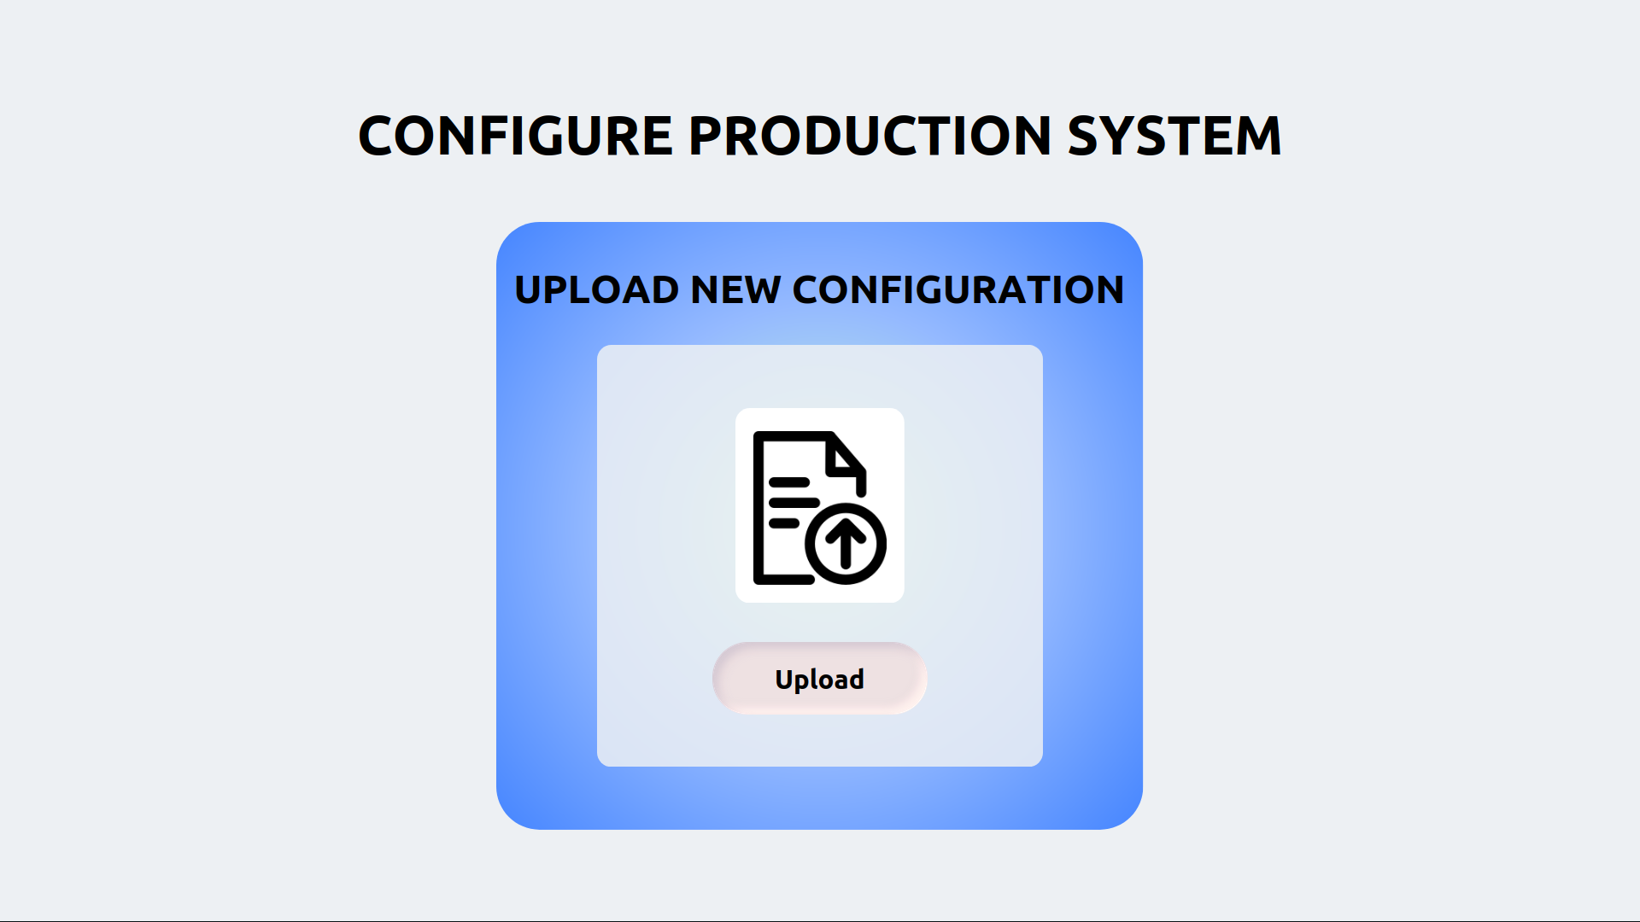

"Configure Production System" mock-up form

Detailed use case for "Configure Production" task  
O - Occurrence, CL - Cognitive Level, S - Normalized Salary, SC - Step Cost

| **Step** | **O** | **CL** | **S** | **SC** |
| --- | --- | --- | --- | --- |
| **1** **ACTOR** opens the "Configure Production System" form. |  |  |  |  |
| **2** **SYSTEM** displays the "Upload" button. |  |  |  |  |
| **3** **ACTOR** push the "Upload" button and upload the configuration file. |  |  |  |  |
| **4** **SYSTEM** shows a confirmation message. |  |  |  |  |
| **5** **ACTOR** closes the form. |  |  |  |  |
| Human task cost | | | |  |

## Ingestion System

### Configure Ingestion System

This task is performed by a ML Engineer.

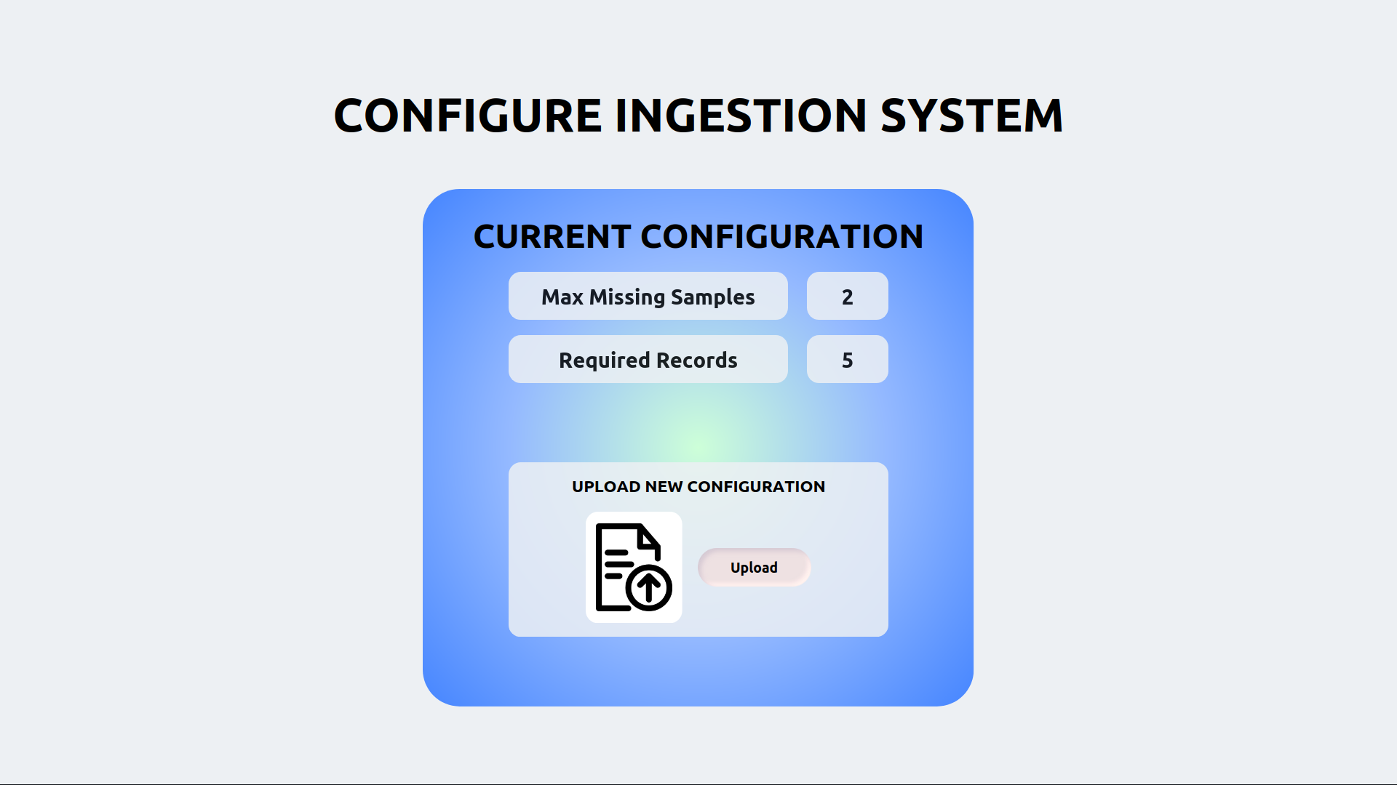

"Configure Ingestion System" mock-up form

Detailed use case for "Configure Ingestion" task  
O - Occurrence, CL - Cognitive Level, S - Normalized Salary, SC - Step Cost

| **Step** | **O** | **CL** | **S** | **SC** |
| --- | --- | --- | --- | --- |
| **1** **ACTOR** opens the "Configure Ingestion System" form. |  |  |  |  |
| **2** **SYSTEM** displays the current configuration and the "Upload" button. |  |  |  |  |
| **3** **ACTOR** push the "Upload" button and upload the configuration file. |  |  |  |  |
| **4** **SYSTEM** shows a confirmation message. |  |  |  |  |
| **5** **ACTOR** closes the form. |  |  |  |  |
| Human task cost | | | |  |

## Preparation System

### Configure Preparation System

This task is performed by a ML Engineer.

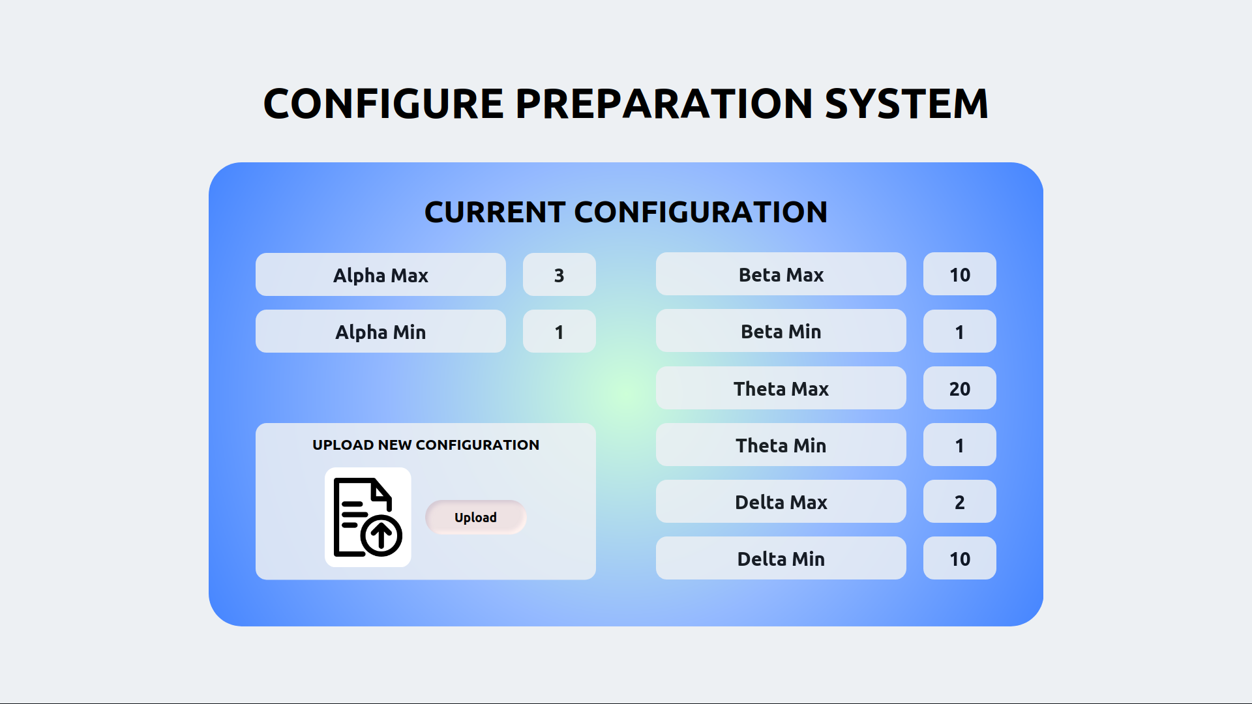

"Configure Preparation System" mock-up form

Detailed use case for "Configure Preparation" task  
O - Occurrence, CL - Cognitive Level, S - Normalized Salary, SC - Step Cost

| **Step** | **O** | **CL** | **S** | **SC** |
| --- | --- | --- | --- | --- |
| **1** **ACTOR** opens the "Configure Preparation System" form. |  |  |  |  |
| **2** **SYSTEM** displays the current configuration and the "Upload" button. |  |  |  |  |
| **3** **ACTOR** push the "Upload" button and upload the configuration file. |  |  |  |  |
| **4** **SYSTEM** shows a confirmation message. |  |  |  |  |
| **5** **ACTOR** closes the form. |  |  |  |  |
| Human task cost | | | |  |