Email: <daneityoun@gmail.com>

# 1. Introduction

Fresh fruits and vegetables are in greater demand as a result of rising living standards. Due to their perishable nature, it is extremely difficult to preserve the nutritional value and freshness of agricultural products after harvest. Inadequate processing, a lack of suitable refrigerated equipment, and inadequate cold chain logistics facilities have led to significant losses in fruits and vegetables**.** In the world, food is lost at a rate of 40–50% per year for fruits and vegetables. Low temperature slows bacterial proliferation, respiratory intensity, and metabolism, which delays spoiling (Lagarda-Leyva et al, 2023). This report presents the findings of a simulation model developed to help the manager of a refrigerated storage facility determine the appropriate number of forklifts and specialist handling machines needed to meet service standards when dealing with food shipments in order to avoid the losses. The simulation model was developed using Simul8 software.

# 2.0 Model Description

# 2.1 Model Aims

The main aim of this simulation model is to determine the minimum requirements for forklifts and specialist handling machines during peak hours and off-peak hours to ensure that the service levels are met. Specifically, the model aims to:

1. Determine the required number of forklifts and handling machines for efficient handling of varying arrival rates during off-peak and peak hours.
2. Minimize customer waiting times by efficiently allocating resources to each category's queue, especially during peak hours.
3. Maintain efficient warehouse operations as a 24-hour facility to handle food shipments at any time while meeting service standards and customer expectations.

# 2.2 Description of Model

The simulation model represents a refrigerated storage facility used for expensive food supplies. The arrivals at the facility are classified into three categories based on their time tolerance outside a refrigerated environment.

The model process begins by the arrivals of the incoming shipments to the arrival bay and are met by a forklift operator. The forklift operator takes the loads to one of three queues based on their category. The arrivals are categorized into three queues - Category 1, Category 2, and Category 3, based on their classification. Each queue represents the time that shipments can survive outside a refrigerated environment without spoiling. Specialized handling machines are responsible for loading the arrivals from the queues into the main warehouse facility. For Category 1 arrivals, 99% of shipments should not have to wait for more than 15 minutes in total. Category 2 arrivals should not have to wait for more than 70 minutes in total, and Category 3 arrivals should not have to wait for more than 110 minutes in total.

During off-peak hours, the arrival rates are exponentially distributed with averages of 2 category 1 arrivals per hour, 10 category 2 arrivals per hour, and 16 category 3 arrivals per hour. During peak hours (8 am - 5 pm), the arrival rates increase to 4 category 1 arrivals per hour, 22 category 2 arrivals per hour, and 30 category 3 arrivals per hour. The time taken by a forklift to transport shipments from the arrivals bay to the appropriate queue is fixed at 10 minutes. For Category 1 arrivals, the time to be loaded into the warehouse by a specialist handling machine follows an average distribution of 5 minutes. For Category 2 arrivals, the process is normally distributed with a mean of 12 minutes and a standard deviation of 2 minutes. For Category 3 arrivals, the time for this process is also normally distributed with a mean of 15 minutes and a standard deviation of 3 minutes.

# 2.3 Activity Flow Diagram and Model Logic

***Figure 1. flowchart of the simul8 model***

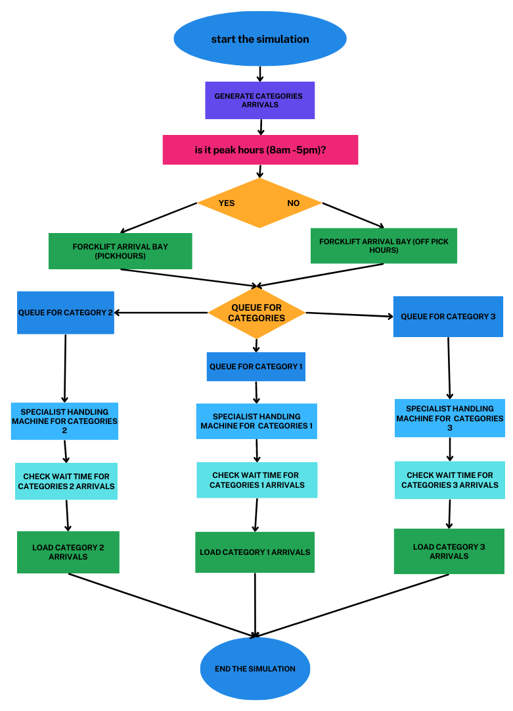

In the figure 1 above, the flowchart shows the general flow of the simulation model, where arrivals are generated based on the given arrival rates during peak and off-peak hours. The forklift operator takes the loads to the appropriate queues based on their categories. The specialist handling machines then load the arrivals into the main warehouse facility.

# *Figure 2. Snapshot of the simul8 model*

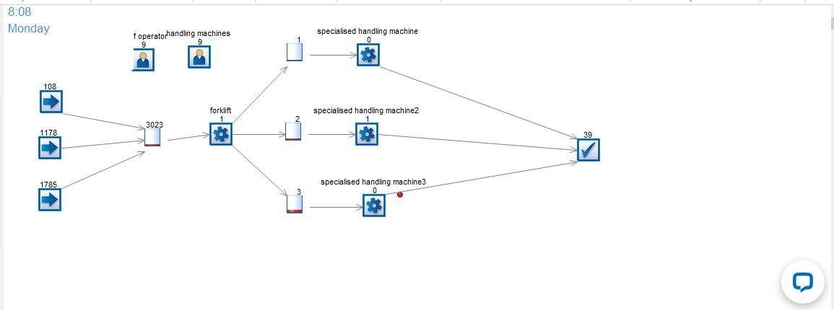

**Activities**

**Figure 2 *is the snapshot of the model***.

The model has three entries, which are the arrivals bay for categories 1, 2, and 3. External factors have been included in the arrival bay, then a queue for the forklift machine operator, which transfers the categories into their appropriate category queues for each to be handled by the specialized machine to make service standards for each category of arrivals, and then a combined exit for all, which is the warehouse.

To achieve including the off-peak hours’ arrival with an exponentially average distribution of 2 category 1 arrivals per hour, 10 category 2 arrivals, and 16 category 3 arrivals, and also the peak hours (8 a.m.–5 p.m.) having 4 category 1 arrivals per hour, 22 category 2 arrivals, and 30 category 3 arrivals. We gave each start point object properties, with cat1, cat2, and cat3, respectively, for each start point object, and each property has a scheduled time for exponential distribution as specified.

# 3.0 Simulation Experiments and Results

To answer the question which required us to determine the minimum requirements for forklifts and specialized handling machines, the model was run for 24 hours and the analyzed results showed in the proceeding tables below.

# *Figure 3: table for resources utilization analysis.*

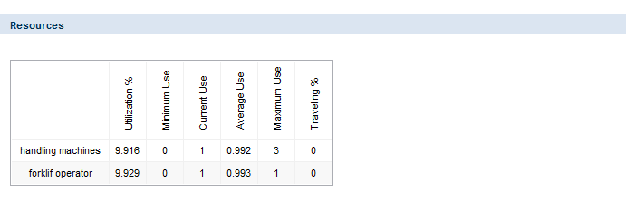

***Figure 3. The table above shows the minimum and maximum use of forklifts and specialized handling machines in the simulation.***

Based on the simulation results, it has been observed that the minimum utilization of forklifts and specialized handling machines is 0, indicating that there are instances during the simulation when these resources remain idle or are not fully utilized. On the other hand, the maximum utilization of forklifts is 1, meaning that at times, the forklifts are fully occupied with tasks. Similarly, the maximum utilization of specialized handling machines is 3, indicating that in some scenarios, up to three machines are simultaneously engaged in loading activities. The utilization pattern of forklifts and handling machines reflects their adaptability to varying arrival rates during off-peak and peak hours (Lee et al, 2019). When the arrival rates are lower during off-peak hours, the machines may not be fully utilized, resulting in a minimum utilization of 0. However, during peak hours when arrival rates are higher, the machines are efficiently deployed to meet the service standards, leading to maximum utilization.

By analyzing the minimum and maximum use of these resources, warehouse managers can identify the periods of low activity and potentially adjust their staffing or resource allocation to optimize efficiency (Fares et al, 2023). Additionally, during peak hours, the utilization data can inform decisions on whether to invest in additional machines or adjust the workforce to meet the higher demand effectively.

# 4.0 Conclusion

By aligning the resource allocation strategy with the dynamic arrival rates during different hours of operation, the warehouse can effectively manage its operations, reduce waiting times, and maintain the desired service standards. The simulation has provided valuable information to guide decision-making and ensure optimal resource utilization in the refrigerated warehouse, ultimately enhancing customer satisfaction and operational efficiency. As the warehouse continues its 24-hour operations, the insights gained from this simulation will contribute to enhancing overall productivity and maintaining the highest quality standards for the stored goods.

# References

Fares, N., Lloret, J., Kumar, V., Frederico, G. F., & Kamach, O. (2023). A hybrid framework for fleet management with quality concerns: a case for the food industry. *International Journal of Quality & Reliability Management*.

Lagarda-Leyva, E. A., Morales-Mendoza, L. F., Segura-Campos, M. R., Bojorquez-Alvarado, A. L., & Romero-Guzmán, M. P. (2023). Coupling reverse logistics and dynamic modeling for waste management: a food service provider case study. *Clean Technologies and Environmental Policy*, 1-14.

Lee, C. K., Zhang, S., & Ng, K. K. (2019). In-plant logistics simulation model for the catering service industry towards sustainable development: A case study. *Sustainability*, *11*(13), 3655.