MANU2484 – DESIGN FOR ASSEMBLY AND AUTOMATION

PROJECT 2 – DEVELOPING A GRAVITY SELECTOR DEVICE FOR BOTTLE CAP SORTING

GROUP 1E

Tutorial Session 2

Lecturer: Mr. Jaronie Mohd Jani

Truong Tan Gia Huy – s3806881

Nguyen Bao Tuan – s3713061

Nguyen Mau Tung – s3755518

Dinh Tho Chuong – s3891640

Patrick Mark Kennelly – s4079249

**Submission date:** **22nd May, 2024**

**Table of Contents**

PROJECT INTRODUCTION 3

PROTOTYPE DEVELOPMENT 5

DETAIL OF PROTOTYPE DESIGN 12

CONCLUSION 23

REFERENCES 24

# PROJECT INTRODUCTION

This design proposal document portrays the engineering efforts undertaken by Group 1E in developing a simple bottle cap selector/orientor device in response to ‘Assignment 2’ of the Design for Assembly and Automation (MANU2484) course. Here the projects scope is introduced, the prototype development path outlined, final design analysed, and the conclusions presented. This report does not feature results.

**The Project**

Student groups were tasked with the design and manufacture of a ‘simple feeding mechanism’ used to select and/or orientate bottle caps with the threads facing the same direction. To guide the process, the following design requirements were set:

1. Size: Maximum size. length = 300 mm and width = 350 mm.
2. Simplicity: Rail design with gravity feed concept.
3. Material: Any materials. Due to limited time, please do the 3D-printing on your own

(RMIT, 2024)

Furthermore, a ‘product testing’ process was outlined, assessing the probability of caps passing the screening, the accuracy of the feeding and time taken to complete the 50-bottle cap feed task.

**Development:**

The team collaboratively produced four bottle cap selector prototypes. These prototypes, having been iteratively developed, all feature the initial (Prototype 1) house shaped hopper to centred track shape. Feature dimensions and the sorting/selecting order was changed in the second, while the third & fourth made further adaptations to the selector slot and scale. Prioritising suitability to the additive manufacturing process and its constraints.

**Finalised Design:**

The fifth & final design iteration predominantly saw the geometry further tweaked to make appropriate for printing by the FlashForge 4 Pro. On from this, the final tweaks to the selector slot and feed point were made to reduce jamming percentage and increase selection accuracy. To conclude the design, some chamfers and final aesthetic edits were made. The result, a design the team is confident will function to a passable degree.

Figure 1: Team 1E Prototype Bottle Cap Selector

**Members’ Responsibilities:**

* **Truong Tan Gia Huy**: Replicate example model, Detail of Prototype Design, Reference, Editing
* **Patrick Kennelly:** Project Introduction, Proto 1 & 2 Description, Proto 2 Development, Conclusion
* **Nguyen Bao Tuan:** Detail of Prototype Design, Prototype 3 Development
* **Nguyen Mau Tung:** Prototype Development, Prototype Model Designing and Modifying.
* **Dinh Tho Chuong:** Prototype Development Research

# PROTOTYPE DEVELOPMENT

A bottle cap orientor, also known as a cap sorter or cap feeder, is an automated equipment used in bottling lines that accurately places caps onto containers. The general operation involves placing a cap on every open container as it goes through the cap feeder to ensure that the neck finish of the container and the bottom of the closure line up [1, 2]. A star wheel or conveyor is used to transport open containers to the cap feeder. These tools are essential to maintaining accuracy and efficiency in high-speed bottling operations. They can accommodate a range of cap sizes and designs and are designed to prevent scuffs and scratches during the capping process.

A conveyor or star wheel moves open containers to a cap feeder. Every container that goes through the cap feeder gets a cap. To put it more precisely, cap sorters take in bulk loads of caps and arrange them in the required orientation. Before moving on to the next stage of the production cycle, they make sure the caps are facing the right way. There are several ways to complete the task at hand:

**Sorters that use waterfalls:** The caps are fed into the capping machine through a single file cap chute, and they are correctly aligned by means of inclined cleated belts and the "center of gravity" principle.

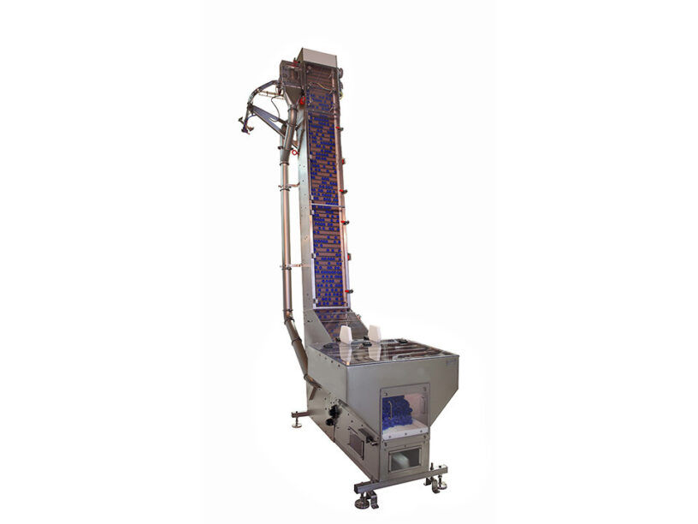

Figure 2: An Industrial bottle cap selector [3]

Through a single cap chute, rotary orientors align caps using different combinations of pressurized air, centrifugal force, and creative geometry before delivering them to the cap applicator/dispenser. To accommodate a broad range of closure types, geometries, and sizes, rotary orientors are available in a number of configurations [3].

**Cap sorter features [4, 5]:**

* Constructed in stainless steel (Acasi Machinery’s Cap feeder 810-000)
* Cap rejecting by photoelectric sensor
* Variable vibration and speed control
* Preserve caps’ integrity and cleanness

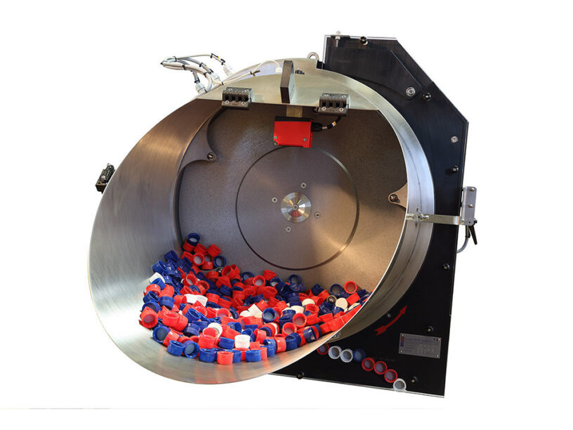

Figure 3: An Industrial bottle cap selector [3]

In automation, a "selector and orientor" is a device or system that is intended to pick the proper location for parts and make sure they are orientated correctly before being delivered.

* **Selector:** During the production process, the selector component chooses the location or workstation to which each part must be supplied. Usually, a number of variables, like the kind of item, the production timeline, or the assembly specifications, play a role in this decision.
* **Orientor:** This part makes sure that the pieces are oriented correctly for the assembly or use for which they are designed. To comply with particular assembly or processing specifications, this may entail turning, flipping, or aligning the components.

This method ensures that parts are supplied to the exact area and in the correct orientation for smooth assembly or subsequent processing, thereby streamlining the production process, lowering mistakes, and increasing overall efficiency. No rotating or vibratory feeders are needed for Project No. 2, nor is machinery necessary for it to run. The team must create a straightforward model with a straight rail, selector, and/or orienter mechanisms. Other specifications include simplicity, no material restrictions, and a maximum size of **500mm in length and 350mm in width.** In the project description, it stated the prototype includes a Selector **and/or** Orientor and since the Orientor is optional, and the team want to lower the risk of fail testing during the demonstration and complicating the design. Thus, we decided to make the project model with only Selector feature.

**Prototype Model No.1**

Kicking off the designing, the team leader Truong Tan Gia Huy sought to replicate the example model to understand the selector & orientor mechanisms and begin to identify required areas for improvement.

Figure 4: Example model provided by the lecturer

The first prototype model was designed by Nguyen Mau Tung, producing a simplified version that featured a house-shape hopper that promotes a directed flow to the selector feature. The rail is centered, and the selector, the covered top at the end of the track, seamlessly makes up the part feeding interface. Finally, the protruding channel shaped track guides the caps over the selector slot, resulting in only thread-to-sky orientated caps passing onwards. Finally, another top cover is added for rigidity.

Figure 5: Improved design of the selector device

**Second Prototype Model No.2**

The primary modification of Patrick Kennelly’s prototype 2, is the switching of the top cover and selector slot locations. The justification being the selector cut-out slot will NOT be effective without the bottle caps properly ‘selected’ (lying flat). This order of operations typical in industry, as seen in (maxi reis, 2020) & (王鈞盈, 2014) demonstrations [6, 7]. The selecting section/top cover was extended, and fillets added at the section point to reduce jamming occurrences.

Figure 6: Closer view at the selector device features

**Track & Selector Slot Modifications**

Modifications to the track and selector slot were made to increase the suitability towards standard soda bottle caps (previously identified as PCO1881 28mm). The track width needed to be modified to ensure the caps passed over the selector slot appropriately. The caps have a 30mm outer diameter and thus the internal track width was reduced to 32mm to give 2mm clearance (see below sketch).

The selector slot itself was then modified to better suit the cap and the new track width. The selector cut-out was deepened, ensuring the wrongly oriented caps ‘tip’ down the through cut-out, even when against the opposing wall. As a result, the selector will be more accurate.

Figure 7: Conventional bottle cap size

**Prototype Model No.3 and No.4.**

The third model modified by Nguyen Bao Tuan. Since the printer has a limited dimension. Result in shorten the design bottle caps holder size and the rail length for suitable printing requirements for the machine. This model fixed the selector slot height to 15mm so the bottle cap PCO1881 28mm with the height of 16.3mm [8] with the thread side upward orientation will not fall through the selector slot. Moreover, the part thickness is changed to 2mm to optimize material cost and still can hold the bottle caps weight. But the prototype dimension is 300x150mm and it still bigger than the build size of available printers in RMIT SSET. Model No.4 is added with some top covers in both side of the rail in order to reinforce the walls from bending and aesthetic feature.

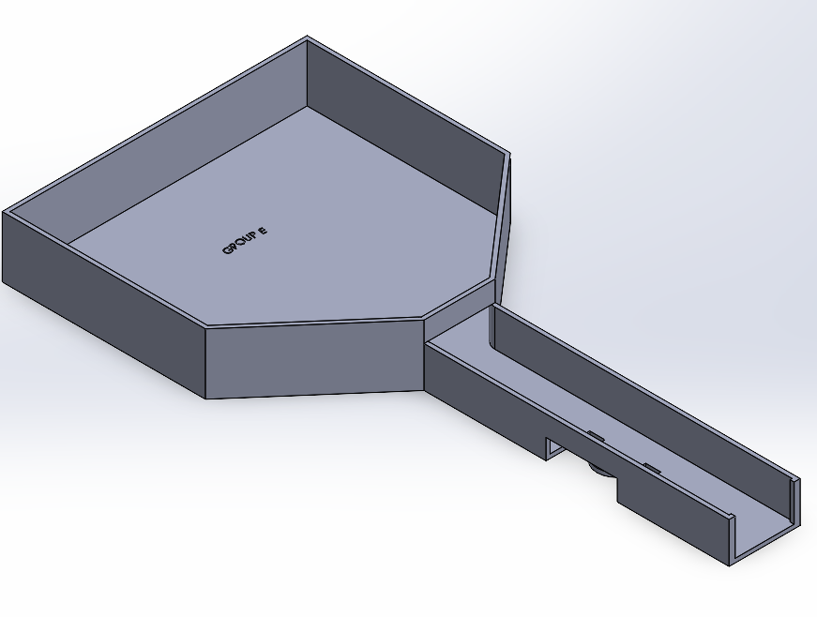

Figure 8: Prototype model third version

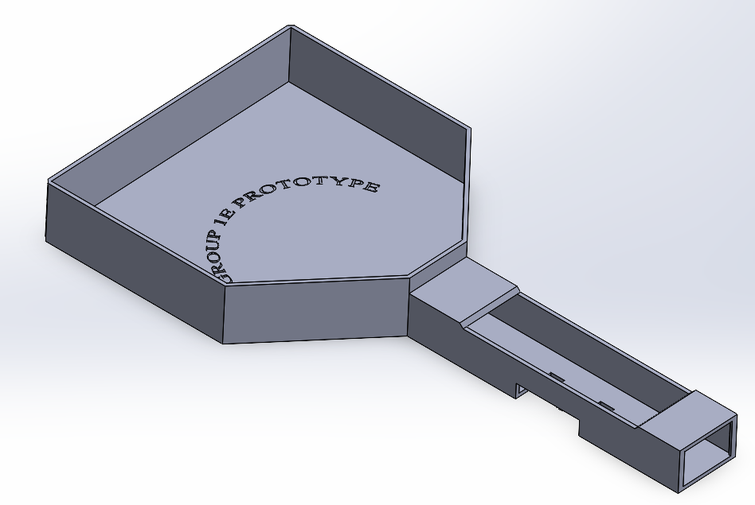

Figure 9: Prototype model fourth version

**Prototype Model No.5 (Finalized Model)**

The final design, modified by Nguyen Mau Tung, building upon Model No.4, shares many similarities but noticeably a further reduced size down to (220x150x30mm) in order to fit in the FlashForge 4 Pro’s (220 x 200 x 250) mm build volume capabilities (FLASHFORGE n.d.). The team’s brand - TEAM 1E PROTOTYPE – is cut on the surface of the selector’s storage compartment. It is printed curve as an attraction to increase aesthetic.

The rail top cover length was also shortened to prevent the bottle caps jamming into the top cover edge. Some edges have been chamfered to improve aesthetics and the team brand has again been improved visually. The selector side slot has been lengthened slightly ensuring the caps fall without hindrance.

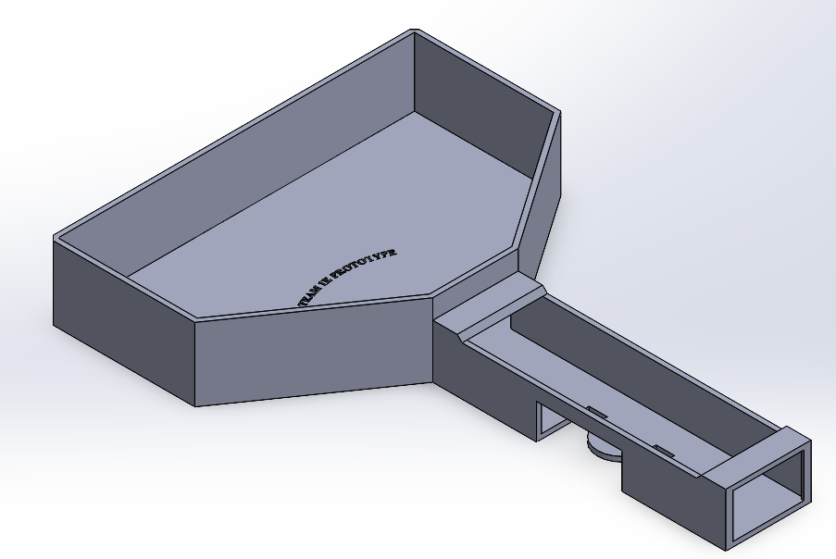

Figure 10: Finalized Prototype

# DETAIL OF PROTOTYPE DESIGN

**Build and Operation Instructions**

In general, the bottle caps will be put in the trapezoid-shape storage compartment, which is where the team’s brand is embedded into the plastic. During the test, the operator will tilt down the selector towards the rail direction so the bottle caps will drop down to the rail using gravity. The rail here is calculated and designed so only one cap can fit at a time. Moreover, the width of this rail is slightly larger than the standard PCO1881 cap’s diameter, just enough for the cap to move through. This helps providing the cap stable moving trajectory, ensuring the cap will lie at the designated location of the rail’s selecting feature. At the bottom plate of this rail, there is a dome-shape slot that replicate half the shape of a circular cap, which serve as the main feature to select between upright and upside down cap.

Figure 11: Side views of the selector

Figure 12: Top view of the selector

Figure 13: Bottle cap selector drawing

The dome-shaped platform served as a rail for the bottle cap when it was upside down. In this manner, it will keep going in the direction of the rail and keep the cap from tilting and falling out. However, if the user tilts the gadget too far to the right or shakes it too vigorously, there is a chance that they will fall out of the rail at the side hole.

Figure 15: Selector in operation when bottle cap is upside down

However, when the bottle cap is upright, it will tilt downward because its inner hollow side matches the shape of the slot, causing more than half of the cap to rest on the space adjacent to the rail's dome-shaped platform. After that, gravity will take over and force the cap into the slot.

Figure 16: Selector in operation when bottle cap is upright

Figure 17: The gap between the cap and the side hole, shown as dY distance

All dimensions of this selector are carefully calculated, so there will only be a small gap between the holes and the bottle caps, which is just enough for the bottle cap to pass through while not too large so both scenario of the cap’s orientation will fall out of the slot during the selecting process.

**Analysis**

* **Estimated material cost to 3D print the model:**

The model volume is recorded in Mass Properties function in SolidWorks software with custom PLA material with mass density = 1300 kg/ [9].

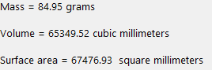

Volume 65349.52 = 0.0653 litters

Based on All3DP [10], a kg of PLA plastic used for 3D print costs around $20 on average.

Prototype cost: 0.0653 * 20 = 1.3 $

* **Estimate time required to fabricate using Flashforge Adventurer 4 Pro FDM 3D Printer**

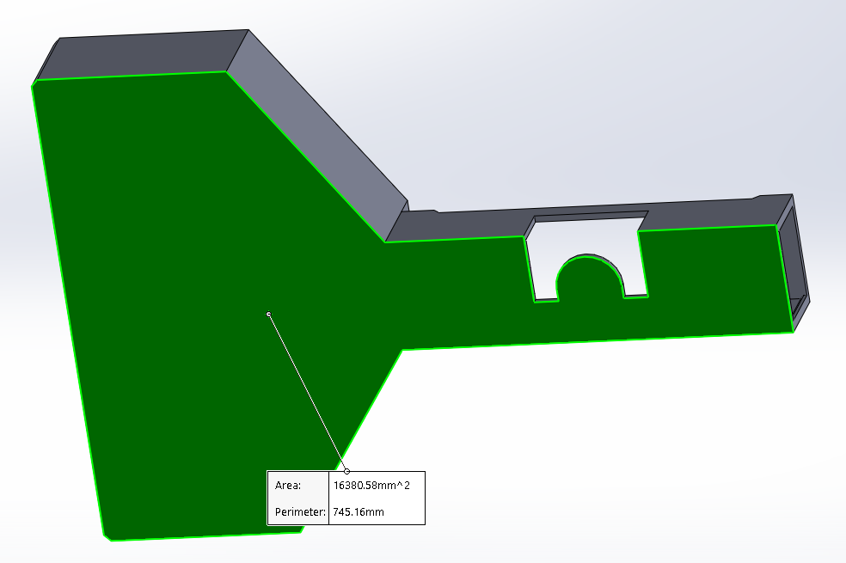

Figure 18: Total surface area of the bottom of the selector

* **Time to print the base**

Layer thickness = 0.4 mm [11]

Assume normal print speed (v) = 100 mm/s [11]

Spot diameter (D) = 0.4 mm [11]

Base layer area ( = 16380.58

Base thickness = 2 mm

Excluded setup time, repositioning and recoating time ( = 0

Number of base layer (N) = = 5 layers

Time to complete base layer: + = = 409.5145 s

Base build cycle time: = = 409.5145 * 5 = 2047.5725 s = 34.1262 mins

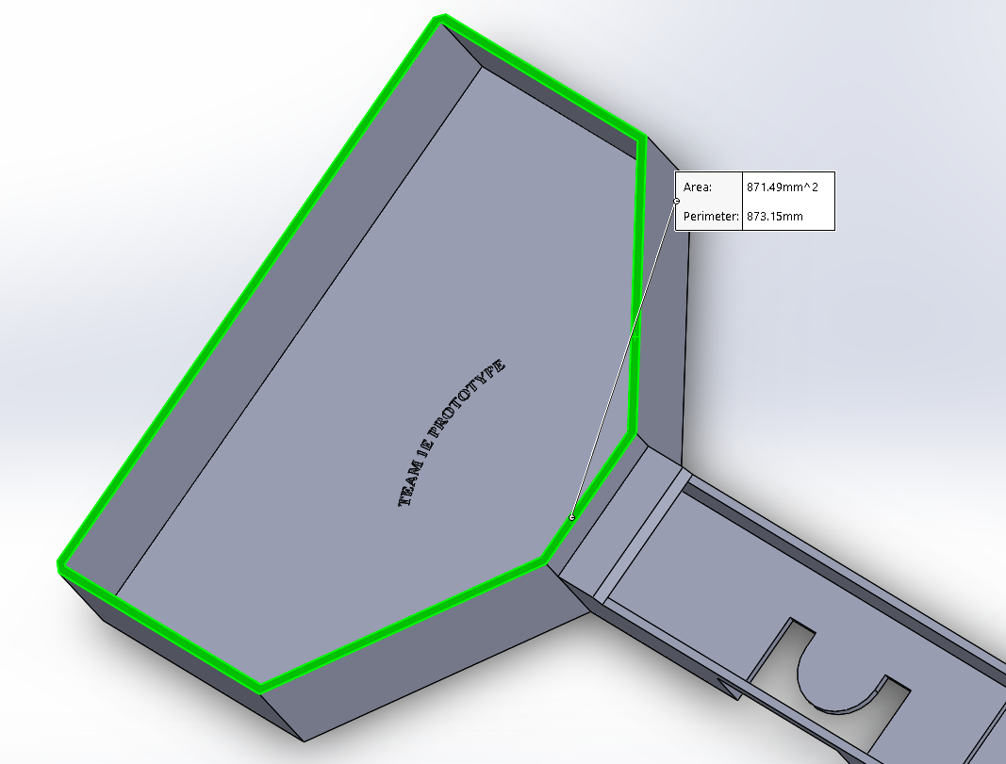

Figure 19: Area at the edge of holder layers

* **Time to print the holder**

Holder layer area ( = 871.49

Holder thickness = 30 mm

Number of holder layers (N)= = 75 layers

Time to complete holder layer: + = = 21.7873 s

Holder build cycle time: = = 21.7873 * 75 = 1634.0438 s = 27.2341 mins

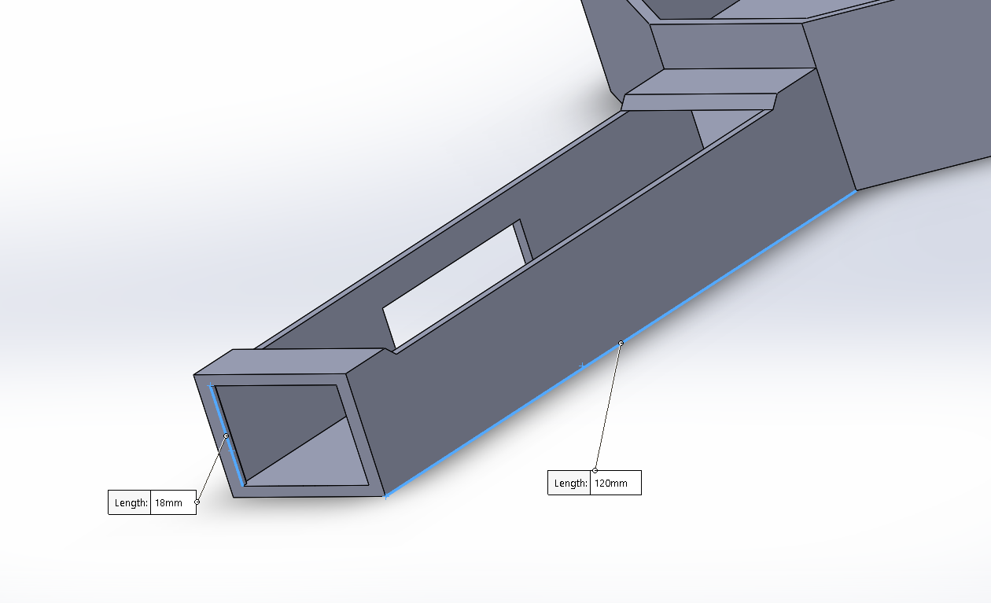

Figure 20: Selector path dimensions

* **Time to print the selector**

Selector layer area ( = 4*120 = 480

Selector thickness = 18 mm

Number of selector layer (N)= = 45 layers

Time to complete selector layer: + =  = 12 s

Selector build cycle time: = = 12 * 45 = 540 s = 9 mins

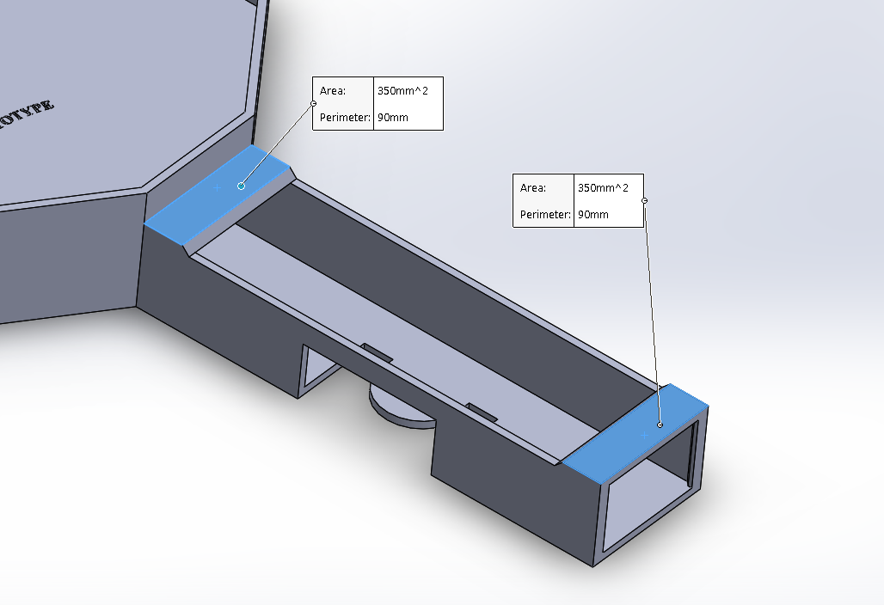

Figure 21: Area of selector top layers

* **Time to print selector top layer**

Selector top layer area ( = 700

Selector top thickness = 2 mm

Number of selector top layer (N) = = 5 layers

Time to complete selector top layer: + =  = 17.5 s

Selector top build cycle time: = = 17.5 * 5 = 87.5 s = 1.4583 mins

Figure 22: Selector side slot dimensions

* **Time to print selector top layer**

Selector slot layer area ( = (14.5 - 2) * 35 = 437.5

Selector slot thickness = 2 mm

Number of selector slot layer (N) = = 5 layers

Time to complete selector slot layer: + = = 10.9375 s

Selector slot build cycle time: = = 10.9375 * 5 = 54.6875 s = 0.9115 mins

Total print time (excluded setup time, repositioning and recoating time) = base build time + holder build time + selector build time + selector top build time – selector slot build time + = 34.1262 + 27.2341 + 9 + 1.4583 - 0.9115 = 70.9071 mins = 1.1818 hours

The total print time is calculated without setup time, repositioning and recoating time because they are unknow parameters. The actual print time of RMIT SSET 3D printer will be longer.

# CONCLUSION

This proposal document showcased the development and analysis of Group 1E’s bottle-cap selector in response to assignment 2 of MANU2484. The design path was outlined by five prototype iterations and the geometric & time/cost factors analysed. Conclusively, a final design is achieved by the team. This final design seeks to perform suitably against the testing criteria. The expected results are as follows.

***Expected Results***

* ***Size Requirement:***With final design dimensions (220L x 150W x 30H) the design meets the rubric max size requirements. As it is a ‘max’ size requirement being under 10% size should not factor into scoring of this criteria. Predicted ‘excellent’ score.
* ***Simplicity:***The team avoided over-complicating the design at various stages of design and development. The result being a simple design that does utilise a rail design and gravity feeding when angled as intended. The expected result is between good and excellent for this factor.
* ***Weight:***The weight criterion ranks the designs weight against the class average. As our design is well within the size requirements, features thin walls, simple geometry and lightweight material, we conclude that the design will receive a ‘good’ mark here.
* ***Probability:***Understood as the probability of caps passing successfully along the selector device, the team predict scores in the average range here. The design in its simplicity uses less orientating and selecting features then complex industry standard apparatuses.
* ***Accuracy:***Without prior testing of the design, performance in this area is hypothetical. We hypothesise lower success in this criterion but with unclear testing procedure it is impractical to make quantitative conclusions.
* ***Duration:***Again, with unclear test procedures, particularly in terms of feeding/disturbing the bottle caps, accurate estimates are improbable in this criterion. Nonetheless, our team should foreseeably complete the sorting of 50 caps in 30 – 60 seconds resulting in a ‘Good’ rubric grade.

**Team Conclusions / Future Direction:**

Conclusively, the team functioned well and put in a good collective effort to complete this project. However, several areas for improvement have been identified. We need to establish clearer test procedures and initiate testing earlier in the process. Additionally, while we managed to stay on schedule to a degree, we should avoid last-minute 3D printing to ensure higher quality and reduce stress.

The teams next course of actions is to 3D print the final design. Once printed, testing will occur, and the design can be properly evaluated. In future projects, it would benefit the group to iteratively evaluate prototypes against the rubric criteria. Furthermore, testing physical prototypes earlier in the development process will allow us to confidently present better products on demo day. This iterative approach will not only improve our final outcomes but also enhance our overall project management and execution skills.

# REFERENCES

[1] Kinex Cappers, “QuickFeed Cap Feeder”. [Online]. Available: https://www.kinexcappers.com/cap-feeder/ <https://www.kinexcappers.com/cap-feeder/> (accessed May 21, 2024).

[2] Pacepackaging, “Bottle Orienters”. [Online]. Available: <https://www.pacepackaging.com/products/bottle-orienter/> (accessed May 21, 2024).

[3] Zalkincapping, “Cap Orienting”. [Online]. Available: <https://www.zalkincapping.com/products/cap-orienting/> (accessed May 21, 2024).

[4] RS Components, "PSTX Softstarter - PSTX30...PSTX370". [Online]. Available: <https://docs.rs-online.com/0829/A700000009237236.pdf>. (accessed May 21, 2024).

[5] Sidel, “Gebo Aidlin 24”. [Online]. Available: <https://www.sidel.com/en/conveying/cap-feeding/standard-cap-feeder-pd-409> (accessed May 21, 2024).

[6] Max Reis (2020). “Alimentador Vibratorio De Tapas De Lavandina +54 9 351 8 559443”. Available: <https://www.youtube.com/watch?v=tGgw-MgN4gI> (accessed May 21, 2024).

[7] 王鈞盈 (2014). Youtube. “MVI 4370 cap sorter”. [Online]. Available: <https://www.youtube.com/watch?v=jXfh9Nzx_9c> (accessed May 21, 2024).

[8] KGInt. “106402 - Technical Drawing”. [Online]. Available: <https://www.kgint.com/PDF%20Documents/Technical%20Drawings/106402%20-%20Technical%20Drawing.pdf> (accessed May 21, 2024).

[9] MakeItFrom, “Polylactic Acid (PLA, Polylactide)”. [Online]. Available: <https://www.makeitfrom.com/material-properties/Polylactic-Acid-PLA-Polylactide> (accessed May 21, 2024).

[10] Lucas. C. “3D Printer Material Cost of 2023”. All3DP. [Online]. Available: <https://all3dp.com/2/3d-printer-material-cost-the-real-cost-of-3d-printing-materials/#i-3-pla> (accessed May 21, 2024).

[11] Flashforge. “Flashforge Adventurer 4 Pro”. [Online]. Available: <https://flashforge.com/products/flashforge-adventurer-4-pro#faq> (accessed May 21, 2024).