**Comandos Digitados**

git init

git branch -M main

git add .

git commit -m “Mantenedouro”

git remote add origin <https://github.com/EuLucaMacedo/Mantenedouro>

git push -u origin main

Capturas de Tela

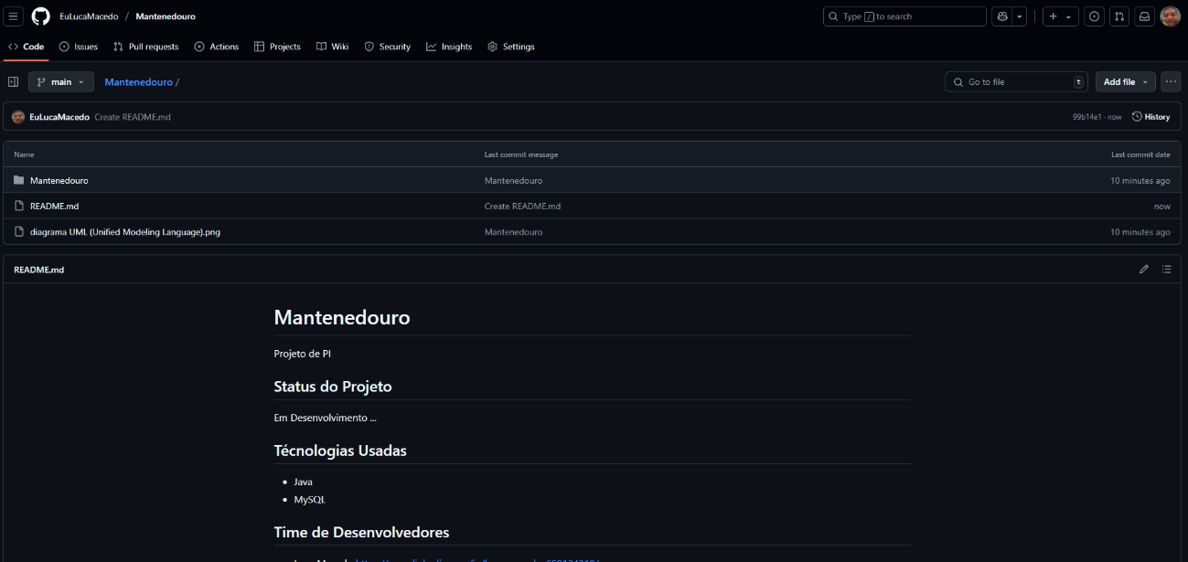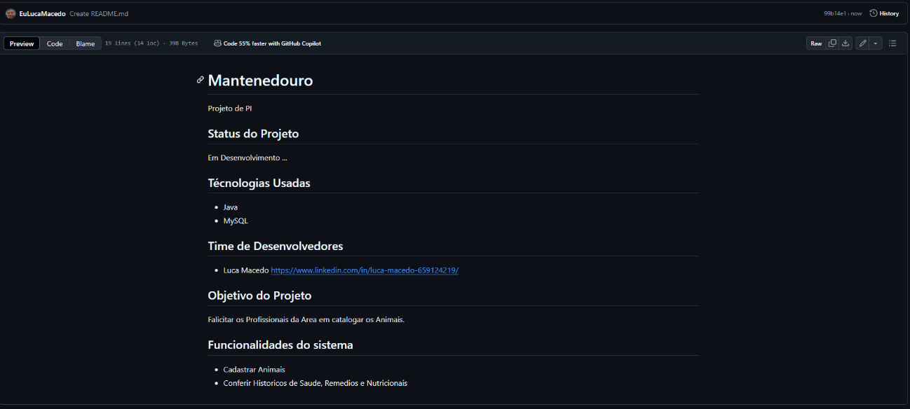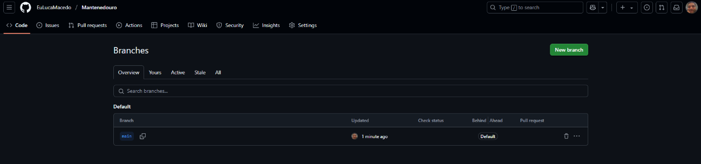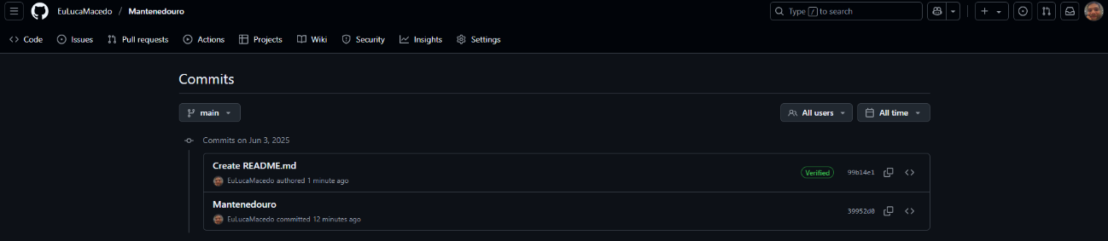

Link Repositório

https://github.com/EuLucaMacedo/Mantenedouro