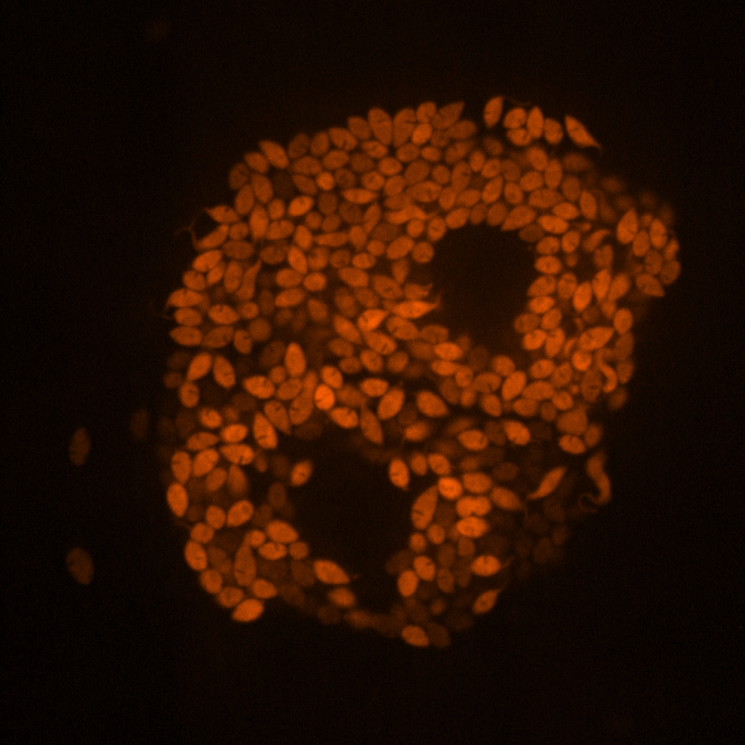
Amastigotes beginning to convert to Trypomastigotes

Epimastigotes

