VectorBase Population Biology (PopBio) map

*While you interact with the PopBio map interface please type your feedback here:*

[*http://tinyurl.com/y68uforb*](http://tinyurl.com/y68uforb)

*VectorBase developers are actively working on this tool, thank you!*

1. Go to the PopBio map page following this link: <https://www.vectorbase.org/popbio/map/#>
2. Currently, the PopBio map has six views.

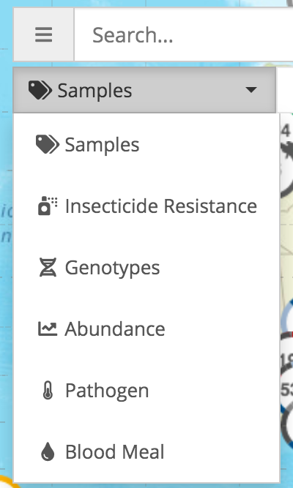

1. Follow the next steps to identify the data types in each view:
   * Go to the samples view
   * In the right-hand side menu selects the filter ‘available data types’.

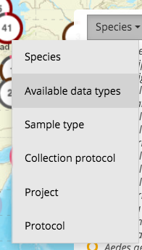

1. Work in groups of three people to identify how to construct the following queries. Take a screenshot and paste it in a document in your computer, with your keywords and/or filters, *e.g*.,



The bullets in each view, each represent an *independent* query.

1. Samples:

* Vector species identified with PCR
* Mosquitoes from the *Anopheles* genus collected with animal baited net trap
* Vectors collected with pyrethrum spray catch and genotyped by high throughput sequencing

1. Insecticide Resistance (phenotypes)

* Distribution in west Africa of the mosquitoes *Anopheles gambiae* with assays for malathion susceptibility/resistance
* Show data for the genus *Aedes* with assays for pyrethroids resistance
* For larvae collections display a temephos WHO larvicide dose-response test
* Show data for WHO paper kit diagnostic test

1. Genotypes (currently only for insecticide resistance)

* Is the kdr locus (L1014) being assayed in the mosquitoes *Anopheles arabiensis* from Madagascar?
* Is there genotype data for *Anopheles gambiae* s.l.?
* In which continents are there assays for the AChE1 G119 mutations?
* Which loci have been assayed in India?

1. Abundance

* What is the data submitted by Lyric Bartholomay, from the state of Iowa, for the genus *Culex* collected with CDC gravid traps?
* From the project VBP0000213 filter for the samples identified to species by with morphological examination and which pathogen infection status (infected or not) was assayed with RT-PCR
* Pools of mosquitoes collected in houses resting during the day
* Is there abundance data for *Aedes albopictus* mosquitoes?
* Iowa mosquitoes collected during the moths of June, July, and August

1. (vector infection with) Pathogen

* In addition to *Culex*, has any other mosquito genus been found infected with West Nile Virus using real-time PCR?
* Which vector species has the most pathogen data?
* Which pathogens are currently available in this view?

1. Blood meal (source)

* Is there data for any other host in addition to human? If yes mention three.
* What are the top three blood meal sources for *Anopheles darlingi*?
* Has sequencing been used to identify hosts?
* In which species has ELISA been used for host identification?