# Site Search

***Note:*** *this exercise uses VectorBase* [*https://beta.vectorbase.org*](https://beta.vectorbase.org) *as an example database, but the same functionality is available on all VEuPathDB resources.*

Answer Key (release 47 - June 2020)[1]

**Learning objectives:**

* Use keywords in site search
* Explore site search results
* Filter site search results by categories
* Filter site search results by organisms
* Filter site search results by category fields
* Export results to a search strategy
* Find a specific gene using its ID in site search

1. Enter the word *kinase* (singular) in the site search window, top center of the page. Then click enter on your keyboard or click on the magnifying glass icon.
2. How many results with the word kinase did you get? Are all the results genes?

|  |  |
| --- | --- |
| Number: 43,876 | Yes or No: No |

Explore the filter panel on the left side of the webpage. Filter the results so that you only view gene results (hint: click on the word *genes* in the *Filter results* section).

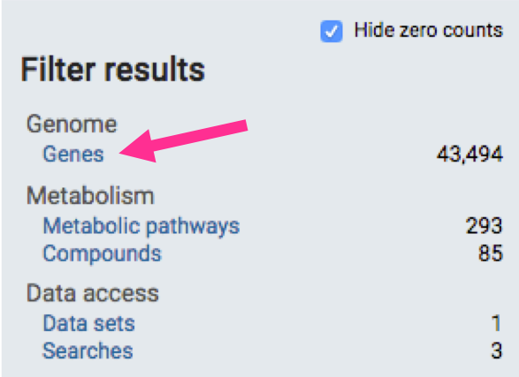

1. How many of the genes included the word kinase in their product descriptions? Notice that once you filter the result by genes (click on the *Genes* filter), the fields section expands to reveal additional filtering options. Once you select the *Product descriptions* field you are provided the option to *apply* this filter or cancel it (box middle panel below). Once a filter is applied it can be cleared by clicking on *Clear filter* (box left panel below).

|  |
| --- |
| 8,085 |

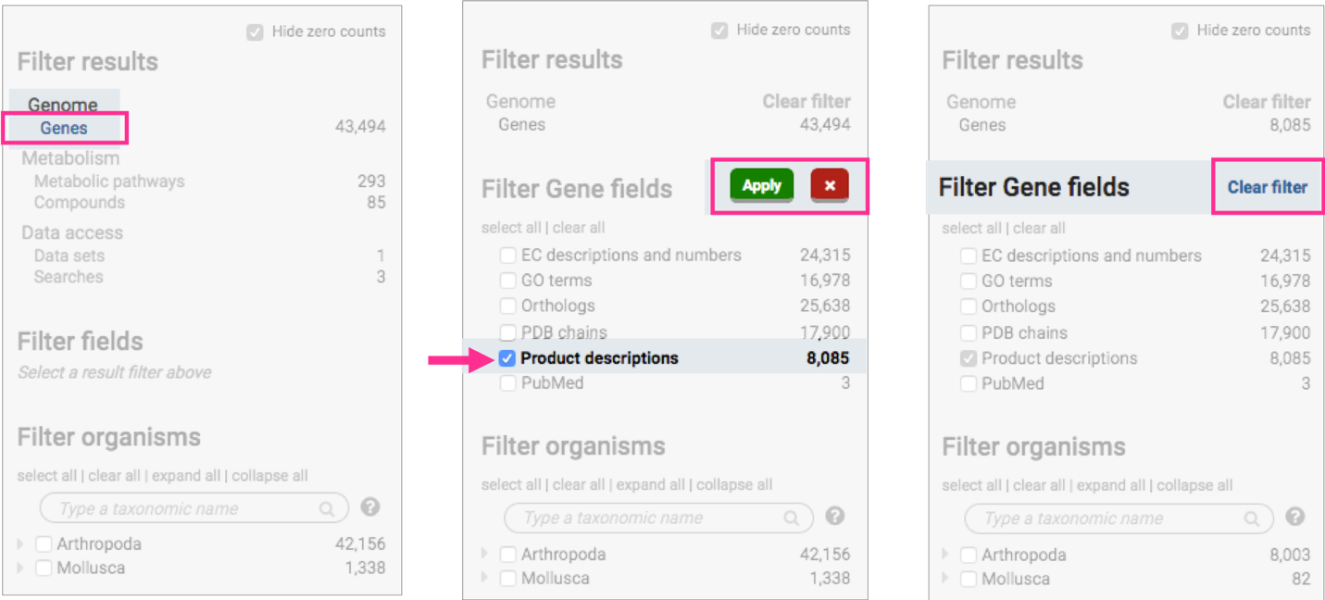

|  |
| --- |
| 244 |

1. 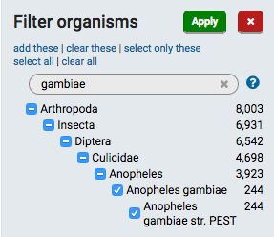How many of the above genes are found in *Anopheles gambiae* PEST? How did you find this number? (hint: explore the *Filter organisms* section of the results filter). Select the correct organism (you only need to type part of the scientific name) and apply the filter.

1. 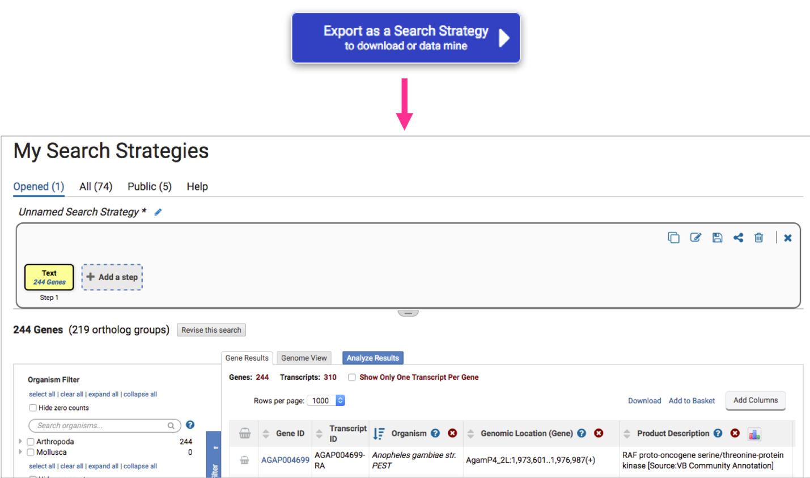Export the results to a search strategy. (hint: to achieve this click on the blue *Export as a search strategy* button at the top right-hand side of the results).
2. Return to the site search results page. How did you do this? (hint: you can achieve this in two ways: 1. Click on your browser’s back arrow. 2. Click on the back to results arrow in the site search window. Notice that your previous results and filter settings were preserved.
3. Clear all filters. How did you do this? (hint: you can achieve this in two ways:
   1. You can click on the single *clear filters option* in the site search window.
   2. 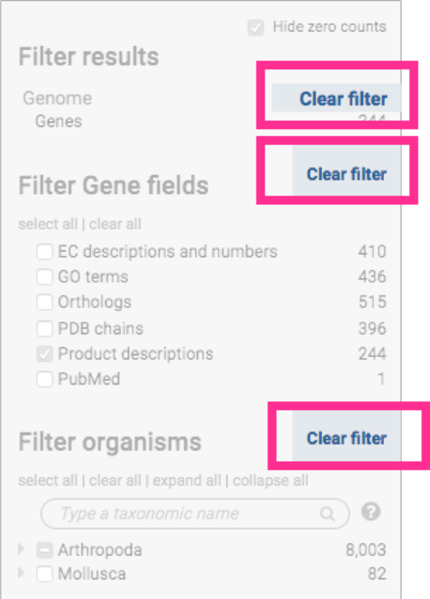You can click on each of the clear filter options in the filter results panel on the left
4. Try the *Hide zero counts* check box in the *Filter results* panel. What does this do?

|  |
| --- |
| Displays all the categories of site content searchable in the site, including the ones for which there is not a match with the keyword used in the Site Search box or the applied filters |

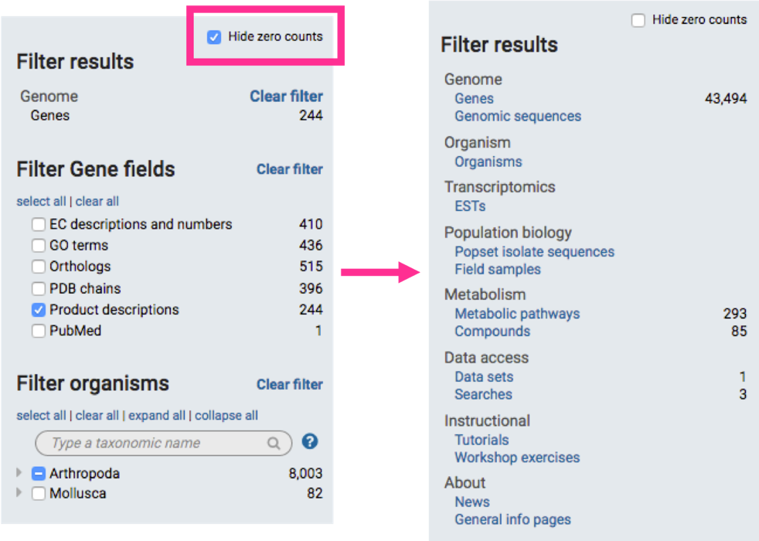

1. Try running a search with a wild card. The wild card is denoted by an asterisk *.

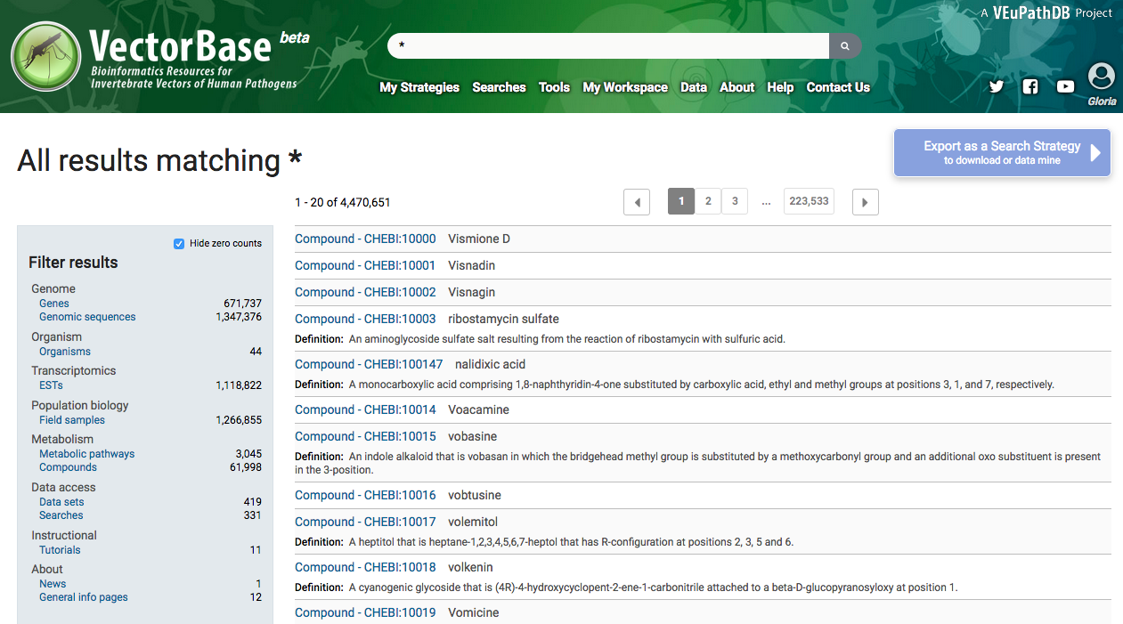1) The wild card can be used alone to retrieve all results available to the site search or

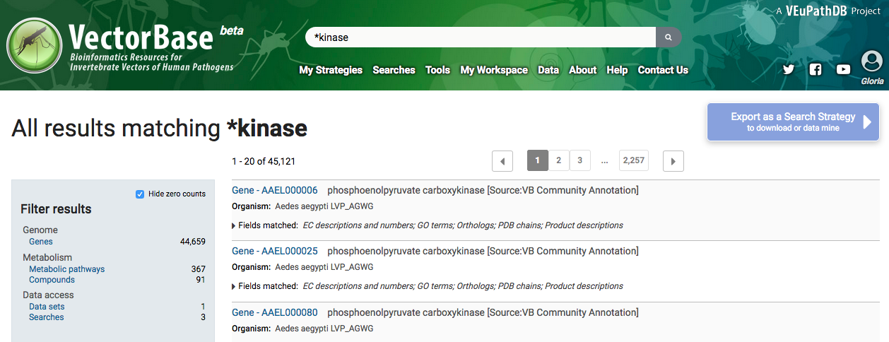2) combined with a word such as *\*kinase* to retrieve compound words ending with the word kinase like phosphofructokinase. As usual results can then be explored using the filters in the *Filter results* on the left side of the website.

1. 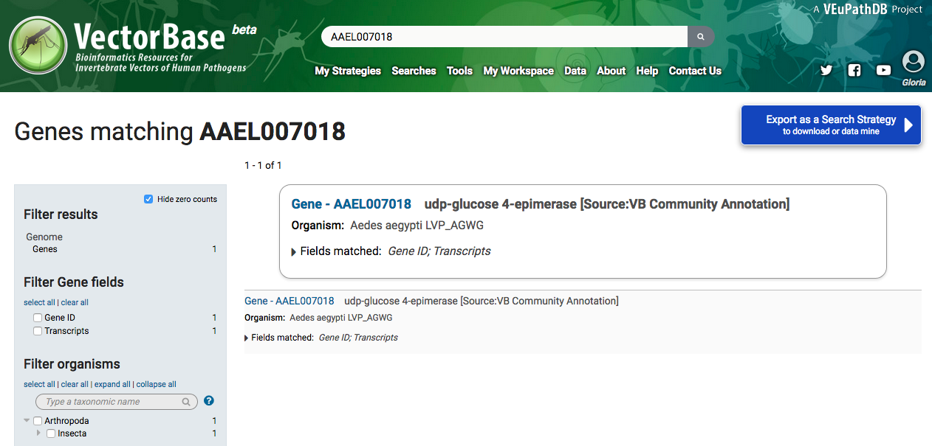Try searching for a specific gene ID. Enter the gene ID below in the site search box: *AAEL007018*

Notice that the gene of interest appears at the top for easy access. You can click on the Gene ID to go to the gene page. In VectorBase, every gene for every genome, uses a nomenclature system for the gene IDs based on each genome scientific name, strain and a consecutive number

Examples:

* ***A****edes* ***ae****gypti* **L**VP_AGWG gene **AAEL**007018
* ***A****nopheles* ***ga****mbiae* **P**EST gene **AGAP**004707

1. The answers might change in future releases. VectorBase (and all other VEuPathDB sites) data are updated every two months. For information about the most recent release please visit: <https://beta.vectorbase.org/vectorbase.beta/app/static-content/VectorBase/news.html#VectorBase47Released>