**CLIMADA MANUAL**  23 Dec 2014

Obtain the full package from <https://github.com/davidnbresch/climada>

David N. Bresch, [david.bresch@gmail.com](mailto:david.bresch@gmail.com)

Lea Mueller, [muellele@gmail.com](mailto:muellele@gmail.com)

Uncertainty and risk of climate change: from probabilistic damage calculation to the economics of climate adaptation – shaping climate resilient development[1].

# Instead of an Introduction: Preamble

Climate adaptation is an urgent priority for the custodians of national and local economies, such as finance ministers and mayors. Such decision-makers ask:

* What is the potential climate-related damage to our economies and societies over the coming decades?
* How much of that damage can we avert, with what measures?
* What investment will be required to fund those measures – and will the benefits of that investment outweigh the costs?

The economics of climate adaptation methodology as implemented in climada provides decision-makers with a fact base to answering these questions in a systematic way. It enables them to understand the impact of climate on their economies – and identify actions to minimize that impact at the lowest cost to society. Hence it allows decision-makers to integrate adaptation with economic development and sustainable growth. In essence, we provide a methodology to pro-actively manage total climate risk. Using state-of-the-art probabilistic modeling, we estimate the expected economic damage as a measure of risk today, the incremental increase from economic growth and the further incremental increase due to climate change. We then build a portfolio of adaptation measures, assessing the damage aversion potential and cost-benefit ratio for each measure. The adaptation cost curve illustrates that a balanced portfolio of prevention, intervention and insurance measures allows to pro-actively managing total climate risk.

climada consists of the core module, providing the user with the key functionality to perform an economics of climate adaptation assessment. Additional modules implement global coverage (automatic asset generation), a series of hazards (tropical cyclone, surge, rain, European winter storms, … and even earthquake and meteorites) and further functionality, such as Google Earth access, animations…

Contents

Instead of an Introduction: Preamble 1

A visual primer 4

A brief introduction to the concepts behind climada 5

Probabilistic damage model 5

Adaptation cost curve 7

Getting started 9

Process on one page 10

Excel interface to climada 11

From tropical cyclone hazard generation to the adaptation cost curve 13

Hazard set 13

Assets and damage functions 21

Damage calculation 23

Adaptation cost curve 24

Function reference 27

Basic entity functions 27

Core calculations 27

Basic hazard functions 28

Further display functions 28

Tropical cyclone (TC) specific functions 28

Basic functions 28

Admin functions 28

Special functions 29

climada modules 29

Appendices 31

climada, the inner workings 31

Implementation 32

Insurance remarks 33

Insurability & forms of insurance 33

Insurance conditions 35

climada implementation of insurance conditions 36

Note on scenarios 37

climate impact scenarios – remarks on climada implementation 39

Climate impact scenarios – sources 40

Tropical cyclones – technical remarks 40

Windfield calculation 40

Single cyclone track evolution animation 43

Economics of Climate Adaptation (ECA) – key routines 44

A remark on loss, damage and vulnerability 47

# A visual primer

Climate change scenario

Economic growth rate

Implementation of adaptation measures

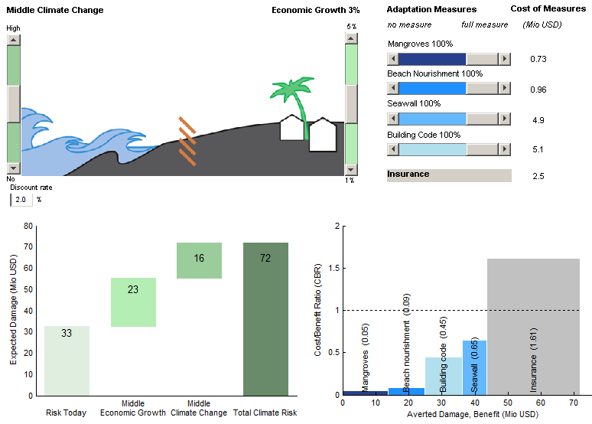

The total climate risk and its key drivers, e.g. for given parameters (set in sliders above) economic growth contributes second most to the total climate risk.

The adaptation measures, their damage aversion potential and costs, e.g. for 0.45 dollar invested in building code, 1 dollar of loss can be averted.

Figure: The demonstration code climada_demo implements the concept of total climate risk and cost-effective adaptation in an interactive way: The user can experiment with key relevant factors (sliders, top) and instantly observe the effect – both on risk (measured by expected damage, graph on the left) and the basket of adaptation measures (shown as adaptation cost curve, graph on the right).

# A brief introduction to the concepts behind climada

Instead of studying this now, the user might also jump to the step-by-step introduction below and later come back.

## Probabilistic damage model

A model is nothing more than a simplified representation of reality. Natural hazard models use the virtual world of computers in an attempt to simulate natural catastrophe damage expected in reality. The risk of natural depends on three basic sets of data, which must be fed into the damage model. They are:

* Hazard (sometimes also called peril): Where, how often and with what intensity do events occur?
* Damage function (sometimes referred to as vulnerability or vulnerability curve): What is the extent of damage at a given event intensity?
* Assets (also referred to as value distribution or portfolio of exposed assets): Where are the various types of insured objects located and how high is their value?

These three building blocks are quantified separately and are then combined in the process of estimating event damage. This approach may generally be applied to all forms of natural hazard, whether storm, flood or any other type of peril.

The simplest way to assess the damage is to simulate an individual natural catastrophe scenario. This is known as “deterministic” or “scenario-based” modeling. Such models often refer back to major historical damage events, applying these to the assets that exist now (“as-if analysis”). The disadvantage of this method is that, whilst it allows a single, extreme, individual event damage to be assessed, it fails to take account of all the other events that might occur. It is not possible to calculate an expected annual damage for a portfolio of assets on the basis of single event damage, and any prediction as to the occurrence frequency of the model scenario will remain very uncertain.

Today, in an attempt to avoid these problems, so-called “probabilistic” models are being used to assess hazards such as storms and floods. Rather than simply analyzing one event, the computer is programmed to function as a sort of time-lapse film camera, simulating all the possible events that could unfold within a sufficiently long period of time (thousands or tens of thousands of years). This type of model produces a “representative” list of event damages (i.e. a list that accurately reflects the risk). From this list it is possible to understand the relationship between damage potential and occurrence frequency, and hence the cost of average and extreme damage burdens.

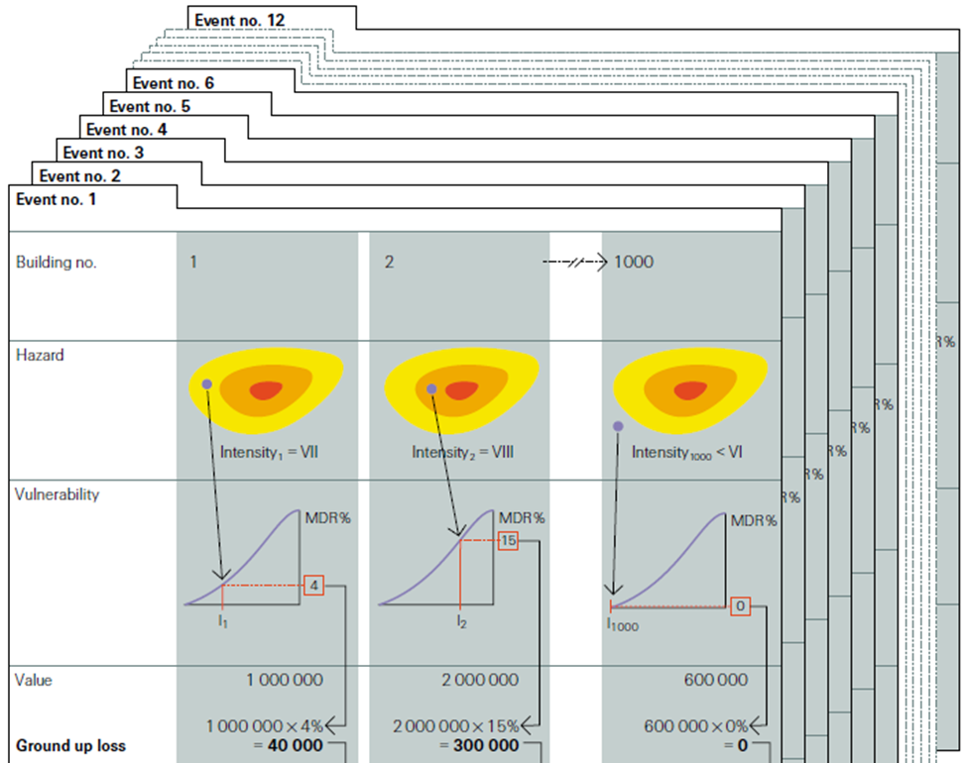

Figure: Using risk assessment tools to calculate event damage. Let's assume a hypothetical portfolio containing 1000 assets (buildings). For the sake of simplicity, let us assume that the risk assessment tool only contains 12 potential events over a projected period of 200 years. The following calculations would be performed:

* The hazard module generates the expected intensity (VII) for event no.1 at asset (building) location no.1.
* The damage function (called vulnerability in the figure) corresponding to the asset provides us with the mean damage ratio (MDR[2]) for given hazard intensity (4 stands for 4% of the asset's value)
* The damage is calculated by multiplying the MDR and the value of the asset (1'000'000), resulting in a (ground up) damage (called loss in the figure) of 40'000.
* Above steps are performed on all 1'000 assets in the portfolio. The sum of all damages produces the total damage from event no.1, i.e. event damage no1.
* All above steps are then repeated for the other (11) events in the event set.
* Upon completion of all these stages in the modeling process, a list of all event damage is produced, upon which damage statistics can be derived (average damage, max damage…).

See mentioned lecture course and the Swiss Re publication "Natural catastrophes and reinsurance", which covers the methodology in detail: <http://media.swissre.com/documents/Nat_Cat_reins_en.pdf>

## Adaptation cost curve

Assessing the cost and damage aversion potential of each measure can be quite difficult. The potential damage aversion is particularly uncertain, even for measures for which extensive research exists – for example, for building codes to fix roofs against hurricane winds.

The assembled cost curve shows – from left to right – the range of measures from least cost-efficient to most cost-efficient. The results should thus be used to start discussions on the different measures and the opportunity to avert expected damage, rather than be read as recommendations to implement certain measures.

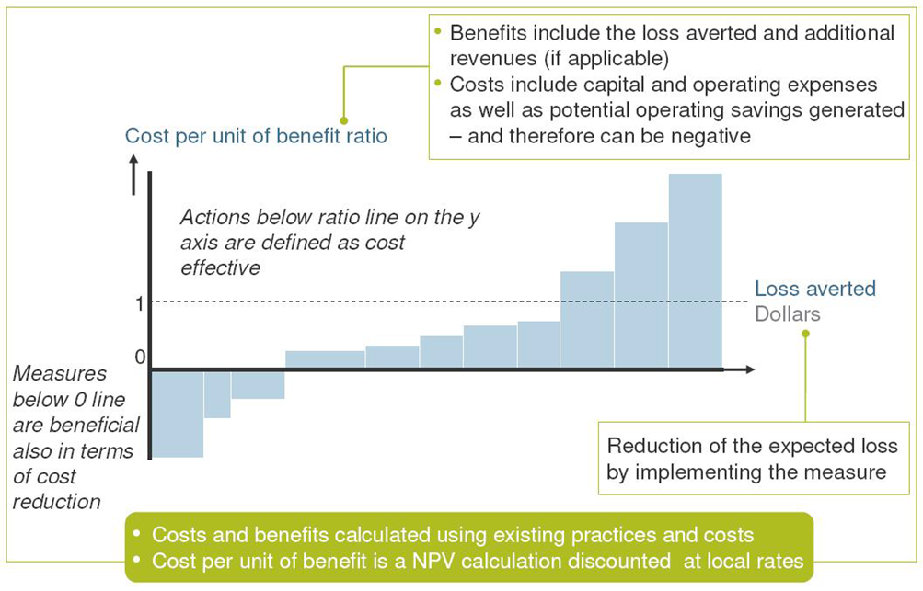

Figure: The width of each bar in a cost curve represents the cumulative potential of that measure to reduce total expected damage up to 2030 for a given scenario. The height of each bar represents the ratio between costs and benefits for that measure. Whether or not this ratio is attractive to a decision maker depends on many factors, including risk appetite. After considering the other – including non-economic – impacts and benefits related to implementing a measure, a risk-neutral decision maker would select measures based on a sense of how much protection they offer and at what cost. The advantage of calculating cost-benefit ratios for all measures is that doing so allows decision-makers to compare measures using a single simple metric.

In a recipe form, the adaptation cost curve is constructed as follows (repeat for each measure)

1. Calculate present value (PV) of costs of measure [e.g. Excel, outside of climada]
2. Risk today: import today's assets and damage functions (input via Excel) and expose them to present hazard (part of climada)
   1. climada calculates annual expected damage with no measures
   2. climada calculates annual expected damage with measure applied  
      🡪 difference 2.1) minus 2.2) shows benefit of measure today
3. Future risk (e.g. year 2030): import future assets and damage functions (input via Excel, damage functions likely to be unchanged) and expose them to future hazard (part of climada)
   1. climada calculates annual expected damage with no measures
   2. climada calculates annual expected damage with measure applied  
      🡪 difference 3.1) minus 3.2) shows future benefit of measure
4. climada discounts benefits --> horizontal axis of adaptation cost curve
5. climada calculates the cost benefit ratio 🡪 vertical axis of adaptation cost curve

# Getting started

* Set the MATLAB Current Folder to climada[3] (use the  button to browse), e.g.:



* Enter startup in the MATLAB Command Window:

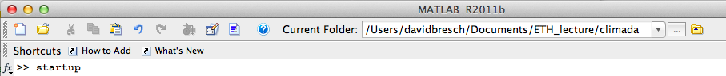

and press Enter (or Return). This initializes climada, sets some variables (e.g. the location of the data folder[4]) and detects any climada_additional modules[5].   
After that, the Command Window looks something like:

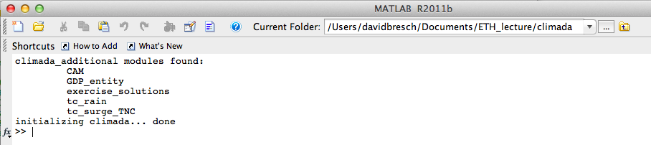

It’s ok if there are no further modules shown, as long as … done appears.

* Start by just invoking the climada demonstration by entering climada_demo in the MATLAB Command Window[6], which is also the best way to test whether climada works properly – you should see something as shown above as a visual primer (see above) and be able to play with the sliders.

If unfamiliar with the basic concepts of damage calculation, climate impact and adaptation measures assessment, please refer to the slides as handed out in the lecture[7] - or play at least a bit with climada_demo ;-)

While the standard climada setup contains the data folder within climada, one can also create a folder named climada_data parallel to climada to allow for core climada data NOT being synched (only the folder ../climada/data within core climada gets synched). This way, any data used in climada beyond the default files will not be synchronised.

In order to grant core climada access to additional modules (see <https://github.com/davidnbresch>), create a folder ‘climada_modules’ on the same level as the core climada folder to store any additional modules. This way, climada sources all modules' code upon startup.

## Process on one page

To cut the whole story short, climada produces an adaptation cost curve, as shown in the lower right part of the visual primer (and many more nice things). According to the modules hazard, assets, damage functions and adaptation measures, the following steps are required in order to come up with a climate adaptation cost curve

1. Generate a hazard event set
   1. Generate a hazard event set for today’s climate
      1. Obtain historical events
      2. Produce the probabilistic events
      3. Store intensities at centroids
   2. Repeat above steps for future hazard   
      (climate change impact scenarios, e.g. for 2030)
2. Import a list of assets and corresponding damage functions[8]   
   (the so-called entity)
   1. Read the list of today’s assets
      1. Encode to centroids
      2. Read the damage functions and make sure they correspond to assets
   2. Repeat above steps for future assets (e.g. 2030)
3. Import the list of adaptation measures   
   (also stored into the entity structure)
   1. Read the list of measures
4. Calculate the damages and benefits of measures
   1. Calculate the damages[9] for the list of today’s assets, today’s hazard event set and the list of measures
   2. Repeat the previous step for future assets but still today’s hazard and the list of measures
   3. Finally, repeat the first step (a.) again now for future assets, the climate change scenarios and the list of measures. Note that for this step, you need to create the hazard event set for the climate change scenarios (e.g. 2030)
5. Display the results – e.g. in the form of an adaptation cost curve.

## Excel interface to climada

The hazard module is usually provided by climada developers (see also the description of the climada modules below). It forms an integral part of climada and can be developed for almost any hazard (wind, flood, surge, landslides...). The assets, the damage functions as well as the list (and costs) of adaptation measures are defined in an Excel sheet which is imported into climada. climada provides several outputs, among them the adaptation cost curve (as a graphic in almost any format). Obviously, any number calculated by climada can be exported, too.

To start with, the key interface to climada is an Excel file[10], with three main tabs:

The tab '**assets**' lists all exposed assets by location (latitude/longitude) and value. Please note that values do not necessarily need to be monetary values. In the case the number of exposed people is stated in the value column, climada might calculate the number of affected people.

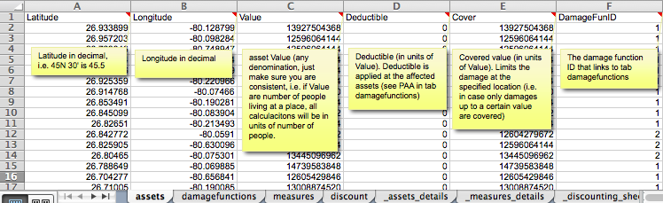

Figure: the assets tab, see ../data/entities/entity_template.xls

The tab '**damagefunctions**' contains the relationship between the hazard intensity (e.g. wind speed in m/s or storm surge height in meters) and the percentage of affected assets (PAA) as well as the mean damage degree (MDD). What's called a damage function in climada is often also referred to as 'vulnerability curve'. If for say a storm surge height of 1 meter, 50% of all assets are affected, and the damage to these affected assets is 5% of their total value, the PAA is 0.5 and MDD 0.05. In the case of value signifying exposed population, PAA is used to reflect affected individuals, while MDD could be used to parameterize some sort of impact to the affected individuals (e.g. using disability or quality adjusted life years, DALY/QALY).

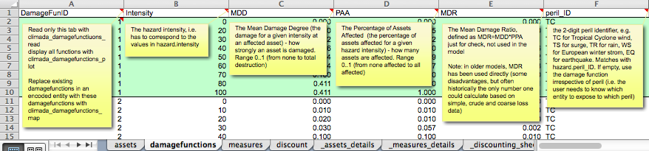

Figure: the damagefunctions tab, see ../data/entities/entity_template.xls

The tab '**measures**' contains the list of climate adaptation measures. It contains the costs of the measures, i.e. the net present value of CAPEX and OPEX for each measure. It also contains the parameterized impact of the measures on the hazard and damage function. Imagine a coastal study region and say a mangrove forest. Outside of climada, is has been calculated that the net present cost of this measure amounts to 1'234'567 million dollars. Let's assume this mangrove forest slows down the wind of a tropical cyclone by a certain amount, say 5 percent reduction in wind speed. Both the cost as well as this 'parameterized' impact is hence entered in the 'measures' tab for this particular measure. Note that climada can handle parameterized impacts of higher complexity, too.

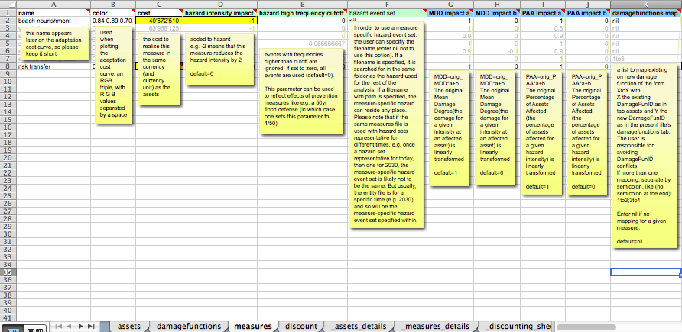

Figure: the measures tab, see ../data/entities/entity_template.xls

Please note that each column header in the Excel contains a detailed explanation as a comment. The reference Excel sheet, called entity_template.xls can be found in the entities sub-folder of the climada data folder[11].

# From tropical cyclone hazard generation to the adaptation cost curve[12]

In the this section, we are going to illustrate the whole process step-by-step, using tropical cyclone as the hazard and a few assets in South Florida for illustration purposes. Note already here that climada provided global coverage for tropical cyclone wind (often referred to as TC wind[13]) and storm surge (often referred to as TC surge[14]) as well as other hazards, such as global earthquake[15].

Instead of starting with a simple hazard set generation, the user might also jump to the damage calculation right away, see second next section "Assets and damage functions".

## Hazard set

First, obtain the historic tracks[16], i.e. define the name and location of the raw text file with historical tropical cyclone tracks

tc_track_file=[climada_global.data_dir filesep ...  
 'tc_tracks' filesep 'tracks.atl.txt'];

tc_track=climada_tc_read_unisys_database(tc_track_file);

tc_track(i) contains position tc_track(i).lon(j) and tc_track(i).lat(j) for each timestep j as well as the corresponding intensity tc_track(i).MaxSustainedWind. E.g. track number 1170 is hurricane Andrew:

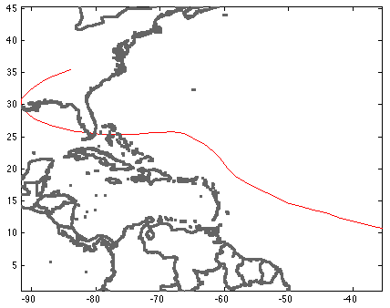

Figure: plot(tc_track(1170).lon,tc_track(1170).lat,'-r'); hold on; set(gcf,'Color',[1 1 1]); axis equal

climada_plot_world_borders(2,'','',1) % plot world borders (for orinentation)

In order to calculate the windfield of this particular single track, we first generate a series of points on which to evaluate the windfield, we call these points centroids:

centroids.Longitude=[];centroids.Latitude=[]; % init

next_centroid=1; % ugly code, but explicit

for i=1:10

for j=1:10

centroids.Longitude(next_centroid)=i+(-85);

centroids.Latitude(next_centroid) =j+ 20;

next_centroid=next_centroid+1;

end % j

end % i

centroids.centroid_ID=1:length(centroids.Latitude);

Next, calculate the windfield[17] for a single track (Andrew again) as

res = climada_tc_windfield(tc_track(1170),centroids);

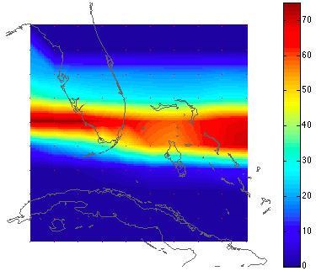

Figure: climada_color_plot(res.gust,res.lon,res.lat); % plot the windfield

We now generate the windfield not for one single hurricane, but for all events and store them in an organized way, the so-called hazard event set:

hazard_set_file=[climada_global.data_dir filesep ...  
'hazards' filesep 'atl_hist'];

hazard = climada_tc_hazard_set(tc_track,hazard_set_file,centroids);

And now this hazard event set contains the single Andrew windfield we generated before in hazard.intensity(1170,:) and therefore we can reproduce the same windfield with the following command (note the full(*), as we store a sparse matrix)

climada_color_plot(full(hazard.intensity(1170,:)),...  
hazard.lon,hazard.lat,'none')

Or, instead, we can plot all hazard intensities at a given point (greencircle) like

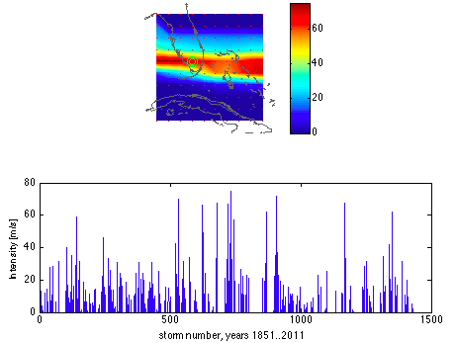Figure: figure; subplot(2,1,1)

climada_color_plot(full(hazard.intensity(1170,:)),...  
hazard.lon,hazard.lat,'none'); hold on;plot(-81,26,'Og'); plot(centroids.Longitude(36),centroids.Latitude(36),'Og','MarkerSize',10);

subplot(2,1,2)

plot(full(hazard.intensity(:,36))); set(gcf,'Color',[1 1 1]);

xlabel(sprintf('storm number, years %i..%i',tc_track(1).yyyy(1),tc_track(end).yyyy(end)))

ylabel('Intensity [m/s]')

Instead of only historic tracks, we can generate artificial or probabilistic tracks, simply by 'wiggling' the original tracks, eg for Andrew 1992 again:

tc_track_prob=climada_tc_random_walk(tc_track(1170));

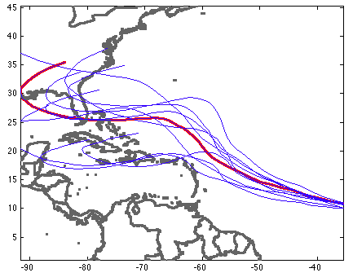

Figure: plot(tc_track(1170).lon,tc_track(1170).lat,'-r','LineWidth',2);

hold on; set(gcf,'Color',[1 1 1]); axis equal

climada_plot_world_borders(2,'','',1)

for track_i=1:length(tc_track_prob)

plot(tc_track_prob(track_i).lon,tc_track_prob(track_i).lat,'-b');

end

And repeated for all historic tracks, we obtain the full probabilistic track set

climada_global.waitbar=0; % switch waitbar off, speeds up,

% hence the next line will take approx. 3 sec

tc_track_prob=climada_tc_random_walk(tc_track);

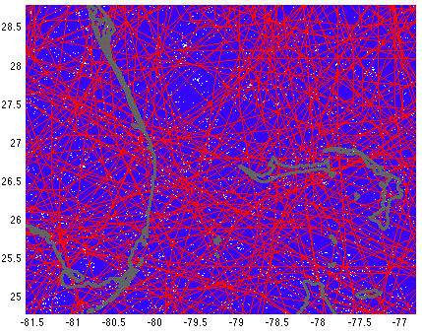

Figure (manually zoomed in):  
for track_i=1:length(tc_track_prob)

plot(tc_track_prob(track_i).lon,tc_track_prob(track_i).lat,'-b');

hold on;end

for track_i=1:length(tc_track)

plot(tc_track(track_i).lon,tc_track(track_i).lat,'-r');end

climada_plot_world_borders(2,'','',1); set(gcf,'Color',[1 1 1]);

Next, we generate the windfields for all 14450 probabilistic tracks (takes a bit less than 2 min)

hazard_set_file=[climada_global.data_dir filesep ...  
'hazards' filesep 'atl_prob.mat'];

hazard = ...  
 climada_tc_hazard_set(tc_track_prob,hazard_set_file,centroids);

The hazard set now contains ten thousands (in fact 14450) tropical cyclone footprints, each stored at all centroids. We can for example plot the largest single event with:

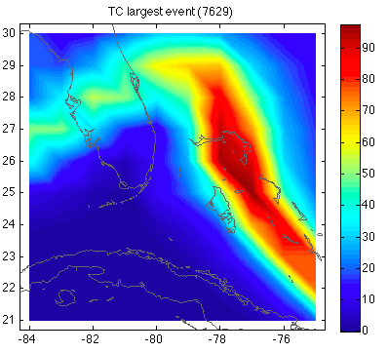

figure; climada_hazard_plot(hazard); set(gcf,'Color',[1 1 1]);

and generate the windspeed maps for several return periods:

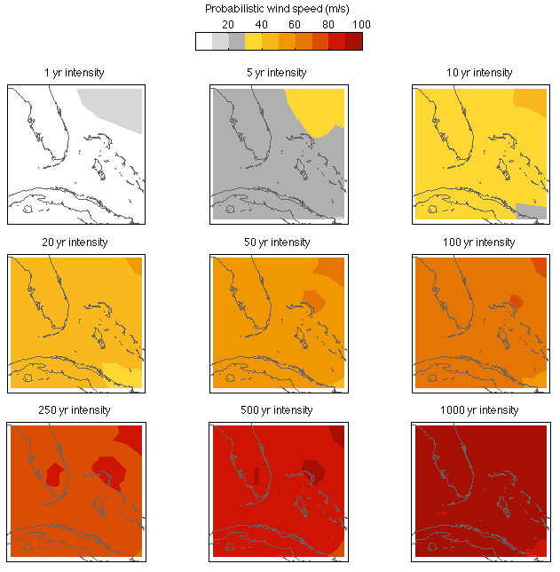

climada_hazard_stats(hazard); set(gcf,'Color',[1 1 1]);

Before we move on, let’s explain the key elements of the hazard structure: hazard.lon(i) and hazard.lat(i) contain the coordinates of centroid i, hence hazard.intensity(j,i) contains the hazard intensity of event j at centroid i. Further hazard.frequency(j) contains the single event frequency of event j. These are in fact the key elements of the hazard structure, note that hazard.intensity is a sparse array (refer to e.g. help sparse in MATLAB[18]). You might refer to functions such as the mentioned climada_tc_hazard_set or climada_excel_hazard_set[19] to see how a hazard event set is generated.

## Assets and damage functions

So much for the hazard event set, let’s now import an asset base (the small asset example as used in climada_demo, the demonstration GUI as shown above[20]). Before we do so, we load the hazard set file as used in climada_demo, in order to later reproduce the results:

hazard_set_file=[climada_global.data_dir filesep ...  
'hazards' filesep 'TCNA_today_small.mat'];

load(hazard_set_file) % loads hazard as variable

and are now in a position to import the Excel file with all the asset information[21]:

entity_excel_filename=[climada_global.data_dir filesep ...  
'entities' filesep 'demo_today.xls'];

entity=climada_entity_read(entity_excel_filename,hazard)

Such an entity structure contains the asset, damage function and adaptation measures information, the tabs in Excel are named accordingly, and so are the elements of the imported structure[22]. In the asset sub-structure, we find[23] entity.assets.Latitude(k) and entity.assets.Longitude(k), the geographical position of asset k (does not need to be the same geographic location as centroid I, since assets are encoded to the hazard[24]) entity.assets.Value(k) contains the Value of asset k. Please note that Value can be a value of any kind, not necessarily a monetary one, e.g. it could be number of people living in a given place. entity.assets .DamageFunID(k) contains a reference ID (integer) to link the specific asset with the corresponding damage function (see Excel tab damagefunctions and entity.damagefunctions). Before we move on the the damagefunctions, note that entity.assets.centroid_index(k) contains the centroid index onto which asset k is mapped in the hazard event set[25].

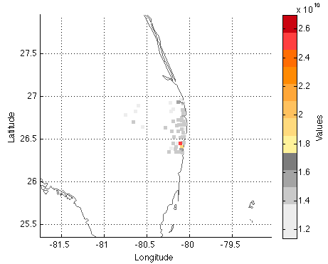

figure; climada_entity_plot(entity,4); set(gcf,'Color',[1 1 1])   
% the asset distribution as stored in entity (read from Excel sheet)

The damagefunctions sub-structure contains all damage function information, i.e. entity.damagefunctions.DamageFunID contains the IDs which refers to the asset’s DamageFunID. This way, we can provide different damage functions for different (groups or sets of) assets. entity.damagefunctions.Intensity contains the hazard intensity, entity.damagefunctions.MDD the mean damage degree and entity.damagefunctions.PAA the percentage of affected assets. Last but not least, entity.damagefunctions.peril_ID contains the peril ID (2-digit character) which allows to indentify specific damage functons with perils. This way, we can in fact use DamageFunID 1 in the assets to link to damage function one, which can exist several times, one for each peril. The damagefunctions are stored in a bit a special format, since we get the first damagefunction as[26]

pos=find(entity.damagefunctions.DamageFunID==...  
entity.damagefunctions.DamageFunID(1))

plot(entity.damagefunctions.Intensity(pos),...  
entity.damagefunctions.MDD(pos)) % not shown, see next figure

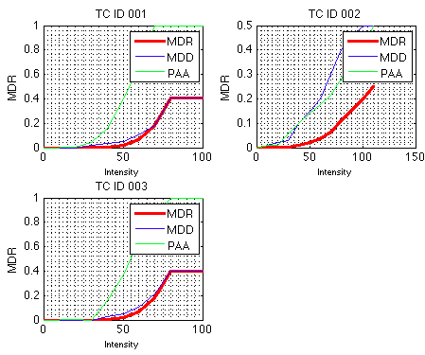

figure;climada_damagefunctions_plot(entity). The three damage functions as defined in the damagefunctions tab of the Excel file. TC is the perilID and stands for tropical cyclone, while 001, 002 and 003 denote the DamageFunID. The horizontal axis denotes the hazard intensity (here tropical cyclone windpseed), the vertical axis is the same for MDD, PAA and MDR.

## Damage calculation

And with that, we’re ready for the damage calculation, simply as:

**EDS=climada_EDS_calc(entity,hazard)**

Where EDS contains the event damage set, it contains the annual expected damage in EDS.ED, the event damage for event j in EDS.damage(j), the event frequency in EDS.frequency(j) and the event ID in EDS.event_ID(j). In futher fields it stores the link to the original assets, the damagefunctions and hazard set used. Instead of plotting the event damage set (here a vector with 14450 elements), one rather refers to the damage excess frequency curve:

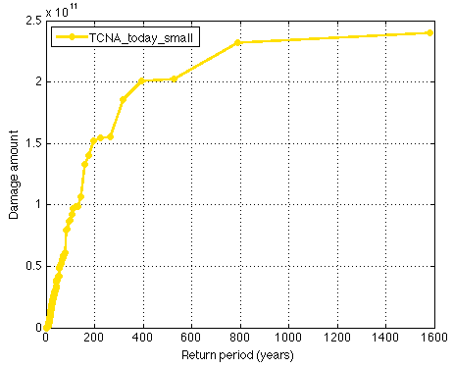

figure; climada_EDS_DFC(EDS) % show damage excess frequency curve  
The horizontal axis denotes the return period in years, the vertical axis the damage (in unites the Values were provided, here USD). The label of the curve denotes the hazard set used.

While one would in a proper application of climada now calculate the damages of future assets (to obtain the effect f economic growth) and then further repeat the calculation with a future hazard set (to obtain the effect of climate change), we illustrate the benefit of adaptation measures by simply using the assets and hazard we have already used.

## Adaptation cost curve

As mentioned, the entity structure contains not only assets and damagefunctions, it also holds the adaptation measures[27]. entity.measures.name{m} contains the name of measure m, entity.measures.name.cost(m) the cost[28]. The following fields allow the parameterization of the measure’s impact on both the hazard as well as the damage function. entity.measures.name.hazard_intensity_impact(m) allows to reduce the hazard intensity (e.g. -1 reduces tropical cyclone windspeed by 1 m/s) for measure m. The hazard_high_frequency_cutoff[29] allows to specify a frequency below which damages are suppressed due to the measures, e.g. the construction/design level of a dam (hazard_high_frequency_cutoff=1/50 means the dam prevents damages up to the 50 year return period). hazard_event_set allows to specify a measure-specific hazard event set, i.e. for this particular measure, climada switches to the specified hazard event set instead of the one used to assess the damages of the reference case. MDD_impact_a and MDD_impact_b allow a linear transformation of the MDD (mean damage degree) of the damage function, such that MDDeff = MDD_impact_a + MDD_impact_b * MDD. Similarly, PAAeff = PAA_impact_a + PAA_impact_b * PAA. damagefunctions_map allows to map to a new damage function to render the effect of measure m, i.e. ‘1to3’ means instead of DamageFunID 1, DamageFunID 3 is used[30]. risk_transfer_attachement and risk_transfer_cover define the attachement point and cover of a risk transfer layer[31].

The simple call

**measures_impact=climada_measures_impact(entity,hazard,'no');**

does it all, e.g. it takes the entity and first calculates the EDSref using hazard in order to create the baseline (situation with no measure applied). It then takes masure m (m=1…), adjusts either hazard and/or damagefunctions according to the measure’s specification and calculates a new EDSm. The difference to EDSref (i.e. EDSm-EDSref) quantifies the benefit (averted damage) of measure m. By doing this on the event damage set, a variety of measures can be compared, even account for measures which for example only act on high frequency events (see hazard_high_frequency_cutoff) or risk transfer layers (see risk_transfer_attachement and risk_transfer_cover). This function further handles all the measure impact discounting etc[32].

Since it would be quite cumbersome for the user to manually construct the adaptation cost curve based on the detailed output provided by climada_measures_impact, the following function does it all:

**climada_adaptation_cost_curve(measures_impact)**

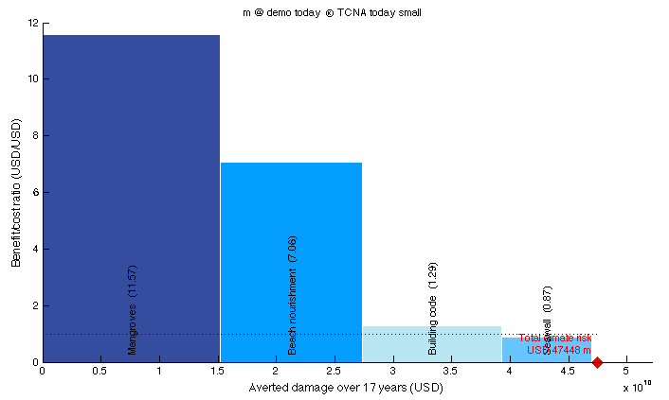

and finally the effect of adaptation measures on different return periods:

climada_adaptation_event_view(measures_impact)

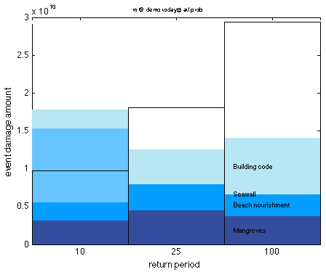Figure: the effect of adaptation measures on return periods of 10, 25 and 100 years. Note that the 10-year event can be fully mitigated by proposed measures, about 70% of the 50-year and about half of the 100-year event.

# Function reference

This section makes reference to key climada functions in order to provide the user with a starting point – the function are provided in a somewhat logical order, i.e. one would usually use functions listed further down later in the process. Please refer to each functions detailed header (use help *functionname* in MATLAB). You might also run compile_all_function_headers once in order to generate a .html file with all function headers for fast reference.

climada_demo: the demo GUI as documented above

climada_demo_step_by_step: the step-by-step demo as documented above

## Basic entity functions

**climada_entity_read**: read entity from Excel file

climada_entity_load: load a previously saved entity (climada_entity_read saves a .mat file – which speeds up subsequent read, unless the original Excel file has been changed, in which case it is re-read and the .mat file overwritten, see climada_check_matfile)

climada_entity_save: save an entity (i.e. after modification in MATLAB)

climada_damagefunctions_read: read damagefunctions tab only

climada_measures_read: read measures tab only

climada_measures_encode: encode measures, i.e. interpret them for use in climada_measures_impact

climada_entity_plot: plot assets distribution of an entity (entity.assets)

climada_assets_encode: encode assets (i.e. to switch to another hazard event set[33])

climada_assets_encode_check: check encoding, plot asset locations and centroids

climada_damagefunctions_plot: plot damagefunctions

climada_damagefunctions_map: map damagefunctions (i.e. to another entity[34])

## Core calculations

**climada_EDS_calc**: calculate event damage set (EDS)

climada_EDS_stats: some statistics of an EDS

climada_EDS_save: save EDS

climada_EDS_load: load EDS

**climada_EDS_DFC**: plot damage frequency curve(s)

climada_damage_exceedence: the damage exceedence calculation

climada_EDS_DFC_report: write an Excel or .csv report of the DFC(s)

climada_waterfall_graph: plot the waterfall (risk today, economic, climate) graph

**climada_measures_impact**: calculate the impact of adaptation measures

climada_NPV: net present value (NPV) calculation

**climada_adaptation_cost_curve**: show the adaptation cost curve

climada_adaptation_event_view: the event view on adaptation measures

## Basic hazard functions

climada_hazard_plot: plot hazard events, max intensity etc.

climada_hazard_load: load hazard event set

climada_hazard_stats: plot hazard intensity return period maps

climada_excel_hazard_set: create a hazard set based on scenarios as provided in an Excel file, see ../data/hazards/Excel_hazard.xls

climada_hazard_cleanup: cleanup a hazard event set (check for internal consistency)

climada_hazard_clim_scen: create a climate scenario version of a hazard event set

climada_plot_IFC_return: plot **i**ntensity/**f**requency relationship at **c**entroid

## Further display functions

climada_plot_world_borders: plot world borders[35]

climada_circle_plot: plot any values at coordinates as circles

climada_color_plot: plot any values at coordinates as colored area

climada_DFC_compare: compare a damage frequency curve (DFC) with other model output

## Tropical cyclone (TC) specific functions

climada_tc_get_unisys_databases: get all TC (besttrack) databases from www

climada_tc_read_unisys_database: read (besttrack) data

climada_tc_random_walk: generate probabilistic tracks

climada_tc_windfield: generate the windfield for one TC event

climada_tc_hazard_set: generate a TC hazard event set

climada_tc_windfield_animation: animate a single TC track’s windfield

climada_plot_ACE: plot accumulated cyclone energy (ACE)

climada_tc_stormcategory: add Saffir-Simpson scale[36]

climada_tc_read_unisys_track: read a single track (see also climada_tc_read_unisys_database above)

## Basic functions

climada_xlsread: read Excel file

climada_odsread: read .ods (Open Office) file, see also climada_init_vars to set this as default

climada_shaperead: read shape file (does require MATLAB mapping toolbox)

climada_centroids_read and climada_centroids_load: read and load centroids

## Admin functions

compile_all_function_headers: generate a html file with headers of all functions (these headers explain all input and output of each function)

climada_code_copy: copy all code into a folder for easy transfer (see GIT, too)

climada_code_update: update local code based on the file provided by climada_code_copy

climada_git_pull_repositories: on a machine with GIT (https://github.com) installed, update all local code and data

climada_template: the function template to start new code from

climada_country_name: get country name and admin0 ISO3 code, see also ../data/system/admin0.txt and admin.xls

climada_init_vars: init global varables (called upon startup by startup)

climada_init_folders: init folder structure (useful when creating a new module)

startup: the startup function, sets root folder and manages MATLAB path[37]

climada_check_matfile: check whether the .mat (binary, fast access) version of a file is older than the (Excel) file, used e.g. in climada_entity_read, which reads the .mat file on second call, unless the Excel entity file has been edited.

## Special functions

climada_code_optimizer: remove some parts from core code (like climada_EDS_calc) for speedup

climada_distance_km: calculate distance between points in km

climada_nonspheric_distance_m: more precise distance in m

climada_collect_measures_impact: collect impact files for two hazards created by climada_measures_impact (sometimes handy to process some measures separately)

waitbar_toggle: toggle waitbars (on/off), see also climada_global.waitbar

# climada modules

While the core climada provides the user with the core probabilistic damage calculation and climate adaptation measures assessment functionalities, it only contains a simple tropical cyclone hazard. Therefore, there are climada extensions, called modules, to add functionality. Since the core climada only contains a simple tropical cyclone hazard, one of the first modules to be considered might be tc_hazard_advanced, which improves the quality of the tropical cyclone hazard event set. There exists modules for other perils (to generate or make sue of other hazards, such as tc_surge and tc_rain, ws_europe and eq_global) and for other functionality, like automatic generation of assets (country_risk and GDP_entity). Each module contains (similar to core climada) a code, data and docs folder, with a detailed documentation in the file {module_name}.pdf in the docs folder. Therefore, one might first inspect these files still on GitHub before downloading a specifc module[38].

GDP_entity, <https://github.com/davidnbresch/climada_module_GDP_entity>

Create a default asset base for almost any specific country, consisting of centroids (used later e.g. to generate a hazard event set of matching resolution) and assets scaled to the country GDP for today and future.

country_risk, <https://github.com/davidnbresch/climada_module_country_risk>

This module runs all (available) perils for one country (or list of countries). It generates country or admin1 (state/province) assets, the earthquake (EQ), tropical cyclone (TC), torrential rain (TR) and storm surge (TS) hazard event sets, checks for European winter storm (WS) exposure and runs all risk calculations for a given country.

eq_global, <https://github.com/davidnbresch/climada_module_eq_global>

This module implements a raw global earthquake model. Consider climada modules country_risk or GDP_entity to generate the centroids.

etopo, <https://github.com/davidnbresch/climada_module_etopo>

This module implements ETOPO, a global bathymetry (and topography) dataset. It’s a separate module, since topographic (and bathymetry) information can be used in various contexts – and since the dataset is quite large (ETOPO1 is 933 MB, ETOPO2 still 233 MB).

meteorites, <https://github.com/davidnbresch/climada_module_meteorites>

This module implements a basic meteorite global hazard. Consider climada modules country_risk or GDP_entity to generate the centroids.

tc_hazard_advanced, <https://github.com/davidnbresch/climada_module_tc_hazard_advanced>

This module implements the tropical cyclone (TC) attenuation after landfall for probabilistic events. Make yourself familiar with the core climada tropical cyclone hazard event set (and its generation) first. A good implementation of both the basic, probabilistic and advanced tropical cyclone hazard generation can be found in the climada module country risk and there in the routine centroids_generate_hazard_sets.

tc_rain, <https://github.com/davidnbresch/climada_module_tc_rain>

This climada module allows to generate the precipitation fields accompanying a tropical cyclone - the torrential rain (TR) hazard event set. Please see tc_hazard_advanced, too, as generating rain fields makes far more sense after application of this module.

tc_surge, <https://github.com/davidnbresch/climada_module_tc_surge>

This module implements a tropical cyclone storm surge model . It’s based on climada’s core tropical cyclone (TC) module. Hence in order to run tc_surge, make sure you’ve made yourself familiar (to some extent at least) with the core climada tropical cyclone hazard module. Needs the climada module etopo, highly recommended to make use of module tc_hazard_advanced , too.

ws_europe, <https://github.com/davidnbresch/climada_module_ws_europe>

This climada module contains the European winter storm hazard event sets as used in the following publication: Schwierz, C., P. Köllner-Heck, E. Zenklusen Mutter, D. N. Bresch, P.-L.Vidale, M. Wild, C., and Schär, 2010: Modelling European winter wind storm losses in current and future climate. Climatic Change (2010) 101:485?514, doi: 10.1007/s10584-009-9712-1.

barisal_demo, <https://github.com/davidnbresch/climada_module_barisal_demo>

Barisal, Bangladesh, demo module, all numbers and results are for demonstration purposes only.

# Appendices

The appendices contain detailed description of relevant aspects and shall provide the advanced user with further information and especially serve those consider expanding climada functionality.

## climada, the inner workings

This section describes the core damage calculation. The damage is calculated for each single asset at each location for each scenario or event, so basically

damage = asset value * damage function

where damage is summed up over assets and events, i.e. above line is at the core of two loops, the outer one over assets, the inner one over events. More precisely:

damage = asset value * MDD * PAA, where

* MDD * PAA is the damage function
* damage is the damage ‘from ground up’, from the first dollar, so to speak
* asset value is the total value of the asset. Note again that value does not need to a monetary value, it can also e.g. signify number of people at a given location.
* MDD is the Mean Damage Degree (the damage for a given intensity at an affected asset) - how strongly an asset is damaged. Range 0..1 (from none to total destruction). In the case of asset value signifying number of people at a given location, MDD represents the severity with which those people are affected.
* PAA is the Percentage of Assets Affected (the percentage of assets affected for a given hazard intensity) - how many assets are affected. Range 0..1 (from none affected to all affected). In the case of asset value signifying number of people at a given location, PAA represents the percentage of people affected. As the product MDD*PAA ultimately counts, the user shall just make sure this product makes sense for the class of assets under consideration.

So far, the hazard intensity did not show up in the calculation, did we miss something? Well, the damage is a function of the hazard intensity, hence:

MDD = f(hazard intensity)

PAA = f(hazard intensity)

where hazard intensity is the hazard's intensity at each asset for each event. Since the damage also depends on the asset type, we have in fact:

MDD = f(hazard intensity, asset type)

PAA = f(hazard intensity, asset type)

While the hazard intensity is simply the entity.damagefunctions.Intensity, the asset type is referred to by the DamageFunID, i.e. for a certain type of assets, the user defines a specific DamageFunID in the assets tab and the corresponding damage function (MDD and PAA as function of Intensity) in the damagefunctions tab of the entity Excel file.

### Implementation

The core calculation is done by climada_EDS_calc, where EDS stands for event damage set, i.e. a vector with calculated damage for each event (or simply the vector of event damages). The variables in the code have speaking names, but the inner loop is vectorized, hence warrants some comments.

for asset_i=1:n_assets

temp_damage=entity.assets.Value(asset_i)*MDD.*PAA

end % asset_i

* temp_damage since it will be added in an ‘outer loop’ over asset_i
* entity.assets.Value(asset_i) is the Value of asset_i  
  entity is a structure which contains all asset and vulnerability data
* MDD is here a vector of MDDs, one element for each hazard event, PAA is the vector or PAAs, also one element for each hazard event.
* .* is the element-wise (scalar) multiplication

So far, the hazard intensity did not show up in the calculation, did we miss something? Well, the damage function is a function of the hazard intensity, hence:

MDD = f(hazard intensity) and PAA = f(hazard intensity)

where hazard intensity is the hazard intensity at asset_i for event_j, but event_j never shows up in the code, since the code is vectorized along the event dimension for performance reasons.

And now, it gets technical (no way around this, sorry, about line 170ff of climada_EDS_calc) – how to get the vector of MDDs.

Remember: outer loop (explicit) over assets, inner loop (implicit) over events and also remember that the hazard event set contains

* hazard.intensity(event_j,centroid_i): the hazard intensity (like windspeed in m/s) at centroid_i for event_j
* hazard.frequency(event_j) contains the event-frequency for event_j

for asset_i=1:n_assets % approx line 170ff in climada_EDS_calc.m  
  
 % the index of the centroid for given asset in the hazard set   
 asset_hazard_pos=entity.assets.centroid_index(asset_i);

% find the vulnerability for the asset under consideration  
 asset_vuln_pos=find(entity.vulnerability.VulnCurveID == ... entity.assets.VulnCurveID(asset_i));

% convert hazard intensity into MDD: we need a trick to apply  
 % interp1 to the SPARSE hazard matrix: we evaluate only at

% non-zero elements, therefore need a function handle (the   
 % @ below) to pass vulnerability to climada_sparse_interp:   
 interp_x_table=entity.vulnerability.Intensity(asset_vuln_pos);  
 interp_y_table=entity.vulnerability.MDD(asset_vuln_pos);

% apply to non-zero elements only[39]  
 MDD=spfun(@climada_sparse_interp,hazard.arr(:,asset_hazard_pos));

% similarly, convert hazard intensity into PAA  
 interp_y_table=entity.vulnerability.PAA(asset_vuln_pos);  
 PAA=spfun(@climada_sparse_interp,hazard.arr(:,asset_hazard_pos));

% calculate the from ground up (fgu) damage  
 temp_damage=entity.assets.Value(asset_i)*MDD.*PAA;

% add to the resulting EDS (event damage set) structure:

EDS.damage=EDS.damage+temp_damage'; % add to the EDS[40]

EDS.Value=EDS.Value+entity.assets.Value(asset_i); % add Value

end % asset_i

Next, you might consider “climada implementation of insurance conditions” further below.

## Insurance remarks

### Insurability & forms of insurance

Insurance is the mutual cover of a fortuitous, assessable need of a large number of similarly exposed business [Alfred Manes, 1877-1963].

* mutuality: numerous exposed parties must join together to form a risk community, to share and diversify the risk → large number
* fortuitous or randomness: time of occurrence must be unpredictable, occurrence itself must be independent of the will of the insured
* assessability: damage probability and severity must be quantifiable
* similarly exposed business: a large number
* plus: economic viability: private insurers must be able to obtain a risk-adequate premium

The following figures show the effect of insurance, including the working (and benefit) of risk reducing prevention measures. (Climate) adaptation measures work in a similar fashion, hence do not only reduce risk, but render insurance more attractive (i.e. affordable).

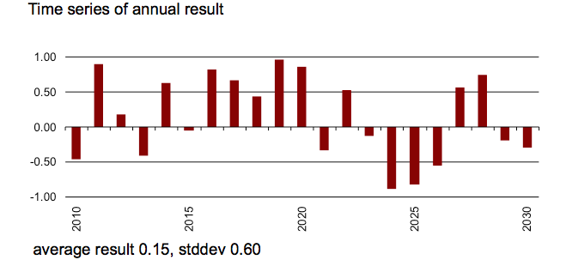

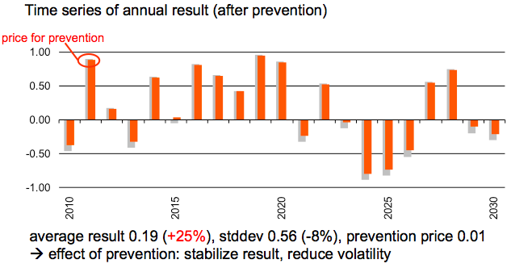

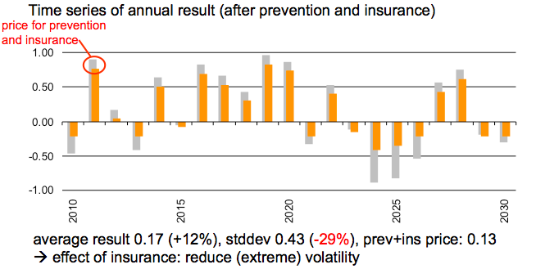

In summary, we therefore have:

Result stdev price[41]

raw 0.15 0.60

+ prevention 0.19 (+25%) 0.56 (-8%) 0.01

🡪 cost-effective adaptation (net gain of 0.04 at cost of 0.01 )

+ insurance (and prevention) 0.17 (+12%) 0.43 (-29%) 0.01+0.12

🡪 substantial reduction of volatility, result increase even after deduction of prevention cost and insurance premium 🡪 affordable!

*for comparison: insurance alone 0.12 (-17%) 0.45 (-25%) 0.153*

🡪 prevention (strongly) incentivizes insurance

Key drivers for risk transfer demand to complement risk reduction measures are:

* Volatility of (remaining) damage
* Level and trend of expected damage (related to budget)
* Damage clusters (relative to budget and financing capacity)
* Budget constraints and opportunity costs (e.g. school investments)
* Availability of emergency relief capital
* Subjective risk appetite

The last point shall no means be underestimated, as it refers also strongly to risk culture.

Risk transfer can be agreed upon based on different triggers:

* indemnity[42], also called incurred or occurred damage: The incurred damage is compensated for, i.e. the insured sends the bill for fixing the damage and gets reimbursed. Pro: exact amount paid, Con: takes time, involves damage assessment and may contain moral hazard (insurance fraud).
* parametric, also called index: A physical parameter exceeding a certain threshold (e.g. wind speed above 35 m/s) triggers the payment of a pre-agreed amount – or more generally an amount as a function of the parameter(s). Pro: fast, unbureaucratic, pre-agreed. Con: the pre-agreed value is paid, actual damage might differ (so called basis risk retained by the insured[43]).
* modeled (well, a form of parametric): A model is run after an event, based on the key properties of the event (e.g. a wind footprint as measured by a meteorological office) and the resulting modeled damage amount is paid

and with different partners, such as:

* policyholders – from macro (e.g. large corporates in Texas) to micro (e.g. smallholder farmers in Ethiopia) – and the usual single household
* insurers (reinsurers insure them)
* other reinsurers, called retrocession
* capital market, called insurance-linked security (ILS) or Cat Bond[44]
* public sector (public-private partnership, PPP)

and can be based either on free choice (whether the take up insurance or not) or mandatory[45] – or any shade in between. Please note the issue of adverse selection (especially pertinent for perils such as flood), i.e. that only the most at risk seek cover, rendering the scheme costly or even non-commercially viable – and hence the justified consideration of compulsory or mandatory schemes.

### Insurance conditions

There are basically two types of insurance conditions, proportional and non-proportional. Proportional means the insured retains a proportional (linear) fraction of the damage, non-proportional in essence means the insured is covered above a certain threshold (called deductible) for a certain cover[46].

proportional: damageafter=damagebefore * share

non-proportional: damageafter=min(max(damagebefore - deductible,0),cover)

Where share needs to be defined depending on who shall be liable for damage after, i.e. if damageafter is the damage to be reimbursed by the insurer, share is the insurer’s share of the total or ‘from ground up’ damage. Likewise, damageafter in above notation in the non-proportional case is the damage the insurer is liable for, as the deductible (and any damage exceeding the cover) remains with the insured.

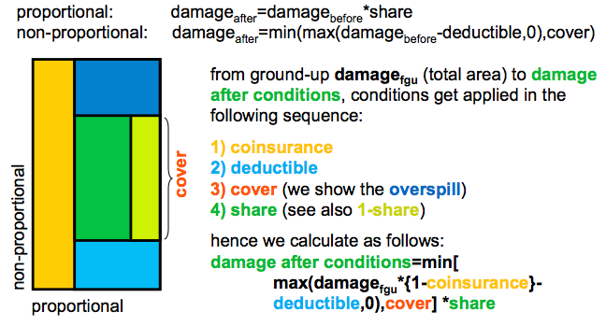

Figure: the elements of insurance conditions. The event based approach as followed in climada does allow for the consideration of all these elements.

### climada implementation of insurance conditions

Please read the above section “” carefully first. Remember that the outer (explicit) loop is over assets, the inner (implicit) one over events.

for asset_i=1:n_assets % approx line 170 in climada_EDS_calc.m  
 […]

% calculate the from ground up (fgu) damage  
 temp_loss=entity.assets.Value(asset_i)*MDD.*PAA;

if entity.assets.Deductible(asset_i)>0 || ...   
 entity.assets.Cover(asset_i) < entity.assets.Value(asset_i)

% apply Deductible and Cover  
 temp_damage=min(max(temp_damage-...  
 entity.assets.Deductible(asset_i)*PAA,0),...  
 entity.assets.Cover(asset_i));

end

% add to the resulting EDS (event damage set) structure:

EDS.damage=EDS.damage+temp_damage'; % add to the EDS

[…]

end % asset_i

Similarly, any conditions on the event damage set (EDS) can be evalaued, always of the form min(max(loss-deductible,0 ),cover), i.e. a non-proportional per-event cover (CatXL) can be evaluated on the EDS as:

EDS.damage = share * min(max(EDS.damage -deductible,0),cover)

For any index based risk transfer, the EDS can be computed starting from the hazard event set and calculating the index value for each event. In the case of the simplest index, just a wind speed threshold T at a given location, payout P of $10 per m/s above threshold, this might look as simple as:

temp_hazard = hazard.intensity(*,hazard_pos);

nz_pos = find(temp_hazard);

EDS_index = min(temp_hazard(nz_pos)-T,0)*P

where hazard_pos contains the index of the centroid next to the station (determined using climada_geo_distance). Note that due to the sparsity of hazard.intensity, the min function is speeded up by using find first.

More specifically, and to ease the use of risk transfer measures, they can also be specified in the measures tab of the entity Excel sheet[47]. In column ‘risk transfer attachment’, one enters the attachment point (synonym for deductible) in the same currency and currency unit as all other figures, and in column ‘risk transfer cover’ the cover. In column ‘cost’, one only needs to enter the cost in addition to the pure expected damage (which is calculated within climada, when the risk transfer gets applied). Costs for risk transfer are – to keep it simple here – a fixed amount for management expenses and capital costs that scale first order with the cover[48]. As an approximation, one might use rules of thumb to determine a proxy for the sum of management expenses and capital costs, like (GLM stands for geometric layer mean):

1. determine sqrt(GLM), where GLM=sqrt(attachment_point*cover)
2. look up the probability of a damage of size sqrt(GLM) on the DFC (without measures, to keep it simple)
3. proxy for sum of costs is max(sqrt(probability of damage),0.01)*cover

## Note on scenarios

Since climada makes use of scenarios in at least three instances, it might be worthwhile providing a definition and some remarks.

climada uses scenarios e.g. in:

* hazard event set generation (generating artificial single hazard events or scenarios, such as by ‘wiggling’ path and intensity of tropical cyclones)  
  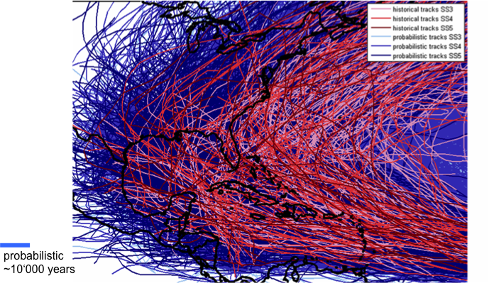  
  Figure: historic (red) and probabilistic (blue) storms, see functions climada_tc_*
* charting out economic pathways (the economic development scenarios, leading to future assets) and
* last but not least climada uses climate impact scenarios in the sense of modified hazard event sets (one could also see them as events compatible with future climate conditions).

Definition: A scenario is a snapshot that describes a possible and plausible future. Scenario analysis is a systematic approach to anticipate a broad range of plausible future outcomes.

Scenario analysis is used in general …

* as a risk management tool to assess the potential impact of an event or development to anticipate and understand risks (as e.g. in the climada hazard event sets)
* as a tool to spot new business opportunities and to discover strategic options[49] (e.g. as climada adaptation measures)
* as foresight in contexts of accelerated change, greater complexity and interdependency
* for evaluation of highly uncertain events that could have a major impact (e.g. climada climate change hazard event sets)
* to steer mitigation strategies, implementation and monitoring by reviewing and tracking different possible developments (as in the whole economics of climate adaptation assessment)

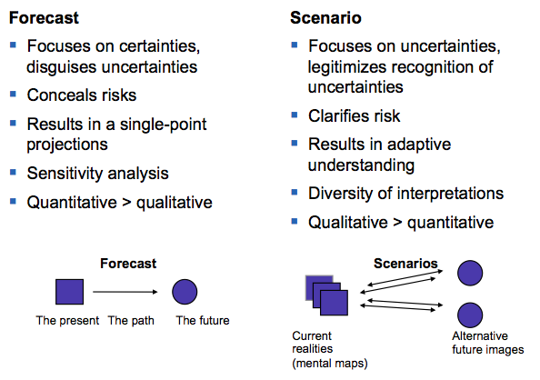

Figure: Some key properties of forecasts and scenarios in comparison.

### climate impact scenarios – remarks on climada implementation

There are different ways to represent climate change scenarios in the model.

Representation is possible via

* Parameterized impact:  
  Estimate the climate change impact on key hazard parameters and represent those changes in the probabilistic event set, either by
  + re-generating the probabilistic event set based on these parameters (e.g. consider changing properties of tc_track prior to calling climada_tc_hazard_set) or by
  + reflecting those changes by modification of the ‘present climate’ hazard event set (e.g. multiply the hazard intensity by a factor), see further below
* Downscaled event set:   
  Extract events from a downscaled GCM-driven model chain[50]

Note that a changing climate might also have impacts on e.g. vulnerabilities

While there all degrees of freedom to implement climate change impact scenarios in climada, the following few remarks might be of value:

Remember that hazard contains the hazard event set, hazard.intensity the sparse array with intensities, hazard.frequency the vector of event (occurrence) frequencies. Therefore, the following cases are very straightforward (we use wind speed as example, works similarly for parameters such as flood height):

* Increase wind speed for all events by 5%:  
  hazard.intensity =hazard.intensity *1.05;
* Increase event frequencies by 5%:  
  hazard.frequency=hazard.frequency*1.05;
* Increase all wind speeds by 5 m/s (note that hazard.intensity is sparse, hence we first need to identify the non-zero elements);  
  nz_pos=find(hazard.intensity) %non-zeros  
  hazard.intensity(nz_pos)=hazard.intensity(nz_pos)+5;
* Increase only wind speeds > 45 m/s by 5 m/s:

pos45=find(hazard.intensity>45);

hazard.intensity(pos45)=hazard.intensity(pos45)+5;

The code climada_hazard_clim_scen allows for such impact parameterizations.

### Climate impact scenarios – sources

Since the advanced user will likely construct own climate change impact scenarios, she might find relevant information at the following sources:

<http://www.ipcc.ch/pdf/assessment-report/ar5/wg1/WG1AR5_AnnexI_FINAL.pdf> and <http://www.ipcc.ch/report/ar5/wg1/docs/ar5_wg1_annexI_all.zip>: IPCC Atlas of Global and Regional Climate Projections

<http://sealevel.climatecentral.org>: domestic US coastal surge information until 2100

<http://climate-adapt.eea.europa.eu>: European adaptation site

<http://www.meteoschweiz.admin.ch/home/klima/zukunft/klimaszenarien.html>: Swiss climate impact scenarios

and last but not least: <http://newclimateeconomy.report>

## Tropical cyclones – technical remarks

### Windfield calculation

To determine the impact of any given storm, function climada_tc_windfield generates wind field resulting from single track of tropical cyclone. The function starts from ther track center tc_track.MaxSustainedWind in knots and generates the 2D windfield in res.gust in m/s.

Normally wind footprint calculation is tested on a single tc_track prior to generation of the hazard event set of all the entire historical and probabilistic track set (as shown in the step-by-step approach at the beginning of the manual, see climada_demo_step_by_step). The windfield calculations are speeded up by only calculating for centroids within 750 km distance of min/max track lon/lat.

res = climada_tc_windfield(tc_track(1170),centroids);

For details, see the header of climada_tc_windfield

**Method**

Currently, the code implements the Holland windfield[51]. Given that the distance of the centroid (D) to the eye of the storm is smaller than its corresponding radius (R), the wind speed (S) is given by:



where *M* denotes the maximum sustained wind and *T* is the celerity (forward speed). In case where *D* is still ten times smaller than *R*, you find yourself in the outer core of the storm where the wind speed takes the form of the second line in the equation above. If none of these cases are true, the wind speed is set to zero.

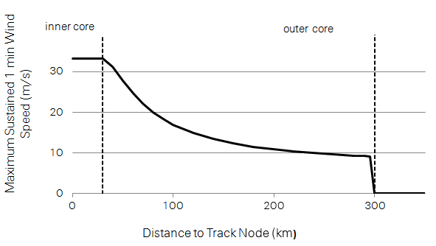

Figure: Maximum sustained 1 min wind speed in relation to the distance to the track node.

The radius of maximum wind (R, in km) depends on the latitude of the track node (L) as follows:



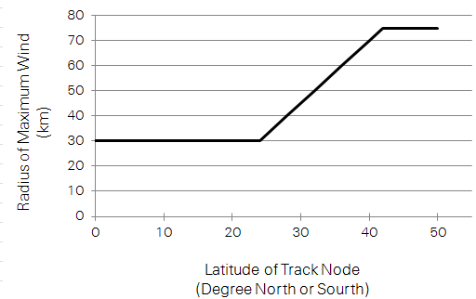

Figure: Radius of maximum wind in relation to latitude of track node.

Finally, the wind speed, *S*, describes the maximum sustained 1 min wind speed. To derive wind gusts lasting just a few seconds (3-5 s), we note that wind peaks are typically around 27% higher than a 1 min sustained wind in a hurricane environment.

<http://www.prh.noaa.gov/cphc/pages/FAQ/Winds_and_Energy.php>

Any other wind field parameterization can be implemented in a similar fashion (just implement in a copy of climada_tc_windfield, e.g. climada_tc_MY_windfield, see also the routine climada_tc_hazard_set to change the caller when generating the probabilistic set).

In order to test the wind field calculation, the following might help:

Use the tc_track structure (should still be in memory), but start with only one track, e.g. tc_track(84) for the 84th track. Investigate tc_track.name to find a particular event. Use e.g. the following code to show a list of track number, year and name:

for i=1:length(tc_track)

fprintf('%i %i %s\n',i,tc_track(i).yyyy(1),char(tc_track(i).name));

end

Obtain centroids (points at which to evaluate the winfield) using

centroids = climada_centroids_read(‘’,1)

Note that this call with the 1 also plots the centroids (use the zoom function on the map). See also the parameter check_plot in the PARAMETER section of the climada_tc_windfield code or refer to the routine climada_color_plot.



Figure: Wind field calculated based on track 577 of the South Indian Ocean. This particular track results in the second highest wind speed in the city of Beira, Mozambique.

### Single cyclone track evolution animation

The function climada_tc_windfield_animation[52] refines tc_track to 1hour resolution, calculates wind field for every time step of 1h. The function displays the wind fields for selected aggregated time steps, e.g. 3h, 6h, 24h. Aggregation default is 6h.

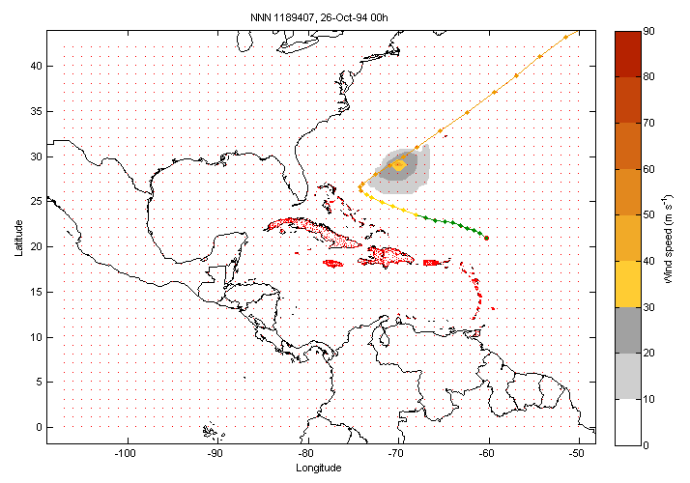

Figure: Snapshot from the animation, wind field calculated for every time step.

## Economics of Climate Adaptation (ECA) – key routines

The function climada_waterfall_graph plots the waterfall figure for today’s damage and future damage including economic growth and climate change for the annual expected loss or any specific return period. Inputs are the three event damage sets (e.g. EDS_today.mat, EDS_2030.mat, EDS_2030_clim.mat), prompted for if not given. Any specific return period or annual expected damage can be chosen.



Figure, see climada_waterfall_graph

The function climada_adaptation_cost_curve plots the adaptation cost curve, i.e. the cost/benefit (or benefit/cost) ratio for each measure on the vertical axis, the benefit on the horizontal axis. Note that all values are NPV.

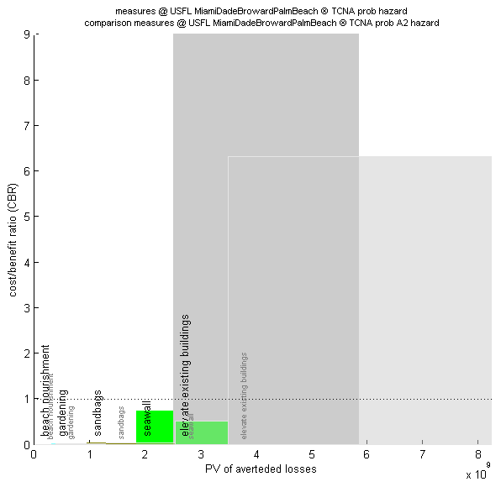

Figure, showing the option to plot two adaptation cost curves for direct comparison, see climada_adaptation_cost_curve

Proposed colours to use for measures:

|  |  |  |  |  |  |  |  |
| --- | --- | --- | --- | --- | --- | --- | --- |
| **Color** | **red** | **green** | **blue** | **red** | **green** | **blue** | **for excel** |
| 1 | 211 | 205 | 177 | 0.82 | 0.80 | 0.69 | 0.82 0.8 0.69 |
| 2 | 194 | 186 | 148 | 0.76 | 0.73 | 0.58 | 0.76 0.73 0.58 |
| 3 | 231 | 179 | 75 | 0.90 | 0.70 | 0.29 | 0.9 0.7 0.29 |
| 4 | 250 | 192 | 144 | 0.98 | 0.75 | 0.56 | 0.98 0.75 0.56 |
| 5 | 255 | 219 | 105 | 1.00 | 0.86 | 0.41 | 1 0.86 0.41 |
| 6 | 188 | 226 | 146 | 0.73 | 0.88 | 0.57 | 0.73 0.88 0.57 |
| 7 | 152 | 193 | 129 | 0.59 | 0.75 | 0.50 | 0.59 0.75 0.5 |
| 8 | 181 | 195 | 184 | 0.71 | 0.76 | 0.72 | 0.71 0.76 0.72 |
| 9 | 162 | 202 | 190 | 0.63 | 0.79 | 0.74 | 0.63 0.79 0.74 |
| 10 | 162 | 194 | 232 | 0.63 | 0.76 | 0.91 | 0.63 0.76 0.91 |
| 11 | 112 | 189 | 210 | 0.44 | 0.74 | 0.82 | 0.44 0.74 0.82 |
| 12 | 174 | 214 | 224 | 0.68 | 0.84 | 0.88 | 0.68 0.84 0.88 |
| 13 | 255 | 175 | 175 | 1.00 | 0.68 | 0.68 | 1 0.68 0.68 |
| 14 | 205 | 183 | 201 | 0.80 | 0.71 | 0.79 | 0.8 0.71 0.79 |
| 15 | 255 | 209 | 248 | 1.00 | 0.82 | 0.97 | 1 0.82 0.97 |
| 16 | 174 | 167 | 139 | 0.68 | 0.65 | 0.54 | 0.68 0.65 0.54 |
| 17 | 155 | 147 | 113 | 0.61 | 0.57 | 0.44 | 0.61 0.57 0.44 |
| 18 | 200 | 140 | 57 | 0.78 | 0.55 | 0.22 | 0.78 0.55 0.22 |
| 19 | 238 | 153 | 110 | 0.93 | 0.60 | 0.43 | 0.93 0.6 0.43 |
| 20 | 255 | 184 | 80 | 1.00 | 0.72 | 0.31 | 1 0.72 0.31 |
| 21 | 149 | 193 | 112 | 0.58 | 0.75 | 0.44 | 0.58 0.75 0.44 |
| 22 | 117 | 154 | 98 | 0.46 | 0.60 | 0.38 | 0.46 0.6 0.38 |
| 23 | 142 | 156 | 145 | 0.55 | 0.61 | 0.57 | 0.55 0.61 0.57 |
| 24 | 125 | 164 | 151 | 0.49 | 0.64 | 0.59 | 0.49 0.64 0.59 |
| 25 | 125 | 155 | 202 | 0.49 | 0.61 | 0.79 | 0.49 0.61 0.79 |
| 26 | 85 | 150 | 173 | 0.33 | 0.59 | 0.68 | 0.33 0.59 0.68 |
| 27 | 136 | 177 | 190 | 0.53 | 0.69 | 0.74 | 0.53 0.69 0.74 |
| 28 | 255 | 137 | 137 | 1.00 | 0.54 | 0.54 | 1 0.54 0.54 |
| 29 | 167 | 144 | 163 | 0.65 | 0.56 | 0.64 | 0.65 0.56 0.64 |
| 30 | 255 | 171 | 232 | 1.00 | 0.67 | 0.91 | 1 0.67 0.91 |



Figure: Example plot with proposed colours

See also climada_adaptation_event_view, which shows the effect of measures for events of different return periods.

See also climada_EDS_DFC to visualize the effect of specific measures on the occurrence damage exceedence frequency curves (DFC).

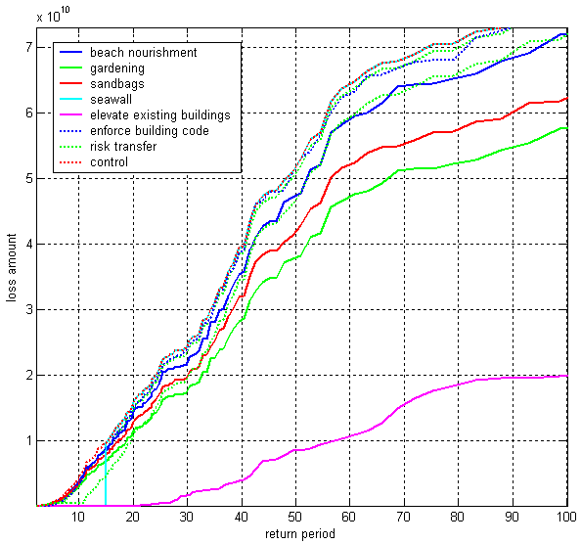

Figure: The occurrence damage exceedence frequency curve (DFC) for today’s hazard. Note the effect of the dam (cut-off at 15yr return period, light blue curve). Note further the prominent impact of ‘elevate existing buildings’, but this is entirely due to an optimistic modification of the underlying damage function.

## A remark on loss, damage and vulnerability

**Loss**: irrevocable loss [unersetzbarer Verlust], e.g. loss of glaciers (due to warmer climate) or loss of coastal land (due to sea level rise) or loss of precipitation (due to changed weather patterns). Losses can only be compensated for, not re-stated or re-placed. A risk management approach to loss does strongly suggest avoiding such losses due to their irrevocable nature. Risk management options such as intervention or sharing of risk can only deal with some of the consequences of the loss, not the loss itself. Irrevocable losses are uninsurable - still, some of their consequences can be insured (e.g. glacier melt is not random, hence cannot be insured, but the risk of a glacier lake bursting can be insured, since it's a random event. Likely: sea level rise and the loss of coastal land cannot be insured, since it's not random - but storm surge risk can be insured, since it's a random event).

**Damage**: replaceable damage [ersetzbarer Verlust], e.g. damage of property (can be repaired/rebuilt), consequential damage, like business interruption (can be monetarily compensated). Damage can be repaired or rebuilt at a cost. The full scale of risk management options can be employed: avoidance, prevention, intervention and risk transfer. Therefore, an economic analysis provides a suitable framework to assess the damage and to determine the most effective combination of avoidance, prevention, intervention and risk transfer measures to address damage.

**→ Corollary**: Any mechanisms to deal with loss & damage has to make this differentiation - To propose a 'standard' risk management approach to replaceable damage and a (e.g. compensation) mechanism to the irrevocable loss. Since most adaptation measures as dealt with by climada a risk management ones, **we refer to 'damage' wherever possible in the climada context**.

**Vulnerability** (weadapt.org): The ordinary use of the word ‘vulnerability’ refers to the capacity to be wounded, i.e., the degree to which a system is likely to experience harm due to exposure to a hazard. The scientific use of ‘vulnerability’ has its roots in geography and natural hazards research but this term is now a central concept in a variety of research contexts such as natural hazards and disaster management, ecology, public health, poverty and development, secure livelihoods and famine, sustainability science, land change, and climate impacts and adaptation. In order to make sense of the range of definitions, the different interpretations and definitions can be seen to be rooted in three academic disciplines namely risk and hazard or biophysical approaches, political economy and the concept of ecological resilience. From a climate change perspective, according to the IPCC, vulnerability is “the degree to which a system is susceptible to, or unable to cope with, adverse effects of climate change, including climate variability and extremes”.

**Damage function**: functional relationship between the hazard intensity and the resulting damage. The hazard intensity is measured (or modeled) at a given spatiotemporal point (a location, a given event) of a hazard (e.g. a flood height at a given latitude longitude at a given time). The damage is expressed as a percentage of the exposed (and hence possibly affected) asset. One often differentiates between the percentage of affected assets (PAA) as well as the mean damage degree (MDD). What's called a damage function in climada is often also referred to as 'vulnerability curve'.

If for say a storm surge height of 1 meter, 50% of all assets are affected, and the damage to these affected assets is 5% of their total value, the PAA is 0.5 and MDD 0.05. If the total asset value is 100, the resulting damage is hence 100 x 0.5 x 0.05 = 2.50

In the case of value signifying exposed population, PAA is used to reflect affected individuals; while MDD could be used to parameterize some sort of impact to the affected individuals (e.g. using disability or quality adjusted life years, DALY/QALY).

**→ Corollary**: While many modelers use 'vulnerability' or 'vulnerability curve' as a standard term to denote what is described as damage function above, **we refer to 'damage function' wherever possible in the climada context**.

1. See lecture course at the Swiss Federal Institute of Technology (ETH): [www.iac.ethz.ch/edu/courses/master/modules/climate_risk](http://www.iac.ethz.ch/edu/courses/master/modules/climate_risk)
2. Please note that climada uses MDR=MDD*PAA, where Mean damage degree (MDD) and percentage of affected assets (PAA) allow to deal with local deductibles in a more appropriate form than a simple Mean damage ration (MDR) model could do, since one does, due to the PAA, know how many assets are affected, hence deductible application is more specifc.
3. Usually the folder you extracted climada.zip to
4. The global variable climada_global (a struct) contains all these variables. See the code climada_init_vars.m which sets all these variables. Make sure you never issue a clear all command, as this would also delete climada_global and hence climada would not find it’s stuff any more.
5. A climada_additional module extends the functionality of climada and allows users to further develop climada without risking to change the core code. See further below for some examples of modules.
6. From now on, just type any command in Courier in the MATAB Command Window, as we will not state this each time again.
7. [www.iac.ethz.ch/education/master/climate_risk](http://www.iac.ethz.ch/education/master/climate_risk)
8. Sometimes also referred to as ‚vulnerability curves’ of just ‚vulnerabilities’. See lecture material for proper definitions.
9. In essence, we calculate damagej,k=valuek * f(intensityj,k), where valuek ist he value of asset k and intensityj,k the hazard intensity of event j at location of asset k. f denotes the damage function, i.e. the relation between the hazard intensity and the resulting damage (as a fraction of the asset value). See further below for some more details on the damage calculation ;-)
10. Since the content oft he Excel file is imported (using climada_xlsread) into MATLAB, any other source can be used to define the content oft he entity structure of climada, too. In order to understand the entity structure, it’s in fact easiest to import the file ../data/entities/entity_template.xls using entity=climada_entity_read and to inspect the resulitng entity structure.
11. ../data/entities/entity_template.xls
12. See the climada code climada_demo_step_by_step which performs all the steps and illustrates the intermediate results by plots, just as shown here.
13. Part of climada core module (i.e. the module this manual is part of)
14. Obtain it from <https://github.com/davidnbresch/climada_module_tc_surge> and see <https://github.com/davidnbresch/climada_module_tc_surge/blob/master/docs/climada_module_tc_surge.pdf> for this module’s manual.
15. See <https://github.com/davidnbresch/climada_module_eq_global>
16. See the function climada_tc_get_unisys_databases to automatically download all databasesfrom the internet (from weather.unisys.com/hurricane)
17. We implement a windfield according to Holland, G. J., 1980: An analytic model of the wind and pressure profiles in hurricanes. Monthly Weather Review, 108, 1212-1218. In addition to the axisymmetric vortex, we take forward speed into account. See also Holland, G. J., 2008: A Revised Hurricane Pressure–Wind Model, Monthly Weather Review, 136, 3432-3445. A natural next step would be the consideration of roughness (not implemented), see e.g. Vickery, P.J. et al., 2009: A Hurricane Boundary Layer and Wind Field Model for Use in Engineering Applications. J. Appl. Meteor. Clim.
18. In essence, a sparse array stores the non-zero elements of an array only. Since a single event hits only a few centroids – especially true for hazard set for a larger geographical region – we save a lot of memory and speed up the calculations substantially.
19. This function generates a hazard event set based on Excel input. The Excel sheet needs to contain all the event footprints. An easy method to use climada with a finite (small) number of predefined events (more hazard event scenarios then a full probabilistic set). See file ../data/hazards/ Excel_hazard.xls which contains a small example (for Mozambique).
20. One can also generate assets (value distributions) in climada, see e.g. the climada module <https://github.com/davidnbresch/climada_module_country_risk>
21. Please have a look at the Excel file, each column header is explained by a small comment (tiny yellow triangel in the upper right corner of the cell).
22. Please note that we discuss the measures information further below
23. We focus on the key content here, please inspect the structure in MATLAB yourself.
24. See function climada_assets_encode. Encoding means: map asset positions to calculation centroids oft he hazard event set. This step is required to allow the user to freely specify asset locations, rather than stick tot he centroids the hazard set has been stored at. A beginner-level user should not need to deal with such technical details, though.
25. As mentioned in a previous footnote, the beginner level user does not need worry too much about, this simply speeds up damage calculation substantially.
26. In the case there is only one perilID, see further details in climada_damagefunctions_plot
27. Please refer tot he measures tab in the Excel file and the comments in each of the header fields.
28. entity.measures.color{m} contains the color (RGB) as shown in the adaptation cost curve of measure m. colorRGB contains this converted into an RGB triple.
29. We do not repeat entity.measures.X(m) any more, just refer to X.
30. The filed entity.measures.damagefunctions_mapping contains the details, i.e. the mapping as used in climada, a kind of ‘parsed’ version of e.g. ‘1to3’.
31. Please refer the tot he lecture, [www.iac.ethz.ch/edu/courses/master/modules/climate_risk](http://www.iac.ethz.ch/edu/courses/master/modules/climate_risk)
32. See function climada_NPV
33. climada_entity_read prompts for a hazard event set and hence encodes to the selected hazard’s centroids already. For speedup, this is done prior to calling climada_EDS_calc, as mapping all asset locations to the centroids oft he hazard event set usually does not need to be repeated each time (e.g. only once for the series of calculations involved in assessment of adaptation measures). In case multiple hazards (perils) are assessed, re-encoding is required indeed (that’s why climada measures impact works for one hazard at a time only – this code does indeed checl for encoding).
34. This is especially useful if the user stores all damage functions in a kind of ‚reference’ file and attaches the damage functions after reading any new entity, which might itself not contain (all) damage functions (in this case, just disregard the warnings issues by climada_entity_read).
35. Uses ../data/system/admin0.mat for the border shapes, see the file admin0.txt there and also climada_shaperead('SYSTEM_ADMIN0'). The user can specify an other shape file, either as parameter or in climada_global.map_border_file
36. See e.g. <http://en.wikipedia.org/wiki/Saffir%E2%80%93Simpson_Hurricane_Scale>
37. Adds paths to all climada modules
38. Please refer to the section ‚Getting started’ above about where to store the module(s). The process is also described in each module’s readme file.
39. interp_x_table and interp_y_table are passed as global variables to climada_sparse_interp for performance reasons
40. A note on ' : for historical reasons the EDS.damage vector is transposed
41. Note that price is already taken into account in result
42. specific or market-share
43. That’s why one often finds hybrid solutions, but we refrain from getting into details.
44. Not this one:   
      
    
45. See e.g. Source: Efficient Monopolies. The Limits of Competition in the European Property Insurance Market, Thomas von Ungern-Sternberg, Oxford University press, 2004. ISBN 0-19-926881-9
46. There are unlimited covers, but this stretches the second principle of insurability, namely the ability to assess the outcome.
47. See ../data/entities/entity_template.xls
48. this is a very crude assumption. As climada only adds the expected damage costs, one needs to be careful here.
49. See e.g. the famous <http://s03.static-shell.com/content/dam/shell-new/local/corporate/Scenarios/New_Lens_Scenarios_Low_Res.pdf>
50. Please refer to the climada module ws_europe (<https://github.com/davidnbresch/climada_module_ws_europe>) and see Schwierz, C., P. Köllner-Heck, E. Zenklusen Mutter, D. N. Bresch, P.-L.Vidale, M. Wild, C., and Schär, 2010: Modelling European winter wind storm losses in current and future climate. Climatic Change (2010) 101:485?514, doi: 10.1007/s10584-009-9712-1.
51. Holland, G. J., 1980: An analytic model of the wind and pressure profiles in hurricanes. Monthly Weather Review, 108, 1212-1218.
52. See climada module <https://github.com/davidnbresch/climada_module_tc_hazard_advanced>