Calibration Report
Brewer #157; Izana, Spain; October 13-19, 1998

Instrument Status:
Brewer #157, a new Mark III instrument installed in July by the customer, was working well at the beginning of the calibration, although the UV calibration was believed to be very poor.
The instrument’s constants were at factory settings of ETC’s 1583/447 and absn. coefficients .3413/1.1442. Set at these values, the ozone readings were about 1% lower than #017 (see daily means below). Standard Lamp ratios R6/R5 have been stable at 305/575 which are essentially the same as at the factory. #017 was re-calibrated in Hawaii in March/98 and is frequently checked against the Triad in Toronto. Note: the instruments Acceptance Manual was not available on site during this visit, so some conclusions stated here may not be correct.

Ozone Test Results:
This inter-comparison resulted in approximately two hundred near simultaneous Direct Sun measurements of #157 with #017. The sun scan results showed (reference graph on next page) that the cal step of 285 was proper. The dispersion test results at step 285 produced an absorption coefficient of 0.342/1.15 which were put into use.

Brewer #157 using org. icf35697 constants ETC 1583/447 - SL R6/R5 305/575:
Julian day | O₃ | dev | SO₂ | dev | #/tot | mu | hr | ZS | dev | O₃ ETC
28698 | 261.1 | +1.4 | -2.8 | +0.9 | 24/27 | 155 | 13 | 274.3 | +0.9 | 1553
28798 | 261.2 | +2.0 | -2.8 | +1.1 | 40/46 | 154 | 12 | 283.5 | +1.2 | 1551
28898 | 273.4 | +2.5 | -2.7 | +1.1 | 25/37 | 156 | 14 | 0.0 | +0.0 | 1540
28998 | 280.1 | +2.3 | -2.5 | +1.0 | 35/39 | 160 | 11 | 299.04 | +0.9 | 1537
29198 | 263.8 | +2.8 | -2.7 | +0.7 | 32/61 | 153 | 13 | 0.0 | +0.0 | 1503
29298 | 268.9 | +2.1 | -2.6 | +1.0 | 65/75 | 165 | 13 | 0.0 | +0.0 | 1538

Brewer #017 using icf28898 - ETC's 3195/3100, absn. .3425/1.15:
Julian day | O₃ | dev | SO₂ | dev | #/tot | mu | hr | ZS | dev | O₃ ETC
28698 | 264.9 | +1.4 | 0.1 | +0.2 | 27/32 | 160 | 15 | 0.0 | +0.0 | 3219
28798 | 265.3 | +1.5 | -0.1 | +0.3 | 43/62 | 158 | 12 | 263.3 | +0.0 | 3221
28898 | 276.6 | +1.6 | 0.1 | +0.3 | 58/71 | 167 | 13 | 266.7 | +0.0 | 3220
28998 | 282.7 | +1.9 | 0.1 | +0.3 | 62/68 | 165 | 13 | 276.1 | +0.9 | 3221
29198 | 269.8 | +0.8 | 0.2 | +0.3 | 38/78 | 169 | 12 | 263.4 | +5.0 | 3196
29298 | 272.4 | +1.0 | 0.0 | +0.4 | 64/73 | 164 | 13 | 266.6 | +2.9 | 3210

Brewer #157 using icf28898.157 - ETC's 1551/185, .342/1.15:
Julian day | O₃ | dev | SO₂ | dev | #/tot | mu | hr | ZS | dev | O₃ ETC
28698 | 266.6 | +1.0 | 0.6 | +0.2 | 24/27 | 155 | 13 | 274.3 | +0.9 | 1553
28798 | 266.8 | +1.1 | 0.6 | +0.3 | 40/46 | 154 | 12 | 283.5 | +1.2 | 1551
28898 | 278.8 | +1.3 | 0.6 | +0.3 | 25/37 | 156 | 14 | 0.0 | +0.0 | 1540
28998 | 285.3 | +1.1 | 0.7 | +0.2 | 35/39 | 160 | 11 | 299.0 | +0.9 | 1537
29198 | 269.4 | +2.1 | 0.7 | +0.3 | 32/61 | 153 | 13 | 0.0 | +0.0 | 1503
29298 | 274.0 | +1.1 | 0.5 | +0.2 | 65/75 | 165 | 13 | 0.0 | +0.0 | 1538

<157cal98.doc> Nov. 8, 1998
Page 1
UV calibration results:
UV calibrations were performed with IOS lamps #188, 354, and compared to local lamps #646,647, 648. The initial UV response file (uvr28798.157) derived from Lamp 188 was very different from supplied calibration file (uvr.157); refer to attached graph. When the instrument was inside, the final calibration (uvr29098.157) was performed with lamps 188, 354 and believed to be more accurate than outside where there is frequent noise interference due to close proximity to television transmitters. Quick scans were taken on local lamps 646,647, 648 and 517 for future monitoring of stability. Using this new calibration a timed UV (ua) scan was processed, and the results compared well with #017. The new dispersion constants (dcf28898.157) were put into use due to improved accuracy at the higher wavelengths (~9 steps). The HeCd laser scan results were low in intensity due to weak laser but provided the desired slit function results.

Servicing:
No servicing was found to be necessary, but the pushrod bearings were oiled. The leveling of the tracker was improved slightly but the tracking had been good prior to this.

Recommendations:
Change the ETC constants to the new values and install the new UV response (UVR29098.157) file by editing the op_st.157 file after exiting to DOS. Use the QS test for monitoring UV stability.

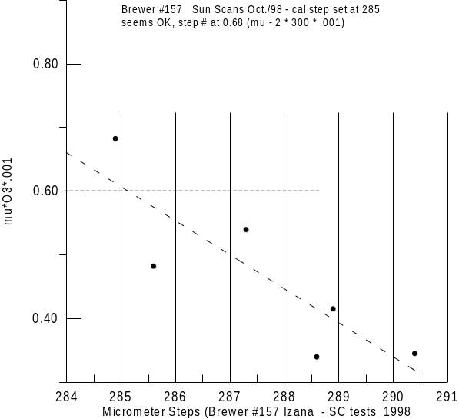
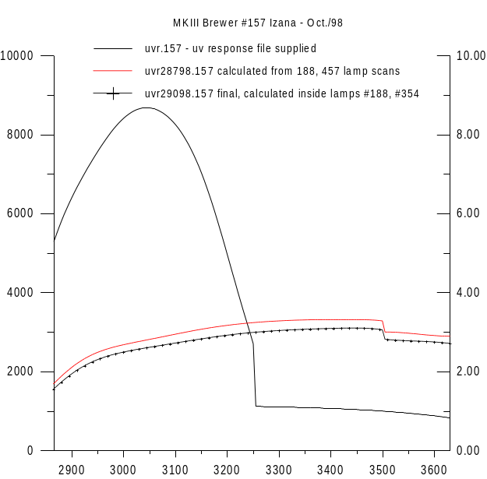

Submitted by: Ken Lamb, International Ozone Services Inc. (IOS) <157cal98.doc> Nov. 8, 1998
Page 2
Supporting graphs: 157cal98.doc
Brewer #157 Izana (October 1998) page 3

