H
HealthWithSevgi
Sprint 3 — Screenshot-Based Demonstration Report
Cankaya University · SENG 430 · Software Quality Assurance · Spring 2025-2026
Group X | Instructor: Dr. Sevgi Koyuncu Tunç
Role | Name | Student ID
Product Owner + Developer | Efe Çelik | 202128016
UX Designer | Burak Aydoğmuş | 202128028
Lead Developer + Scrum Master | Batuhan Bayazıt | 202228008
Developer | Berat Mert Gökkaya | 202228019
QA / Documentation Lead | Berfin Duru Alkan | 202228005

Date: March 30, 2026
GitHub: github.com/EudaLabs/HealthWithSevgi
Live Demo: huggingface.co/spaces/0xBatuhan4/HealthWithSevgi

Table of Contents

Sprint 3 Burndown Chart (Jira)
4. Step 4 — Model Selection & Parameter Tuning
4.1 Model Tab Bar (8 Algorithms)
4.2 Parameter Controls per Model
4.3 Clinical Tooltips (PARAM_HINTS)
4.4 Auto-Retrain & Debounce
4.5 KNN Decision Boundaries Visualization
4.6 All Models Training Successfully
4.7 Model Comparison Table
5. Step 5 — Results & Performance Metrics
5.1 Six Performance Metric Cards
5.2 Confusion Matrix (2×2)
5.3 Clinical Alert Banners (FN/FP)
5.4 ROC Curve & AUC
5.5 Model Comparison
5.6 Multi-Domain Demonstration

Sprint 3 Burndown Chart (Jira)
Sprint 3 duration: March 19–30, 2026. Scope: Step 4 (Model & Parameters) and Step 5 (Results). 90 total issues across the sprint board (56 Stories, 29 Tasks, 5 Bugs). 28 story points completed, 62 story points remaining. Sprint scope increased by +62 points during the sprint due to QA test case tickets being added mid-sprint. 49 issues marked Done, 34 In Progress (QA verification), 4 Idea, 3 To Do (Sprint 4).
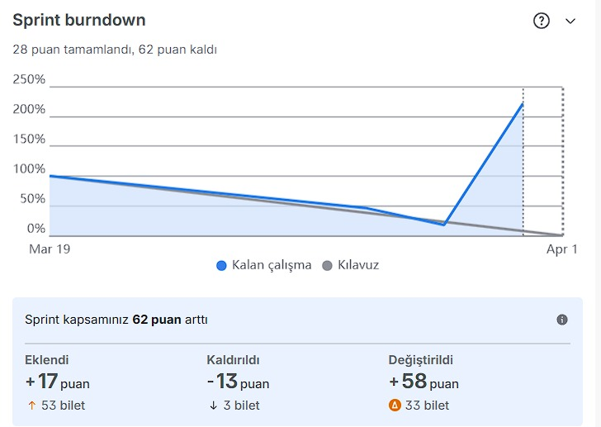
Sprint 3 Burndown Chart — Jira Board (March 19–30, 2026)
Metric | Value
Sprint Duration | March 19 – March 30, 2026
Total Issues | 90 (56 Stories, 29 Tasks, 5 Bugs)
Points Completed | 28 SP
Points Remaining | 62 SP
Scope Change | +62 SP (53 tickets added, 3 removed, 33 modified)
Done | 49 issues
In Progress | 34 issues — QA test case verification
Idea / To Do | 4 + 3 issues (Sprint 4 backlog)
Dev Completion | All Step 4 & Step 5 features delivered
Note: The burndown chart shows a scope increase mid-sprint because 46 QA test case tickets (TC-S3-001 through TC-S3-046) were created and added to the sprint during the testing phase. This is expected scope growth — all development work for Step 4 and Step 5 was completed on schedule. The 34 "In Progress" items are QA verification tickets; all 46 test cases passed testing on the live HuggingFace deployment. 3 "To Do" items belong to Sprint 4 scope (Step 6 — Explainability).

4. Step 4 — Model Selection & Parameter Tuning
8 ML algorithms with interactive hyperparameter controls, clinical tooltips, auto-retrain with debounce, and KNN decision boundary visualization. Demonstrated on Cardiology (heart failure) domain.

4.1 Model Tab Bar (8 Algorithms)
8 model tabs: KNN, SVM, Decision Tree, Random Forest, Logistic Regression, Naive Bayes, XGBoost, LightGBM. Sprint spec required minimum 6; implementation exceeds requirement with 8 models.
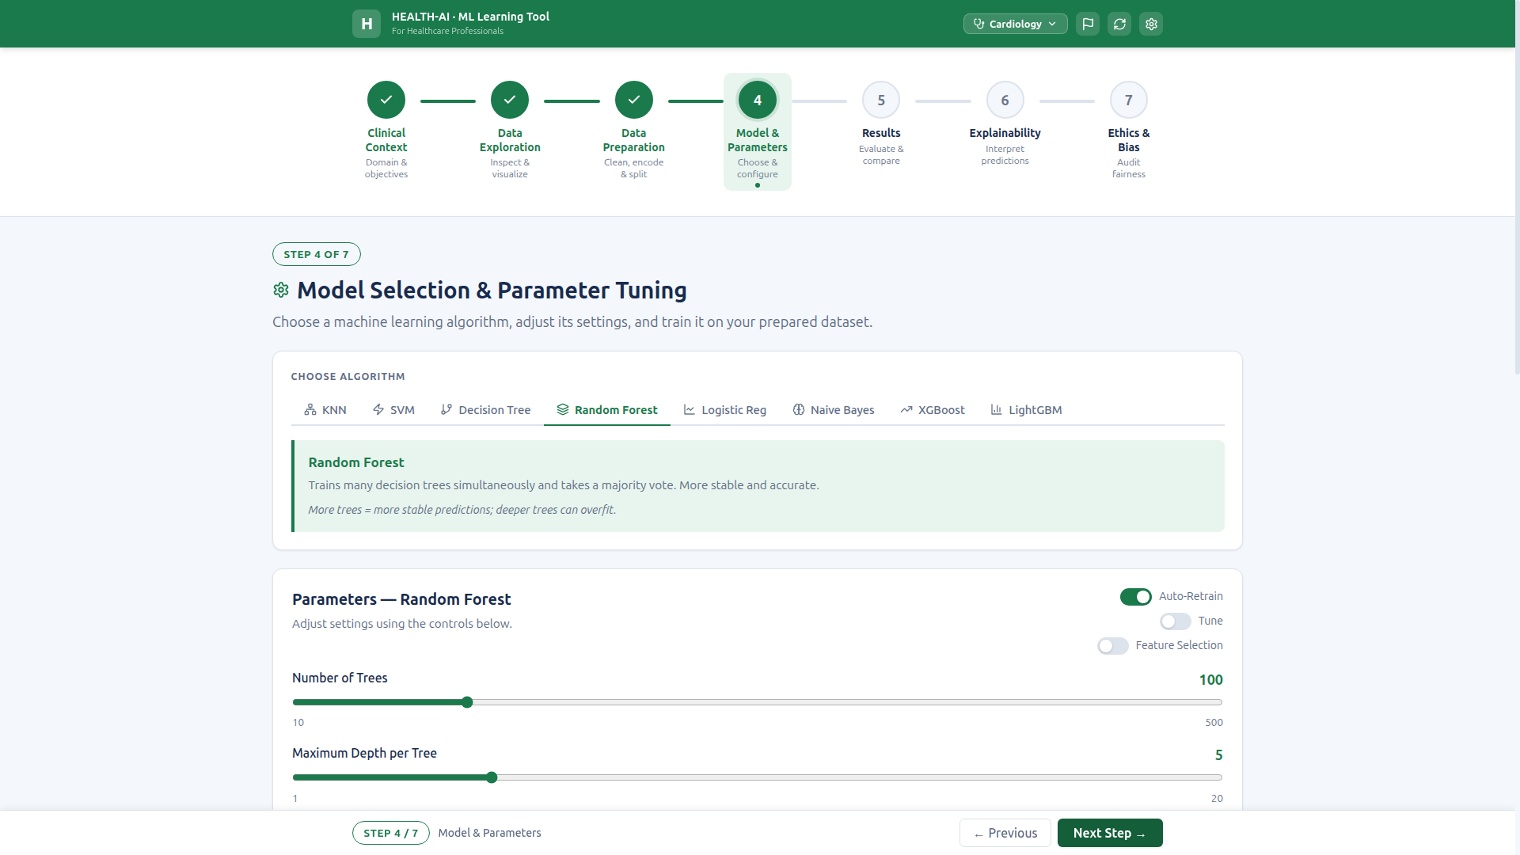
Step 4 opens with 8 model tabs, Random Forest selected by default.

4.2 Parameter Controls per Model
Each model displays its own relevant parameter controls. KNN: K slider (1–25) + distance metric. SVM: kernel + C slider. DT: max depth + criterion. RF: trees + depth. LR: C + max iterations. NB: pre-set variance smoothing informational text.
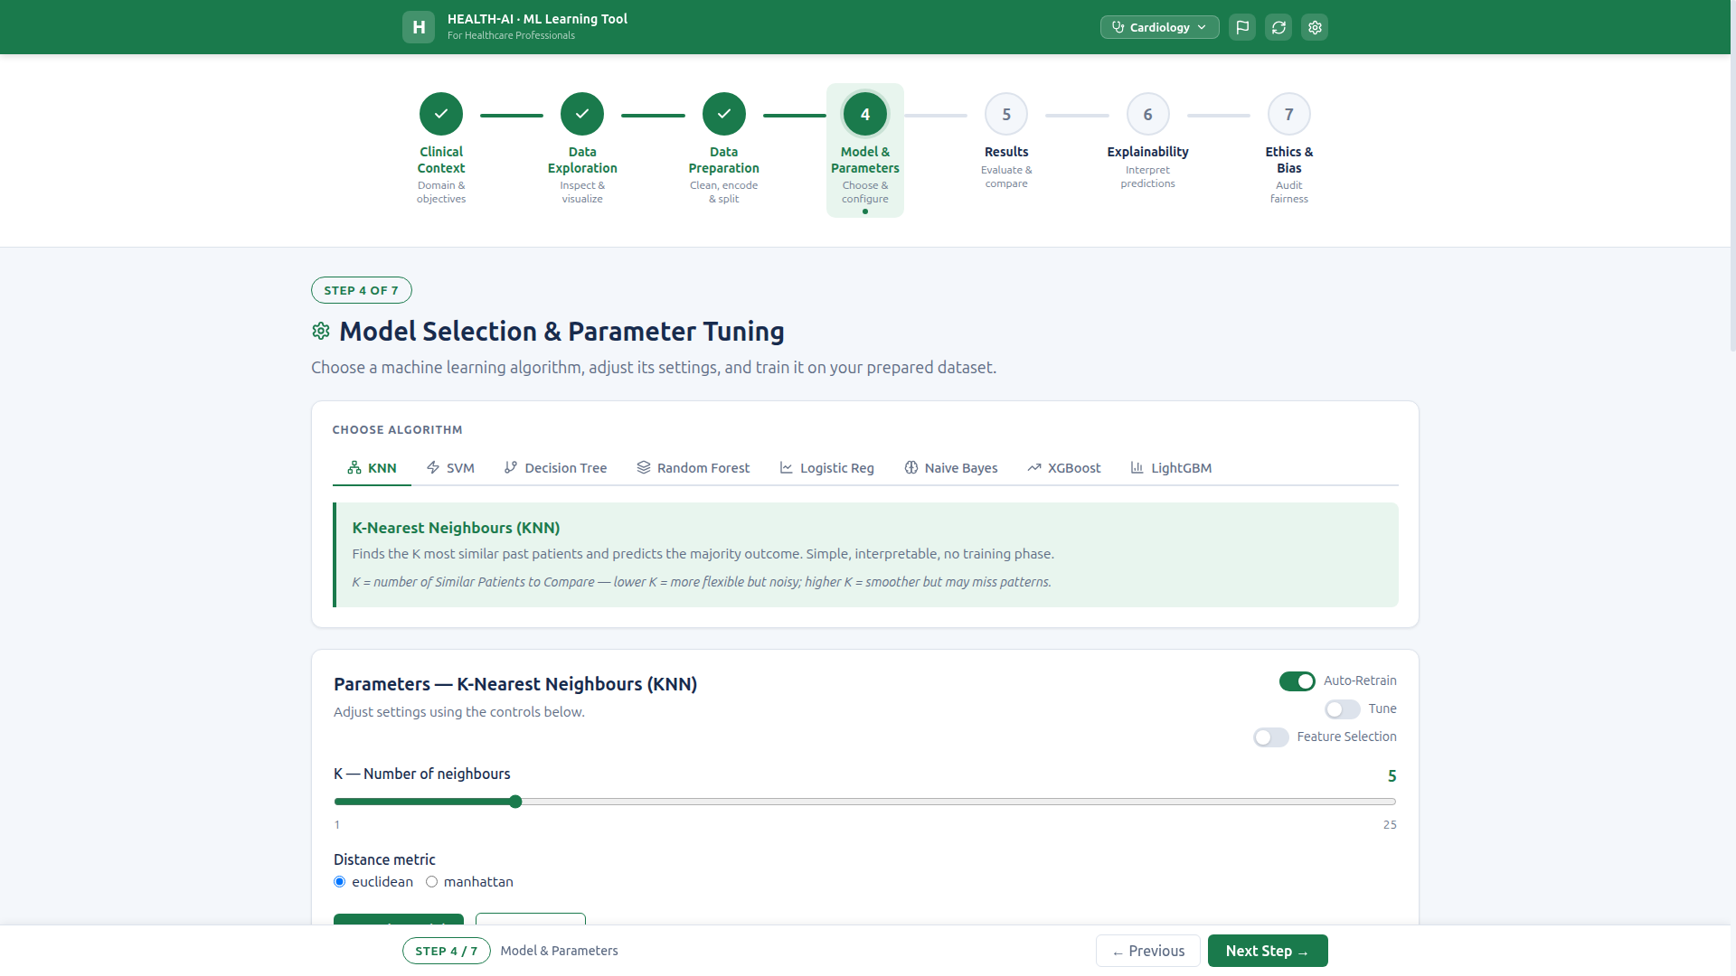
KNN selected — K slider and distance metric (euclidean/manhattan) controls.
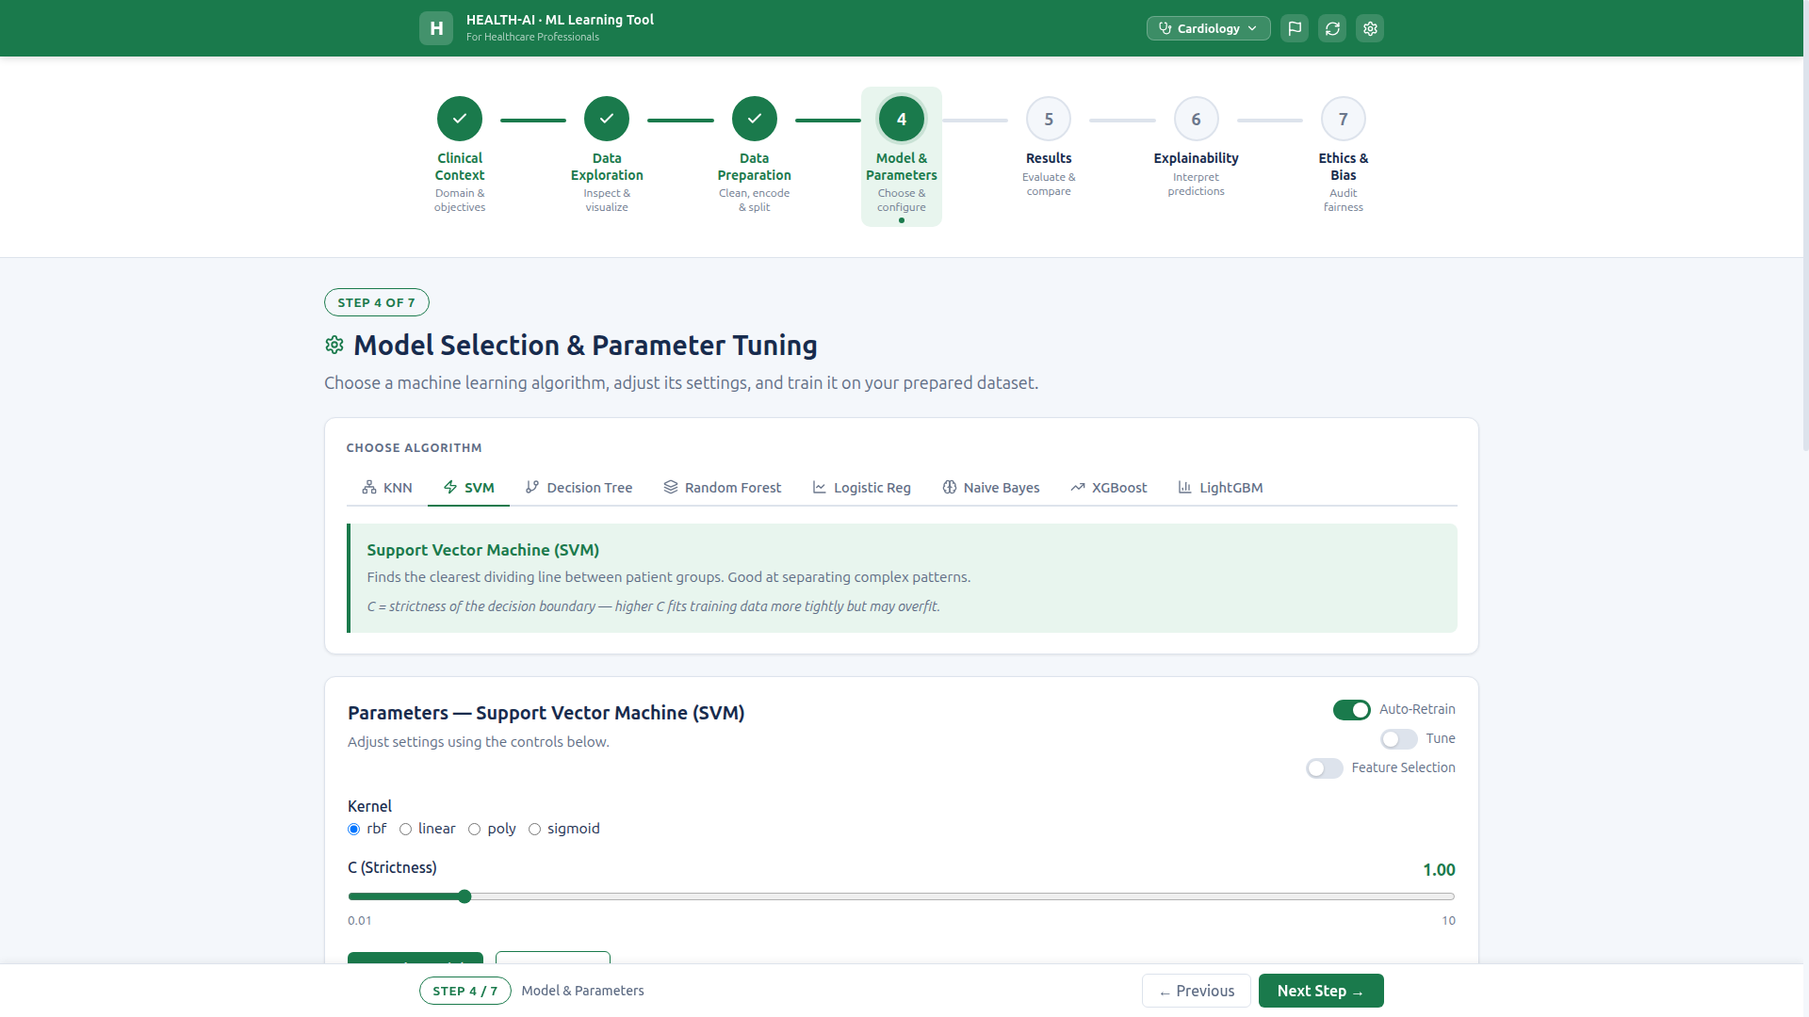
SVM — Kernel radio (rbf, linear, poly, sigmoid) and C strictness slider.
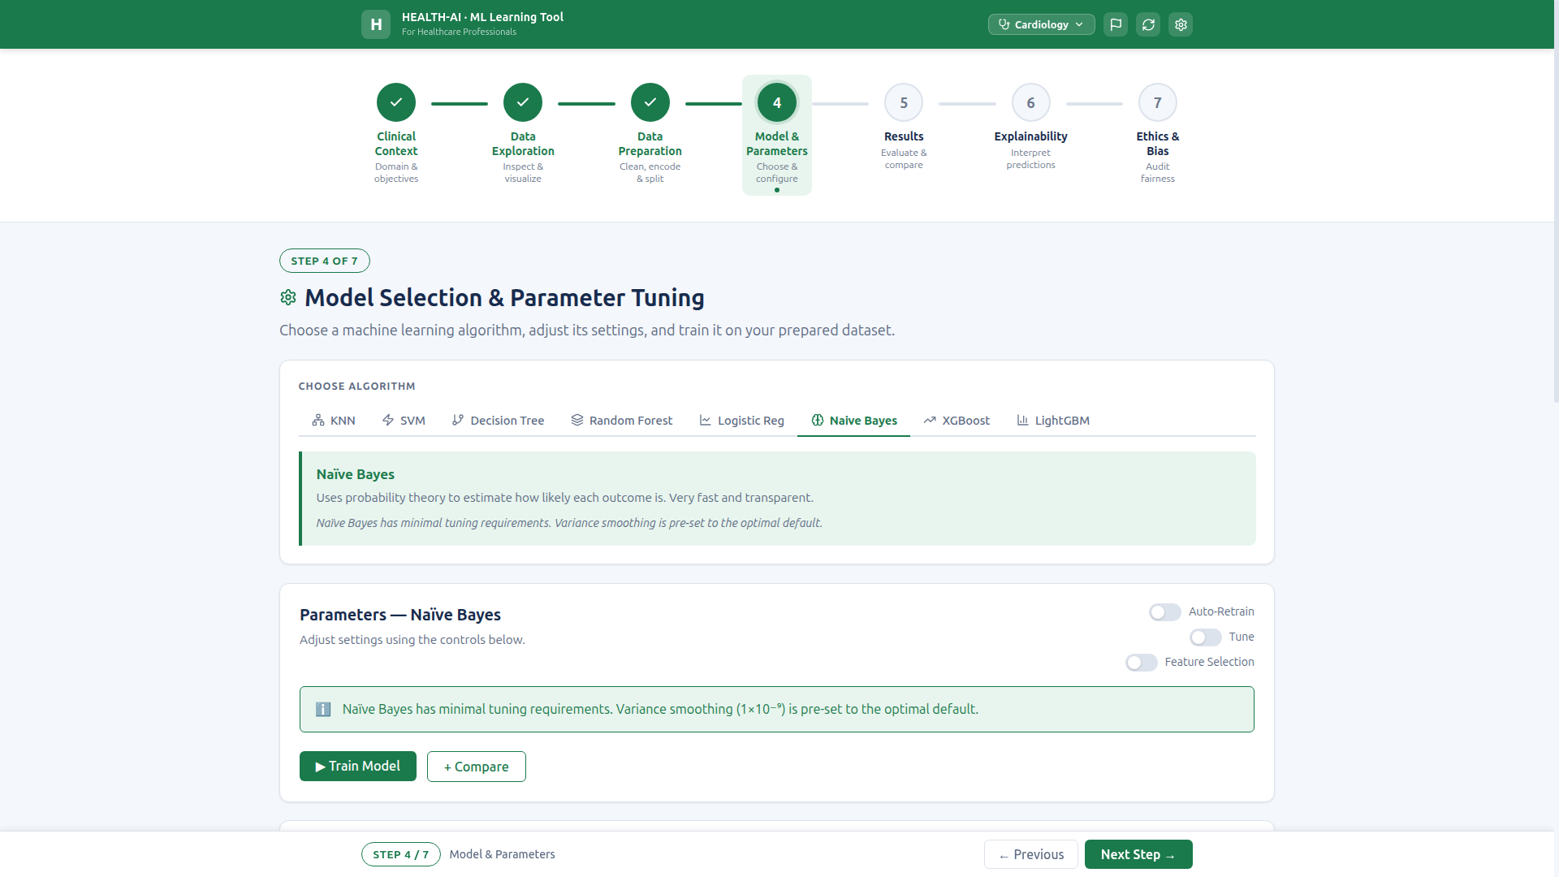
Naive Bayes — informational text, variance smoothing pre-set to optimal default.

4.3 Clinical Tooltips (PARAM_HINTS)
Every model displays plain-language clinical tooltips. Examples: "Finds the K most similar past patients", "like a clinical decision pathway". No raw ML jargon without explanation.
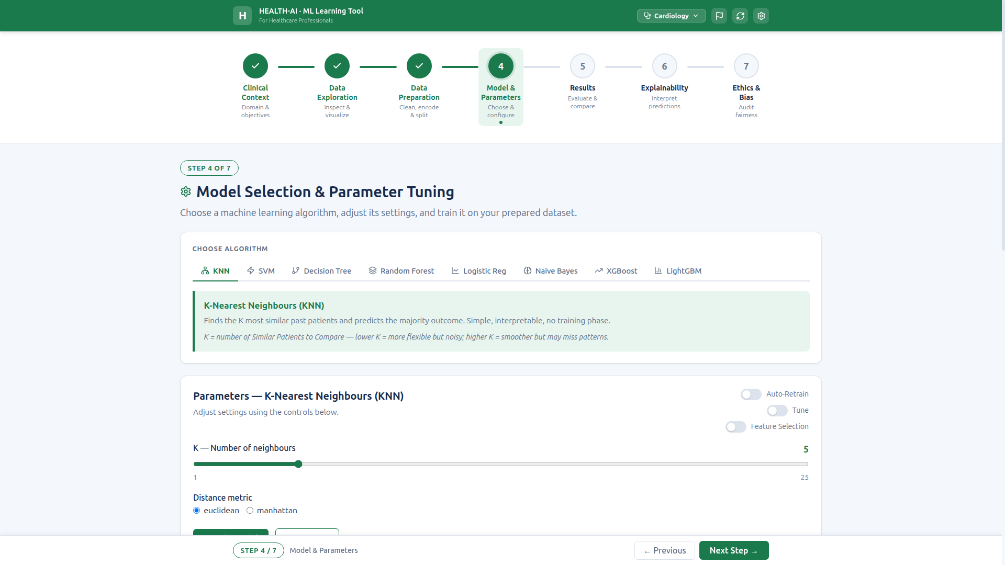
Inline PARAM_HINTS visible for KNN — clinical language for healthcare users.

4.4 Auto-Retrain & Debounce
Auto-Retrain toggle ON by default. Debounced at 300ms — slider changes trigger a single API call after user stops interacting. "Training..." loading state appears during retrain and disappears on completion. Manual training available when toggle is OFF.

Auto-Retrain checkbox checked by default, model parameters visible.
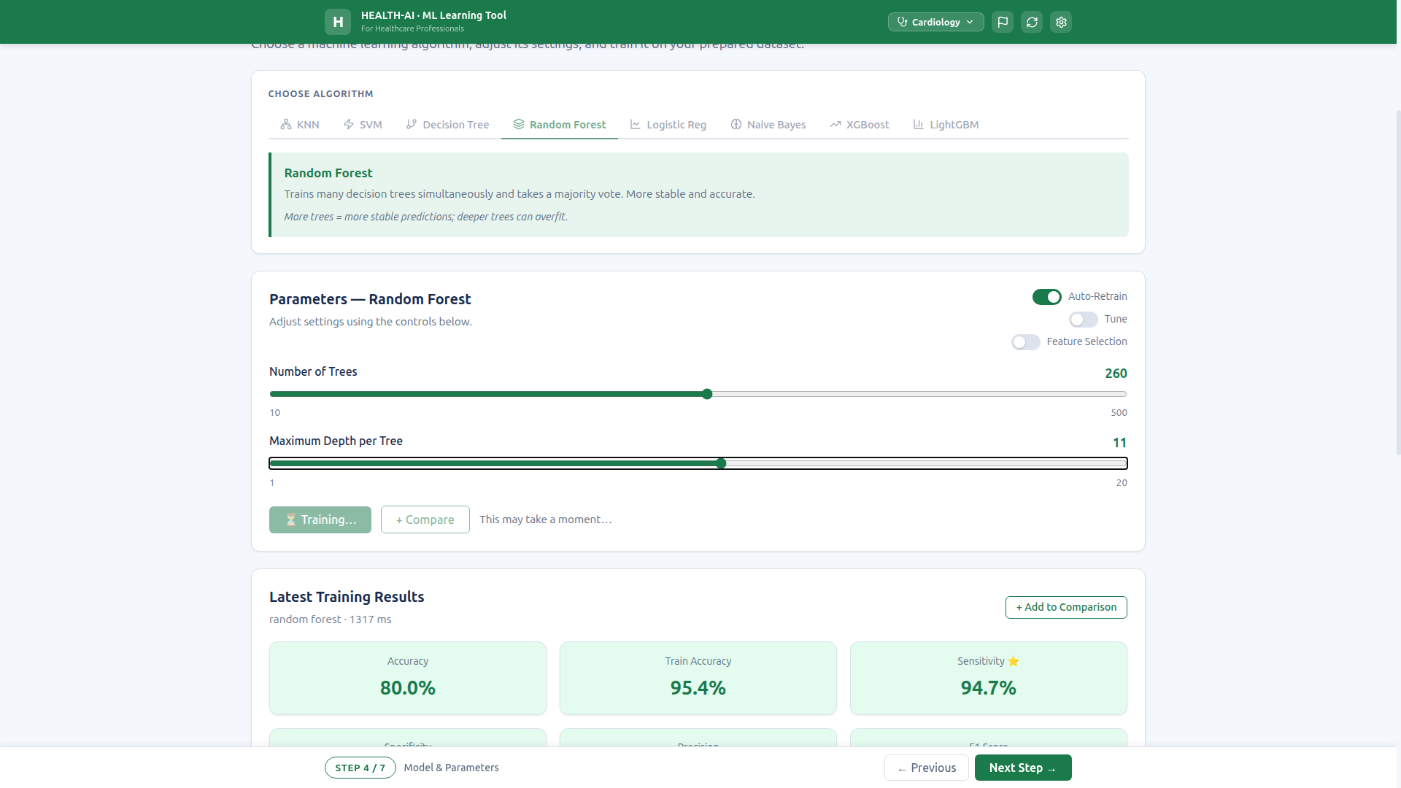
"Training..." loading state captured during auto-retrain — buttons disabled.

4.5 KNN Decision Boundaries Visualization
Canvas-based 2D scatter plot with PCA-projected decision boundary mesh. Redraws on K change with smooth performance (≤16ms target). Color-coded regions show model decision regions.
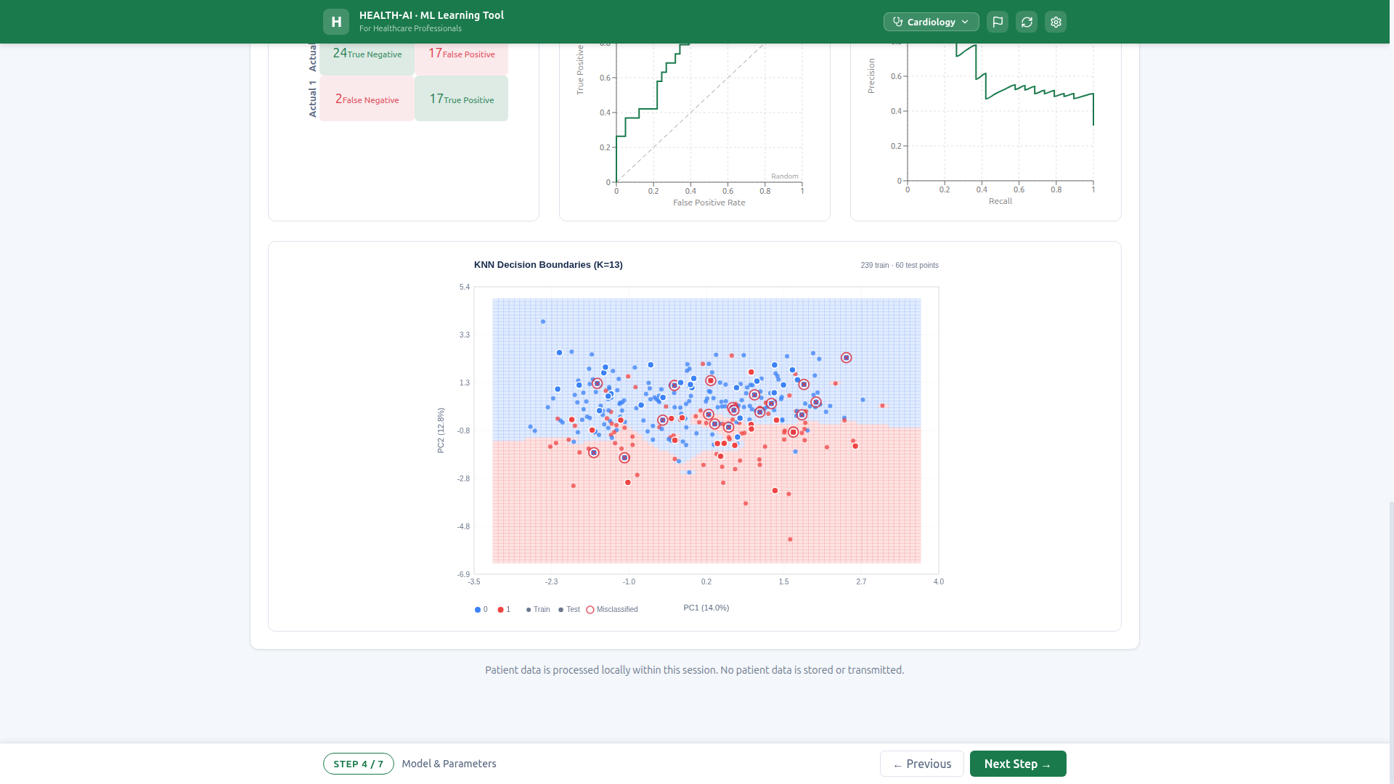
KNN Decision Boundaries (K=13) — PCA scatter with color-coded decision regions.

4.6 All Models Training Successfully
All 8 models train without crash or error. Training latency under 3 seconds for all models. KNN: 75.0%, SVM: 78.3%, DT: 78.3%, RF: 83.3%, LR: 83.3%, NB: 75.0%, XGBoost: 83.3%, LightGBM: 83.3%.
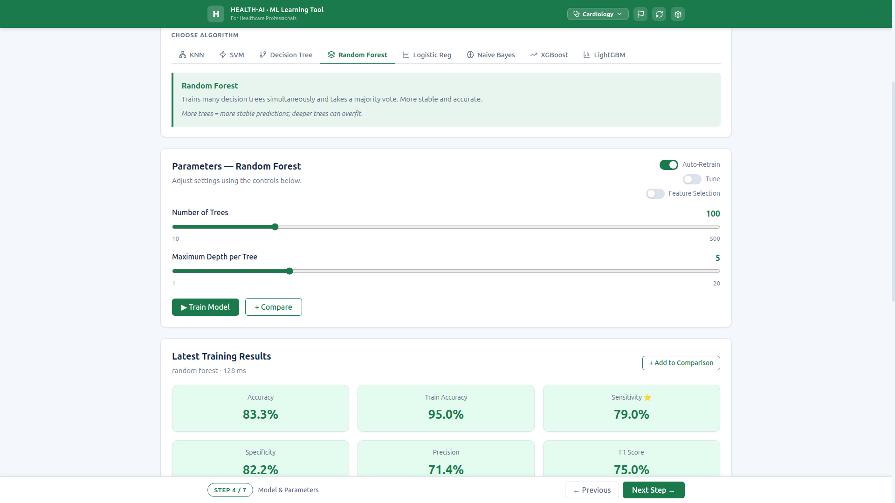
Random Forest trained — 83.3% accuracy, 95.0% train accuracy, 79.0% sensitivity.
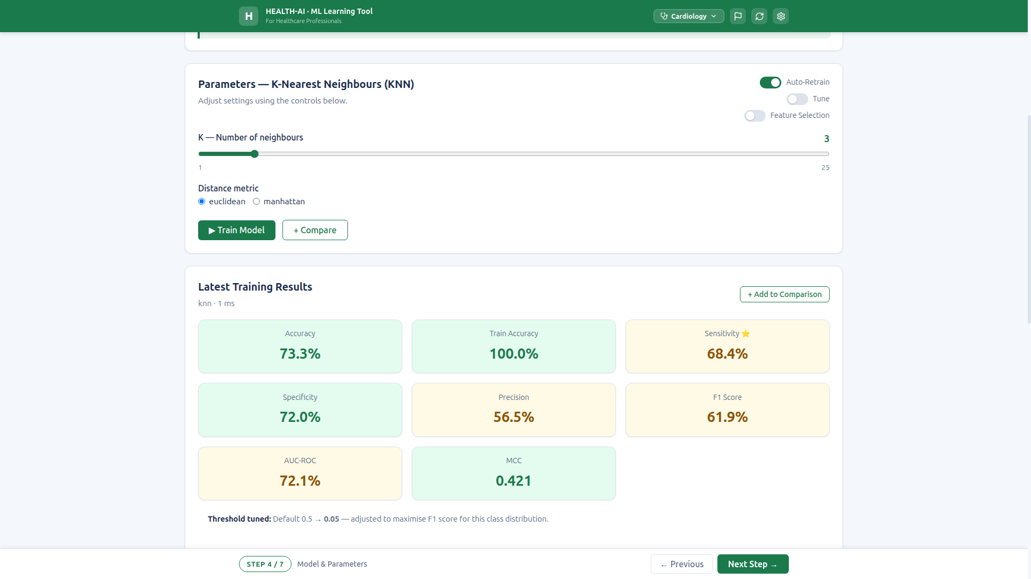
KNN trained — 75.0% accuracy, 89.5% sensitivity.

4.7 Model Comparison Table
"+ Compare" button adds models to a sortable comparison table. Columns: Model, Accuracy, Sensitivity, Specificity, Precision, F1, MCC, AUC-ROC, Time. Duplicate prevention, sensitivity color-coding, "Best" badge on top model.
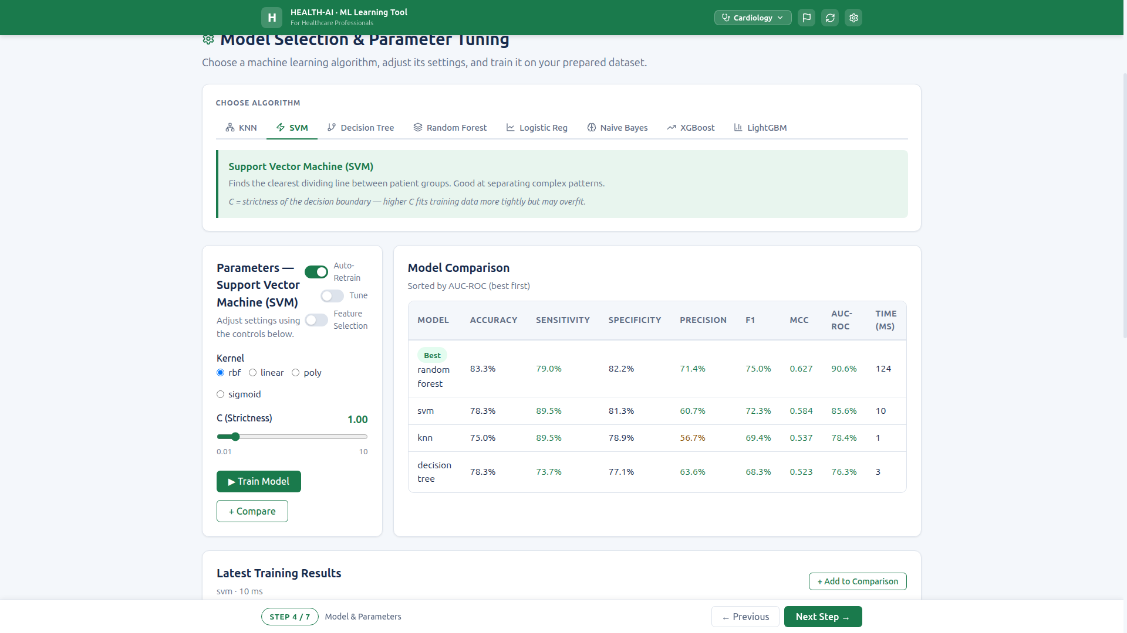
Comparison table with 4 models — sorted by AUC-ROC, "Best" badge on top.

5. Step 5 — Results & Performance Metrics
Comprehensive model evaluation with 6 color-coded metric cards, 2×2 confusion matrix, FN/FP clinical banners, ROC curve with AUC, Precision-Recall curve, overfitting detection, and model strengths/improvements.

5.1 Six Performance Metric Cards
6 metrics displayed as color-coded cards: Accuracy, Sensitivity, Specificity, Precision, F1 Score, AUC-ROC. Green/amber/red thresholds per spec. Each card includes clinical interpretation sentence. Example: Sensitivity — "Of patients who WERE positive, how many did the AI catch? Most important for screening."
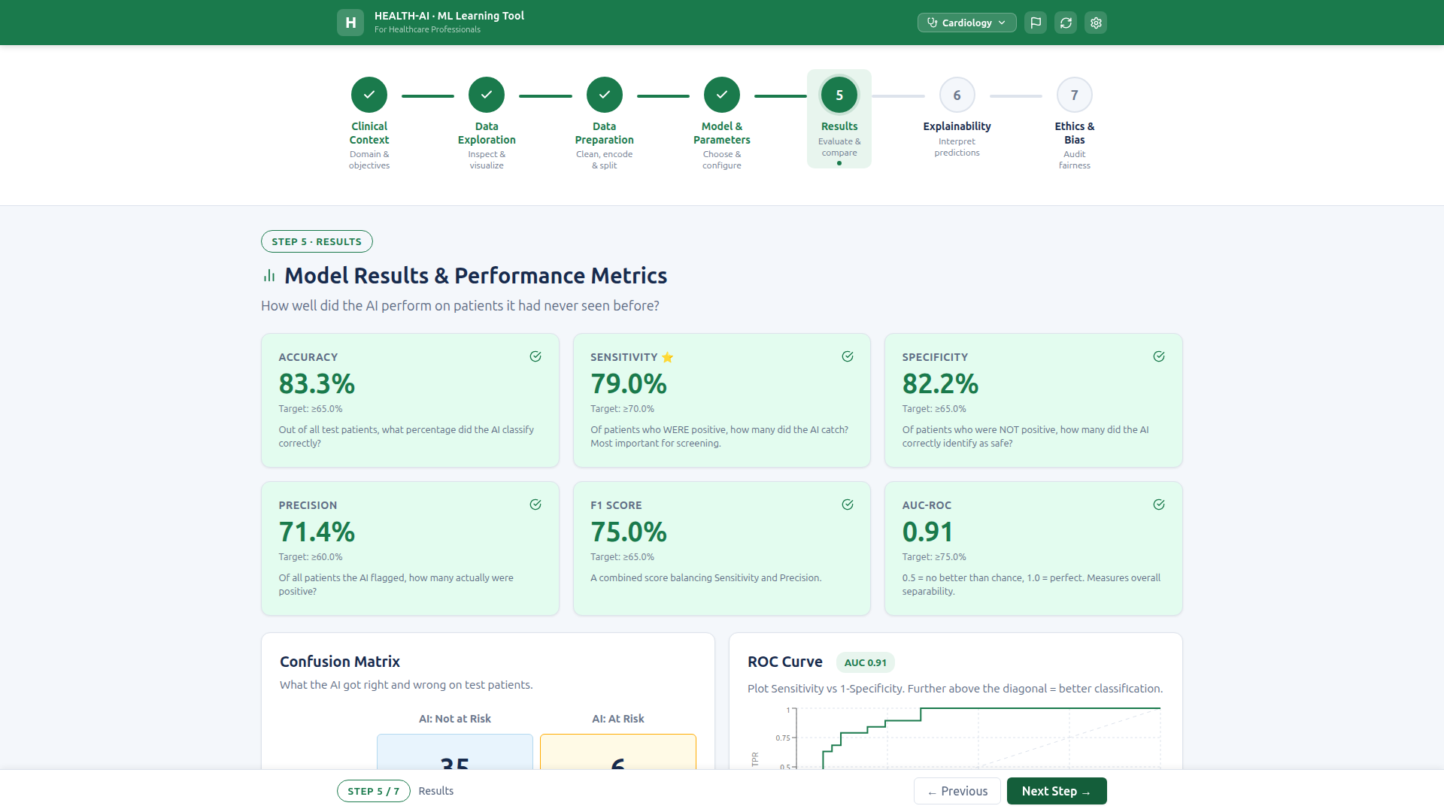
6 metric cards (RF) — Accuracy 83.3%, Sensitivity 79.0%, Specificity 82.2%, Precision 71.4%, F1 75.0%, AUC-ROC 0.91. All green.

5.2 Confusion Matrix (2×2)
2×2 grid with TN/FP/FN/TP. Plain-language labels: "Correctly called safe" (TN), "Unnecessary alarm" (FP), "MISSED — most dangerous" (FN), "Correctly flagged" (TP). Color-coded: TP/TN safe colors, FP amber warning, FN red danger.
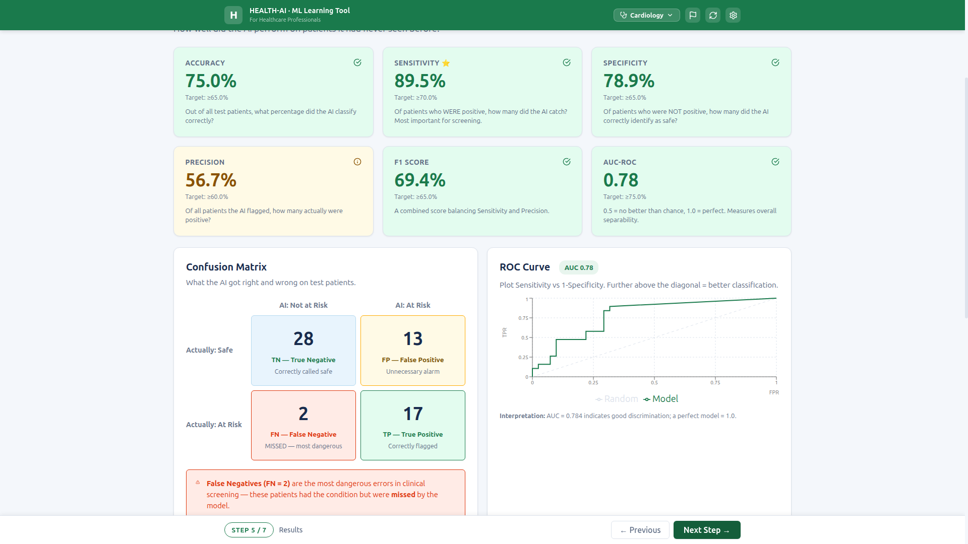
Confusion matrix (KNN) — TN=28, FP=13, FN=2, TP=17 with color coding and labels.

5.3 Clinical Alert Banners (FN/FP)
Red danger banner for False Negatives: "FN are the most dangerous errors in clinical screening — these patients had the condition but were missed." Green info banner for False Positives: "FP represent unnecessary alarms — less dangerous than FN, but they increase clinical workload." Low Sensitivity warning when sensitivity < 50%.
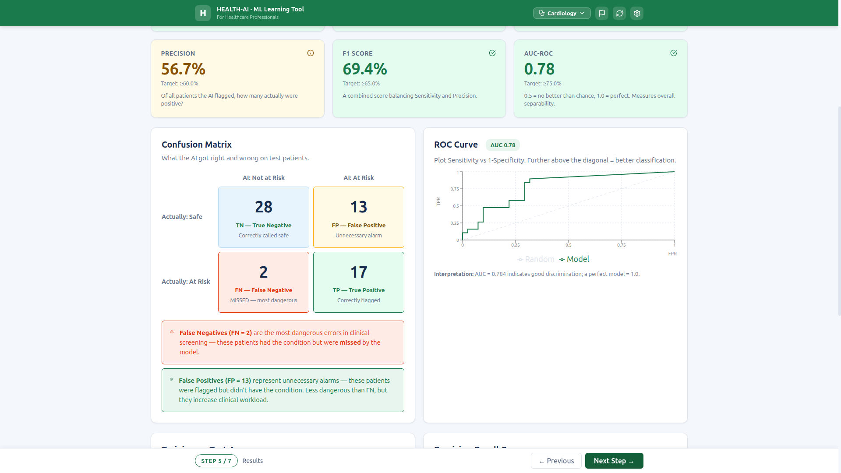
FN danger banner (red) and FP info banner (green) — clinical risk explanation.

5.4 ROC Curve & AUC
Inline SVG ROC curve (Recharts). Includes diagonal reference line ("Random"), AUC badge (e.g., 0.78), and plain-language interpretation: "AUC = 0.784 indicates good discrimination; a perfect model = 1.0."
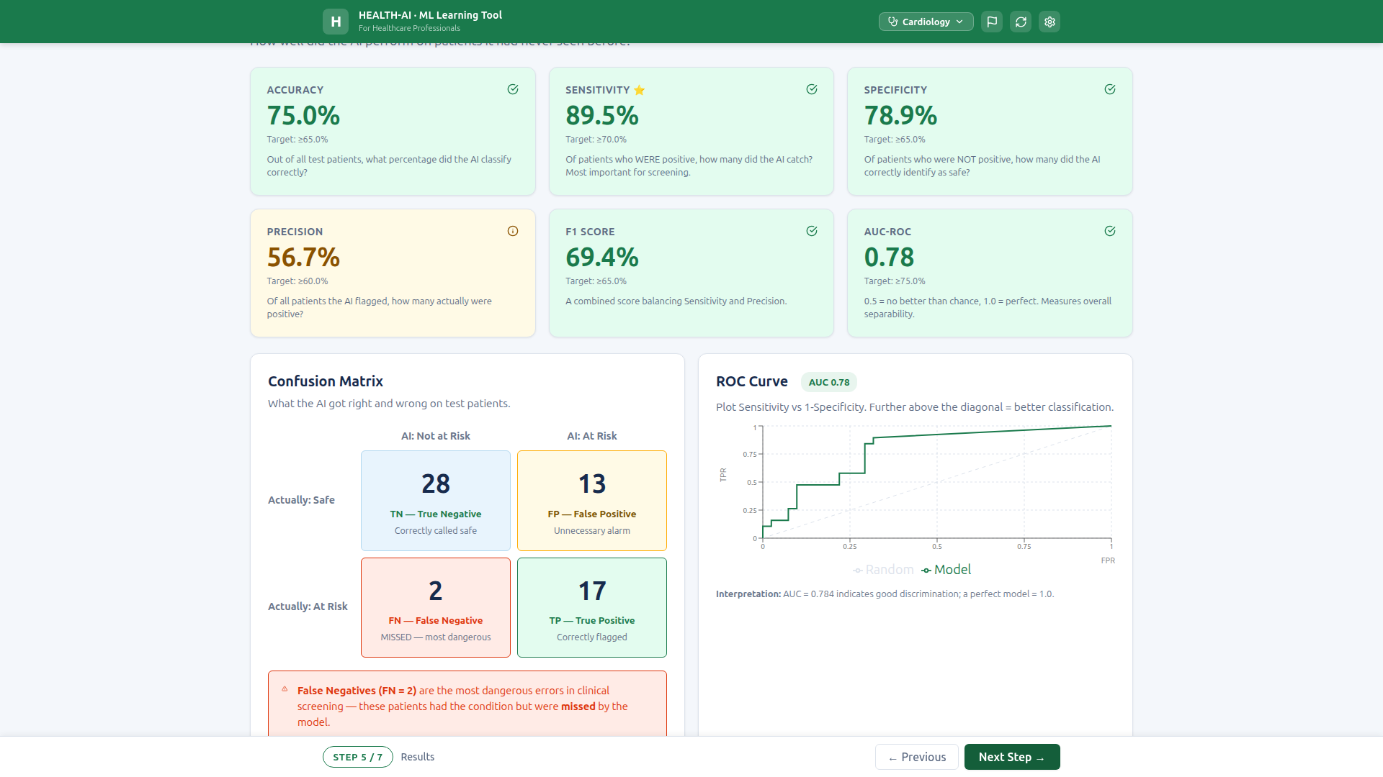
ROC curve with AUC 0.78 badge, diagonal reference line, and interpretation text.

5.5 Full Results Page
Complete Step 5 view: metrics, confusion matrix, ROC/PR curves, Training vs. Test accuracy comparison, overfitting warning, model strengths/improvements, and "Continue to Explainability" CTA button.
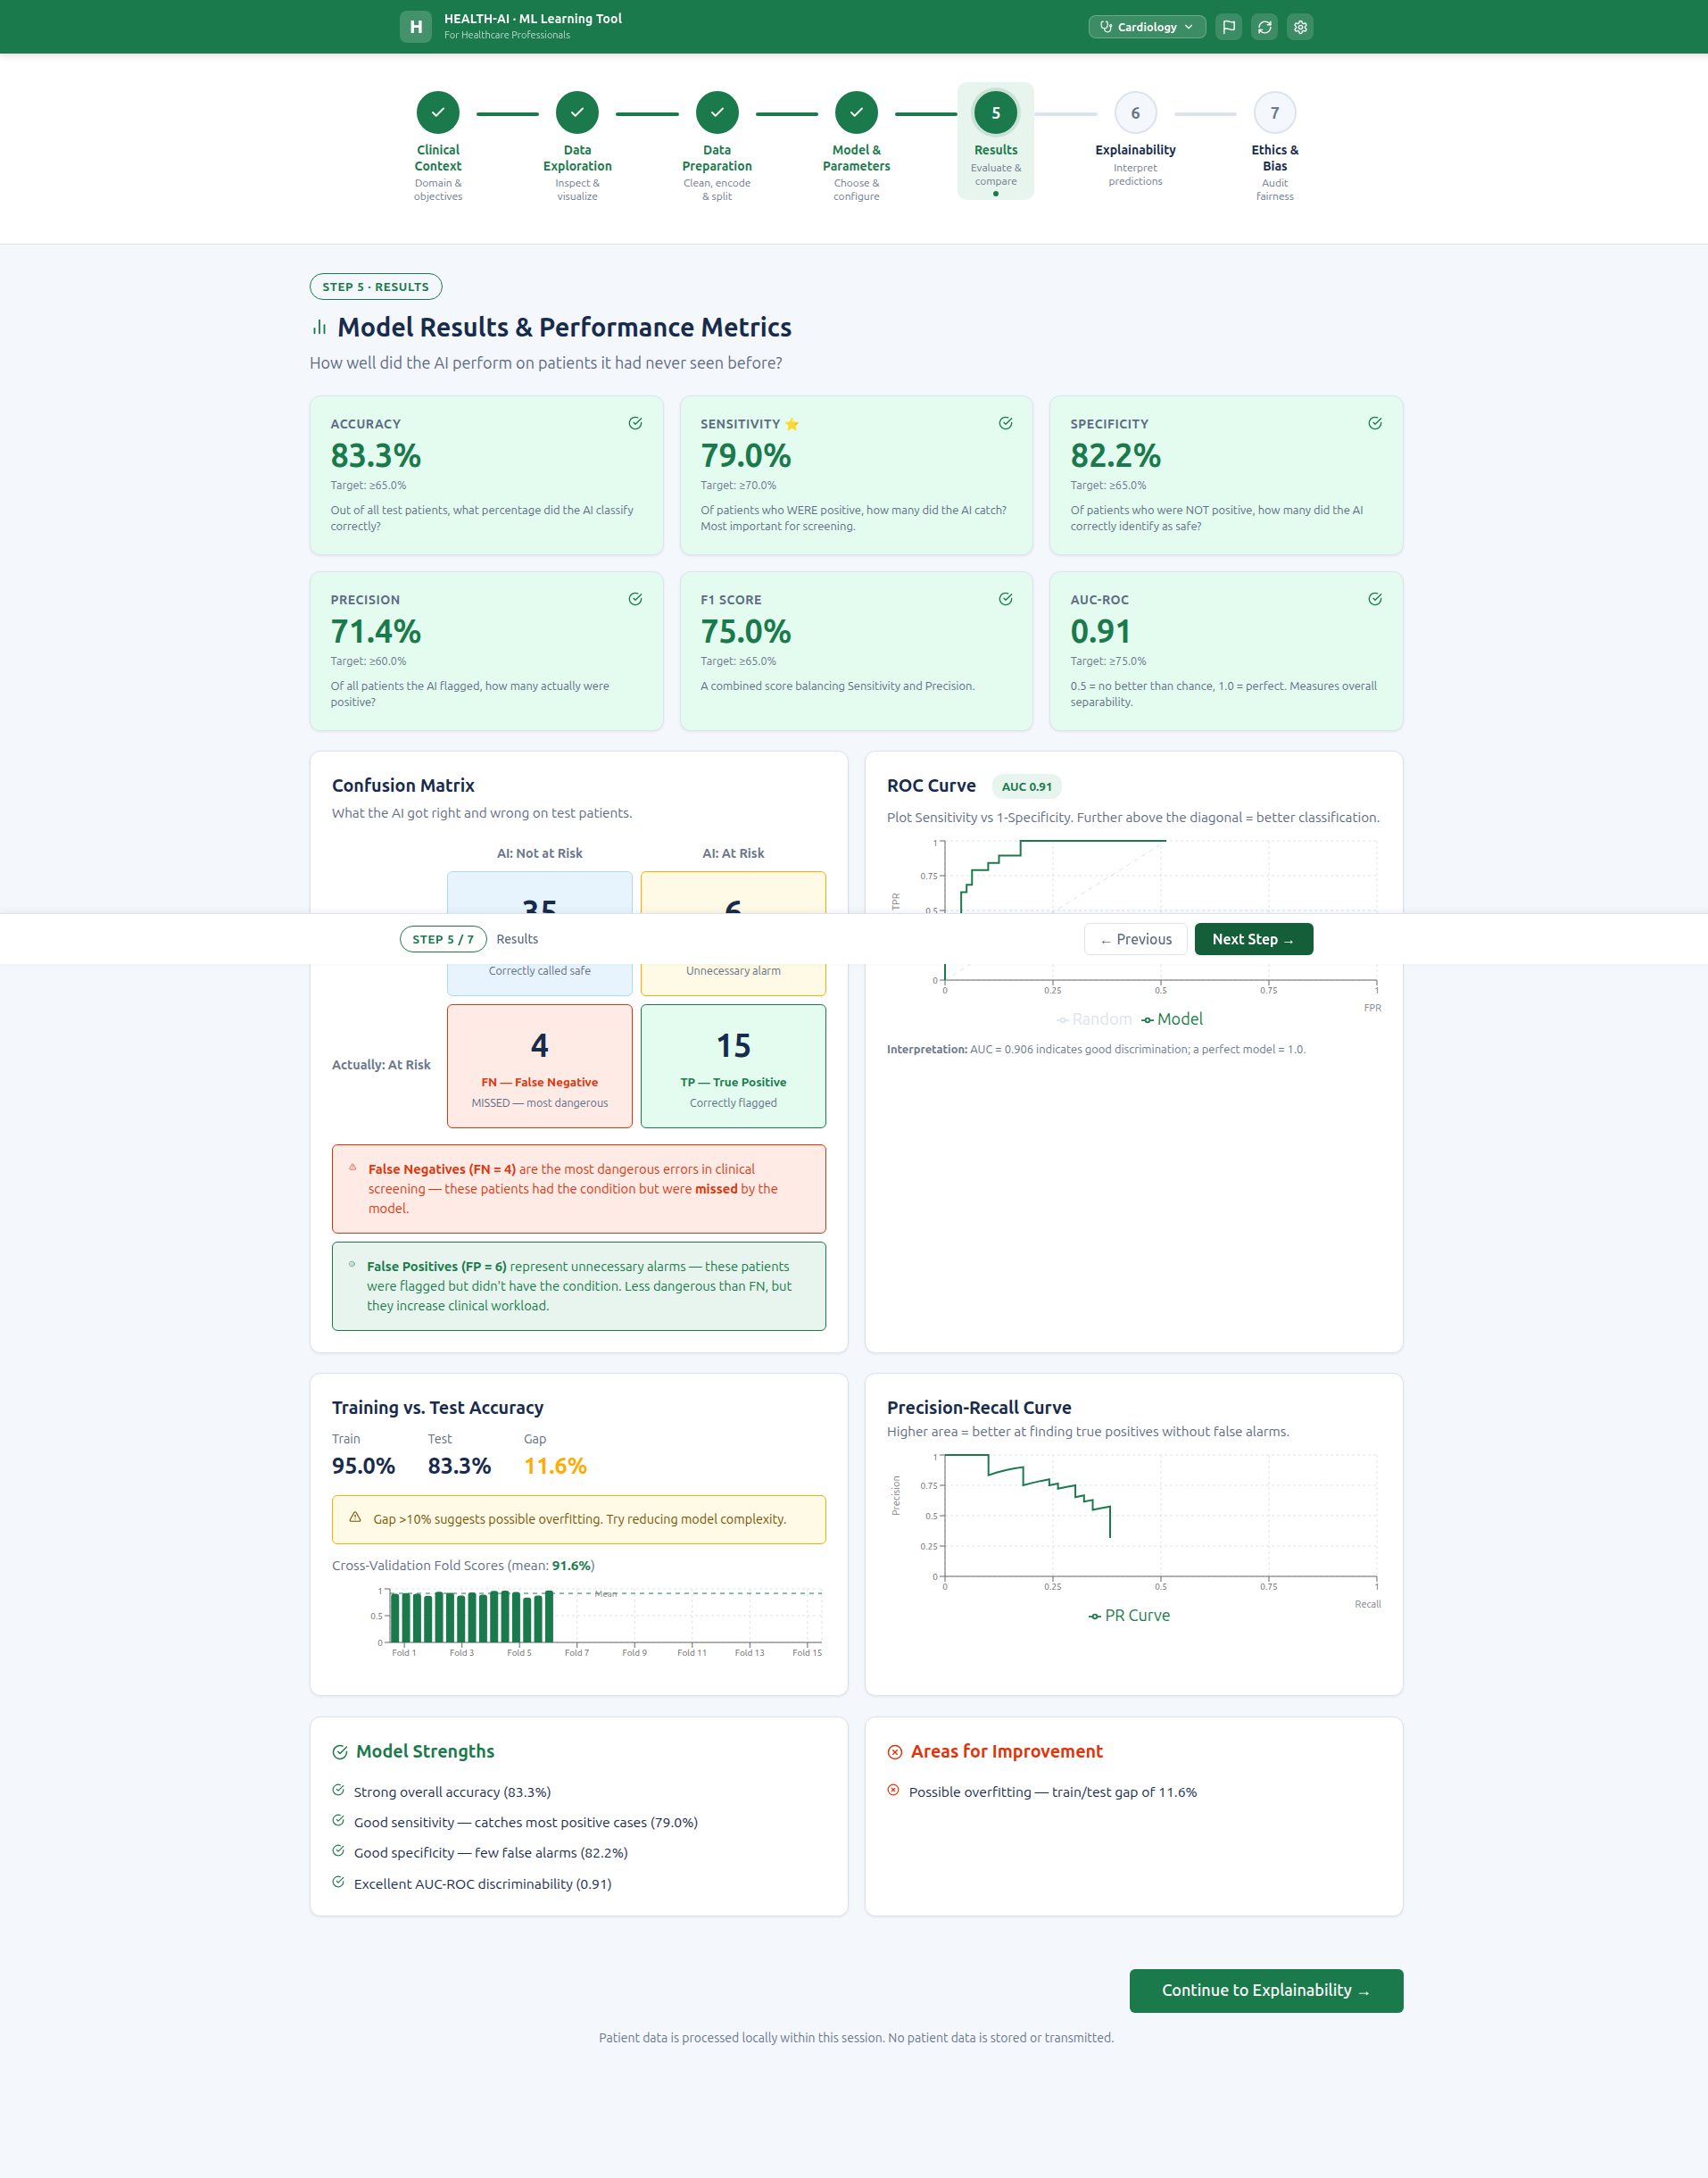
Full Step 5 page — all evaluation components visible end-to-end.

5.6 Multi-Domain Demonstration
Domain switching updates all Step 4–5 content correctly. Tested: Cardiology (KNN 75.0%), Endocrinology-Diabetes (RF 75.3%), Neurology-Parkinson’s (RF 92.3%). No stale data after domain switch.
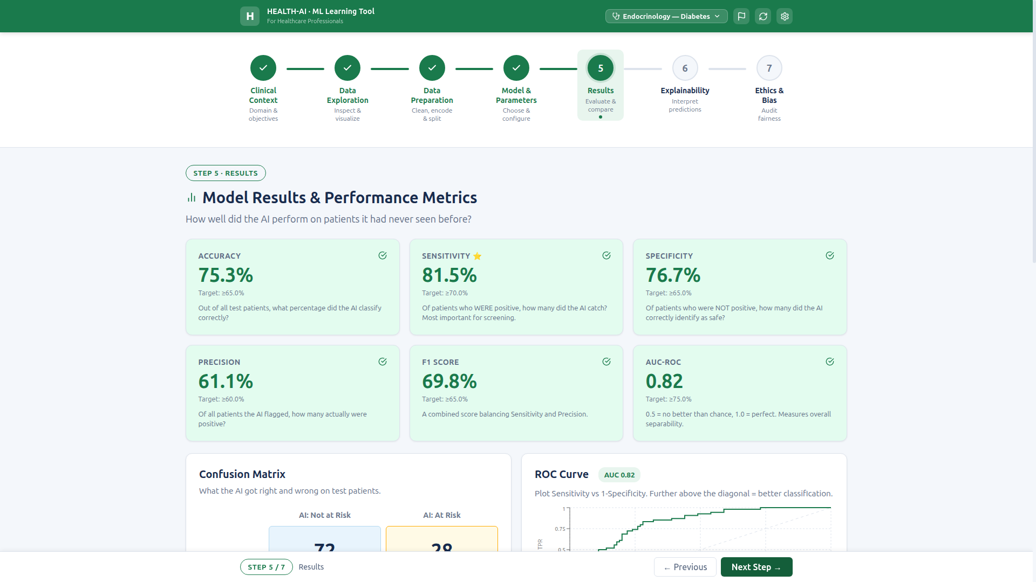
Endocrinology-Diabetes — RF 75.3% accuracy, Sensitivity 81.5%, AUC 0.82.
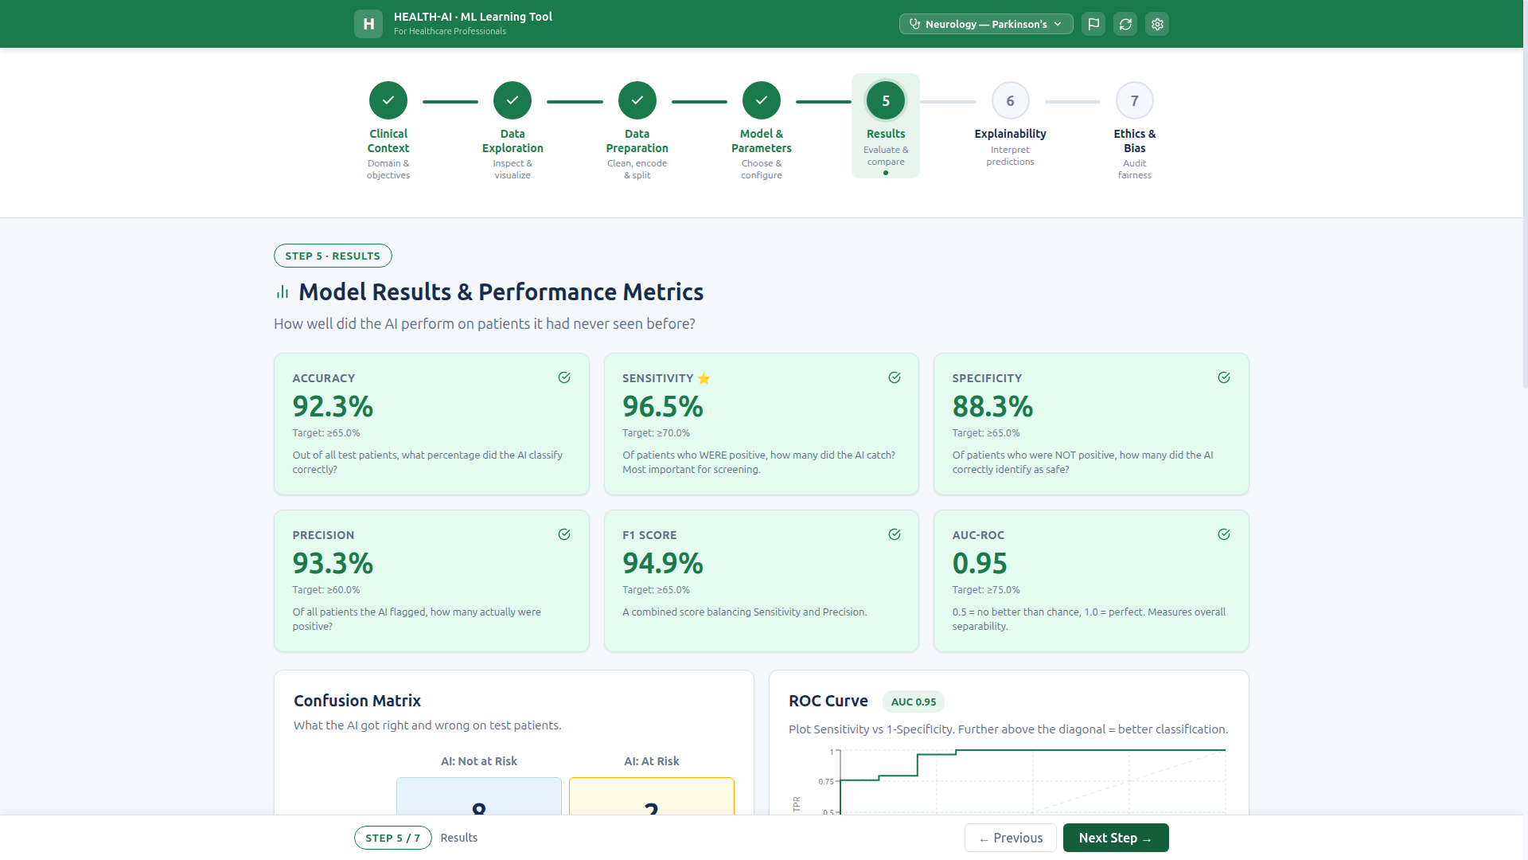
Neurology-Parkinson’s — RF 92.3% accuracy, Sensitivity 96.5%, AUC 0.95.

