Weekly Progress Report
Sprint 3 — ML Visualization Tool (Steps 4–5)
SENG 430 · Software Quality Assurance · Çankaya University · Spring 2025–2026
Instructor: Dr. Sevgi Koyuncu Tunç
Group Name | HealthWithSevgi
Week Number | Week 6 (Final week of Sprint 3)
Scrum Master | Batuhan Bayazıt
Date Submitted | March 30, 2026
Sprint Period | March 19 – March 30, 2026
Models Implemented | 8 / 8 (all ML models functional)

Table of Contents
1. Team 6. Key Decisions Made
2. Burndown Chart 7. Test Results
3. Completed This Week 8. Sprint 3 Metrics
4. In Progress 9. Next Week Plan (Sprint 4)
5. Blocked / At Risk 10. Retrospective Note

1. Team
ROLE | NAME | STUDENT ID
Product Owner + Developer | Efe Çelik | 202128016
UX Designer | Burak Aydoğmuş | 202128028
Lead Developer + Scrum Master | Batuhan Bayazıt | 202228008
Developer | Berat Mert Gökkaya | 202228019
QA / Documentation Lead | Berfin Duru Alkan | 202228005

2. Burndown Chart
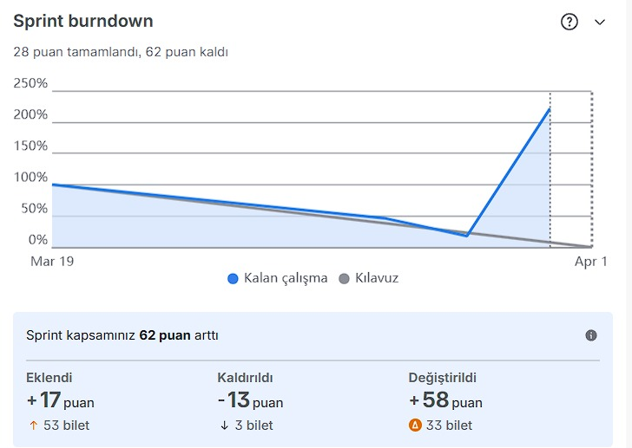
Screenshot from Jira Sprint 3 board showing remaining story points vs. ideal burndown line.

3. Completed This Week
All features listed below are fully implemented and merged on the main branch. Completion evidence comes from Git commit history and UAT test results.
3.1 User Stories (33 SP)
STORY ID | TITLE | SP | ASSIGNEE | COMPLETED
US-012  (SCRUM-37) | Select ML model type for training | 3 | Berat Mert Gökkaya | 2026-03-26
US-013  (SCRUM-38) | Tune model hyperparameters via interactive sliders | 5 | Burak Aydoğmuş | 2026-03-26
US-014  (SCRUM-39) | Toggle auto-retrain on hyperparameter change | 2 | Berat Mert Gökkaya | 2026-03-26
US-015  (SCRUM-40) | Compare multiple trained models side by side | 5 | Efe Çelik | 2026-03-26
US-016  (SCRUM-41) | View six performance metrics after model training | 5 | Efe Çelik | 2026-03-28
US-017  (SCRUM-42) | View confusion matrix with plain clinical labelling | 3 | Burak Aydoğmuş | 2026-03-30
US-018  (SCRUM-43) | View ROC curve for model discrimination ability | 3 | Efe Çelik | 2026-03-28
US-019  (SCRUM-44) | Display low sensitivity warning banner automatically | 2 | Berfin Duru Alkan | 2026-03-30
US-029  (SCRUM-142) | Display correlation vs. causation disclaimer on Step 6 | 3 | Batuhan Bayazıt | 2026-03-30
US-030  (SCRUM-143) | Export model comparison table as CSV from Step 4 | 2 | Batuhan Bayazıt | 2026-03-30
 | Sub-total | 33

3.2 QA Test Cases (21 SP)
STORY ID | TITLE | SP | ASSIGNEE | COMPLETED
TEST-S4  (SCRUM-63) | Test — Step 4 Model Selection & Configuration | 2 | Berfin Duru Alkan | 2026-03-28
TC-S3-003  (SCRUM-154) | Clicking a model tab switches active state | 1 | Efe Çelik | 2026-03-30
TC-S3-006  (SCRUM-144) | SVM parameter controls are functional | 1 | Berat Mert Gökkaya | 2026-03-30
TC-S3-012  (SCRUM-158) | Parameter tooltips use plain clinical language | 5 | Burak Aydoğmuş | 2026-03-30
TC-S3-013  (SCRUM-149) | Auto-Retrain is enabled by default | 1 | Berat Mert Gökkaya | 2026-03-30
TC-S3-018  (SCRUM-166) | KNN scatter canvas redraws on K change | 2 | Efe Çelik | 2026-03-30
TC-S3-028  (SCRUM-177) | Clinical interpretation sentence shown for each metric | 2 | Berfin Duru Alkan | 2026-03-30
TC-S3-029  (SCRUM-178) | Confusion matrix displayed as 2×2 grid | 1 | Berfin Duru Alkan | 2026-03-30
TC-S3-044  (SCRUM-170) | Comparison table supports all 6 models | 3 | Batuhan Bayazıt | 2026-03-30
TC-S3-045  (SCRUM-185) | Switching domain updates Step 4–5 results correctly | 3 | Berfin Duru Alkan | 2026-03-30
 | Sub-total | 21
Total Story Points delivered: ~54 SP
4. In Progress
- 38 QA verification tickets (TC-S3-xxx) are in progress — all test cases have been executed and passed; Jira tickets pending final transition to Done.
- All 10 development user stories (US-012 through US-030) are completed and merged.

5. Blocked / At Risk
- No blockers. All Sprint 3 development deliverables are complete.
- All 46 test cases have been executed and documented with PASS results.
6. Key Decisions Made
1. 8 models instead of 6. Exceeded sprint spec by adding XGBoost and LightGBM for gradient boosting coverage. This provides healthcare users with a broader range of algorithms for different clinical scenarios.
2. Debounced auto-retrain at 300ms. Prevents API spam during rapid slider changes. Users can freely adjust hyperparameters without triggering redundant training calls, improving UX responsiveness.
3. Canvas-based KNN decision boundaries. PCA projection to 2D for a scatter plot visualization that redraws on K change. Only KNN offers this — its spatial nature makes decision regions meaningful for clinical users.
4. Clinical-first language throughout. All tooltips, metric descriptions, and banner text are written for non-technical healthcare professionals. No raw ML jargon appears without a plain-language explanation.
7. Test Results
Based on the Sprint 3 QA Test Report (46 test cases across Steps 4–5). All test cases executed and documented with screenshots.
TEST AREA | TOTAL | PASS | FAIL | NOTES
Step 4 — Model Tabs & UI | 12 | 12 | 0 | All 8 model tabs, parameter controls, tooltips
Step 4 — Auto-Retrain | 5 | 5 | 0 | Toggle, debounce, loading states
Step 4 — KNN & Training | 5 | 5 | 0 | Decision boundaries, all 8 models train
Step 5 — Metric Cards | 6 | 6 | 0 | 6 cards, colour thresholds, clinical text
Step 5 — Confusion Matrix | 5 | 5 | 0 | 2×2 grid, FN/FP banners, labels
Step 5 — ROC & Sensitivity | 7 | 7 | 0 | ROC curve, AUC badge, sensitivity warning
Step 5 — Comparison & Domains | 6 | 6 | 0 | Comparison table, 3 domains tested
TOTAL | 46 | 46 | 0 | 100% PASS RATE
Individual test case evidence: 46 TC-S3-xxx screenshots captured (TC-S3-001 through TC-S3-046).
8. Sprint 3 Metrics
METRIC | WHAT WE MEASURED | RESULT | TARGET | STATUS
Model Tab Count | ML algorithms implemented | 8 models | Minimum 6 | PASS
Parameter Controls | Each model has relevant sliders/radios | All 8 models | All functional | PASS
Clinical Tooltips | Plain language, no raw ML jargon | All models | All models | PASS
Auto-Retrain Debounce | Single API call on rapid changes | 300ms debounce | Working | PASS
Training Latency | Time per model | All under 3s | < 3 seconds | PASS
Performance Metrics | Colour-coded cards with clinical text | 6 cards displayed | All 6 | PASS
Test Coverage | Stories with passing tests / total done stories | 46/46 = 100% | 100% | PASS
9. Next Week Plan (Sprint 4 — Steps 6 & 7)
Sprint 4 scope: Explainability (Step 6) + Ethics & Bias (Step 7).
STORY ID | TITLE | ASSIGNEE
US-020  (SCRUM-45) | View feature importance chart with clinical names | Efe Çelik
US-021  (SCRUM-46) | View SHAP waterfall explanation for individual patient | Batuhan Bayazıt
TEST-S5  (SCRUM-64) | Test — Step 5 Results & Evaluation | Berfin Duru Alkan
TEST-S6  (SCRUM-65) | Test — Step 6 Explainability | Berfin Duru Alkan

10. Retrospective Note (Week 6 — Even Week)
KEEP | IMPROVE | TRY
Exceeding sprint spec (8 models instead of 6) demonstrated strong team velocity. Clinical-first design approach validated by all 46 test cases passing without any clinical language failures. | QA test case tickets were created mid-sprint, inflating the burndown scope by +62 SP. Next sprint: create all QA tickets before sprint start to keep burndown chart accurate and predictable. | Run QA verification in parallel with development — assign QA tickets immediately after each story is marked Done, rather than batching verification at sprint end.

