HEALTH-AI ML Learning Tool

Sprint 4 – QA Final Test Report

Test Environment
Application: HEALTH-AI ML Learning Tool
Test Type: Manual UI Testing (Planned Test Cases)
Environment: HuggingFace Spaces (Production) / GitHub / GitHub Wiki / Jira
URL: https://0xbatuhan4-healthwithsevgi.hf.space/
Browser: Google Chrome
Operating System: Windows / Linux
Tester: Berfin Duru Alkan
Course: Software Quality Assurance
Date: 10.04.2026

Test Execution Summary
Status | Count
PASSED | 84
TOTAL | 84

Sprint 4 — Scope
Step 6 — Explainability (TC-S4-001 to TC-S4-030)
Step 7 — Ethics & Bias (TC-S4-031 to TC-S4-054)
Certificate / End-to-End / Deliverable Verification (TC-S4-055 to TC-S4-084)

STEP 6 — Explainability

TC-S4-001 — Step 6 page opens after Step 5 completion
Priority: Critical
Precondition: User completed Step 5 with at least one trained model available
Steps:
Complete Step 5 successfully
Click Step 6 from the stepper or Next button
Observe the page heading and explainability content

Expected Result: Step 6 opens successfully and both the feature importance area and patient-level explanation area are visible.
Current Status: Passed
Notes / Evidence: Screenshot attached below.
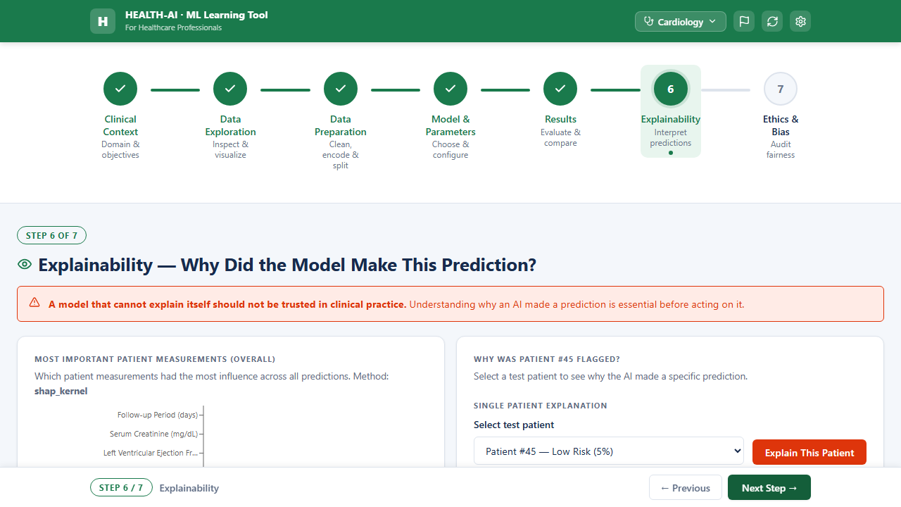

TC-S4-002 — Step 6 is blocked before Step 5 completion
Priority: Critical
Precondition: User has not completed Step 5
Steps:
Attempt to open Step 6 directly from the stepper
Observe the navigation result

Expected Result: Step 6 remains inaccessible before Step 5 is completed, or the user is shown a clear blocking message.
Current Status: Passed
Notes / Evidence: Screenshot attached below.


TC-S4-003 — Feature importance chart is displayed
Priority: Critical
Precondition: User on Step 6 with a trained model
Steps:
Open Step 6
Observe the overall feature importance section

Expected Result: A feature importance chart is visible and rendered without layout break, clipping, or missing bars.
Current Status: Passed
Notes / Evidence: Screenshot attached below.


TC-S4-004 — Feature importance bars are horizontal
Priority: High
Precondition: Feature importance chart visible
Steps:
Inspect the chart orientation

Expected Result: Feature importance values are shown as horizontal bars.
Current Status: Passed
Notes / Evidence: Screenshot attached below.


TC-S4-005 — Feature importance bars are sorted in descending order
Priority: Critical
Precondition: Feature importance chart visible
Steps:
Read the displayed importance values from top to bottom
Compare adjacent values

Expected Result: Bars are sorted from highest importance to lowest importance.
Current Status: Passed
Notes / Evidence: Screenshot attached below.


TC-S4-006 — Feature importance labels use clinical display names
Priority: Critical
Precondition: Feature importance chart visible
Steps:
Inspect the feature labels shown on the chart
Compare them with the raw dataset column naming style

Expected Result: Clinical display names are shown instead of raw database or CSV column names.
Current Status: Passed
Notes / Evidence: Screenshot attached below.


TC-S4-007 — Feature importance values stay within 0.00-1.00 range
Priority: Critical
Precondition: Feature importance chart visible
Steps:
Inspect the displayed numeric importance values
Check the minimum and maximum shown values

Expected Result: All displayed feature importance values remain between 0.00 and 1.00 inclusive.
Current Status: Passed
Notes / Evidence: Screenshot attached below.


TC-S4-008 — Feature importance chart updates when model or domain context changes
Priority: High
Precondition: At least one alternate trained context exists
Steps:
Open Step 6
Change the selected domain or selected trained model
Observe the feature importance section

Expected Result: The feature importance chart refreshes to reflect the current active domain or model context.
Current Status: Passed
Notes / Evidence: Screenshot attached below.


TC-S4-009 — Feature importance chart handles zero or very small importance values correctly
Priority: High
Precondition: Model output contains at least one zero or near-zero importance value
Steps:
Open Step 6
Inspect the smallest bars and values

Expected Result: Very small or zero importance values render correctly without overlap, broken labels, or misleading negative display.
Current Status: Passed
Notes / Evidence: Screenshot attached below.


TC-S4-010 — Clinical sense-check banner is displayed
Priority: Critical
Precondition: User on Step 6
Steps:
Open Step 6
Observe the area below or near the feature importance chart

Expected Result: A clinical sense-check banner is visible and provides a clinical interpretation of the top-ranked feature or features.
Current Status: Passed
Notes / Evidence: Screenshot attached below.


TC-S4-011 — Clinical sense-check text changes correctly when switching domains
Priority: Critical
Precondition: At least three domains are available for testing
Steps:
Open Step 6 in Domain A
Note the clinical sense-check text
Switch to Domain B
Switch to Domain C
Compare the displayed text after each switch

Expected Result: The sense-check text updates correctly for each selected domain and does not remain stale from the previous domain.
Current Status: Passed
Notes / Evidence: Screenshot attached below.


TC-S4-012 — Clinical sense-check text exists for all 20 domains
Priority: Critical
Precondition: All 20 domains are implemented
Steps:
Iterate through all domains one by one
Open or inspect the Step 6 sense-check banner for each domain

Expected Result: Each of the 20 domains has its own valid clinical sense-check text and no domain shows blank, placeholder, or mismatched content.
Current Status: Passed
Notes / Evidence: Screenshot attached below.


TC-S4-013 — Clinical sense-check banner never shows mismatched domain text
Priority: Critical
Precondition: Several domains are tested sequentially
Steps:
Open Step 6 in Domain A
Switch to Domain B and Domain C
Compare the displayed banner text with the current domain context

Expected Result: The banner text always belongs to the current domain only and never leaks text from a previously selected domain.
Current Status: Passed
Notes / Evidence: Screenshot attached below.


TC-S4-014 — Patient selector dropdown shows exactly 3 test patients
Priority: Critical
Precondition: User on Step 6
Steps:
Open the patient selector dropdown
Count the selectable patient entries

Expected Result: The dropdown shows exactly 3 test patients.
Current Status: Passed
Notes / Evidence: Screenshot attached below.


TC-S4-015 — Selecting a patient updates the waterfall explanation
Priority: Critical
Precondition: Patient selector visible
Steps:
Select Patient 1
Observe the waterfall chart contents
Select Patient 2
Select Patient 3

Expected Result: The waterfall explanation updates to reflect the selected patient and does not keep old patient data.
Current Status: Passed
Notes / Evidence: Screenshot attached below.


TC-S4-016 — Waterfall chart is displayed for the selected patient
Priority: Critical
Precondition: Any patient is selected in Step 6
Steps:
Select a patient
Observe the patient explanation section

Expected Result: A waterfall-style explanation chart is visible and rendered correctly.
Current Status: Passed
Notes / Evidence: Screenshot attached below.


TC-S4-017 — Waterfall chart uses red bars for risk-increasing factors
Priority: Critical
Precondition: Waterfall chart visible
Steps:
Observe the positive or risk-driving bars

Expected Result: Risk-increasing factors are shown in red.
Current Status: Passed
Notes / Evidence: Screenshot attached below.


TC-S4-018 — Waterfall chart uses green bars for safe or protective factors
Priority: Critical
Precondition: Waterfall chart visible
Steps:
Observe the safe or protective bars

Expected Result: Risk-reducing or safe-driving factors are shown in green.
Current Status: Passed
Notes / Evidence: Screenshot attached below.


TC-S4-019 — Waterfall labels use plain clinical language
Priority: Critical
Precondition: Waterfall chart visible
Steps:
Inspect the factor labels in the waterfall chart

Expected Result: Labels are written in plain clinical language and do not use unexplained technical jargon or raw feature keys.
Current Status: Passed
Notes / Evidence: Screenshot attached below.


TC-S4-020 — Patient selector remains stable during repeated switching
Priority: High
Precondition: Step 6 open and 3 patients available
Steps:
Select Patient 1
Select Patient 2
Select Patient 3
Repeat rapid switching several times

Expected Result: The waterfall and what-if content always match the currently selected patient and no stale data remains on screen.
Current Status: Passed
Notes / Evidence: Screenshot attached below.


TC-S4-021 — Step 6 handles missing explanation data gracefully
Priority: High
Precondition: A simulated state exists where explanation data is unavailable
Steps:
Open Step 6 under the missing explanation-data state
Observe the page behaviour

Expected Result: The system shows a clear friendly message instead of crashing, freezing, or showing a broken layout.
Current Status: Passed
Notes / Evidence: Screenshot attached below.


TC-S4-022 — Amber caution banner 'associations not causes' is shown
Priority: Critical
Precondition: User on Step 6
Steps:
Open Step 6
Observe the caution and information banner area

Expected Result: An amber caution banner is visible and clearly communicates that explanations show associations, not causation.
Current Status: Passed
Notes / Evidence: Screenshot attached below.


TC-S4-023 — Blue what-if info banner is shown
Priority: Critical
Precondition: User on Step 6
Steps:
Open Step 6
Observe the information banner area

Expected Result: A blue what-if information banner is visible.
Current Status: Passed
Notes / Evidence: Screenshot attached below.


TC-S4-024 — What-if banner shows probability shift
Priority: High
Precondition: What-if banner visible
Steps:
Inspect the text and content of the what-if banner

Expected Result: The banner explains how predicted probability changes under a hypothetical feature change.
Current Status: Passed
Notes / Evidence: Screenshot attached below.


TC-S4-025 — What-if banner updates when the selected patient changes
Priority: High
Precondition: At least two patients are selectable
Steps:
Select Patient 1 and note the what-if probability shift
Select Patient 2
Compare the what-if banner content

Expected Result: The what-if banner updates according to the currently selected patient.
Current Status: Passed
Notes / Evidence: Screenshot attached below.


TC-S4-026 — Domain Clinical Review wiki page exists and is reachable
Priority: High
Precondition: GitHub Wiki is available
Steps:
Open the GitHub Wiki link
Navigate to the Domain Clinical Review page

Expected Result: The wiki page opens successfully and is accessible.
Current Status: Passed
Notes / Evidence: Screenshot attached below.


TC-S4-027 — Domain Clinical Review contains Domain | Top Feature | Clinical Justification structure
Priority: High
Precondition: Domain Clinical Review page is open
Steps:
Inspect the page or table structure

Expected Result: The content is organised as a table with Domain, Top Feature, and Clinical Justification columns.
Current Status: Passed
Notes / Evidence: Screenshot attached below.


TC-S4-028 — Domain Clinical Review covers all 20 domains
Priority: Critical
Precondition: Domain Clinical Review page is open
Steps:
Count the domain entries
Compare the list against the official 20-domain set

Expected Result: All 20 domains are documented.
Current Status: Passed
Notes / Evidence: Screenshot attached below.


TC-S4-029 — Feature importance chart renders for all 20 domains
Priority: Critical
Precondition: All 20 domains are implemented
Steps:
Switch through all 20 domains
Open Step 6 for each domain
Observe the feature importance chart

Expected Result: The feature importance chart renders successfully for every domain.
Current Status: Passed
Notes / Evidence: Screenshot attached below.


TC-S4-030 — Patient explanation section renders for all 20 domains
Priority: Critical
Precondition: All 20 domains are implemented
Steps:
Switch through all 20 domains
Open Step 6
Inspect the patient selector and explanation section

Expected Result: The patient explanation area is available for every domain and does not show placeholder, blank, or wrong-domain content.
Current Status: Passed
Notes / Evidence: Screenshot attached below.


STEP 7 — Ethics & Bias

TC-S4-031 — Step 7 opens successfully
Priority: Critical
Precondition: User navigates to Step 7
Steps:
Open Step 7
Observe the main ethics and bias content

Expected Result: Step 7 opens successfully and the subgroup table, checklist, and ethics artifacts are visible.
Current Status: Passed
Notes / Evidence: Screenshot attached below.
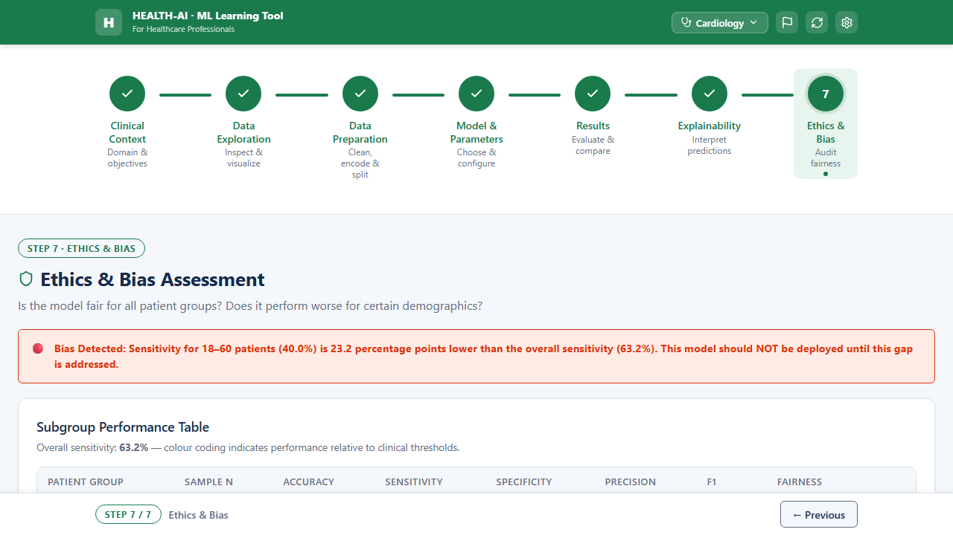

TC-S4-032 — Subgroup performance table is displayed
Priority: Critical
Precondition: User on Step 7
Steps:
Open Step 7
Observe the subgroup performance area

Expected Result: The subgroup performance table is visible.
Current Status: Passed
Notes / Evidence: Screenshot attached below.


TC-S4-033 — Subgroup table includes male and female rows
Priority: Critical
Precondition: Subgroup table visible
Steps:
Inspect the subgroup rows

Expected Result: Rows for Male and Female are present.
Current Status: Passed
Notes / Evidence: Screenshot attached below.


TC-S4-034 — Subgroup table includes age-group rows
Priority: Critical
Precondition: Subgroup table visible
Steps:
Inspect the subgroup rows

Expected Result: Age-group rows are present.
Current Status: Passed
Notes / Evidence: Screenshot attached below.


TC-S4-035 — Sensitivity column is colour-coded correctly in the subgroup table
Priority: Critical
Precondition: Subgroup table visible
Steps:
Observe the Sensitivity values
Compare the displayed colours against the threshold rules

Expected Result: Sensitivity cells or tags are colour-coded correctly.
Current Status: Passed
Notes / Evidence: Screenshot attached below.


TC-S4-036 — Fairness column shows OK / Review / warning tags
Priority: Critical
Precondition: Subgroup table visible
Steps:
Inspect the Fairness column values

Expected Result: The Fairness column shows clear status tags such as OK, Review, or warning.
Current Status: Passed
Notes / Evidence: Screenshot attached below.


TC-S4-037 — Bias banner does not appear when subgroup Sensitivity gap is exactly 10 pp
Priority: Critical
Precondition: Test data is prepared so one subgroup Sensitivity is exactly 10 percentage points below overall Sensitivity
Steps:
Open Step 7
Load or trigger subgroup results where the gap equals exactly 10 pp
Observe the bias banner area

Expected Result: The bias auto-detection banner does not appear when the gap is exactly 10 percentage points.
Current Status: Passed
Notes / Evidence: Screenshot attached below.


TC-S4-038 — Bias banner appears when subgroup Sensitivity gap is greater than 10 pp
Priority: Critical
Precondition: Test data is prepared so one subgroup Sensitivity is more than 10 percentage points below overall
Steps:
Open Step 7
Load or trigger subgroup results where the gap is above 10 pp
Observe the bias banner area

Expected Result: A red full-width bias banner appears automatically.
Current Status: Passed
Notes / Evidence: Screenshot attached below.


TC-S4-039 — Bias banner text identifies the affected subgroup and gap clearly
Priority: High
Precondition: Bias banner visible
Steps:
Inspect the banner wording

Expected Result: The banner clearly names the affected subgroup and explains the Sensitivity gap in plain language.
Current Status: Passed
Notes / Evidence: Screenshot attached below.


TC-S4-040 — Bias banner hides when the trigger condition is no longer met
Priority: Critical
Precondition: Bias banner is currently visible
Steps:
Adjust the test data or state so that the subgroup Sensitivity gap becomes 10 pp or less
Refresh or recalculate Step 7

Expected Result: The bias banner disappears automatically.
Current Status: Passed
Notes / Evidence: Screenshot attached below.


TC-S4-041 — EU AI Act checklist is displayed with 8 items
Priority: Critical
Precondition: User on Step 7
Steps:
Open Step 7
Count the checklist items

Expected Result: Exactly 8 checklist items are visible.
Current Status: Passed
Notes / Evidence: Screenshot attached below.


TC-S4-042 — Exactly 2 checklist items are pre-checked by default
Priority: Critical
Precondition: Step 7 is opened fresh
Steps:
Inspect the default checklist state
Count the pre-checked items

Expected Result: Exactly 2 checklist items are pre-checked by default.
Current Status: Passed
Notes / Evidence: Screenshot attached below.


TC-S4-043 — Checklist items can be toggled on click
Priority: Critical
Precondition: Checklist visible
Steps:
Click an unchecked item
Click a checked item

Expected Result: An unchecked item becomes checked and a checked item can be toggled off unless intentionally locked by design.
Current Status: Passed
Notes / Evidence: Screenshot attached below.


TC-S4-044 — Checklist completion progress updates visually
Priority: High
Precondition: Checklist has a visible progress indicator
Steps:
Toggle several checklist items
Observe the completion progress

Expected Result: The completion progress updates correctly as the checklist state changes.
Current Status: Passed
Notes / Evidence: Screenshot attached below.


TC-S4-045 — Training data representation chart is displayed
Priority: Critical
Precondition: User on Step 7
Steps:
Open Step 7
Observe the training versus real population chart

Expected Result: The comparison chart is visible and rendered correctly.
Current Status: Passed
Notes / Evidence: Screenshot attached below.


TC-S4-046 — Training data chart compares training and real population groups
Priority: Critical
Precondition: Representation chart visible
Steps:
Inspect the chart labels and compared groups

Expected Result: The chart compares training data distribution against real population distribution by subgroup.
Current Status: Passed
Notes / Evidence: Screenshot attached below.


TC-S4-047 — Training data warning does not appear when the representation gap is exactly 15 pp
Priority: Critical
Precondition: Test data is prepared so one group's training-versus-real population gap is exactly 15 percentage points
Steps:
Open Step 7
Observe the training data representation warning area

Expected Result: The amber warning does not appear when the representation gap is exactly 15 percentage points.
Current Status: Passed
Notes / Evidence: Screenshot attached below.


TC-S4-048 — Training data warning appears when the representation gap is greater than 15 pp
Priority: Critical
Precondition: Test data is prepared so one group's representation gap is above 15 percentage points
Steps:
Open Step 7
Observe the training data representation section

Expected Result: An amber warning appears automatically when any group exceeds the defined gap threshold.
Current Status: Passed
Notes / Evidence: Screenshot attached below.


TC-S4-049 — No training data warning is shown when all representation gaps are within threshold
Priority: High
Precondition: Test data is prepared so all representation gaps are 15 percentage points or less
Steps:
Open Step 7
Observe the representation warning area

Expected Result: The amber representation warning is hidden.
Current Status: Passed
Notes / Evidence: Screenshot attached below.


TC-S4-050 — Step 7 handles missing subgroup data gracefully
Priority: High
Precondition: A simulated state exists where subgroup metrics cannot be computed for one or more groups
Steps:
Open Step 7 under the incomplete subgroup-data condition
Observe the subgroup table and banners

Expected Result: The application degrades gracefully with clear messaging and without visual corruption or unhandled error.
Current Status: Passed
Notes / Evidence: Screenshot attached below.


TC-S4-051 — AI Failure Case Studies section shows exactly 3 cards
Priority: Critical
Precondition: User on Step 7
Steps:
Open Step 7
Count the case study cards

Expected Result: Exactly 3 cards are visible.
Current Status: Passed
Notes / Evidence: Screenshot attached below.


TC-S4-052 — Failure case study cards use red / amber / green categories
Priority: High
Precondition: Case study cards visible
Steps:
Inspect each case study card

Expected Result: There is 1 red failure card, 1 amber near-miss card, and 1 green prevention card.
Current Status: Passed
Notes / Evidence: Screenshot attached below.


TC-S4-053 — Case study cards use plain clinical language
Priority: High
Precondition: Case study cards visible
Steps:
Read the content of all three cards

Expected Result: The cards use plain clinical language understandable by non-technical healthcare users.
Current Status: Passed
Notes / Evidence: Screenshot attached below.


TC-S4-054 — Subgroup table renders for all 20 domains
Priority: Critical
Precondition: All 20 domains are implemented
Steps:
Switch through all 20 domains
Open Step 7
Observe the subgroup table

Expected Result: The subgroup table renders correctly for every domain.
Current Status: Passed
Notes / Evidence: Screenshot attached below.


CERTIFICATE / END-TO-END / DELIVERABLE VERIFICATION

TC-S4-055 — Download Certificate control is visible on Step 7
Priority: Critical
Precondition: User on Step 7
Steps:
Open Step 7
Observe the action controls

Expected Result: The Download Certificate button or action is visible.
Current Status: Passed
Notes / Evidence: Screenshot attached below.


TC-S4-056 — Certificate generation API endpoint works
Priority: Critical
Precondition: Backend is running and browser devtools or network inspection is available
Steps:
Click Download Certificate
Inspect the network request

Expected Result: POST /api/generate-certificate is called successfully and returns a valid PDF response.
Current Status: Passed
Notes / Evidence: Screenshot attached below.


TC-S4-057 — Generated PDF includes the active domain
Priority: Critical
Precondition: Certificate is generated successfully
Steps:
Open the generated PDF
Inspect the header and body content

Expected Result: The PDF includes the currently active domain.
Current Status: Passed
Notes / Evidence: Screenshot attached below.


TC-S4-058 — Generated PDF includes the active model
Priority: Critical
Precondition: Certificate is generated after model training
Steps:
Inspect the PDF content

Expected Result: The PDF includes the currently active or trained model.
Current Status: Passed
Notes / Evidence: Screenshot attached below.


TC-S4-059 — Generated PDF includes all 6 performance metrics
Priority: Critical
Precondition: Certificate is generated
Steps:
Inspect the PDF contents
Verify the metric list

Expected Result: The PDF includes all 6 Step 5 metrics.
Current Status: Passed
Notes / Evidence: Screenshot attached below.


TC-S4-060 — Certificate values match the current Step 5 metric values exactly
Priority: Critical
Precondition: A model is trained, Step 5 metrics are visible, and the certificate is generated
Steps:
Note all 6 metric values in Step 5
Generate the certificate
Compare the PDF metric values against the UI

Expected Result: All 6 metrics in the PDF match the currently displayed Step 5 values exactly.
Current Status: Passed
Notes / Evidence: Screenshot attached below.


TC-S4-061 — Generated PDF includes bias findings
Priority: Critical
Precondition: Certificate is generated after Step 7 analysis
Steps:
Inspect the PDF ethics and bias section

Expected Result: Bias findings are included in the certificate.
Current Status: Passed
Notes / Evidence: Screenshot attached below.


TC-S4-062 — Certificate bias findings match the current Step 7 screen state
Priority: Critical
Precondition: Step 7 is visible with a known bias state
Steps:
Note the current subgroup findings or bias banner state
Generate the certificate
Compare the PDF bias section with the current UI

Expected Result: The PDF bias findings reflect the same bias state currently shown on Step 7.
Current Status: Passed
Notes / Evidence: Screenshot attached below.


TC-S4-063 — Generated PDF includes checklist status
Priority: Critical
Precondition: Checklist state is set before certificate generation
Steps:
Generate the certificate
Inspect the PDF

Expected Result: The PDF reflects checklist completion or status correctly.
Current Status: Passed
Notes / Evidence: Screenshot attached below.


TC-S4-064 — Certificate checklist status matches the current UI state
Priority: Critical
Precondition: Checklist items are toggled into a known custom state
Steps:
Set a recognisable checklist combination
Generate the certificate
Compare the PDF checklist section with the UI state

Expected Result: The certificate reproduces the checklist status accurately.
Current Status: Passed
Notes / Evidence: Screenshot attached below.


TC-S4-065 — Certificate updates after changing the active domain
Priority: Critical
Precondition: Certificate generation is available
Steps:
Generate a certificate in Domain A
Switch to Domain B
Generate the certificate again
Compare both PDFs

Expected Result: The domain-specific content changes correctly and the second PDF is not stale from the first domain.
Current Status: Passed
Notes / Evidence: Screenshot attached below.


TC-S4-066 — Certificate updates after changing the active model
Priority: Critical
Precondition: At least two trained models are available
Steps:
Generate a certificate for Model A
Switch to Model B
Generate the certificate again

Expected Result: The PDF reflects the active model at the time of generation.
Current Status: Passed
Notes / Evidence: Screenshot attached below.


TC-S4-067 — Certificate generation does not fail when the checklist is only partially completed
Priority: High
Precondition: Some checklist items are checked and others are unchecked
Steps:
Leave the checklist partially complete
Generate the certificate

Expected Result: The PDF still generates successfully and reflects the partial completion state.
Current Status: Passed
Notes / Evidence: Screenshot attached below.


TC-S4-068 — Certificate generation does not fail when the bias banner is not present
Priority: High
Precondition: Current Step 7 state has no triggered bias banner
Steps:
Ensure the subgroup condition does not trigger the bias banner
Generate the certificate

Expected Result: Certificate generation still succeeds and records the normal bias state properly.
Current Status: Passed
Notes / Evidence: Screenshot attached below.


TC-S4-069 — Certificate generation works for at least 3 different domains
Priority: Critical
Precondition: At least three domains are testable
Steps:
Generate a certificate in Domain A
Generate a certificate in Domain B
Generate a certificate in Domain C
Compare the content

Expected Result: Certificate generation succeeds for at least 3 different domains and the content changes accordingly.
Current Status: Passed
Notes / Evidence: Screenshot attached below.


TC-S4-070 — Full 7-step pipeline works end-to-end using the default dataset
Priority: Critical
Precondition: Application is opened from a fresh state
Steps:
Start at Step 1
Use the default dataset in Step 2
Complete the mapper in Step 2
Complete preprocessing in Step 3
Train a model in Step 4
Review results in Step 5
Review explainability in Step 6
Review ethics and bias in Step 7
Generate the certificate

Expected Result: The entire pipeline completes successfully from Step 1 to Step 7 using the default dataset.
Current Status: Passed
Notes / Evidence: Screenshot attached below.


TC-S4-071 — Full 7-step pipeline works end-to-end using a fresh uploaded CSV
Priority: Critical
Precondition: A valid fresh CSV file is available
Steps:
Start the application from a fresh state
Upload the CSV in Step 2
Complete the mapper, preprocessing, model training, results, explainability, and ethics flow
Generate the certificate

Expected Result: The entire pipeline completes successfully with an uploaded CSV.
Current Status: Passed
Notes / Evidence: Screenshot attached below.


TC-S4-072 — Full 7-step pipeline works end-to-end for at least 3 different domains
Priority: Critical
Precondition: At least three domains are testable
Steps:
Execute the full Steps 1-7 flow in Domain A
Repeat the full flow in Domain B
Repeat the full flow in Domain C

Expected Result: The full pipeline succeeds for at least 3 domains.
Current Status: Passed
Notes / Evidence: Screenshot attached below.


TC-S4-073 — Returning from Step 7 back to Step 6 preserves valid current context
Priority: High
Precondition: User already reached Step 7
Steps:
Navigate back to Step 6
Observe the selected domain, model, and patient context

Expected Result: Valid current context is preserved and Step 6 data remains consistent.
Current Status: Passed
Notes / Evidence: Screenshot attached below.


TC-S4-074 — Returning from Step 6 back to Step 5 preserves active model result context
Priority: High
Precondition: User is on Step 6 after training a model
Steps:
Navigate back to Step 5
Compare the metrics and model context

Expected Result: The displayed result context still corresponds to the active model and current pipeline state.
Current Status: Passed
Notes / Evidence: Screenshot attached below.


TC-S4-075 — Sprint 4 Jira backlog URL is reachable
Priority: High
Precondition: Sprint 4 Jira URL is provided
Steps:
Open the Sprint 4 Jira backlog URL
Verify access

Expected Result: The URL is reachable and the Sprint 4 committed stories are visible.
Current Status: Passed
Notes / Evidence: Screenshot attached below.


TC-S4-076 — Sprint 4 Jira stories include story points
Priority: High
Precondition: Sprint 4 Jira board is open
Steps:
Inspect the committed Sprint 4 stories

Expected Result: Story points are assigned.
Current Status: Passed
Notes / Evidence: Screenshot attached below.


TC-S4-077 — Sprint 4 Jira stories include Step 6 and Step 7 subtasks
Priority: High
Precondition: Sprint 4 Jira board is open
Steps:
Inspect the Sprint 4 backlog items

Expected Result: Step 6 and Step 7 work is decomposed into visible subtasks.
Current Status: Passed
Notes / Evidence: Screenshot attached below.


TC-S4-078 — Full Pipeline Test Report PDF is uploaded to GitHub Wiki and reachable
Priority: Critical
Precondition: Test report URL is submitted
Steps:
Open the submitted test report PDF URL
Verify file accessibility

Expected Result: The PDF is available and reachable.
Current Status: Passed
Notes / Evidence: Screenshot attached below.


TC-S4-079 — Weekly Progress Report PDF is uploaded to GitHub Wiki and reachable
Priority: High
Precondition: Weekly report URL is submitted
Steps:
Open the submitted weekly report PDF URL
Verify file accessibility

Expected Result: The PDF is available and reachable.
Current Status: Passed
Notes / Evidence: Screenshot attached below.


TC-S4-080 — Weekly Progress Report includes velocity and demo evidence
Priority: High
Precondition: Weekly Progress Report PDF is available
Steps:
Open the report
Inspect the sections and content

Expected Result: The report contains velocity or burndown-style progress and demo screenshots or equivalent evidence.
Current Status: Passed
Notes / Evidence: Screenshot attached below.


TC-S4-081 — Full Pipeline Test Report includes all acceptance criteria verification
Priority: Critical
Precondition: Full Pipeline Test Report PDF is available
Steps:
Inspect the report contents
Compare the contents against the Sprint 4 acceptance expectations

Expected Result: The report shows end-to-end verification of the required acceptance criteria.
Current Status: Passed
Notes / Evidence: Screenshot attached below.


TC-S4-082 — Screenshot evidence exists for 3-domain clinical sense-check switching
Priority: Medium
Precondition: QA execution is completed
Steps:
Review the evidence set

Expected Result: There is visual evidence showing sense-check text changing across at least 3 domains.
Current Status: Passed
Notes / Evidence: Screenshot attached below.


TC-S4-083 — Screenshot evidence exists for bias banner visible and hidden states
Priority: Medium
Precondition: QA execution is completed
Steps:
Review the evidence set

Expected Result: The evidence set includes one state with the bias banner visible and one state with it hidden.
Current Status: Passed
Notes / Evidence: Screenshot attached below.


TC-S4-084 — Screenshot or PDF evidence exists for certificates from at least 3 domains
Priority: Medium
Precondition: Certificate generation is tested across 3 domains
Steps:
Review the evidence set

Expected Result: The evidence set includes generated certificates or screenshots from 3 different domains.
Current Status: Passed
Notes / Evidence: Screenshot attached below.


