BATTLETECH: OUTWORLDS WASTES
SNOW RAVEN RAID

--------------------------- START TRANSMISSION ----------------------------
INTERSTELLAR EXPEDITIONS IS LOOKING FOR INDEPENDENT SECURITY CONTRACTORS FOR A LONG HAUL MISSION IN THE OUTWORLDS WASTES. WE OFFER FLEXIBLE CONTRACT TERMS AND GENEROUS SALVAGE RIGHTS. JOIN OUR SPINWARD OPERATIONS TEAM TODAY!
---------------------------- END TRANSMISSION -----------------------------

This is a player-vs-GM scenario with an introduction to combined arms and optional simplified campaign logistics rules.

Each player may bring 3,000 BV with 1 OmniMech and 1 Battle Armor unit or 1 BattleMech and 1 Battle Armor unit with magnetic claws, following the BattleTech: Outworlds Wastes event list building rules. A link to the rules is below. Players must select a single faction from any era on the Master Unit List.

Players may use BattleTech: Outworlds Wastes Force Maintenance event rules to improve their force after the scenario. Players can improve their force up to 5,000 BV, including any captured units.

The following optional rules will be used:
Initiative Deck: Initiative is determined by playing cards.
Each player receives one card; their whole force activates together.
The Movement Phase is resolved from lowest value to highest.
The Attack Phases are resolved from highest value to lowest.
Fire for Effect: Attack declaration and resolution occur simultaneously.

BattleTech: Outworlds Wastes:
Web Format - https://outworlds-wastes.jeremylt.org/event-play
PDF Format - https://raw.githubusercontent.com/Eudicods/outworlds-wastes/rules-pdf/battletech-outworlds-wastes-event.pdf

Colorado BattleTech Discord:
https://discord.gg/dbCSXbJspc
--------------------------- START TRANSMISSION ----------------------------
ANTALLOS HAS BEEN A HUB OF DISREPUTABLE MERCENARY ACTION NEAR THE OUTWORLDS ALLIANCE FOR SEVERAL CENTURIES. INTERSTELLAR EXPEDITIONS IS RECRUITING ON ANTALLOS. DESTROYING PIRATE FORCES WOULD BE A GOOD WAY TO GET YOUR UNIT RECOGNIZED AND HIRED BY INTERSTELLAR EXPEDITIONS.

REGION BACKGROUND: THE OUTWORLDS ALLIANCE WAS FOUNDED IN 2413 AND ENJOYED PROSPERITY THROUGHOUT THE STAR LEAGUE ERA. BY THE START OF THE AMARIS CIVIL WAR IN 2766, THE OUTWORLDS ALLIANCE CONTAINED OVER 135 MAJOR SYSTEMS ACROSS 7 ADMINISTRATIVE DISTRICTS. UNFORTUNATELY, THE OUTWORLDS ALLIANCE SUFFERED DURING THE SUCCESSION WARS THAT FOLLOWED THE FALL OF THE STAR LEAGUE IN 2780, AND THEY HAD TO STEADILY ABANDON SYSTEMS THEY NO LONGER HAD THE RESOURCES TO SUPPORT.

CLAN SNOW RAVEN BEGAN EXPLORING THE PERIPHERY FOR RESOURCES SOON AFTER THE BATTLE OF TUKAYYID ENDED OPERATION REVIVAL. IN 3064, CLAN SNOW RAVEN AND THE OUTWORLDS ALLIANCE BEGAN DEVELOPING MUTUAL RESPECT AND TENTATIVE ALLIANCE. FOLLOWING THEIR ABJURATION FROM THE CLAN HOMEWORLDS IN 3075 AS A RESULT OF THE WARS OF REAVING, CLAN SNOW RAVEN TOOK REFUGE IN THE OUTWORLDS ALLIANCE. IN 3083, CLAN SNOW RAVEN AND THE OUTWORLDS ALLIANCE MERGED TO FORM THE RAVEN ALLIANCE.

BY THE ILCLAN TRIAL IN 3151, THE RAVEN ALLIANCE CONTAINED ONLY 47 SYSTEMS. AT LEAST 88 SYSTEMS THAT WERE PART OF THE OUTWORLDS ALLIANCE DURING THE STAR LEAGUE ERA HAVE BEEN LOST. MANY FACTIONS ARE EAGER TO EXPLORE THESE LOST WORLDS IN THE OUTWORLDS WASTES IN SEARCH OF LOST STAR LEAGUE TECHNOLOGY.
LOCAL AREA STAR MAP:

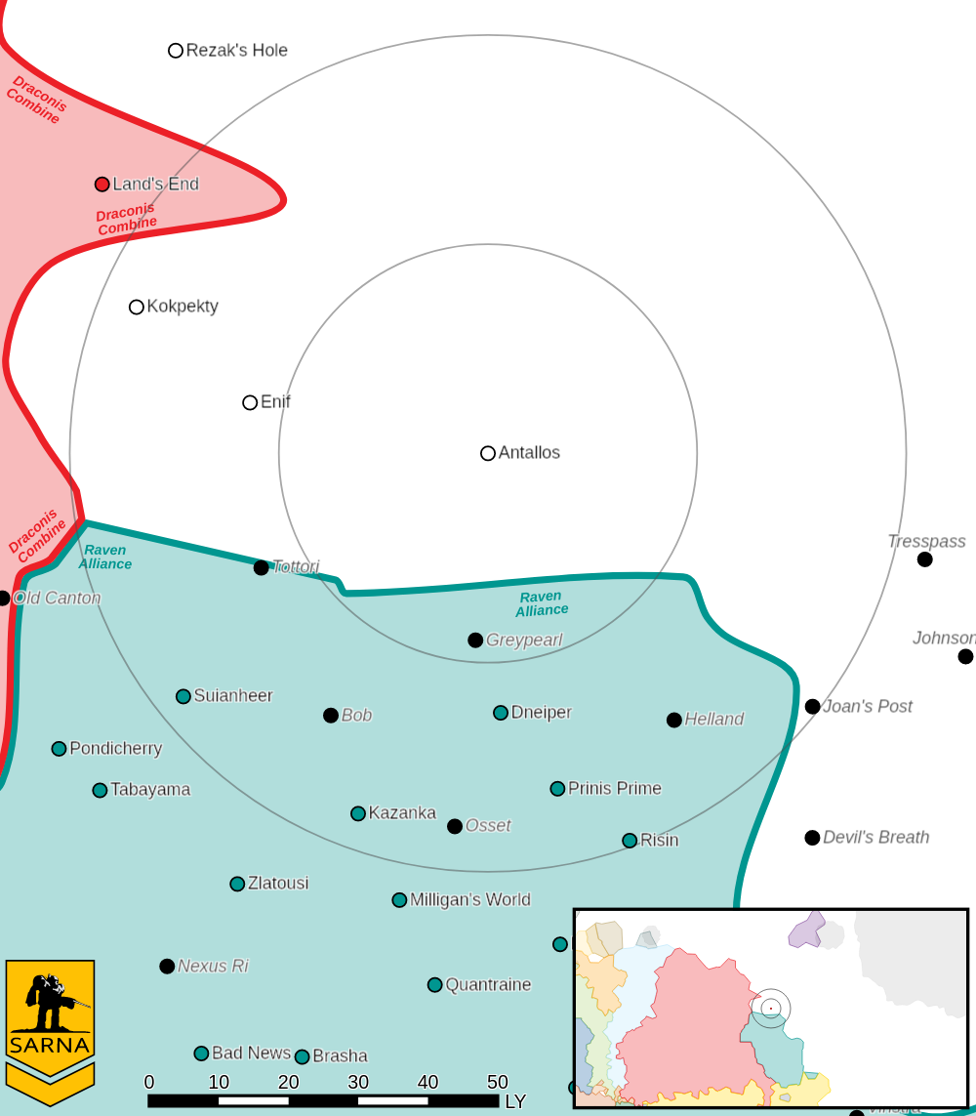

ANTALLOS III PLANETARY READOUT:

STAR TYPE : K4IV (195 HOURS RECHARGE TIME)
POSITION IN SYSTEM : 3 OF 7
NATURAL SATELLITES : 2
TIME TO JUMP POINT : 4.44 DAYS
SURFACE GRAVITY : 0.92 G
DAY LENGTH : 27.0 HOURS
ATMOSPHERIC PRESSURE : STANDARD (BREATHABLE)
EQUATORIAL TEMPERATURE : 49*C
SURFACE WATER : 11 PERCENT
CAPITAL : PORT KRIN
POPULATION : 60,757,822
HPG : B-RATED HPG
SOCIO-INDUSTRIAL LEVELS : C-D-C-D-C
TECHNOLOGICAL SOPHISTICATION : C (MODERATELY ADVANCED WORLD)
INDUSTRIAL DEVELOPMENT : D (LOW INDUSTRIALIZATION)
RAW MATERIAL DEPENDENCE : C (LIMITED RAW MATERIAL PRODUCTION)
INDUSTRIAL OUTPUT : D (NEGLIGIBLE INDUSTRIAL OUTPUT)
AGRICULTURAL DEPENDENCE : C (MODEST AGRICULTURE)

PIRATE RAID

PIRATE FORCES DO NOT HAVE SUFFICIENT MANPOWER FOR ALL OF THEIR UNITS, LEAVING THEIR TANK AND VTOL UNITS VULNERABLE. CAPTURE THEIR UNITS AND TURN THEM AGAINST THE PIRATES.

PRIMARY OBJECTIVES:
CAPTURE ENEMY TANK
CAPTURE ENEMY VTOL

SECONDARY OBJECTIVES:
DESTROY PIRATE FORCES

ADDITIONAL RULES:
INFANTRY/BATTLE ARMOR UNITS CAN CAPTURE TANKS AND VTOLS BY OCCUPYING THE SAME HEX AS THE UNIT DURING THE END PHASE. CAPTURED UNITS CAN BE USED ON THE FOLLOWING TURN.

OPPOSITION FORCES:
PIRATE FORCES CONSIST OF 2 LANCES OF OLDER BATTLEMECHS

---------------------------- END TRANSMISSION -----------------------------
--------------------------- START TRANSMISSION ----------------------------

INTELLIGENCE HAS PROVIDED SATELLITE IMAGERY OF THE LANDING PORT.

GROUND VEHICLES VTOLS
|-- FRIENDLY DEPLOYMENT ZONE --|
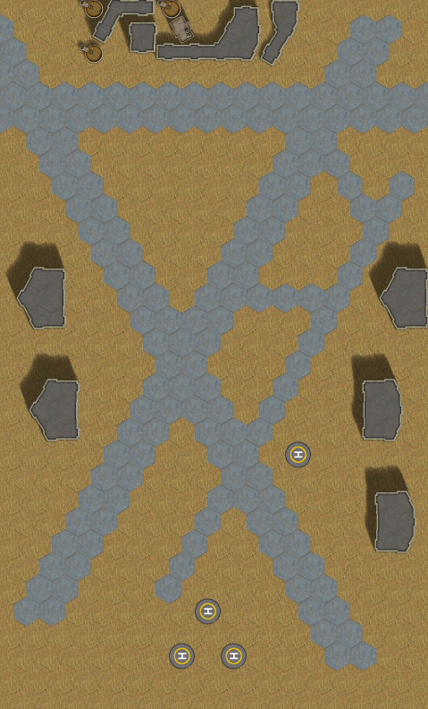

---------------------------- END TRANSMISSION -----------------------------
--------------------------- START TRANSMISSION ----------------------------

INTELLIGENCE HAS PROVIDED SATELLITE IMAGERY OF A PIRATE BASE.

GROUND VEHICLES VTOLS
|-- FRIENDLY DEPLOYMENT ZONE --|

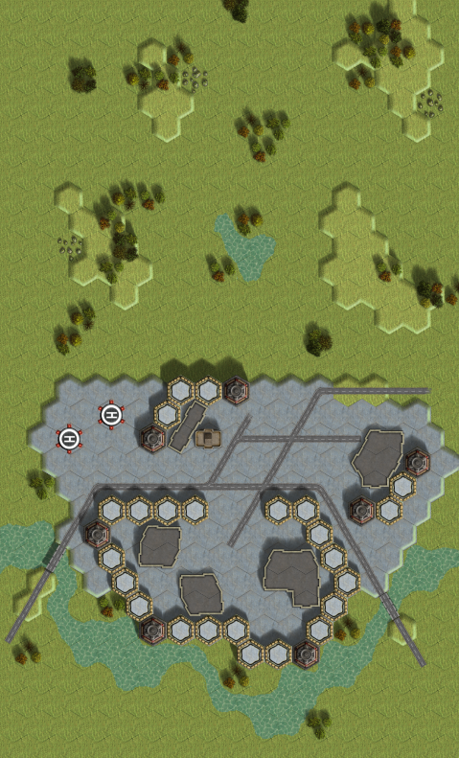
---------------------------- END TRANSMISSION -----------------------------

--------------------------- START TRANSMISSION ----------------------------

INTELLIGENCE HAS PROVIDED SATELLITE IMAGERY OF A PIRATE BASE.

GROUND VEHICLES VTOLS
|-- FRIENDLY DEPLOYMENT ZONE --|

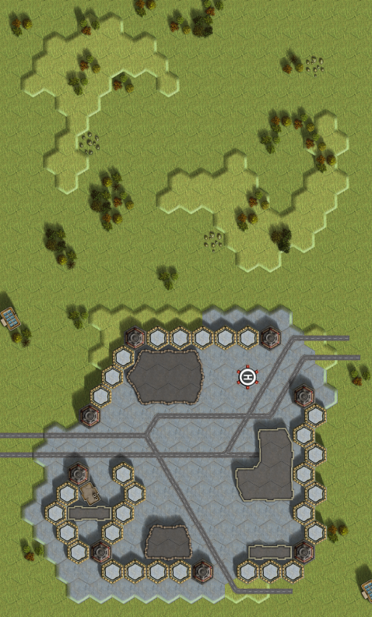
---------------------------- END TRANSMISSION -----------------------------
--------------------------- START TRANSMISSION ----------------------------

THE FOLLOWING BOUNTIES HAVE BEEN ISSUED FOR THIS MISSION.

PAYMENT | ACTIVITY
100,000 | DAMAGE ENEMY UNIT (PER UNIT)
100,000 | CRITICAL OR MOTIVE DAMAGE (PER UNIT)
100,000 | COMPLETE A PHYSICAL ATTACK
100,000 | COMPLETE AN ANTI-MECH ATTACK
100,000 | DAMAGE A UNIT WITH INDIRECT FIRE
100,000 | SKID A UNIT WITHOUT DESTROYING IT
250,000 | KNOCK 'MECH PILOT UNCONSCIOUS
250,000 | REDUCE A COMBAT VEHICLE TO 0 MP
250,000 | KILL ALL BUT 1 TROOP IN AN INFANTRY UNIT
250,000 | HAVE A UNIT SCORE A HIT AT ALL 3 RANGES
250,000 | COMPLETE A CHARGE ATTACK
250,000 | COMPLETE A DEATH FROM ABOVE ATTACK
500,000 | SHOOT DOWN A VTOL WITH A TMM OF 5+
500,000 | SHOOT A 'MECH IN THE HEAD
500,000 | PHYSICAL ATTACK A 'MECH IN THE HEAD
500,000 | CAPTURE A VEHICLE CREW OR 'MECH PILOT

---------------------------- END TRANSMISSION -----------------------------
GM Notes

--------------------------- START TRANSMISSION ----------------------------

Base 1:
Maps: Deserts Pack, AeroBase #1, AeroBase #2

Base 2:
Maps: Grasslands Pack, Open Terrain #3, River CommCenter

Base 3:
Maps: Grasslands Pack, Open Terrain #2, Forward Base

Mission:
Pirates: Pirates will try to focus on the player Mechs and drive off the player forces. Pirate forces should have approximately 4,000 BV per player, in a pair of Battlemechs, one light and one medium.

Salvage: Each player may keep any salvaged vehicles but must repair any damage to these vehicles from the scenario. Each ground vehicle should be approximately 1,300 BV and each VTOL should be approximately 700 BV.

---------------------------- END TRANSMISSION -----------------------------

