BATTLETECH: OUTWORLDS WASTES
LINDEN 'THE CASTLE'

---------------------------- START TRANSMISSION ---------------------------
YOUR FORCE IS ORDERED TO THE LINDEN SYSTEM TO RECOVER STAR LEAGUE DEFENSE FORCE EQUIPMENT. LINDEN WAS PART OF THE BLOMMESTEIN PROVINCE OF THE OUTWORLDS ALLIANCE. THE SLDF SENT THE 963RD INDEPENDENT AERO WING AND 135TH MECHANIZED INFANTRY DIVISION TO THE REGION. THE 135 MID WAS DESTROYED IN THE PERIPHERY UPRISING OF 2765. 963 IAW WAS DEPLOYED TO SUPPORT THE SLDF RESPONSE TO THE AMARIS CIVIL WAR. FOLLOWING THE AMARIS CIVIL WAR THE 963 IAW WAS ABSORBED BY THE DRACONIS COMBINE MUSTERED SOLDIERY. LINDEN WAS THE LOCATION OF THE DEPARTMENT OF MEGA-ENGINEERING DEEP SPIN MAINTENANCE YARD. YOUR FORCE IS ORDERED TO RECOVER AS MUCH SLDF EQUIPMENT AS POSSIBLE.
----------------------------- END TRANSMISSION ----------------------------

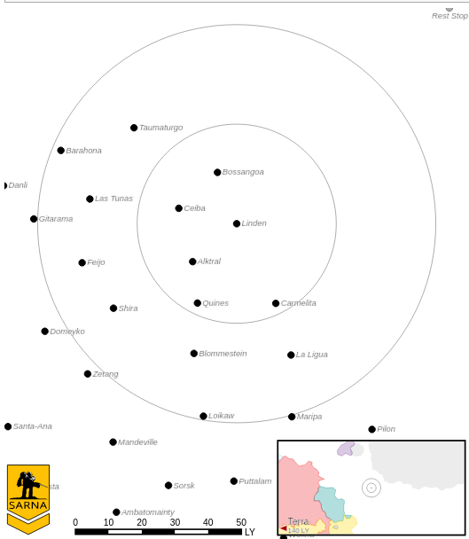
---------------------------- START TRANSMISSION ---------------------------
FORCES ARE ATTEMPTING TO ASSASSINATE THE LEADER OF A MILITIA GROUP, SUPREMELY DIVINE INVINCIBLE GRAND HIGH SUPREME GENERALISSIMO HIRAM MAXIMUS BRAGADOCIOUS GLORIANUS I. ESCORT THE GENERALISSIMO TO HIS DROPSHIP FOR EXTRACTION. BROADCAST PROPAGANDA FOR THE GENERALISSIMO IF POSSIBLE.
----------------------------- END TRANSMISSION ----------------------------

Unit Limits: 6K BV for 1v1, 10K for 2v2.

Map: Four mapsheets, with flat desert terrain. The defender selects seven hexes in a circle as the extraction zone. The extraction zone must be within 3 hexes of the attacker's home edge and within 3 hexes of the centerline of one mapsheet. This location is known to both sides. Place the radio station on the middle of the opposite side of the map.

Primary Objective: Escort the Generalissimo to the extraction zone. The Generalissimo pilots a Crusader CRD-3R and has Gunnery 5/Piloting 4 with the Antagonizer and Demoralizer SPAs. The Generalissimo leads from the front. The attacker earns 1M C-bills for each section of the Generalissimo's mech, excluding the head, that receives internal damage. The defender earns 1M C-bills for each section of the Generalissimo's mech that does not receive internal damage. The defenders can extract with the Generalissimo's mech when he reaches the extraction zone.

Secondary Objective: Broadcast propaganda. A unit in the same hex as the radio tower can upload the propaganda. If control of the radio tower is contested, no propaganda is uploaded. During the End Phase, roll 2D6 for each unit in the same hex as the radio tower. On a roll of 8+, or 4+ for infantry, the propaganda is successfully uploaded and broadcast. 3M C-bills per commander on a side if this objective is accomplished. The attacker automatically achieves this objective if the defender does not.

Base Pay: 1.2M (1v1) or 1.0M (2v2) C-bills per commander if no objectives are completed.

---------------------------- START TRANSMISSION ---------------------------
SUPREMELY DIVINE INVINCIBLE GRAND HIGH SUPREME GENERALISSIMO HIRAM MAXIMUS BRAGADOCIOUS GLORIANUS I NEEDS A NEW BATTLEMECH. SEARCH A LOCAL JUNKYARD AND BRING A SUITABLE BATTLEMECH TO THE GENERALISSIMO.
----------------------------- END TRANSMISSION ----------------------------

Unit Limits: 6K BV for 1v1, 10K for 2v2.

Map: Four mapsheets, with urban terrain. Randomly distribute 3 unknown junkyard mechs on each mapsheet. Place the junkyard office in the center of the map. The junkyard office has a construction factor of 20.

Primary Objective: Search the mech junkyard. At the end of each unit's movement, roll 2D6 if they are adjacent to a junkyard mech. On a 3+ for infantry, 5+ for ground units, or 7+ for airborne units, you identify the junkyard mech. Units with an active probe automatically identify all junkyard mechs within the search radius of their active probe at the end of their movement. Recover a junkyard mech by dragging it to your map edge. If a side recovers multiple junkyard mechs, they can only present one to the Generalissimo. Add together the BV of the recovered junkyard mechs presented to the Generalissimo. Each side earns a percentage of 7.0M C-bills based upon the percentage of the total BV accounted for by the junkyard mech they presented.

Secondary Objective: Capture the junkyard manifest. If an infantry unit occupies the same hex as the junkyard boss during the End Phase and the hex is not contested, that side automatically identifies all of the junkyard mechs. The junkyard boss starts in the junkyard office. If the junkyard office is destroyed, the junkyard boss flees, moving one hex in a random direction at the start of every Movement Phase.

Base Pay: 1.2M (1v1) or 1.0M (2v2) C-bills per commander if no objectives are completed.

