BTTLETECH
OUTWORLDS WASTES

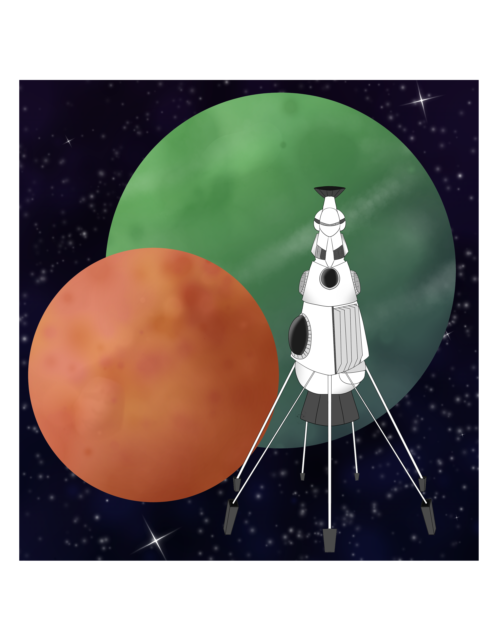

Event Scenario Pack

BATTLETECH: OUTWORLDS WASTES

BOARDING ACTION

--------------------------- START TRANSMISSION ----------------------------
INTERSTELLAR EXPEDITIONS IS LOOKING FOR INDEPENDENT SECURITY CONTRACTORS FOR A LONG HAUL MISSION IN THE OUTWORLDS WASTES. WE OFFER FLEXIBLE CONTRACT TERMS AND GENEROUS SALVAGE RIGHTS. JOIN OUR SPINWARD OPERATIONS TEAM TODAY!
---------------------------- END TRANSMISSION -----------------------------

These are player-vs-GM scenarios with combined arms and optional simplified campaign logistics rules.

Each player may bring 3,000 BV of combined arms, following the BattleTech: Outworlds Wastes event list building rules. A link to the rules is below. Players must select a single ilClan era faction on the Master Unit List.

Players attending multiple scenarios may use BattleTech: Outworlds Wastes Force Maintenance event rules to improve their force between scenarios. Players can improve their force up to 5,000 BV. Players may instead choose to use a new 3,000 BV force for each scenario. The enemy force will use the full BattleTech: Outworlds Wastes Force Maintenance rules for repair between scenarios. Players in the Alpha Strike scenario can add one additional unit of up to 1,500 BV to their list for the scenario.

The following optional rules will be used:
Initiative Deck: Initiative is determined by playing cards.
Each player receives one card; their whole force activates together.
The Movement Phase is resolved from lowest value to highest.
The Attack Phases are resolved from highest value to lowest.
Fire for Effect: Attack declaration and resolution occur simultaneously.

Scenarios:
Boarding Action
Capture the Base

BattleTech: Outworlds Wastes:
Web Format - https://outworlds-wastes.jeremylt.org/event-play
PDF Format - https://outworlds-wastes.jeremylt.org/downloads

Colorado BattleTech:
Website - https://coloradobt.org/
Discord - https://discord.gg/NPXEmTJBrZ
--------------------------- START TRANSMISSION ----------------------------

MISSION BACKGROUND

WE HAVE LOCATED AREAS OF INTEREST ON VOEHN II. UNFORTUNATELY, THE LOCAL WARLORD IS UNWILLING TO ALLOW ACCESS TO THE PLANET. THE WARLORD IS USING A MODIFIED STAR LEAGUE ENGINEERING CORPS ZEPPELIN FOR RECONNAISSANCE AND C3. YOUR MISSION IS TO CAPTURE THIS ZEPPELIN AND ASSOCIATED SUPPORT INFRASTRUCTURE. THE CAPTURE OF THIS PLATFORM WILL GIVE US VALUABLE STAR LEAGUE TECHNOLOGY AND ALLOW ACCESS TO OUR SITES OF INTEREST. EXPECT HEAVY OPPOSITION.

REGION BACKGROUND

THE OUTWORLDS ALLIANCE WAS FOUNDED IN 2413 AND ENJOYED PROSPERITY THROUGHOUT THE STAR LEAGUE ERA. BY THE START OF THE AMARIS CIVIL WAR IN 2766, THE OUTWORLDS ALLIANCE CONTAINED OVER 135 MAJOR SYSTEMS ACROSS 7 ADMINISTRATIVE DISTRICTS. UNFORTUNATELY, THE OUTWORLDS ALLIANCE SUFFERED DURING THE SUCCESSION WARS THAT FOLLOWED THE FALL OF THE STAR LEAGUE IN 2780, AND THEY HAD TO STEADILY ABANDON SYSTEMS THEY NO LONGER HAD THE RESOURCES TO SUPPORT.

CLAN SNOW RAVEN BEGAN EXPLORING THE PERIPHERY FOR RESOURCES SOON AFTER THE BATTLE OF TUKAYYID ENDED OPERATION REVIVAL. IN 3064, CLAN SNOW RAVEN AND THE OUTWORLDS ALLIANCE BEGAN DEVELOPING MUTUAL RESPECT AND TENTATIVE ALLIANCE. FOLLOWING THEIR ABJURATION FROM THE CLAN HOMEWORLDS IN 3075 AS A RESULT OF THE WARS OF REAVING, CLAN SNOW RAVEN TOOK REFUGE IN THE OUTWORLDS ALLIANCE. IN 3083, CLAN SNOW RAVEN AND THE OUTWORLDS ALLIANCE MERGED TO FORM THE RAVEN ALLIANCE.

BY THE ILCLAN TRIAL IN 3151, THE RAVEN ALLIANCE CONTAINED ONLY 47 SYSTEMS. AT LEAST 88 SYSTEMS THAT WERE PART OF THE OUTWORLDS ALLIANCE DURING THE STAR LEAGUE ERA HAVE BEEN LOST. MANY FACTIONS ARE EAGER TO EXPLORE THESE LOST WORLDS IN THE OUTWORLDS WASTES IN SEARCH OF LOST STAR LEAGUE TECHNOLOGY.

LOCAL AREA STAR MAP

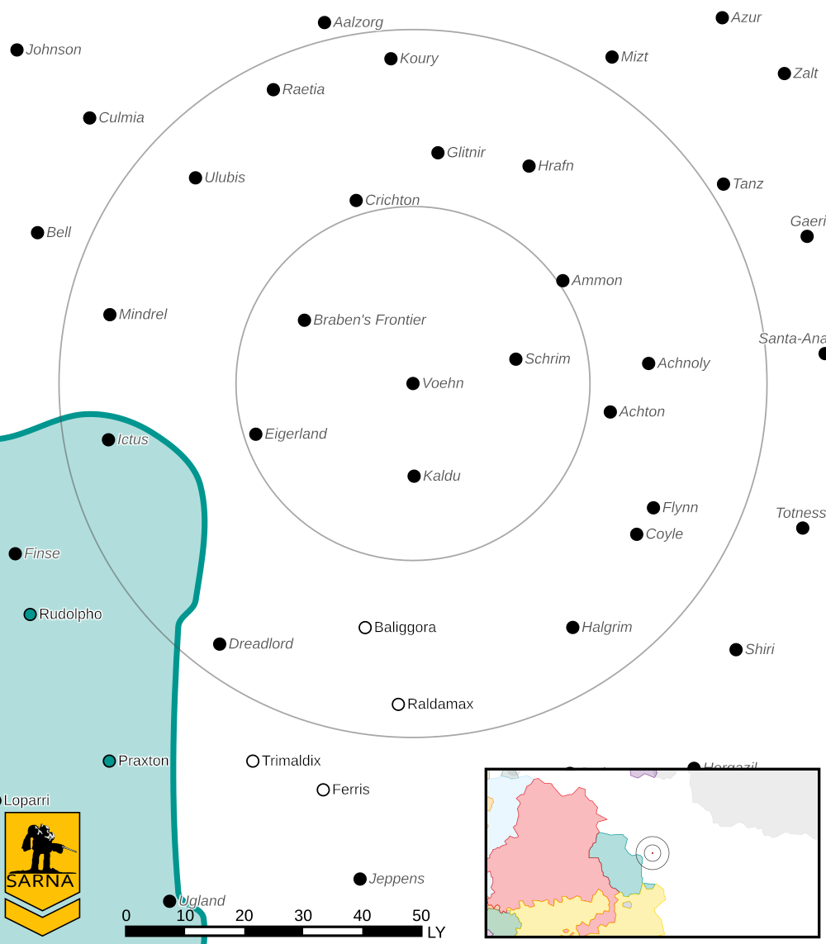

VOEHN II PLANETARY READOUT

STAR TYPE : G8V (189 HOURS RECHARGE TIME)
POSITION IN SYSTEM : 2 OF 5
NATURAL SATELLITES : NONE
TIME TO JUMP POINT : 6.23 DAYS
SURFACE GRAVITY : 0.97 G
DAY LENGTH : 20.0 HOURS
ATMOSPHERIC PRESSURE : STANDARD (BREATHABLE)
EQUATORIAL TEMPERATURE : 22*C
SURFACE WATER : 47 PERCENT
CAPITAL : NOVA GROßRÖHRSDORF
POPULATION : UNK
HPG : NONE
SOCIO-INDUSTRIAL LEVELS : REGRESSED-X-X-X-X
TECHNOLOGICAL SOPHISTICATION : D (PRE-INDUSTRIAL)
INDUSTRIAL DEVELOPMENT : X (PRE-INDUSTRIAL)
RAW MATERIAL DEPENDENCE : X (PRE-INDUSTRIAL)
INDUSTRIAL OUTPUT : X (PRE-INDUSTRIAL)
AGRICULTURAL DEPENDENCE : X (PRE-INDUSTRIAL)

MISSION 1: BOARDING ACTION

WE HAVE LOCATED A MOUNTAIN PASS WITH MINERAL DEPOSITS THAT DISRUPT THE COMMUNICATION SYSTEMS ON THE ZEPPELIN. WE WILL BOARD AND CAPTURE THE ZEPPELIN AS IT FLIES OVER THIS PASS. DESTROY THE ENEMY AIR DEFENSES AND COMMUNICATION STATION.

PRIMARY OBJECTIVES:
PROTECT BOARDING TEAM VTOLS
DESTROY COMMUNICATIONS STATION

SECONDARY OBJECTIVES:
DESTROY AIR DEFENSES
MINIMIZE FRIENDLY LOSSES

OPPOSITION FORCES:
EXPECT AT LEAST 1 STAR OF DEFENDING MECHS AND STATIC DEFENSES

MISSION 2: CAPTURE THE BASE
CAPTURE THE ZEPPELIN HOME BASE. WE NEED THE ZEPPELIN DOCKING TOWER AND MAINTENANCE FACILITIES INTACT. IF THE COMMUNICATIONS STATION WAS DESTROYED, THE ZEPPELIN WILL DOCK BEFORE YOUR ATTACK COMMENCES.

PRIMARY OBJECTIVES:
CAPTURE DOCKING TOWER
CAPTURE BASE COMMAND CENTER
CAPTURE OR DESTROY BASE DEFENSES

SECONDARY OBJECTIVES:
MINIMIZE DAMAGE TO BASE FACILITIES
MINIMIZE FRIENDLY LOSSES

OPPOSITION FORCES:
EXPECT AT LEAST 1 STAR OF DEFENDING MECHS AND STATIC DEFENSES

---------------------------- END TRANSMISSION -----------------------------
--------------------------- START TRANSMISSION ----------------------------

INTELLIGENCE HAS PROVIDED SATELLITE IMAGERY OF THE MOUNTAIN PASS. WE HAVE NOT BEEN ABLE TO LOCATE THE ZEPPELIN HOME BASE AT THIS TIME.

STATIC DEFENSES COMMUNICATIONS TOWER
|-- FRIENDLY DEPLOYMENT ZONE --|
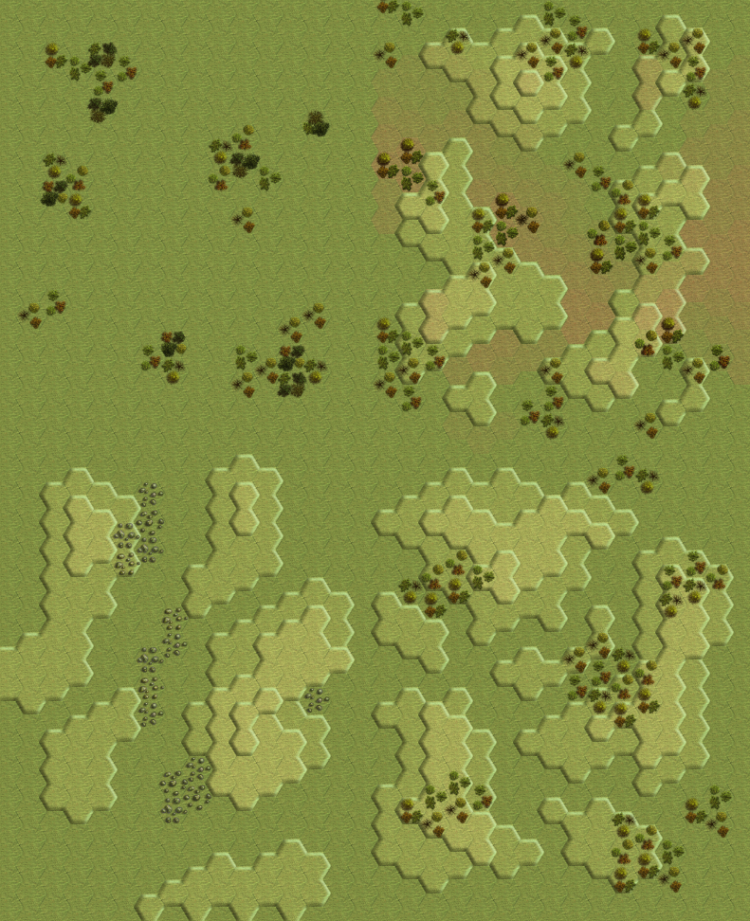
|--- ENEMY DEPLOYMENT ZONE ---|
AIRSHIP FLIGHT PATH

---------------------------- END TRANSMISSION -----------------------------
--------------------------- START TRANSMISSION ----------------------------

INTELLIGENCE HAS PROVIDED SATELLITE IMAGERY OF THE ZEPPELIN HOME BASE.

STATIC DEFENSES DOCKING TOWER COMMAND CENTER
|-- FRIENDLY DEPLOYMENT ZONE --|
|--- ENEMY DEPLOYMENT ZONE ---|
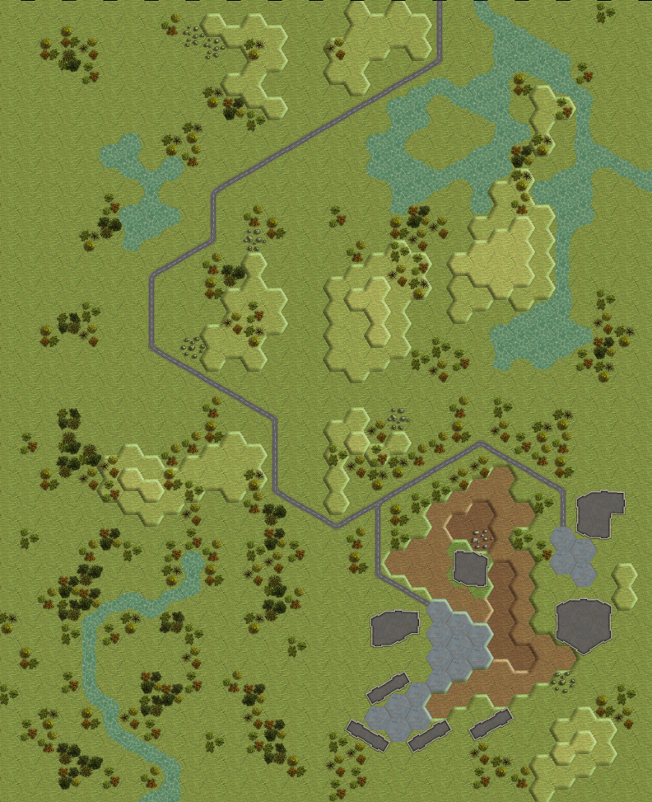
AIRSHIP FLIGHT PATH

---------------------------- END TRANSMISSION -----------------------------
--------------------------- START TRANSMISSION ----------------------------

MISSION BOUNTIES

THE FOLLOWING BOUNTIES HAVE BEEN ISSUED FOR THIS MISSION.

PAYMENT | ACTIVITY
100,000 | DAMAGE ENEMY UNIT (PER UNIT)
100,000 | CRITICAL OR MOTIVE DAMAGE (PER UNIT)
100,000 | COMPLETE A PHYSICAL ATTACK
100,000 | COMPLETE AN ANTI-MECH ATTACK
100,000 | DAMAGE A UNIT WITH INDIRECT FIRE
100,000 | SKID A UNIT WITHOUT DESTROYING IT
250,000 | KNOCK 'MECH PILOT UNCONSCIOUS
250,000 | REDUCE A COMBAT VEHICLE TO 0 MP
250,000 | KILL ALL BUT 1 TROOP IN AN INFANTRY UNIT
250,000 | HAVE A UNIT SCORE A HIT AT ALL 3 RANGES
250,000 | COMPLETE A CHARGE ATTACK
250,000 | COMPLETE A DEATH FROM ABOVE ATTACK
500,000 | SHOOT DOWN A VTOL WITH A TMM OF 5+
500,000 | SHOOT A 'MECH IN THE HEAD
500,000 | PHYSICAL ATTACK A 'MECH IN THE HEAD
500,000 | CAPTURE A VEHICLE CREW OR 'MECH PILOT

---------------------------- END TRANSMISSION -----------------------------

BATTLETECH: OUTWORLDS WASTES

BOARDING ACTION - GM Notes

Mission 1
Maps: Various Packs, Grasslands #1, Grasslands #3, Hilltops #1,
Rolling Hills #2
Scoring: 1M for airship, 1M for communications station

Tanks: Deploy the 3 enemy tanks as blank markers in the portion of the map behind the airship flight path. The mineral deposits block accurate scans. When a friendly unit enters line of sight of the tank, reveal which type of tank is present.

Reinforcements: Roll 1d6 during each end phase for each group of units not deployed. Deploy them during the next movement phase if your roll meets the values below.
Airship: 1-2 round 1; 1-4 round 2; 1-6 round 3
Enemy star: same turn as airship arrives

LRM towers: The LRM towers will shoot at any VTOLs whenever they have a shot. Otherwise they target the nearest unit. Each LRM tower is gunnery 5. The GM selects the construction factor and number of LRMs per tower.

Communication station: The GM selects the construction factor.

Mission 2
Maps: WWE 2018 Terrain Set Map Pack
Scoring: 0.75M for docking tower, 0.75M for headquarters,
0.5M for defenses

Reinforcements: roll 1d6 during each end phase for each group of units not deployed. Deploy them during the next movement phase if your roll meets the values below.
Enemy star: 1-2 round 1; 1-4 round 2; 1-6 round 3

Airship: If the communications tower was destroyed in part i, then the airship starts docked at the docking tower. Otherwise it deploys from its deployment zone on the first turn.

Capturing buildings: The docking tower and command center are captured if occupied by an infantry unit during the end phase. Control is lost if the infantry unit leaves the building. If the docking tower is captured, then during the next turn the players control the two closest LRM towers. If the command center is captured, the players control all LRM towers.

LRM towers: the LRM towers will target the nearest enemy unit, depending upon who controls them. Each LRM tower is gunnery 5. The GM chooses the construction factor and number of LRMs each tower has.

BTTLETECH
OUTWORLDS WASTES

