BATTLETECH
OUTWORLDS WASTES

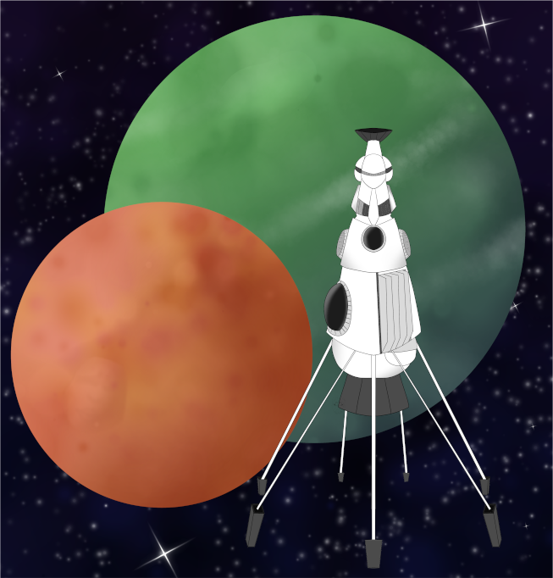

Event Scenario Pack
BATTLETECH: OUTWORLDS WASTES

GRAY DEATH ORIGINS

--------------------------- START TRANSMISSION ----------------------------
PLAY THROUGH THE ORIGINS OF THE GRAY DEATH LEGION! FORM YOUR MERCENARY FORCE AND PROTECT THE CITIZENS OF TRELL FROM THE DRACONIS COMBINE. FIND AND DESTROY THE ENEMY BASE TO CEMENT YOUR REPUTATION AS A TRUSTED MERCENARY!
---------------------------- END TRANSMISSION -----------------------------

These are player-vs-GM scenarios for BattleTech: Outworlds Wastes with combined arms and simplified campaign logistics rules.

Each player may bring 2,000 BV of 'Mechs from a single faction in the Late Succession War - LosTech era on the Master Unit List, following the BattleTech: Outworlds Wastes event list building rules. The list should have at least 2 'Mechs, one of which is piloted by your force commander.

After the first scenario, you may add up to 1,500 BV of units to your force. You must have at least one infantry unit and one unit capable of carrying infantry

Players use BattleTech: Outworlds Wastes Force Maintenance event rules to improve their force between scenarios. Players can improve their force up to 5,000 BV. The enemy force uses the full BattleTech: Outworlds Wastes Force Maintenance rules for repair between scenarios.

The following optional rules are recommended:
- Initiative Deck: Initiative is determined by playing cards.
Each player receives one card; their whole force activates together.
The Movement Phase is resolved from lowest value to highest.
The Attack Phases are resolved from highest value to lowest.
- Fire for Effect: Attack declaration and resolution occur simultaneously.
- Low Gravity: Divide default MPs by 0.86 and round to compute the unit’s new MPs.

BattleTech Outworlds Wastes:
Web: https://outworlds-wastes.jeremylt.org/event-play
PDF: https://outworlds-wastes.jeremylt.org/downloads?event

BattleTech: Outworlds Wastes is fan-made and based upon the official BattleTech rules from Catalyst Game Labs. BattleTech is a registered trademark of The Topps Company, Inc. in the United States and other countries.

Era: Succession Wars or later

Editor: Jeremy L Thompson
--------------------------- START TRANSMISSION ----------------------------

MISSION BACKGROUND

DUKE HASSID RICOL HAS INVADED TRELL WITH DRACONIS COMBINE FORCES DISGUISED AS PIRATES. THE TRELLWAN LANCERS, A NEW MILITIA UNIT ON THE PLANET, HAD SUCCESSFULLY PREVENTED THE INVADING FORCES FROM TAKING OVER THE TRELL GOVERNMENT. UNFORTUNATELY, DUKE RICOL HAS STAGED A COUP AND TAKEN OVER THE GOVERNMENT OF TRELL.

YOUR MISSION IS TO ESCAPE FROM THE GARRISON CASTLE WITH INFORMATION ABOUT THE COUP AND DECEIT. THEN, ATTACK THE COMMUNICATIONS ARRAY AT THE SPACEPORT SO A TEAM CAN GET A MESSAGE OFF PLANET TO THE LYRAN COMMONWEALTH ARMED FORCES TO FORCE THE DRACONIS COMBINE FORCES OFF OF TRELL.

REGION BACKGROUND

TRELL IS A LYRAN COMMONWEALTH SYSTEM NEAR THE PERIPHERY ON THE BORDER BETWEEN THE LYRAN COMMONWEALTH AND THE DRACONIS COMBINE. THE SYSTEM IS NOT TYPICALLY GARRISONED BY LYRAN COMMONWEALTH ARMED FORCES BUT TYPICALLY RELIES UPON MERCENARIES TO OFFER SECURITY AGAINST PIRATE RAIDS.

LOCAL AREA STAR MAP

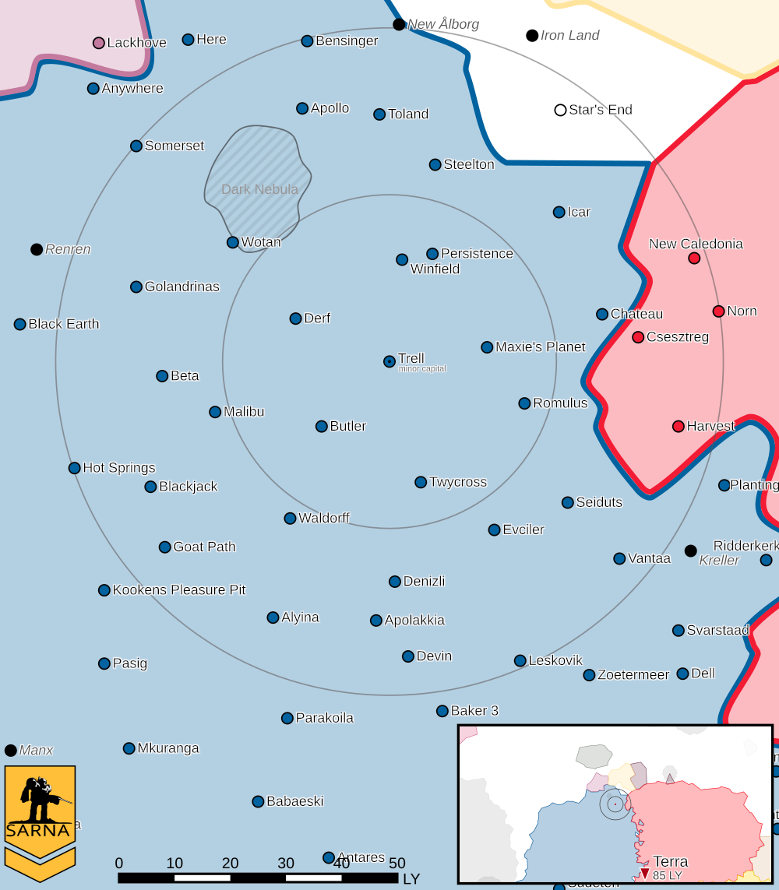

TRELL I PLANETARY READOUT

STAR TYPE : M2VII (203 HOURS RECHARGE TIME)
POSITION IN SYSTEM : 1
NATURAL SATELLITES : 0
TIME TO JUMP POINT : 2.89 DAYS
SURFACE GRAVITY : 0.86 G
DAY LENGTH : 29.0 HOURS
ATMOSPHERIC PRESSURE : STANDARD (BREATHABLE)
EQUATORIAL TEMPERATURE : 40*C
SURFACE WATER : 9 PERCENT
CAPITAL : SARGHAD
POPULATION : 188,538,952
HPG : B-rated HPG
SOCIO-INDUSTRIAL LEVELS : F-D-D-F-C
TECHNOLOGICAL SOPHISTICATION : F (PRIMITIVE WORLD)
INDUSTRIAL DEVELOPMENT : D (LOW INDUSTRIALIZATION)
RAW MATERIAL DEPENDENCE : D (DEPENDENT ON IMPORTS OF RAW MATERIALS)
INDUSTRIAL OUTPUT : F (NONE)
AGRICULTURAL DEPENDENCE : C (MODEST AGRICULTURE)

MISSION 1: ESCAPE

YOU HAVE BROKEN OUT OF THE PRISON IN THE GARRISON CASTLE AND RECOVERED YOUR IMPOUNDED 'MECH. EVADE OR DESTROY THE PURSUING FORCES WHILE JOINING WITH YOUR REINFORCEMENTS IN THE CANYON.

PRIMARY OBJECTIVES:
ESCAPE FROM THE FAR MAP EDGE

SECONDARY OBJECTIVES:
DESTROY PURSUING FORCES

OPPOSITION FORCES:
2 ENEMY 'MECHS

MISSION 2: NO MESSAGES

THE COMMUNICATIONS ARRAY AT THE SPACEPORT MUST BE DESTROYED SO THAT THE TEAM DELIVERING THE WARNING TO THE LYRAN COMMONWEALTH ARMED FORCES CAN SAFELY CAPTURE THE ENEMY JUMPSHIP AND ESCAPE.

PRIMARY OBJECTIVES:
DESTROY COMMUNICATIONS ARRAY

SECONDARY OBJECTIVES:
DESTROY DEFENDING FORCES

OPPOSITION FORCES:
MULTIPLE ENEMY 'MECHS, INCLUDING A MARAUDER

---------------------------- END TRANSMISSION -----------------------------
--------------------------- START TRANSMISSION ----------------------------

INTELLIGENCE HAS PROVIDED SATELLITE IMAGERY OF THE ESCAPE ROUTE.

|-- FRIENDLY DEPLOYMENT ZONE --|
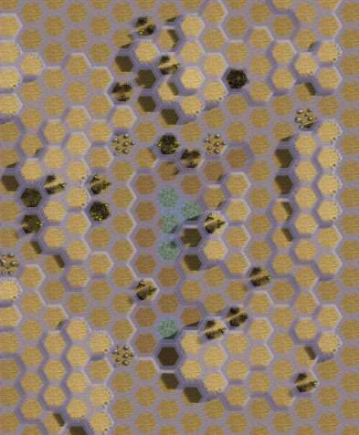
|-- FRIENDLY DEPLOYMENT ZONE --|

---------------------------- END TRANSMISSION -----------------------------
--------------------------- START TRANSMISSION ----------------------------

INTELLIGENCE HAS PROVIDED SATELLITE IMAGERY OF THE SPACEPORT.

COMMUNICATIONS ARRAY

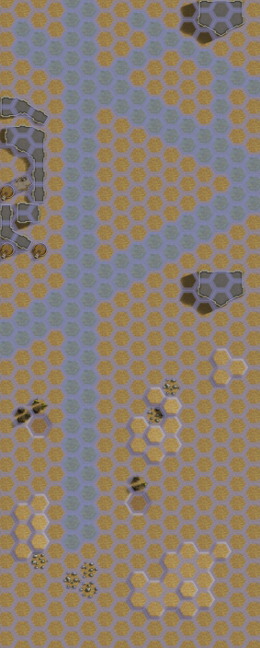
|-- FRIENDLY DEPLOYMENT ZONE --|
---------------------------- END TRANSMISSION -----------------------------
--------------------------- START TRANSMISSION ----------------------------

MISSION BOUNTIES

THE FOLLOWING BOUNTIES HAVE BEEN ISSUED FOR THIS MISSION.

PAYMENT | ACTIVITY
100,000 | DAMAGE ENEMY UNIT (PER UNIT)
100,000 | CRITICAL OR MOTIVE DAMAGE (PER UNIT)
100,000 | COMPLETE A PHYSICAL ATTACK
100,000 | COMPLETE AN ANTI-MECH ATTACK
100,000 | DAMAGE A UNIT WITH INDIRECT FIRE
100,000 | SKID A UNIT WITHOUT DESTROYING IT
250,000 | KNOCK 'MECH PILOT UNCONSCIOUS
250,000 | REDUCE A COMBAT VEHICLE TO 0 MP
250,000 | KILL ALL BUT 1 TROOP IN AN INFANTRY UNIT
250,000 | HAVE A UNIT SCORE A HIT AT ALL 3 RANGES
250,000 | COMPLETE A CHARGE ATTACK
250,000 | COMPLETE A DEATH FROM ABOVE ATTACK
500,000 | SHOOT DOWN A VTOL WITH A TMM OF 5+
500,000 | SHOOT A 'MECH IN THE HEAD
500,000 | PHYSICAL ATTACK A 'MECH IN THE HEAD
500,000 | CAPTURE A VEHICLE CREW OR 'MECH PILOT

---------------------------- END TRANSMISSION -----------------------------
--------------------------- START TRANSMISSION ----------------------------

SAMPLE FORCE

THE FOLLOWING IS A SAMPLE FORCE THAT IS SIMILAR TO THE GRAY DEATH LEGION:

FIRST MISSION:
SHADOW HAWK SHD-2H 1,404 BV (3/4 PILOT)
LOCUST LCT-3V 490 BV
----------------------------------
TOTAL 1,894 BV

SECOND MISSION:
SHADOW HAWK SHD-2H 1,404 BV (3/4 PILOT)
LOCUST LCT-3V 490 BV
LOCUST LCT-1V 432 BV
STINGER STG-3G 497 BV
MOTORIZED PLATOON (RIFLE) 92 BV
----------------------------------
TOTAL 3,405 BV

---------------------------- END TRANSMISSION -----------------------------
BATTLETECH: OUTWORLDS WASTES

GRAY DEATH ORIGINS - GM Notes

Mission 1
Maps: Deserts Pack, Badlands #2
Scoring: 1M if commander escapes, 1M if enemy destroyed (proportional)

DCMS: The DCMS will try to damage commander but will try to retreat before
being destroyed. Any enemy ‘mechs destroyed in this mission will not be in the second.
Recommend Panther PNT-9R and Jenner JR7-D

Mission 2
Maps: Deserts Pack, AeroBase #1 and Desert Runway
Scoring: 2M if communications array destroyed

Deployment: The players may secretly deploy 1 ‘mech anywhere on the first mapsheet
Setup: Communications Array has CF 100; place fuel barrels that do 35 damage to
everything in adjacent hexes in at least 2 hexes next to the Array.

DCMS: The DCMS will follow the player forces if drawn off, but will focus on whichever
units are attacking the Communications Array if they are in range. The DCMS will signal
retreat once the Array is destroyed.
Recommend Marauder MAD-3R, Panther PNT-9R, and Jenner JR7-D

BATTLETECH
OUTWORLDS WASTES

